Prasar Srivastava  
22BCE10841  
AWS CLOUD Architect CSE3016  
Submitted To-Dr. Munsifa Firdaus Khan  
Lab 1

THE CONSOLE PAGE WILL APPEAR

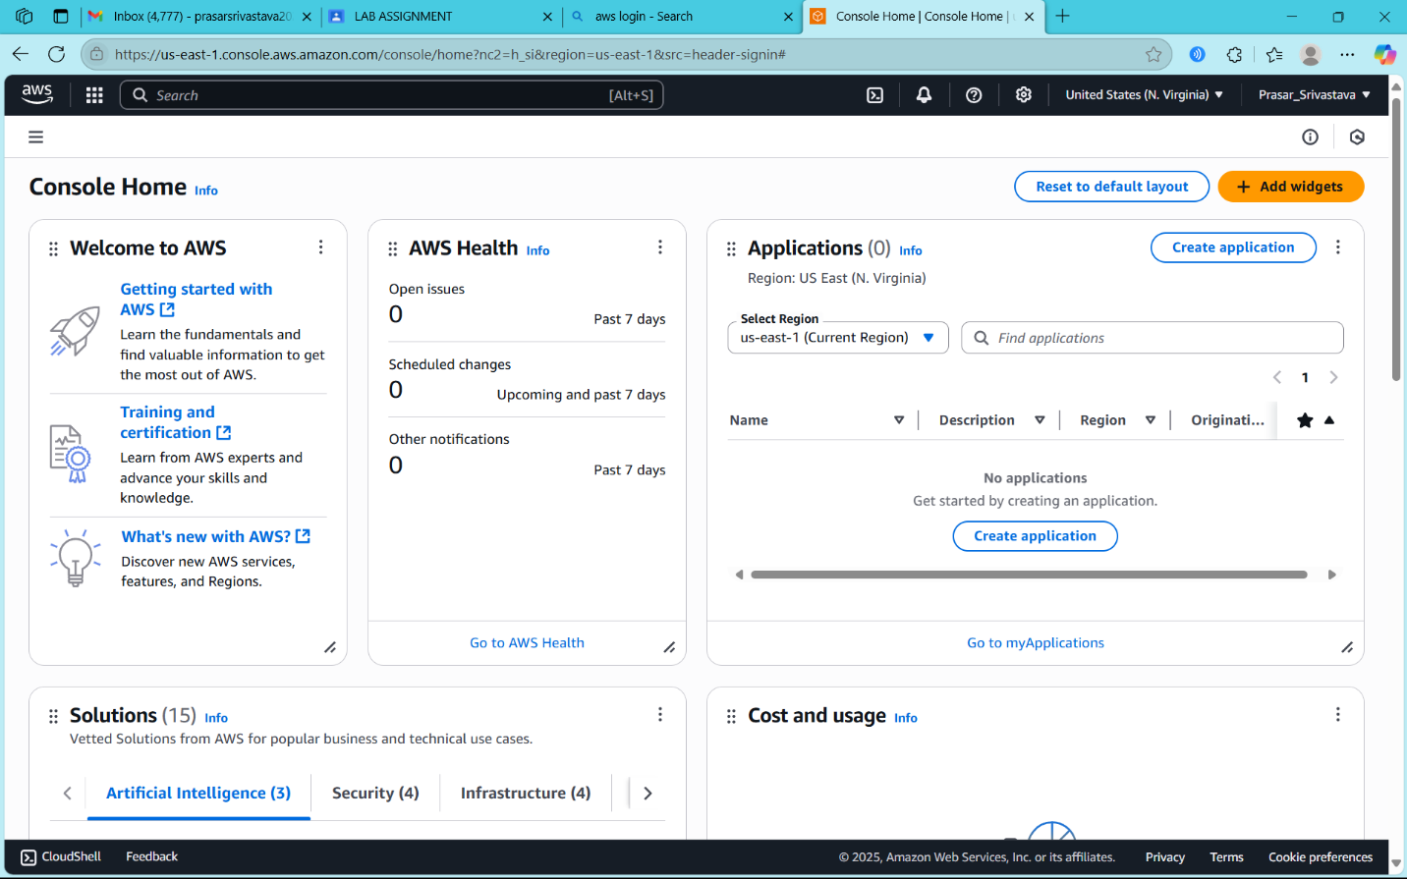

SEARCH/CLICK ON IAM

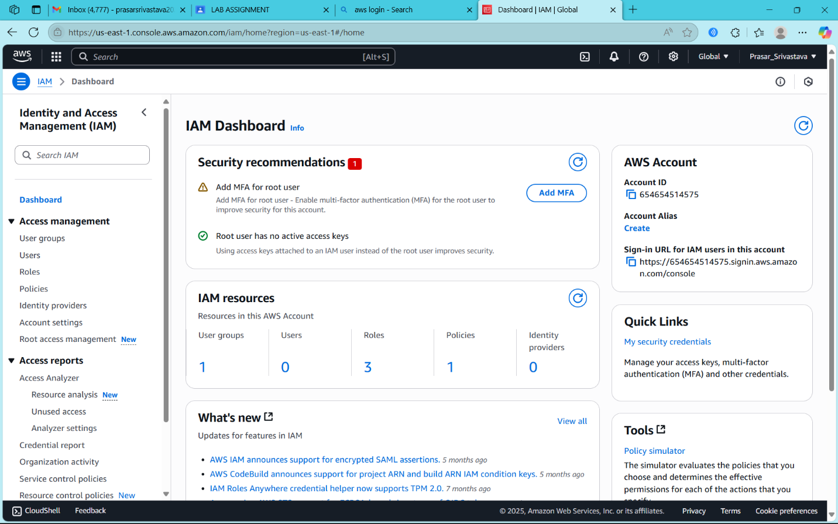

CLICK ON USER

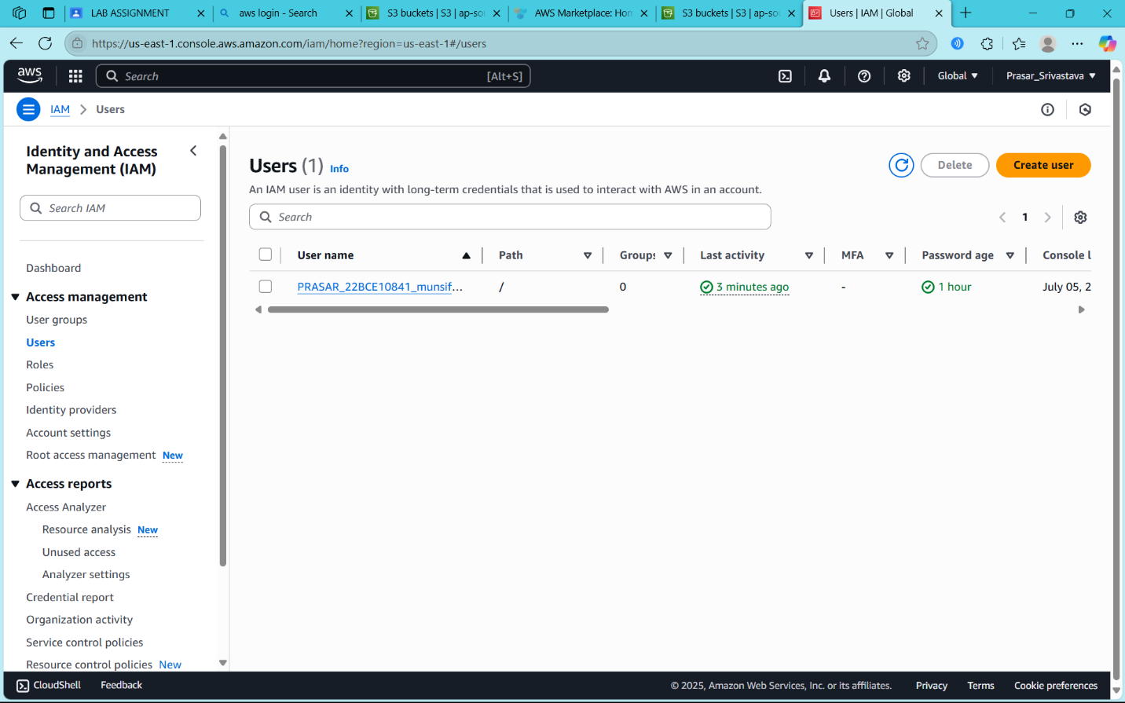

CLICK ON ADD USER TO GROUP AND CREATE GROUP

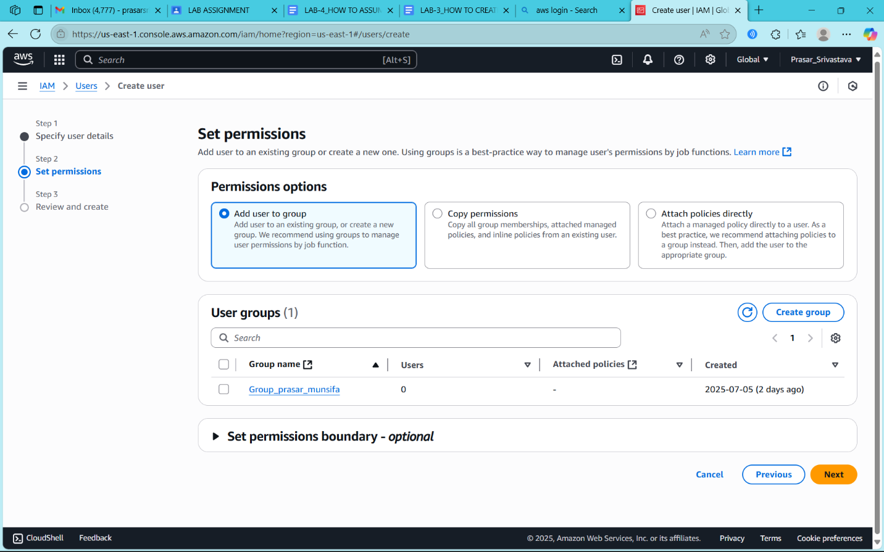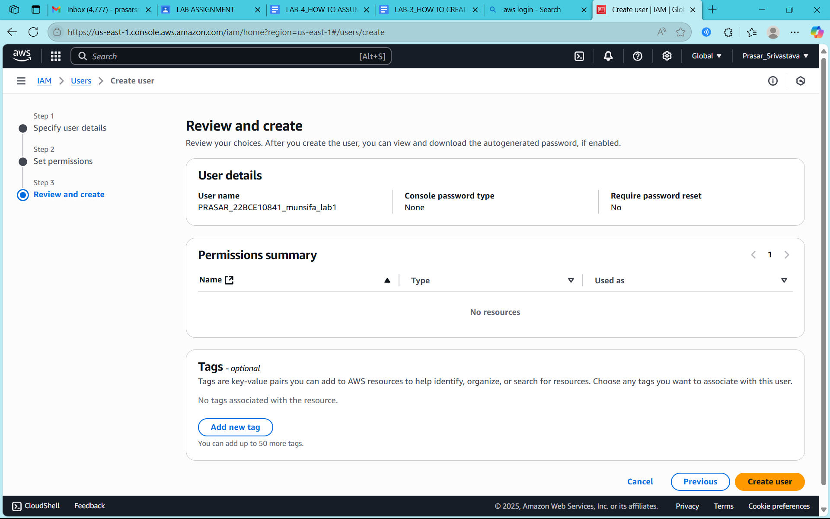

CLICK ON CREATE USER

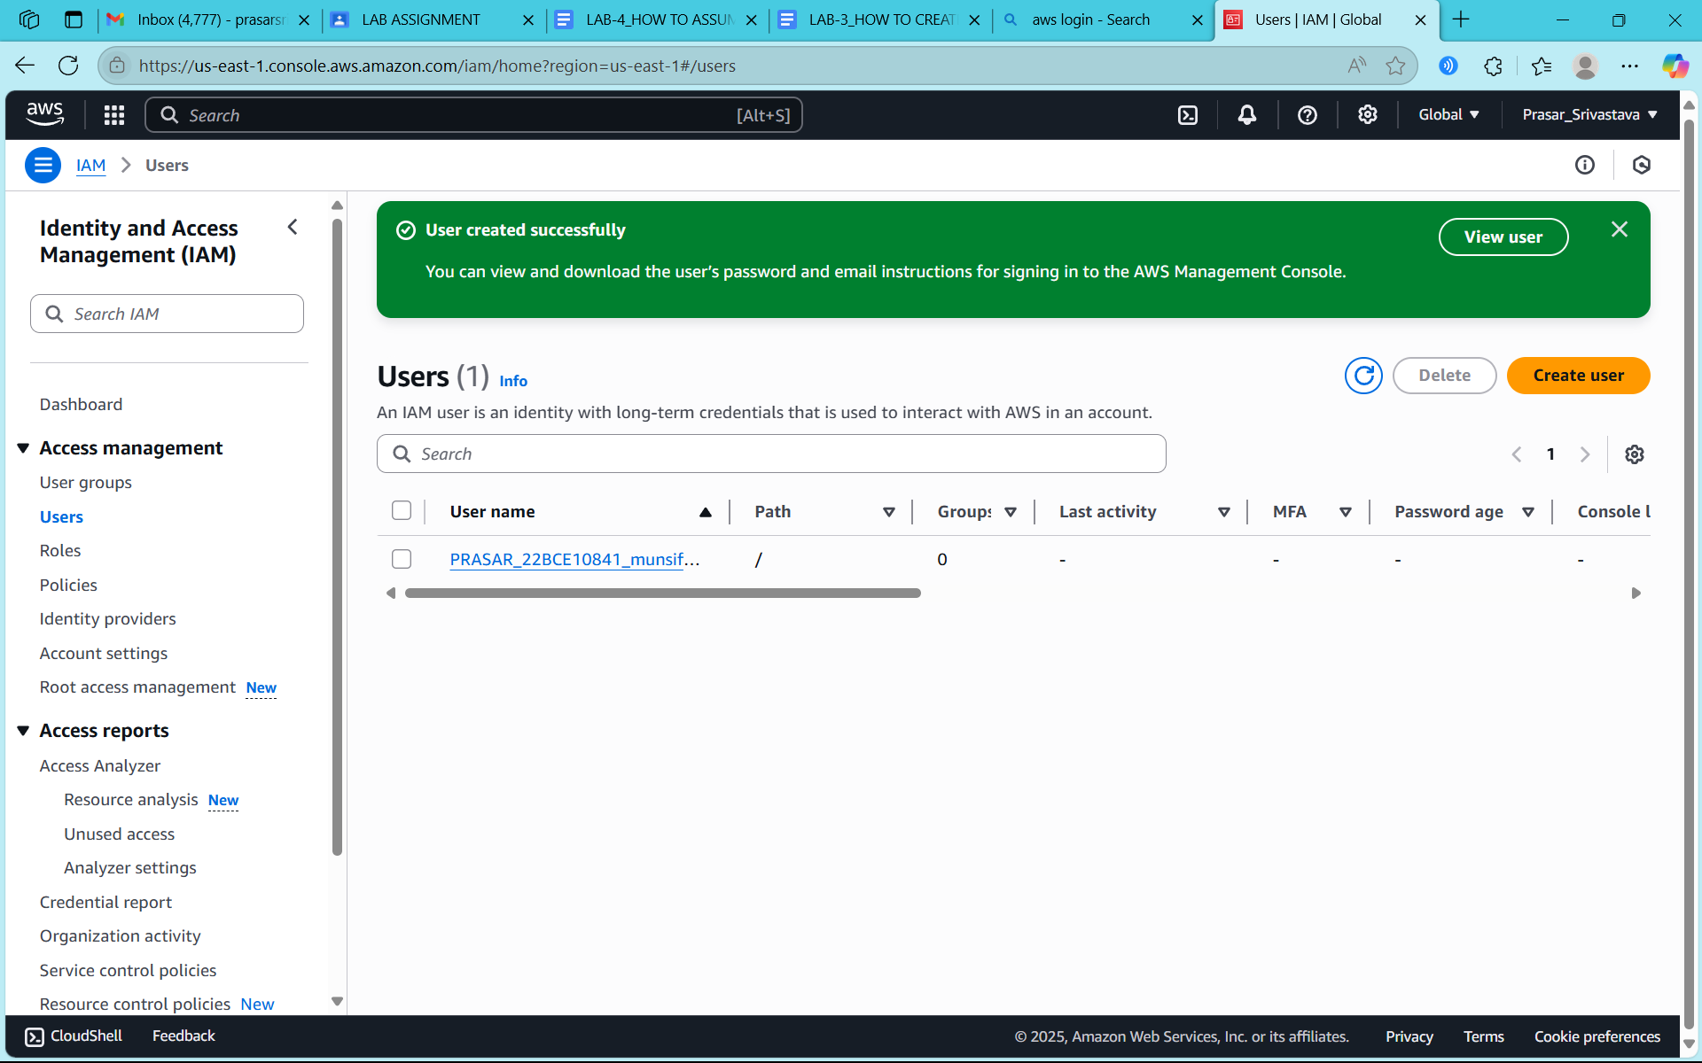

CLICK ON **PRASAR_22BCE10841_munsifa_lab1** to see the details of the IAM user

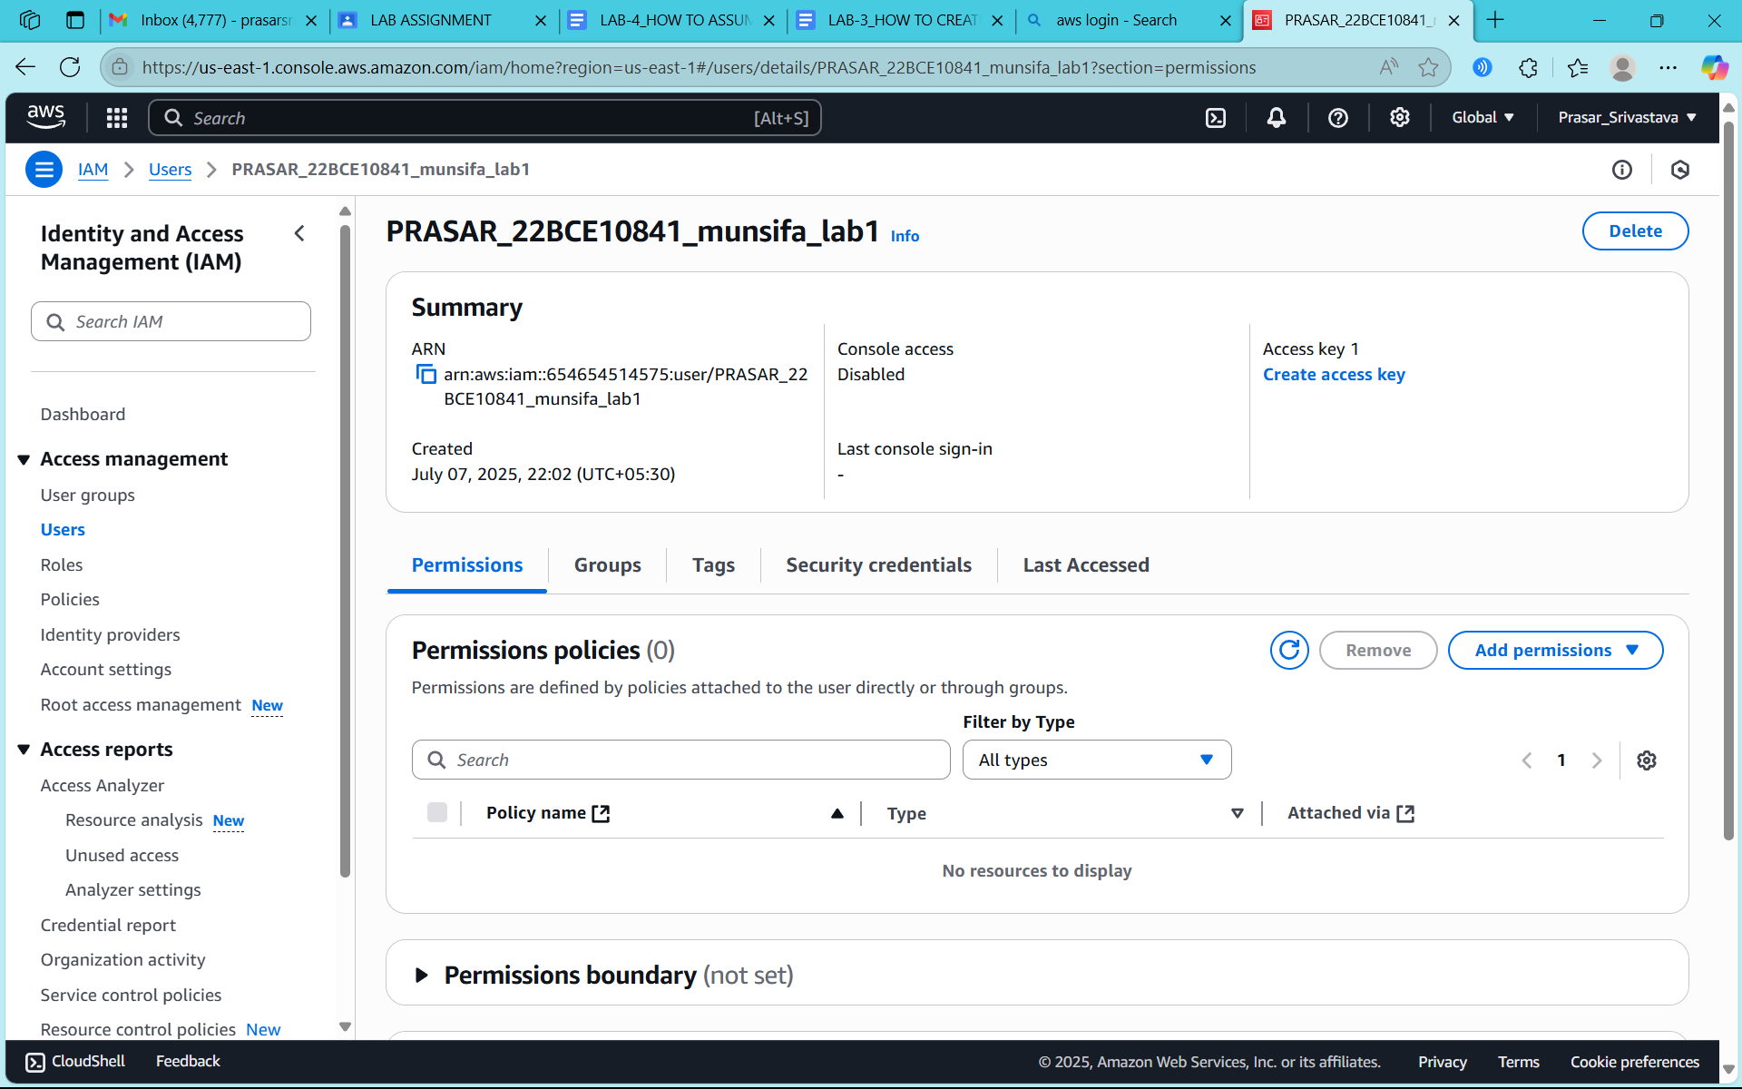

**CLICK ON SECURITY CREDENTIALS**

**CLICK ON ENABLE CONSOLE ACCESS**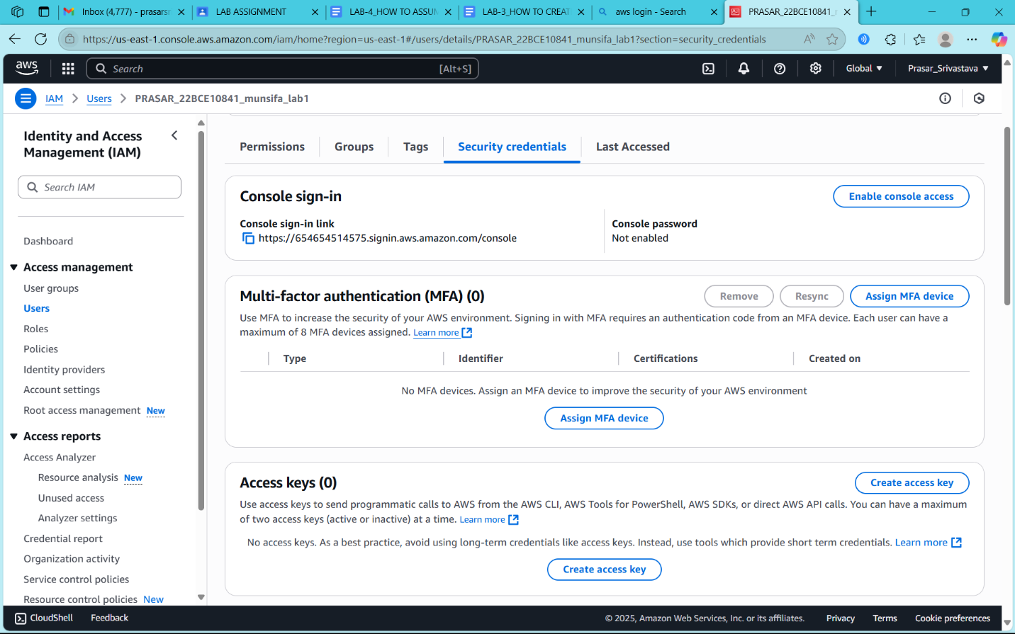

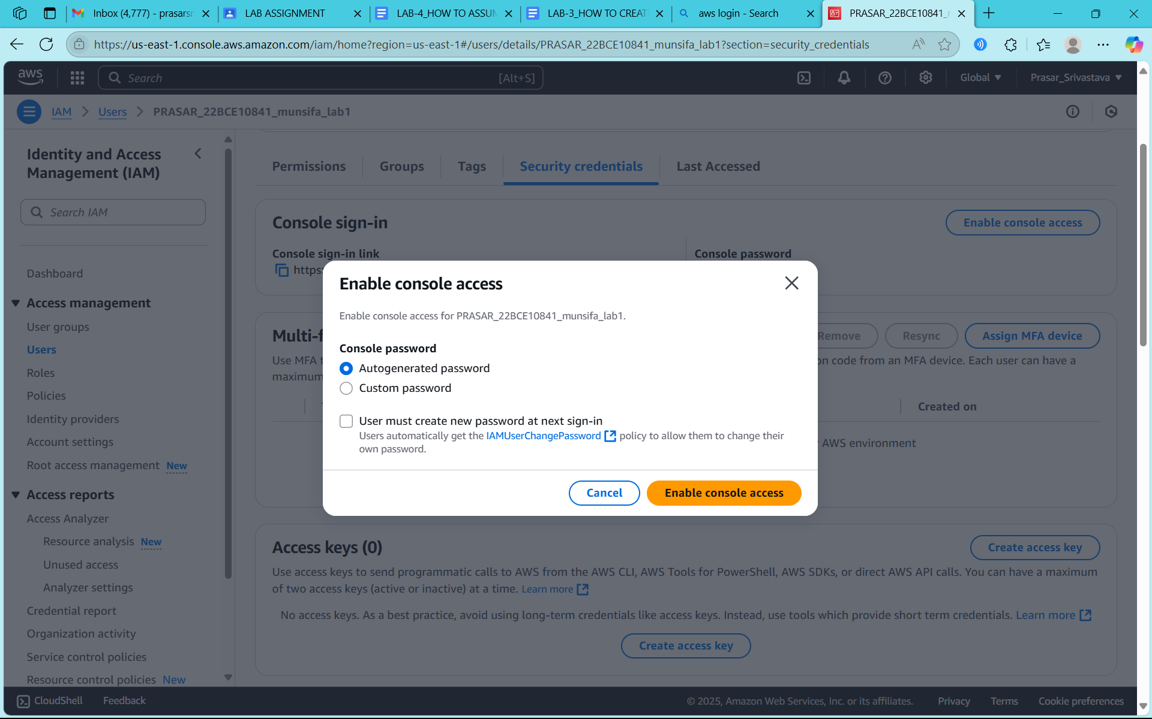

**STEP15: COPY THE INFORMATION ON SEPARATE FILE AND CLICK ON CLOSE**

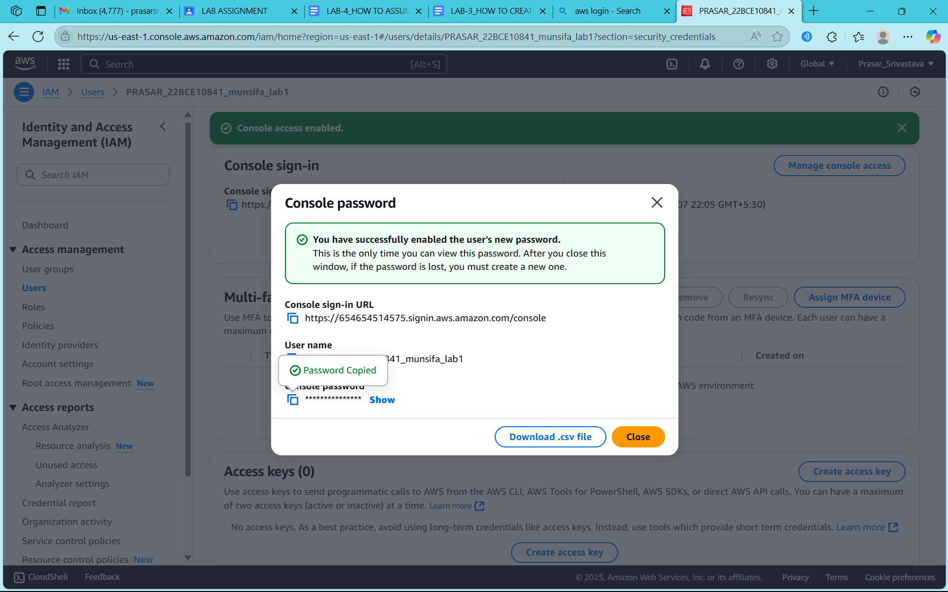

**STEP16: OPEN SEPARATE WINDOW AND COPY THE LINK TO OPEN IAM USER**

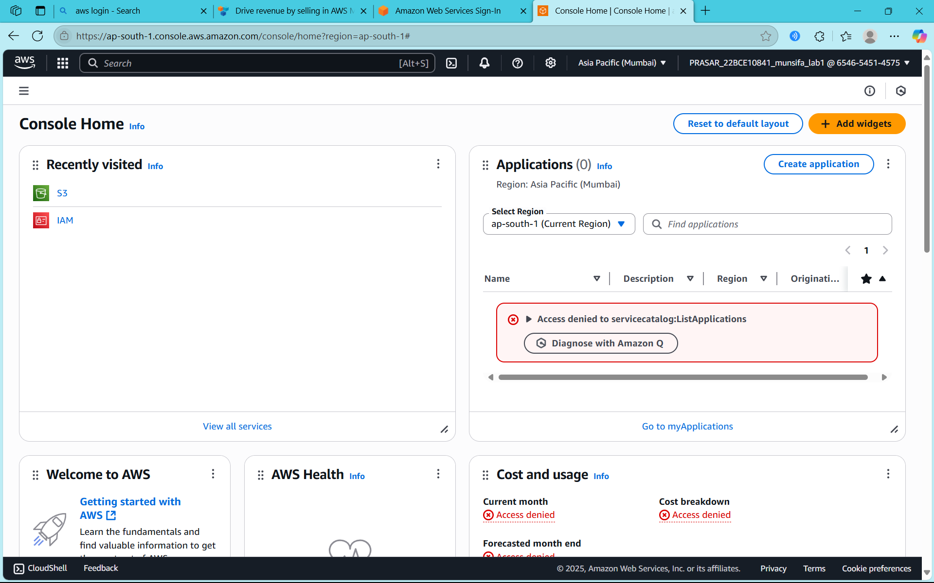

**STEP17: IAM USER CONSOLE PAGE WILL APPEAR**



**STEP18: CLICK ON S3**

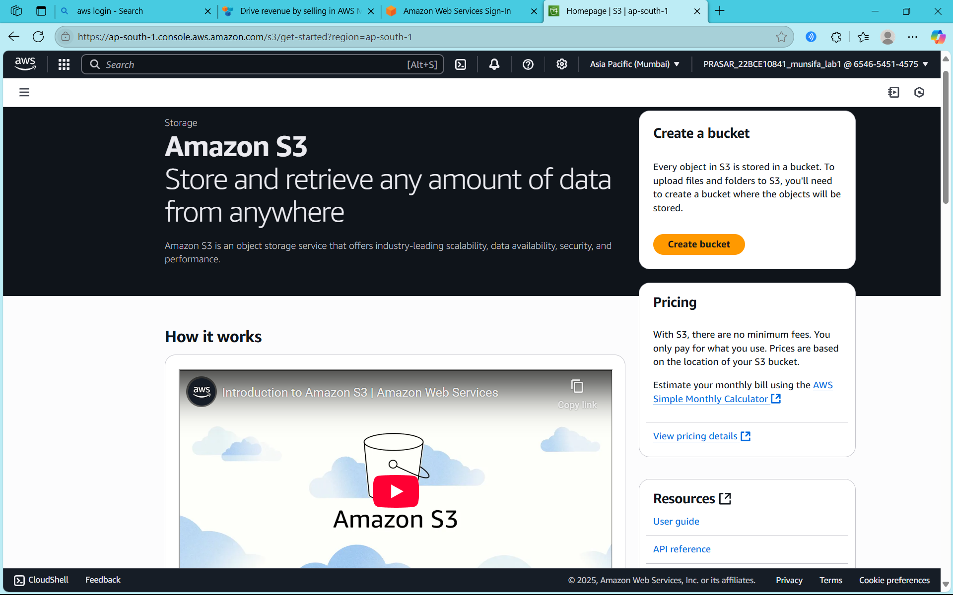

**STEP18: CLICK ON GENERAL PURPOSE BUCKET**

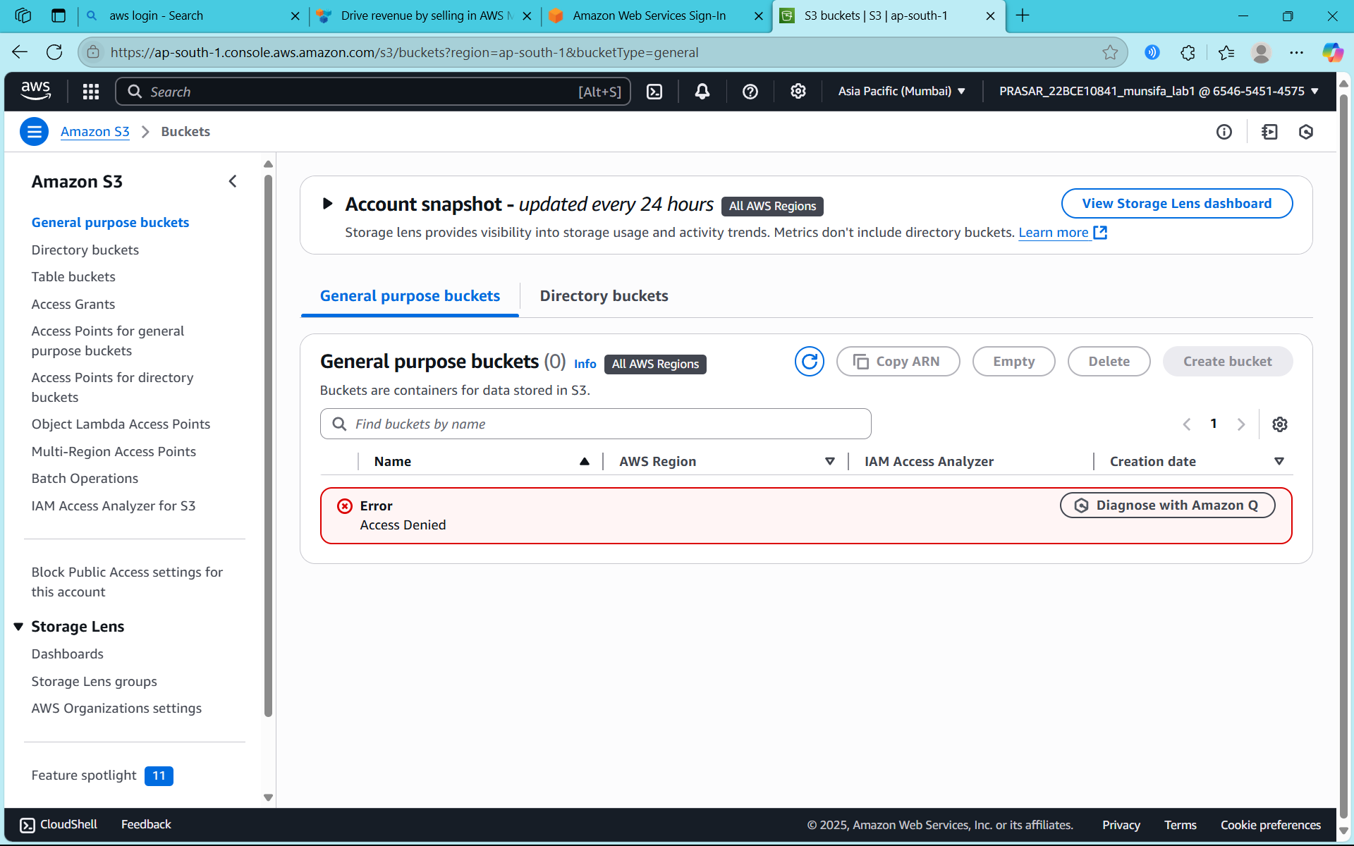

**STEP19: AN ERROR WILL APPEAR**

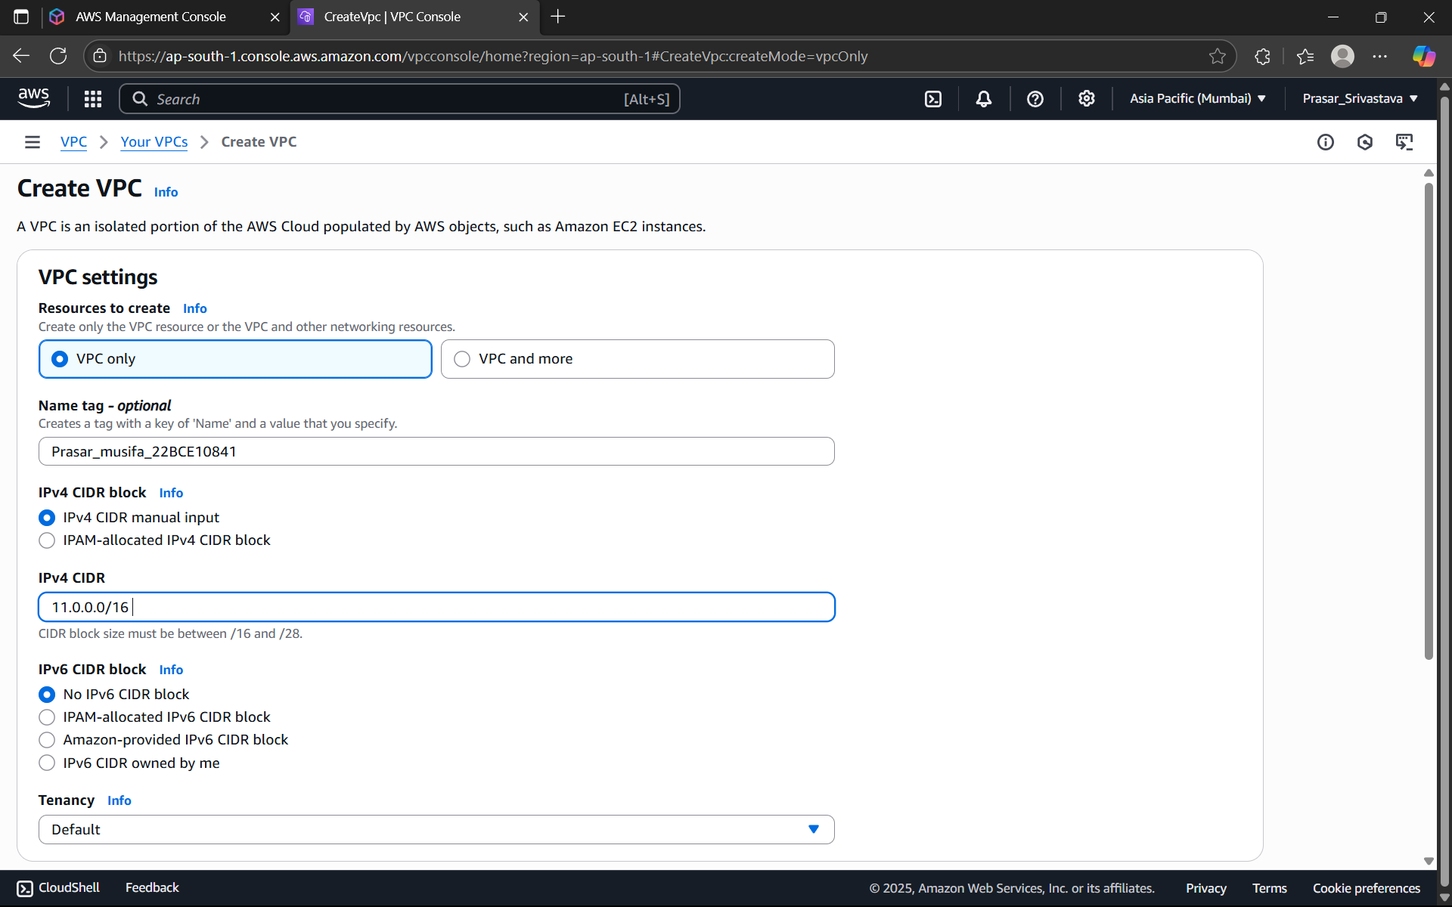

**STEP20: WE NEED TO CREATE POLICIES FROM ROOT USER, CLICK ON CREATE POLICY**

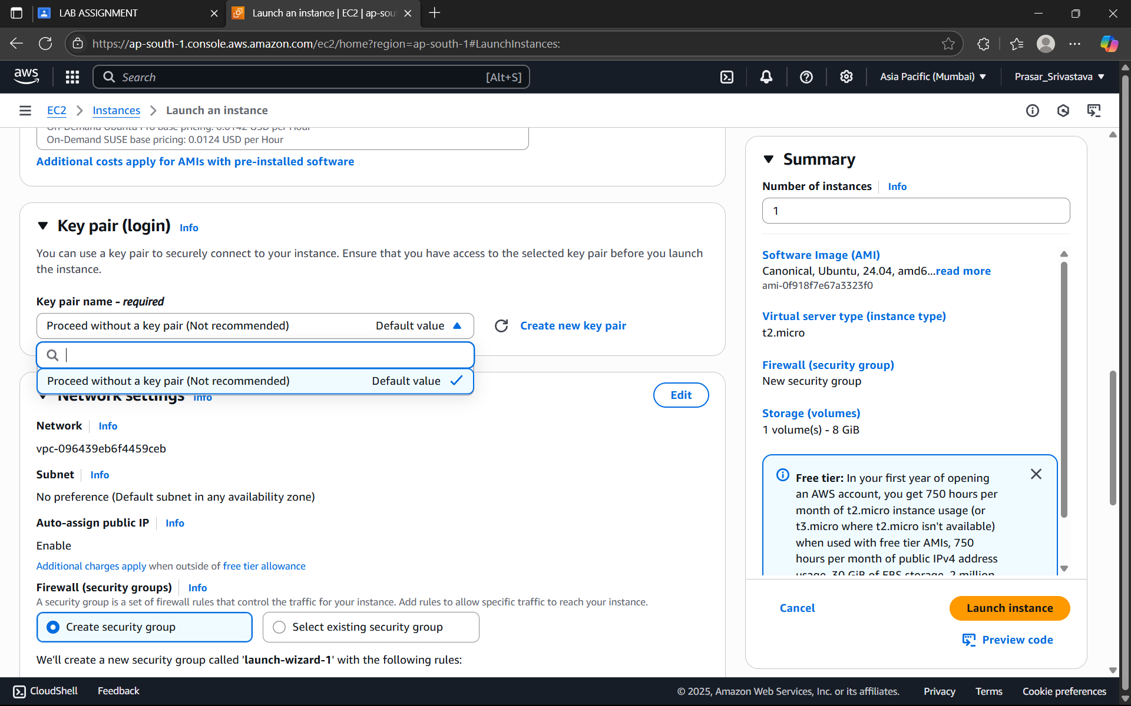

**STEP21: CLICK ON JSON TAB AND MODIFY THE FOLLOWING CODE**

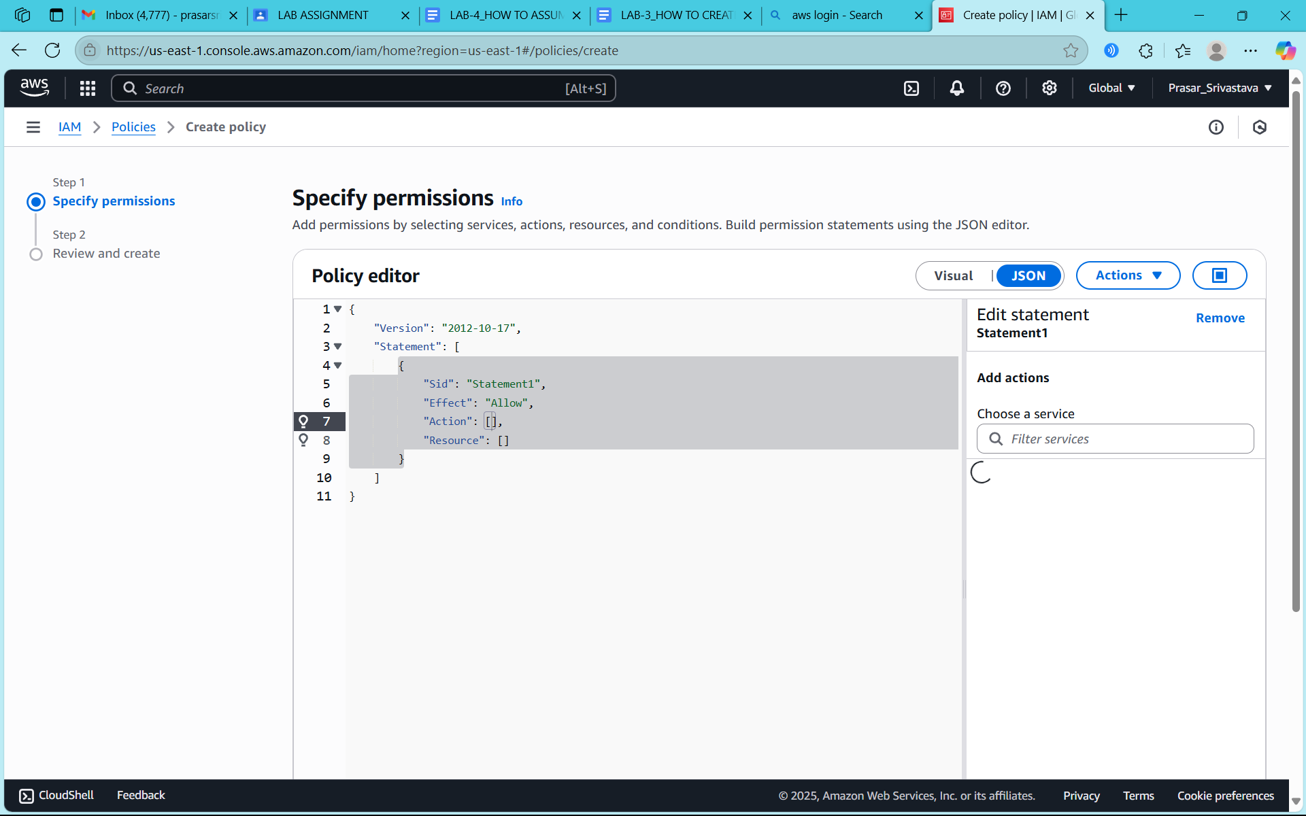

**STEP22: WRITE THE FOLLOWING CODE AND CLICK ON NEXT**

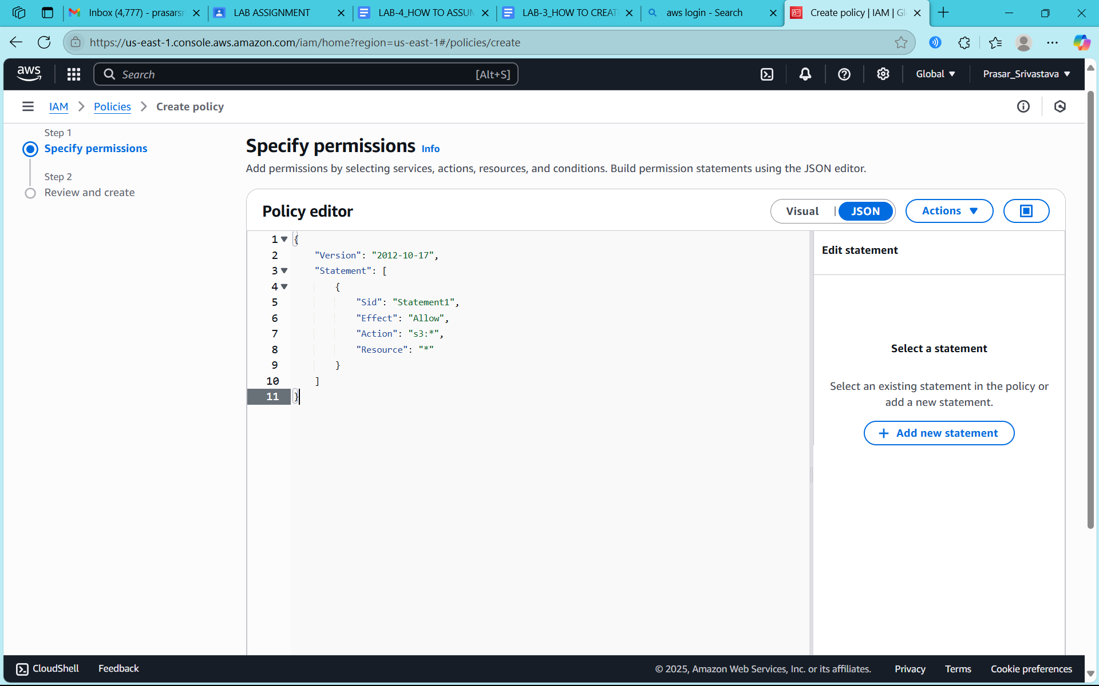

**STEP22: WRITE THE POLICY NAME**

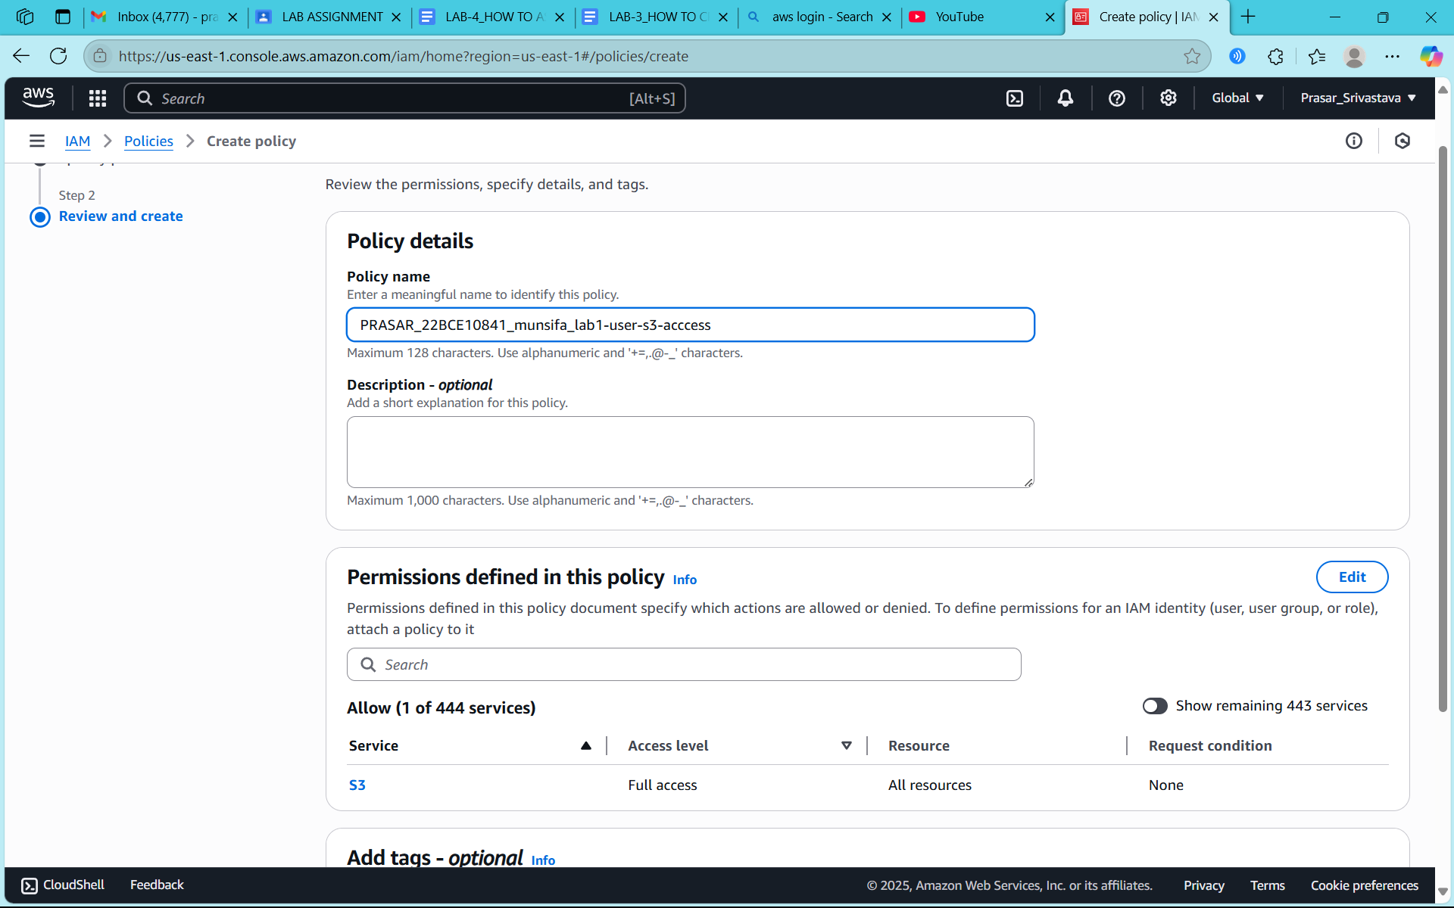

**STEP23: CLICK ON CREATE POLICY**

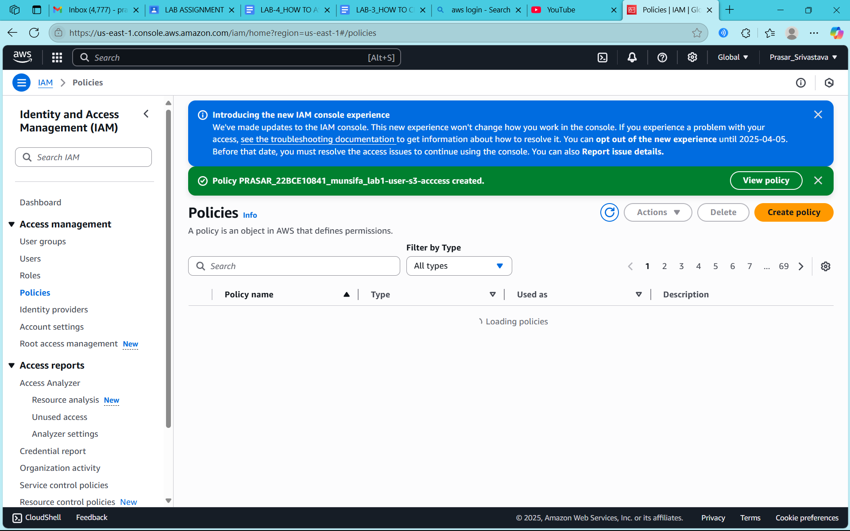

**STEP24: POLICY IS CREATED**

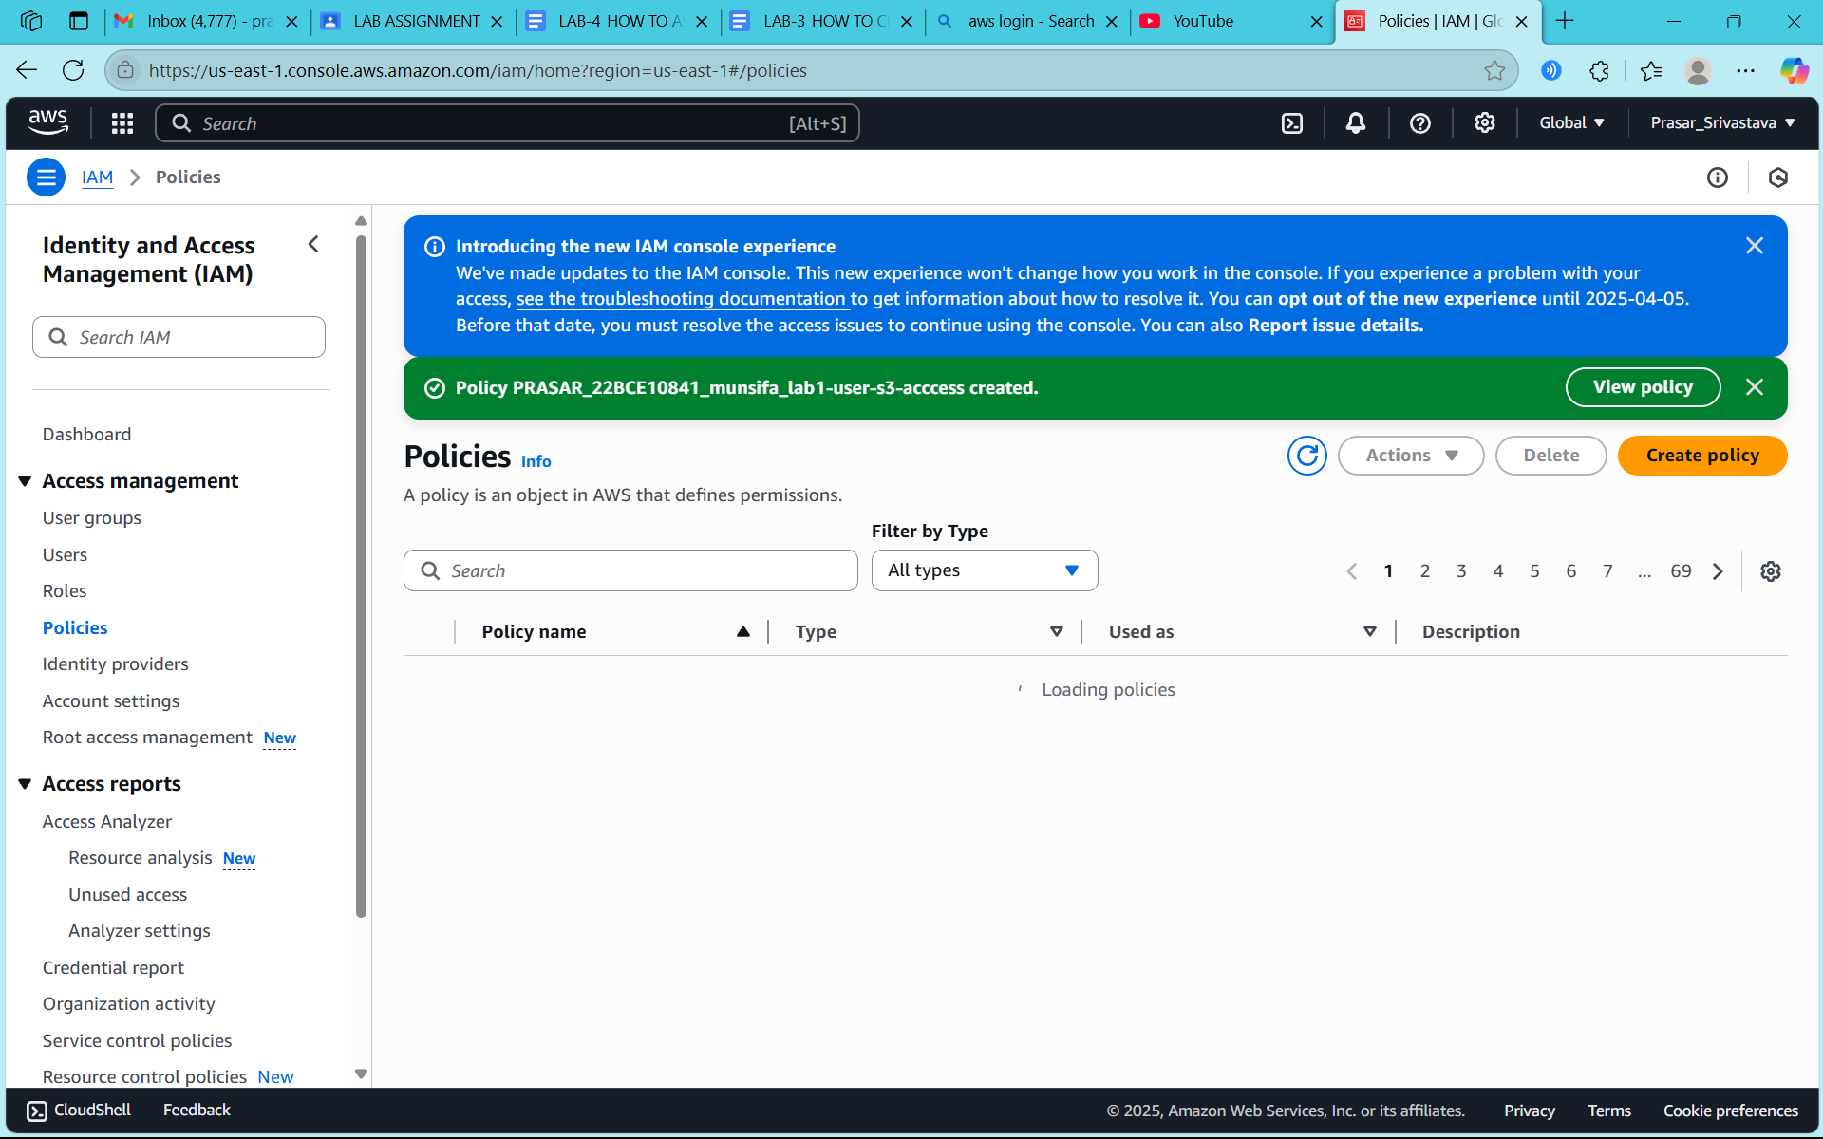

**STEP25: CLICK ON ADD PERMISSIONS**

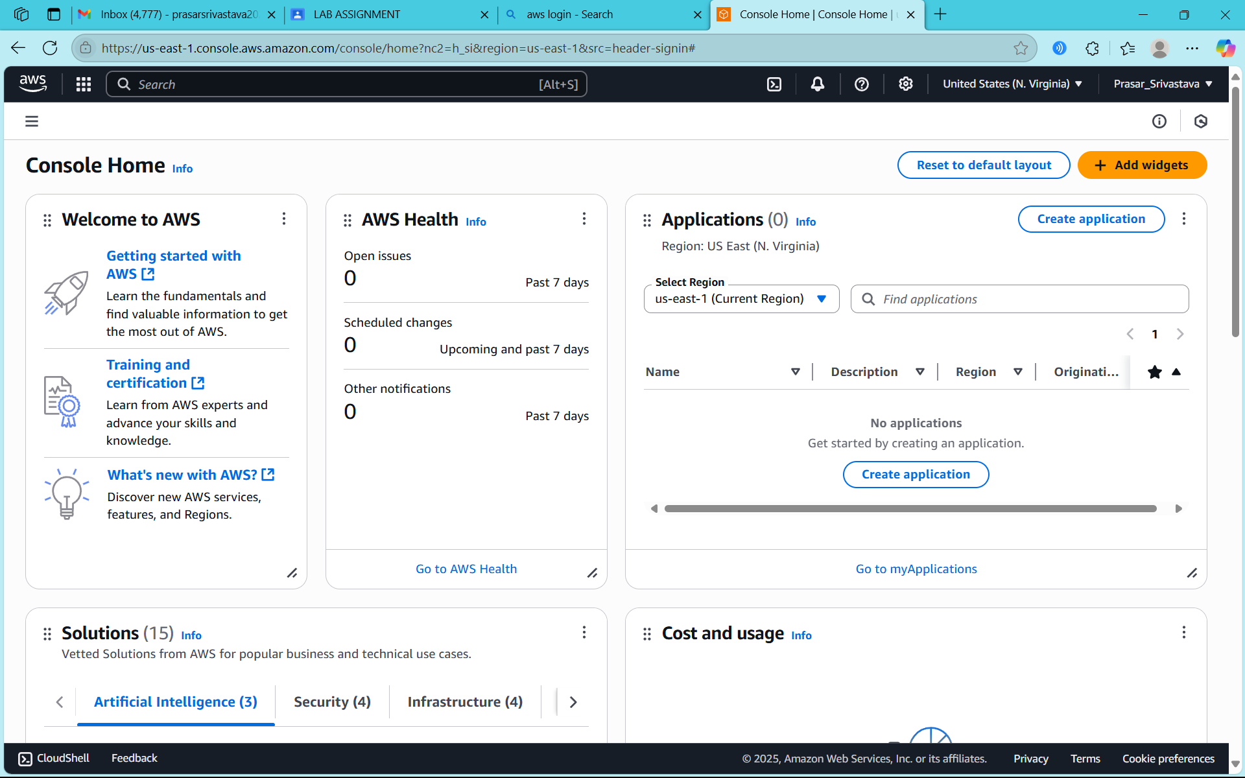

**STEP26: CLICK ON ATTACH POLICY DIRECTLY**

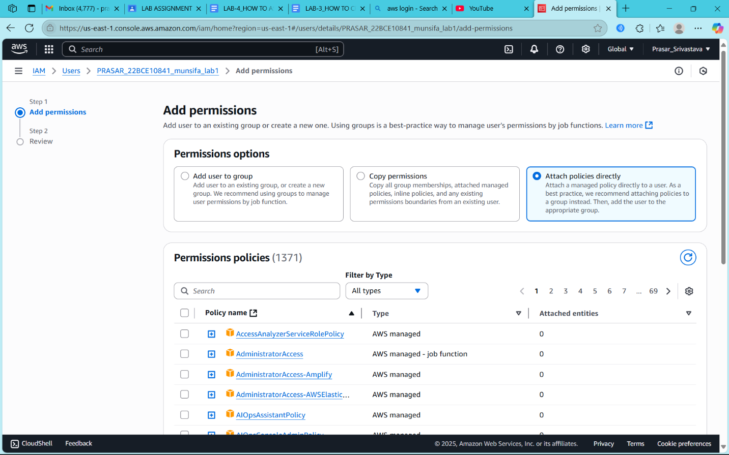

**STEP27: SEARCH FOR THE POLICY CREATED AND CLICK ON NEXT**

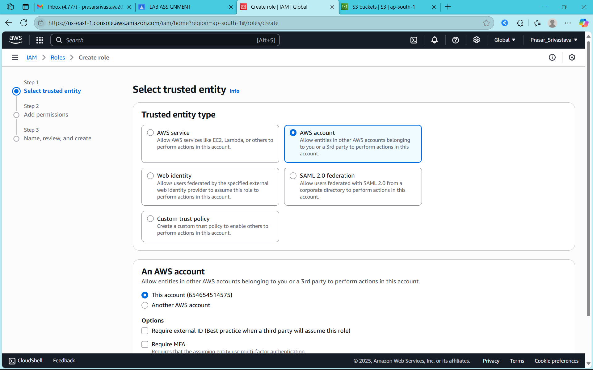

**STEP28: CLICK ON ADD PERMISSION**

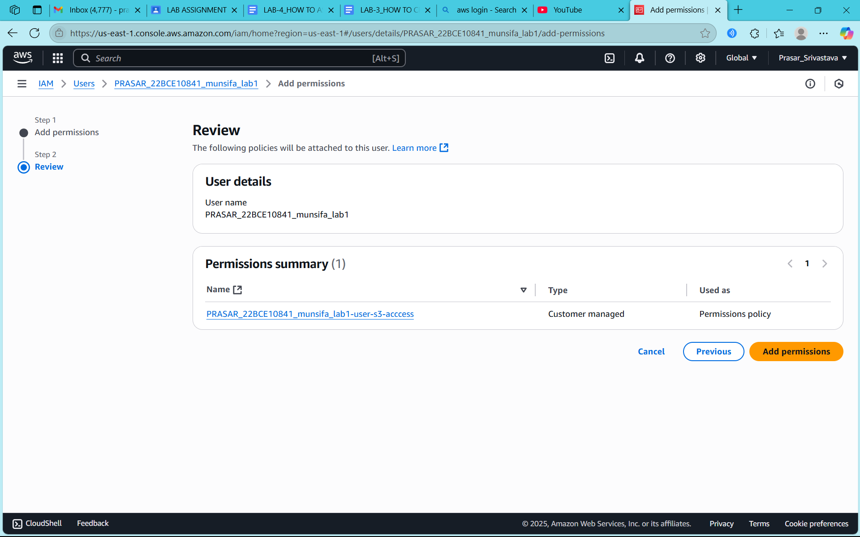

**STEP29: POLICY IS ADDED IN ROOT USER**

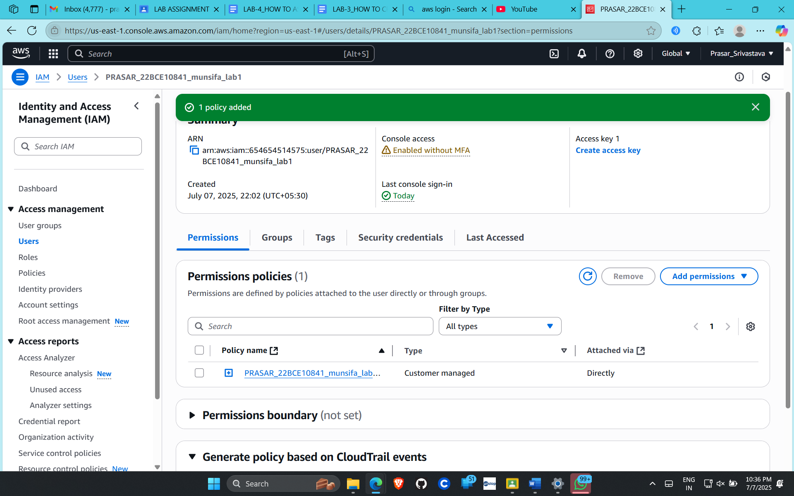

**STEP30: NOW IF YOU OPEN THE CONSOLE PAGE OF IAM USER, NO ERROR IS THERE**

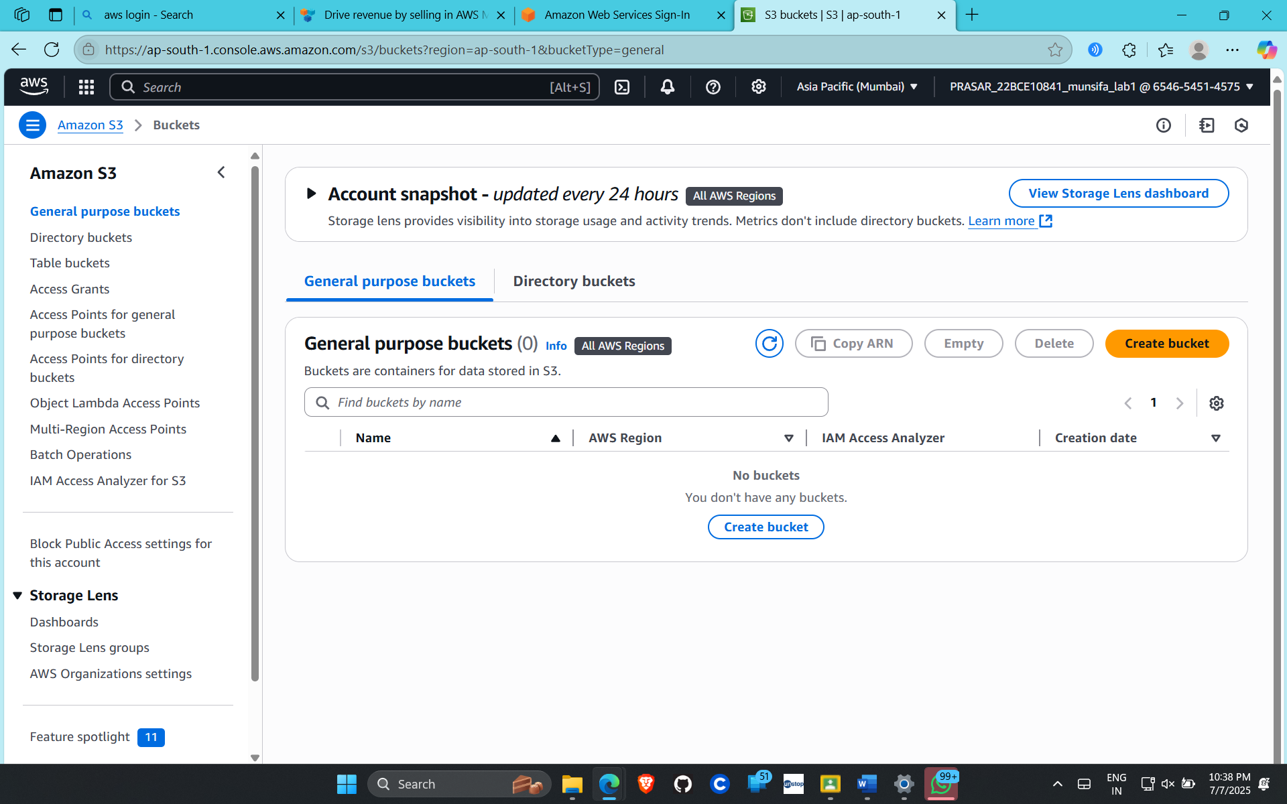

Prasar Srivastava  
22BCE10841  
AWS CLOUD Architect CSE3016  
Submitted To-Dr. Munsifa Firdaus Khan

Lab 6

***CREATE AN EC2 INSTANCE***

STEP1: OPEN THE AWS ROOT ACCOUNT AND SEARCH FOR EC2

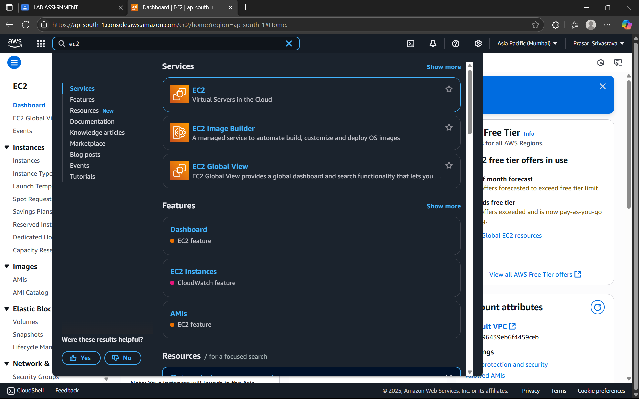

STEP2: CLICK ON EC2, EC2 DASHBOARD WILL APPEAR.

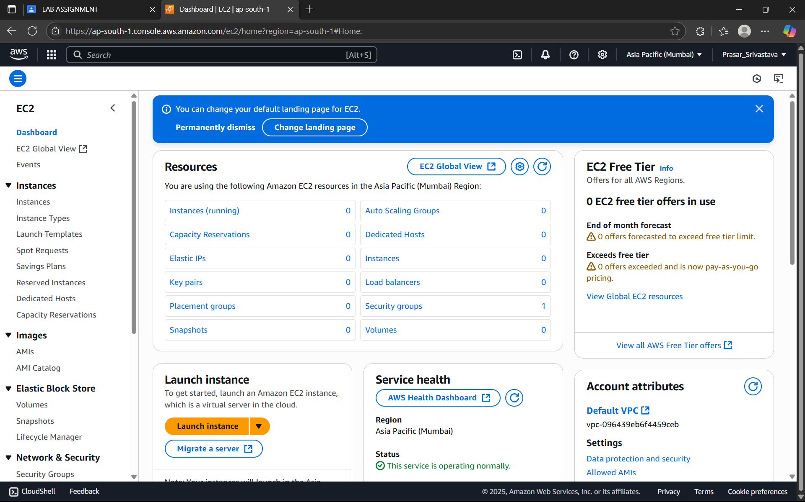

STEP3: SELECT THE REGION>ASIA PACIFIC>MUMBAI

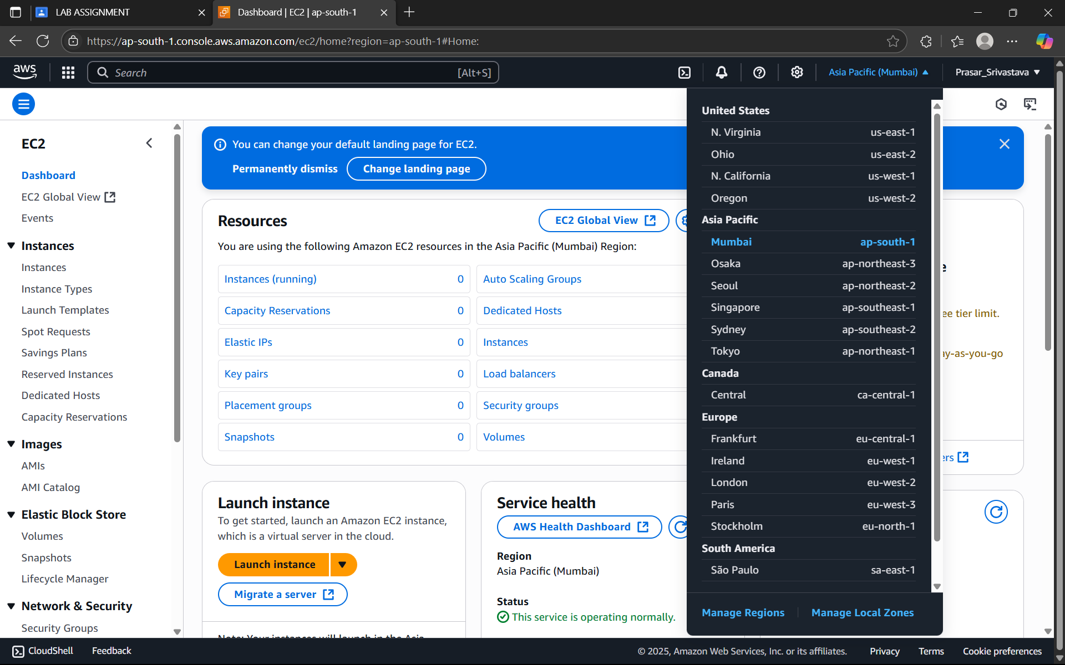

STEP4: SELECT LAUNCH INSTANCE

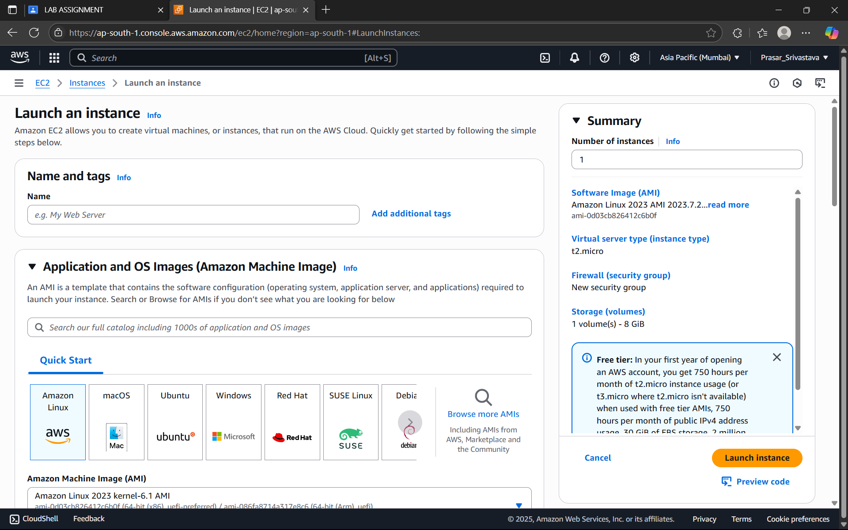

STEP5: TYPE THE NAME OF THE INSTANCE

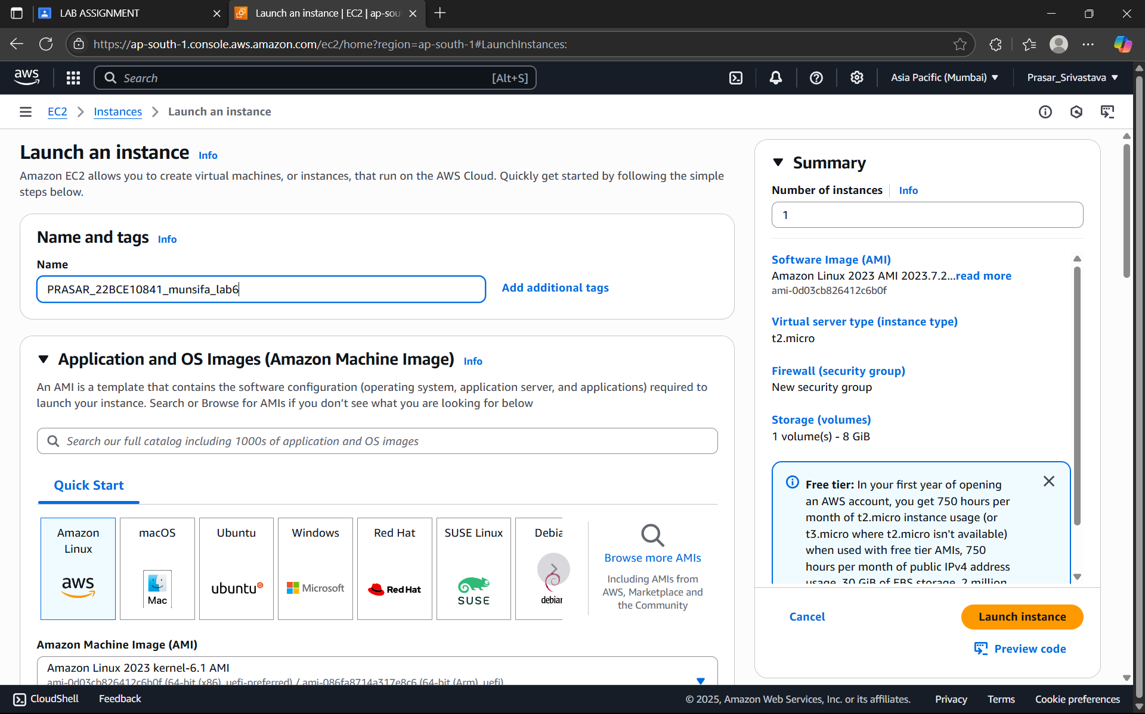

STEP6: CHOOSE THE OPERATING SYSTEM>UBUNTU

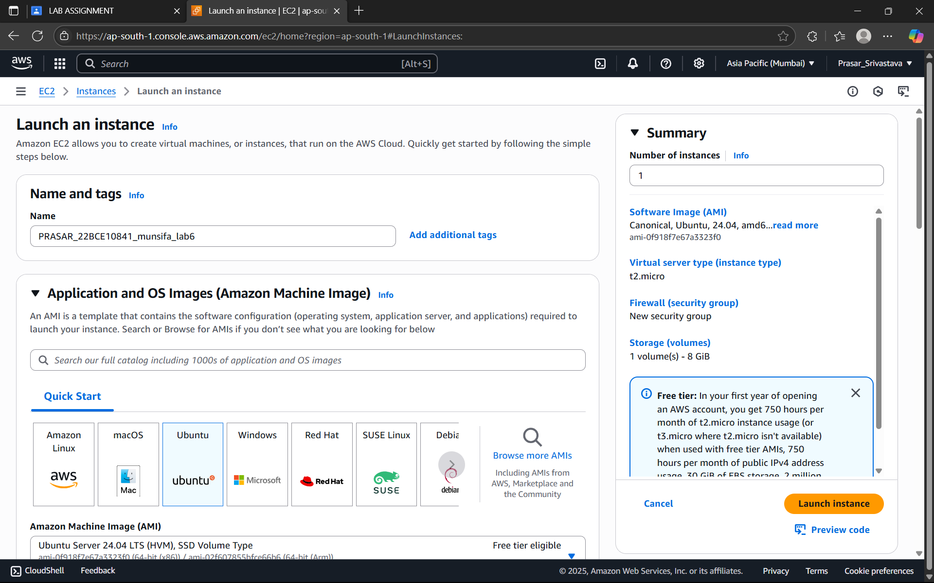

STEP7: CHOOSE THE ARCHITECTURE>64-bit(x86)

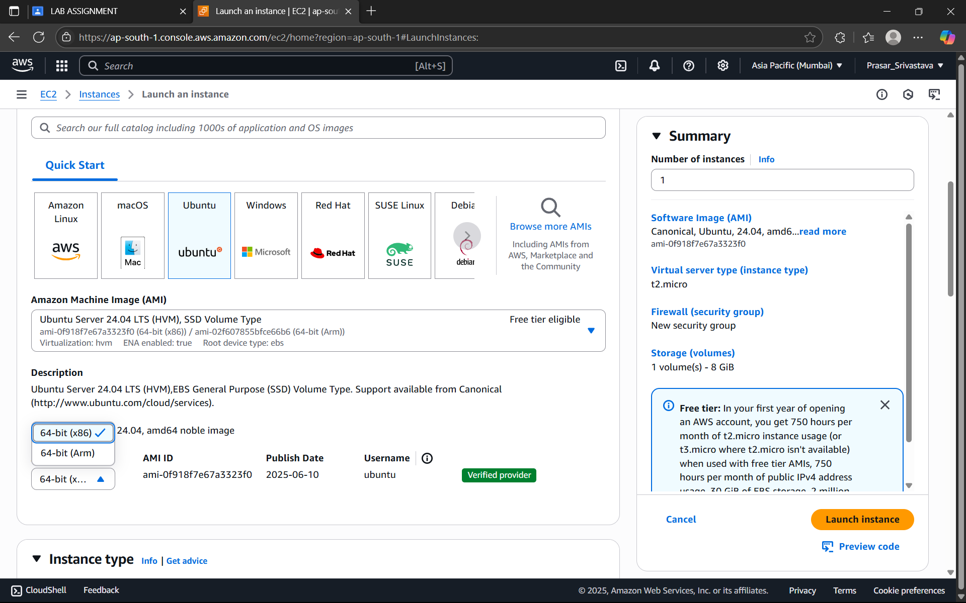

STEP8: CHOOSE INSTANCE TYPE: t2 micro (Free tier eligible)

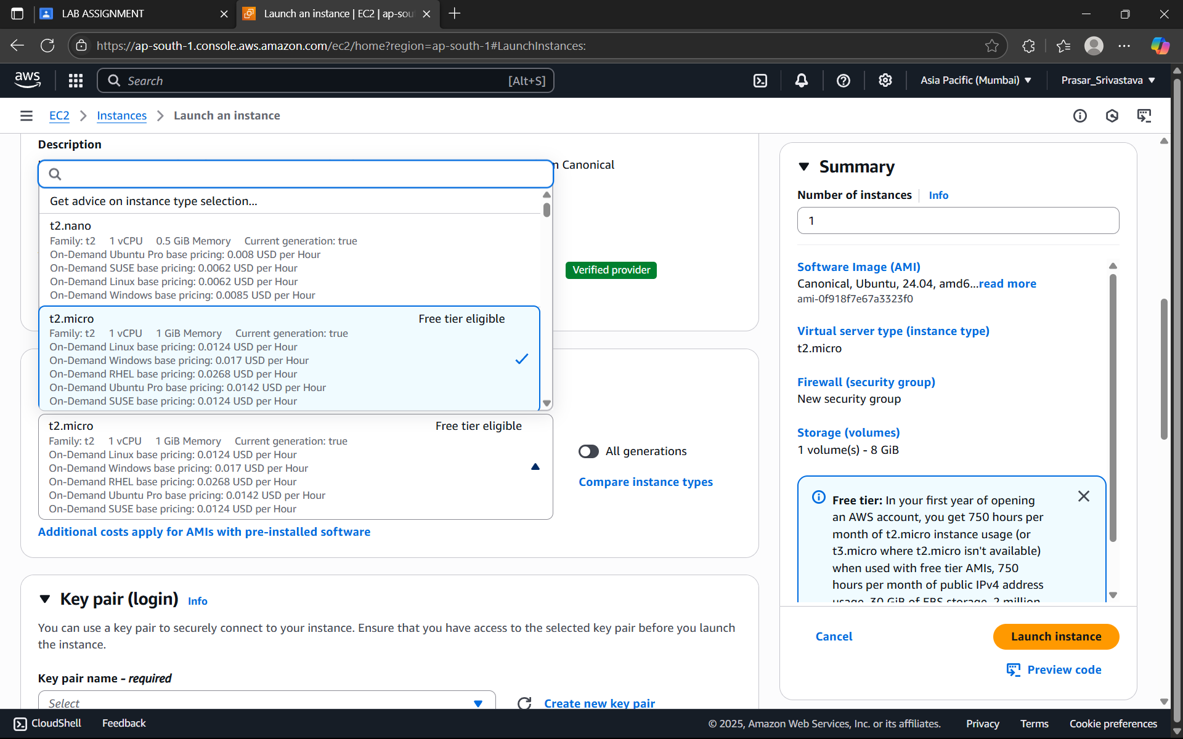

STEP9: CREATE A NEW KEY PAIR:

There are two keys involved in this step. One is private key for user and another

is public key for the EC2 instance. Once we create a pair, both the keys will be

generated. Public key need to saved separately for future use. Both keys will

have same name as given.



STEP10: PUBLIC KEY IS AUTOMATICALLY ENABLED IN EC2 INSTANCE

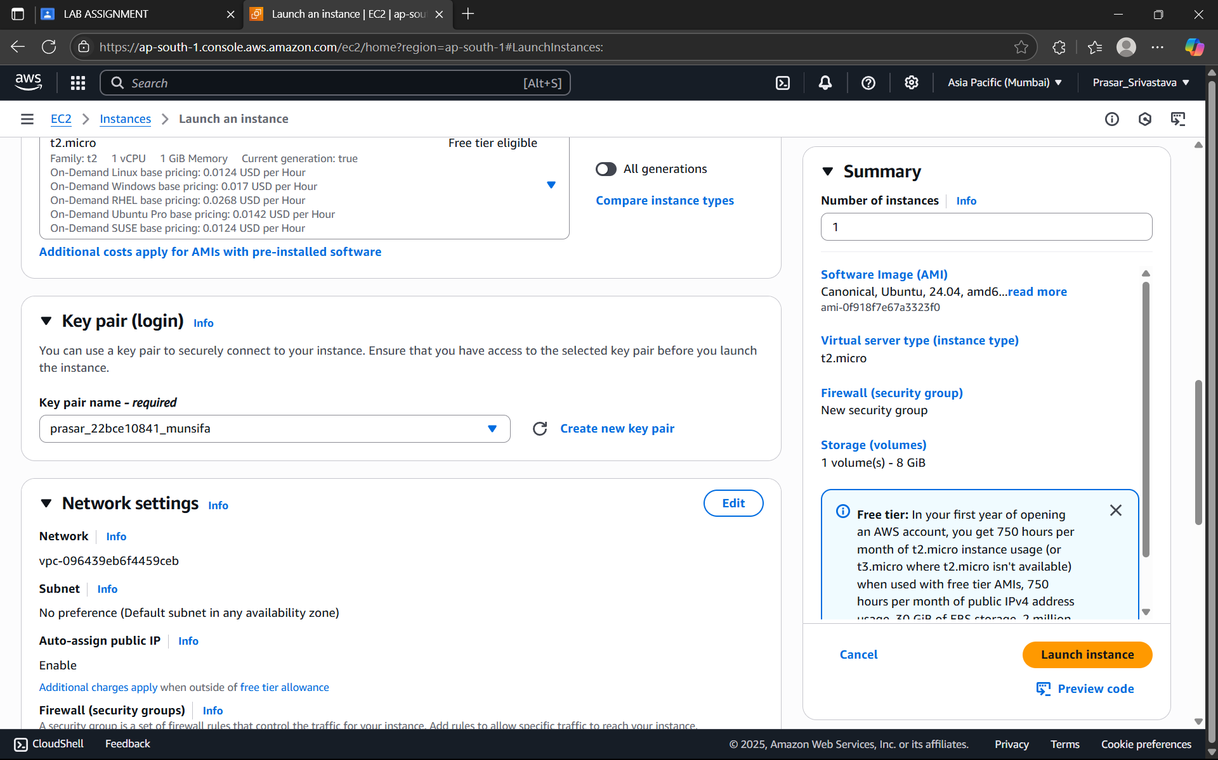

STEP11: CHOOSE THE DEFAULT NETWORK SETTINGS(NOTE: Auto-assign public IP should be enabled and source:0.0.0.0/0 allows all the IP addresses to

access the EC2 instance )

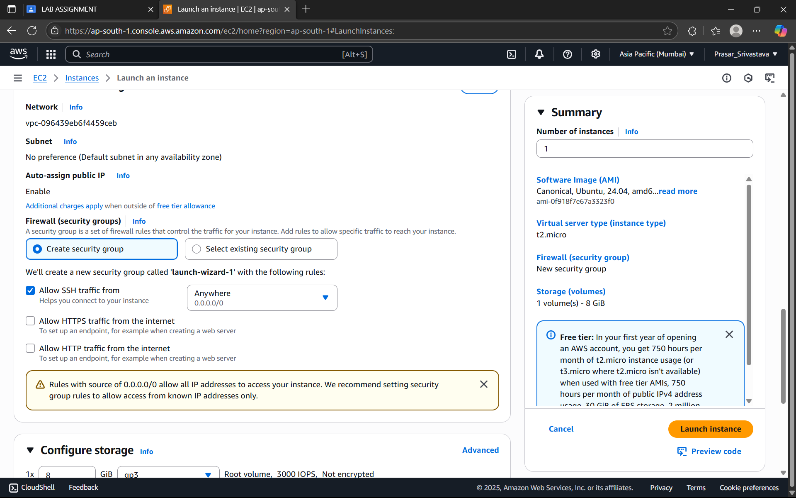

STEP12: CHOOSE THE DEFAULT CONFIGURE STORAGE AND CLICK ON LAUNCH INSTANCE

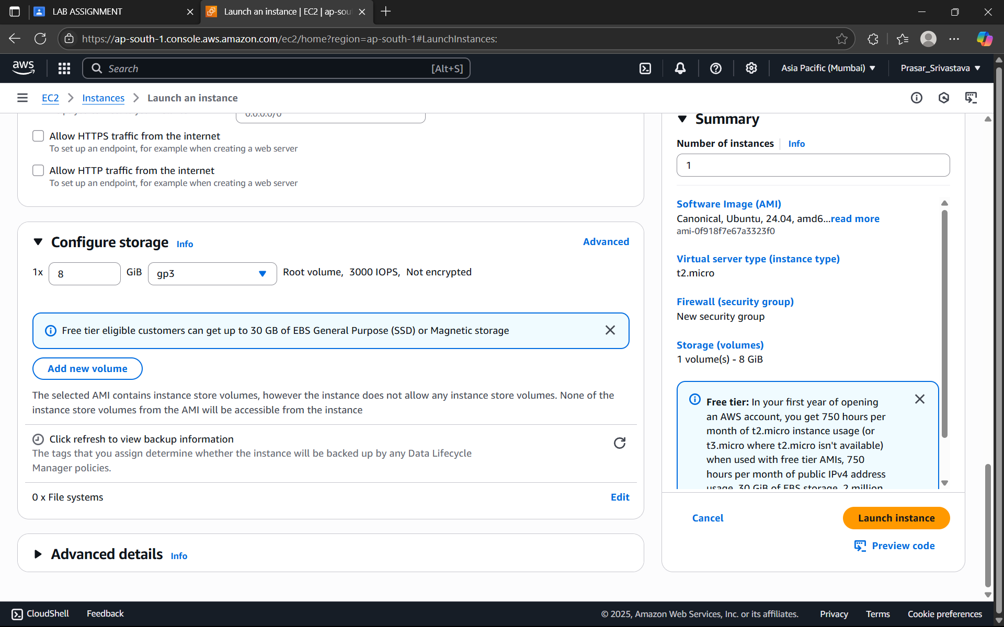

STEP13: EC2 INSTANCE IS CREATED, CLICK ON THE INSTANCE.

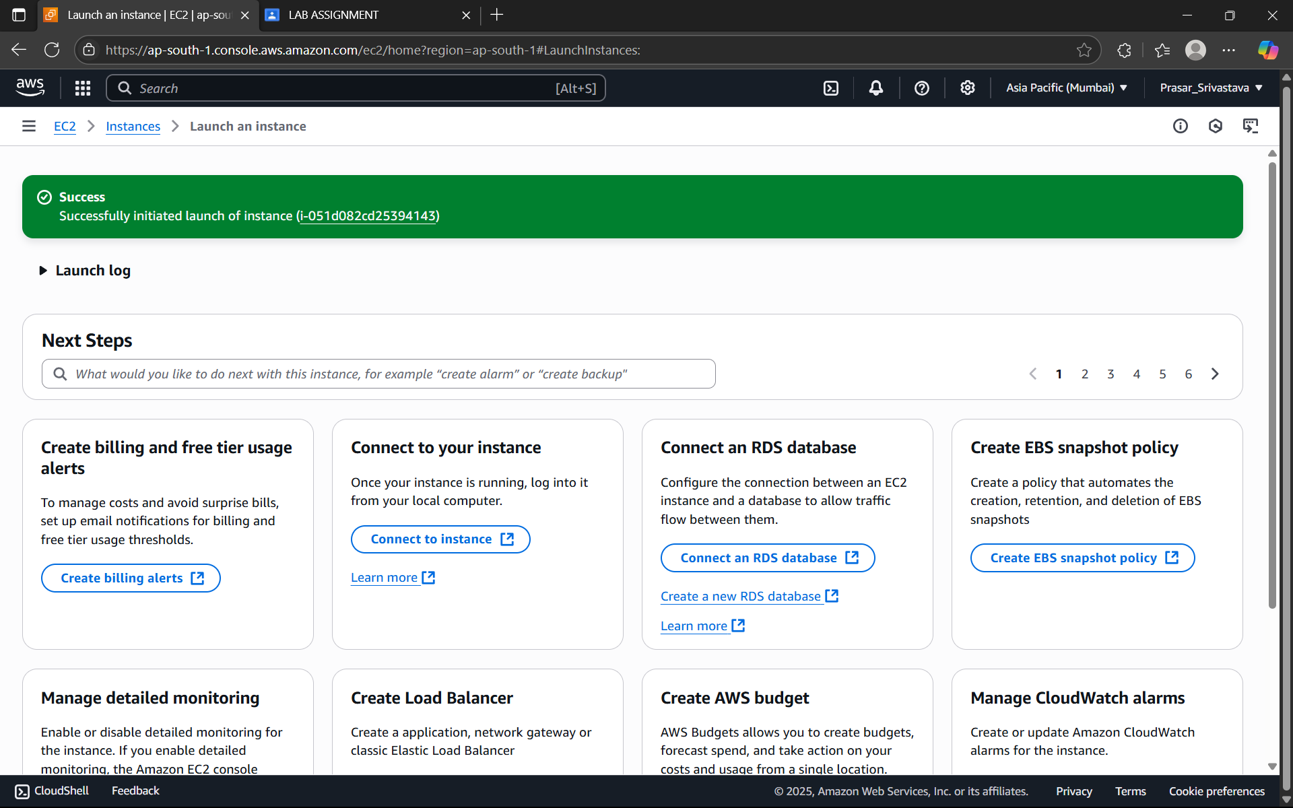

STEP14: NOW CLICK ON THE EC2 INSTANCE

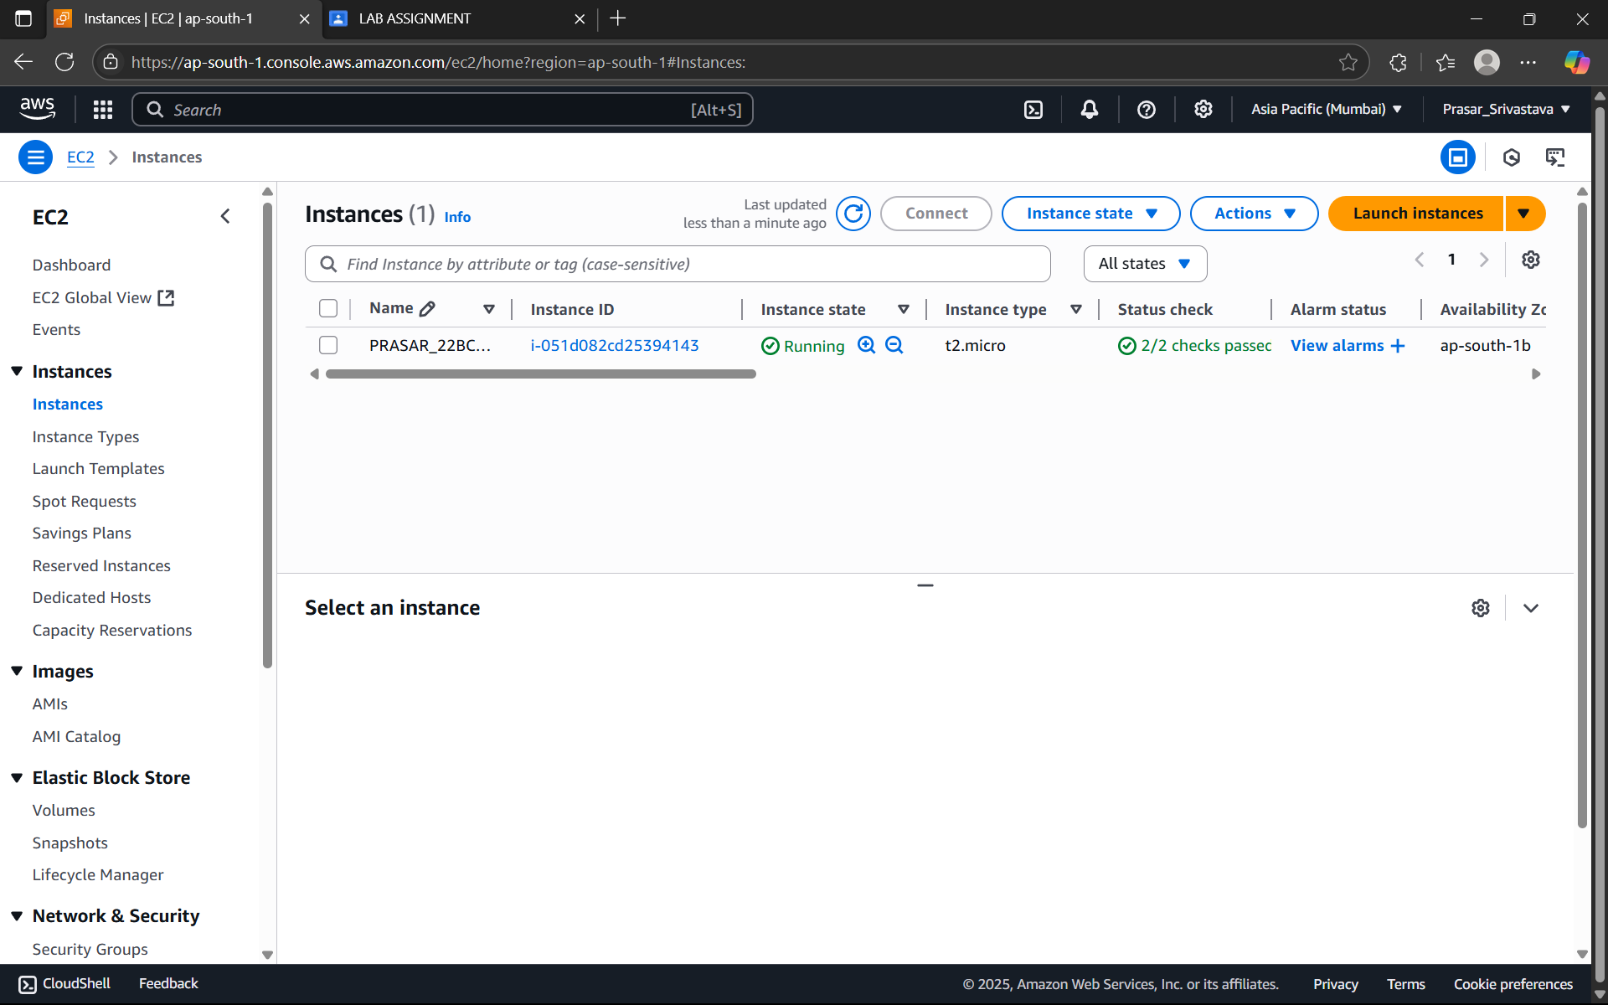

STEP15: DETAILS OF THE EC2 INSTANCE IS SHOWN, CLICK ON CONNECT

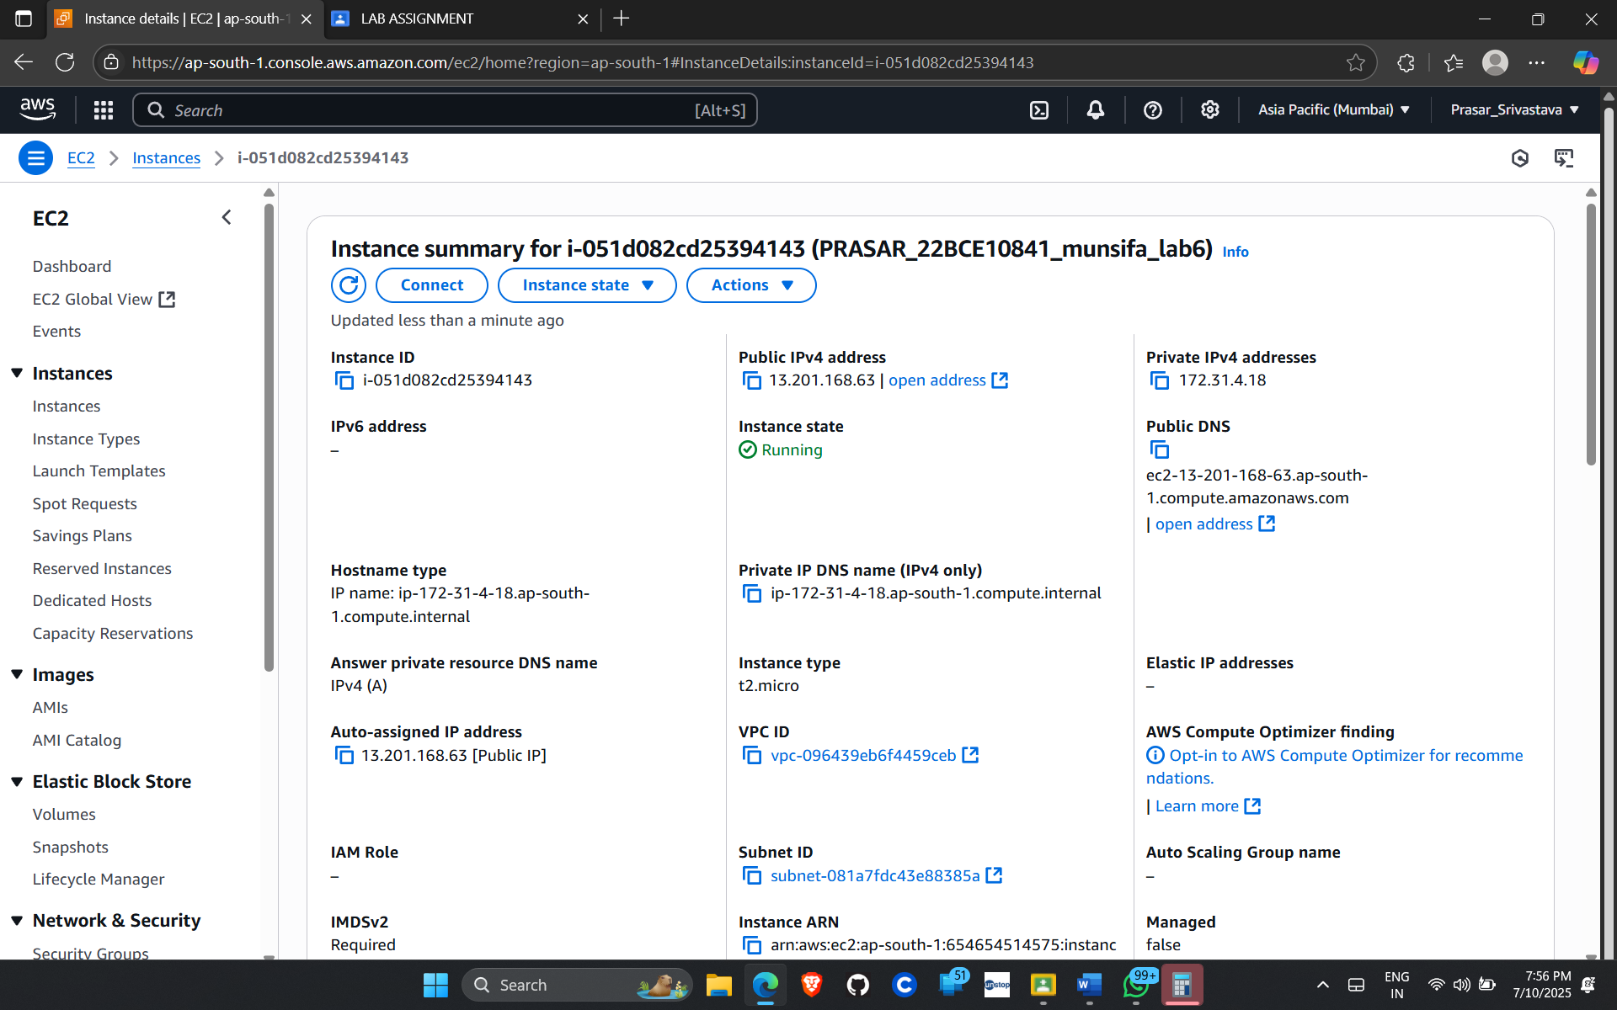

STEP16: CLICK ON EC2 INSTANCE CONNECT>CONNECT

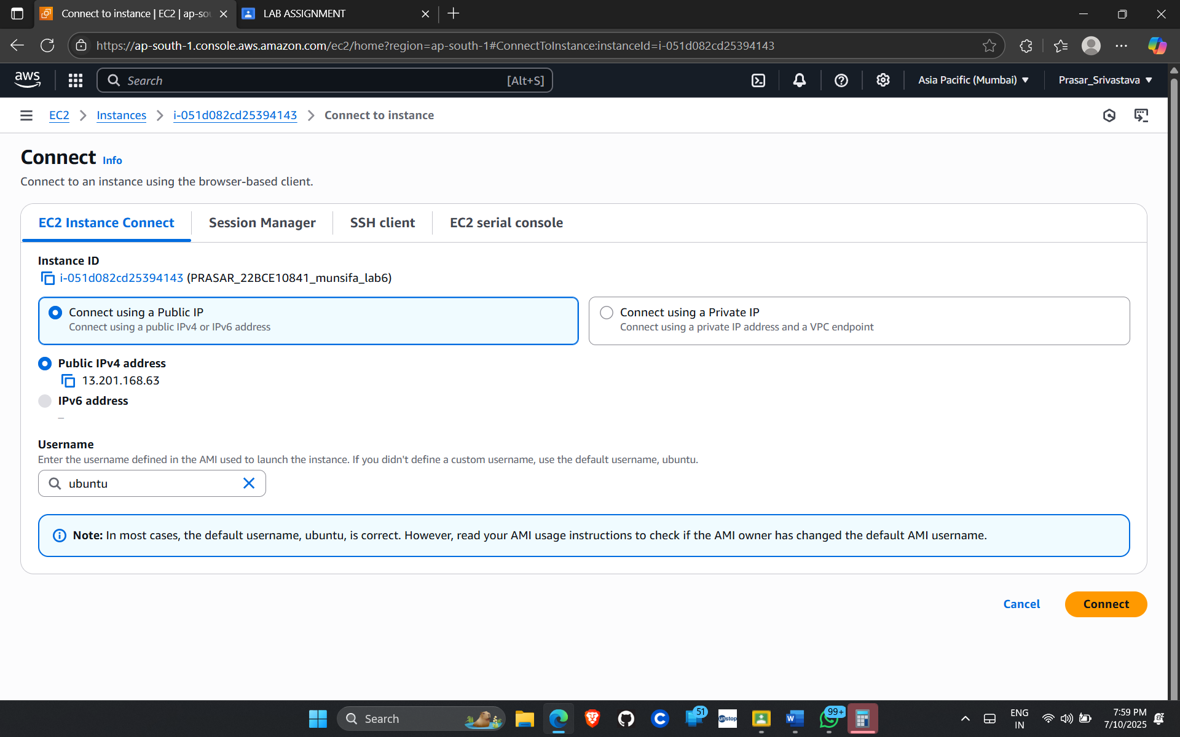

STEP17: IT WILL LAND YOU TO THE TERMINAL PAGE

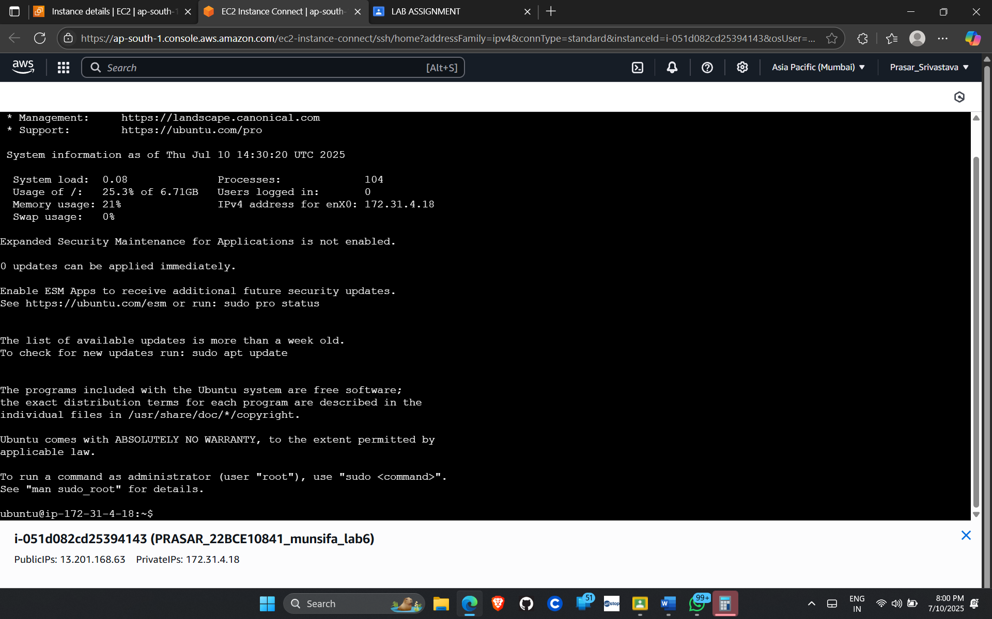

***Lab 7***

***HOW TO LAUNCH AN EC2 INSTANCE IN WINDOWS***

STEP1: LOG IN WITH ROOT USER>EC2 DASHBOARD>CLICK ON INSTANCES> LAUNCH INSTANCES

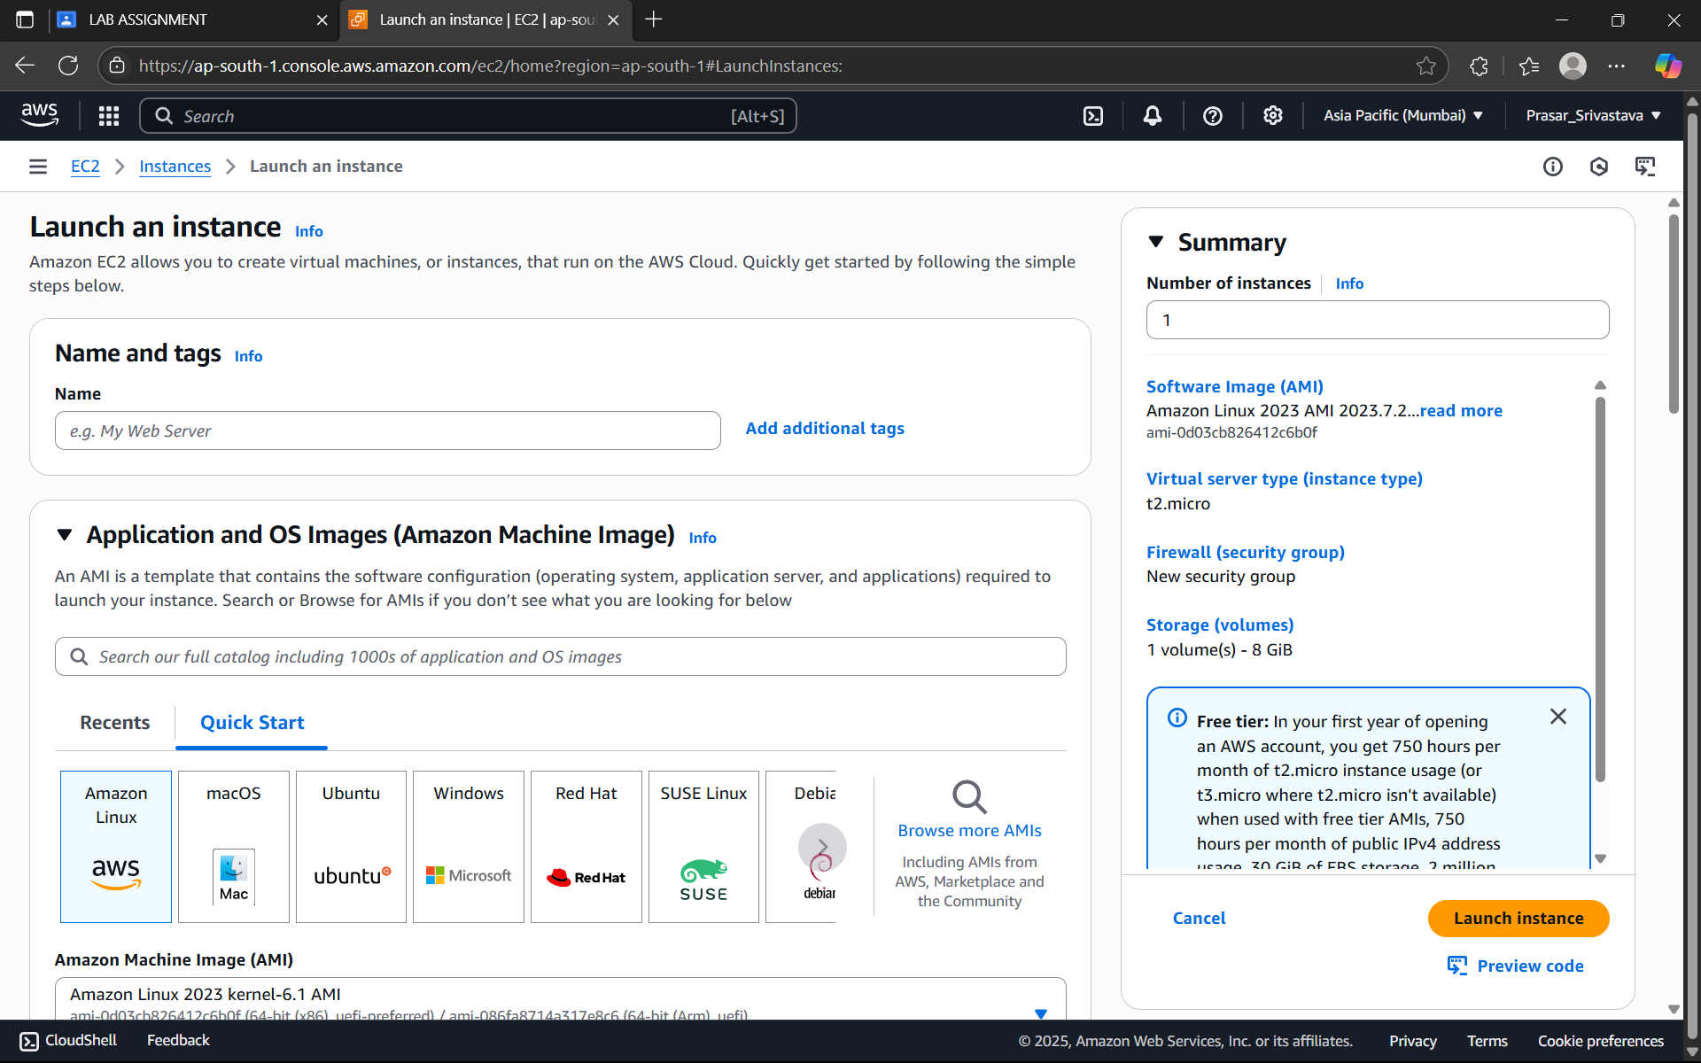

STEP2: WRITE AN INSTANCE NAME

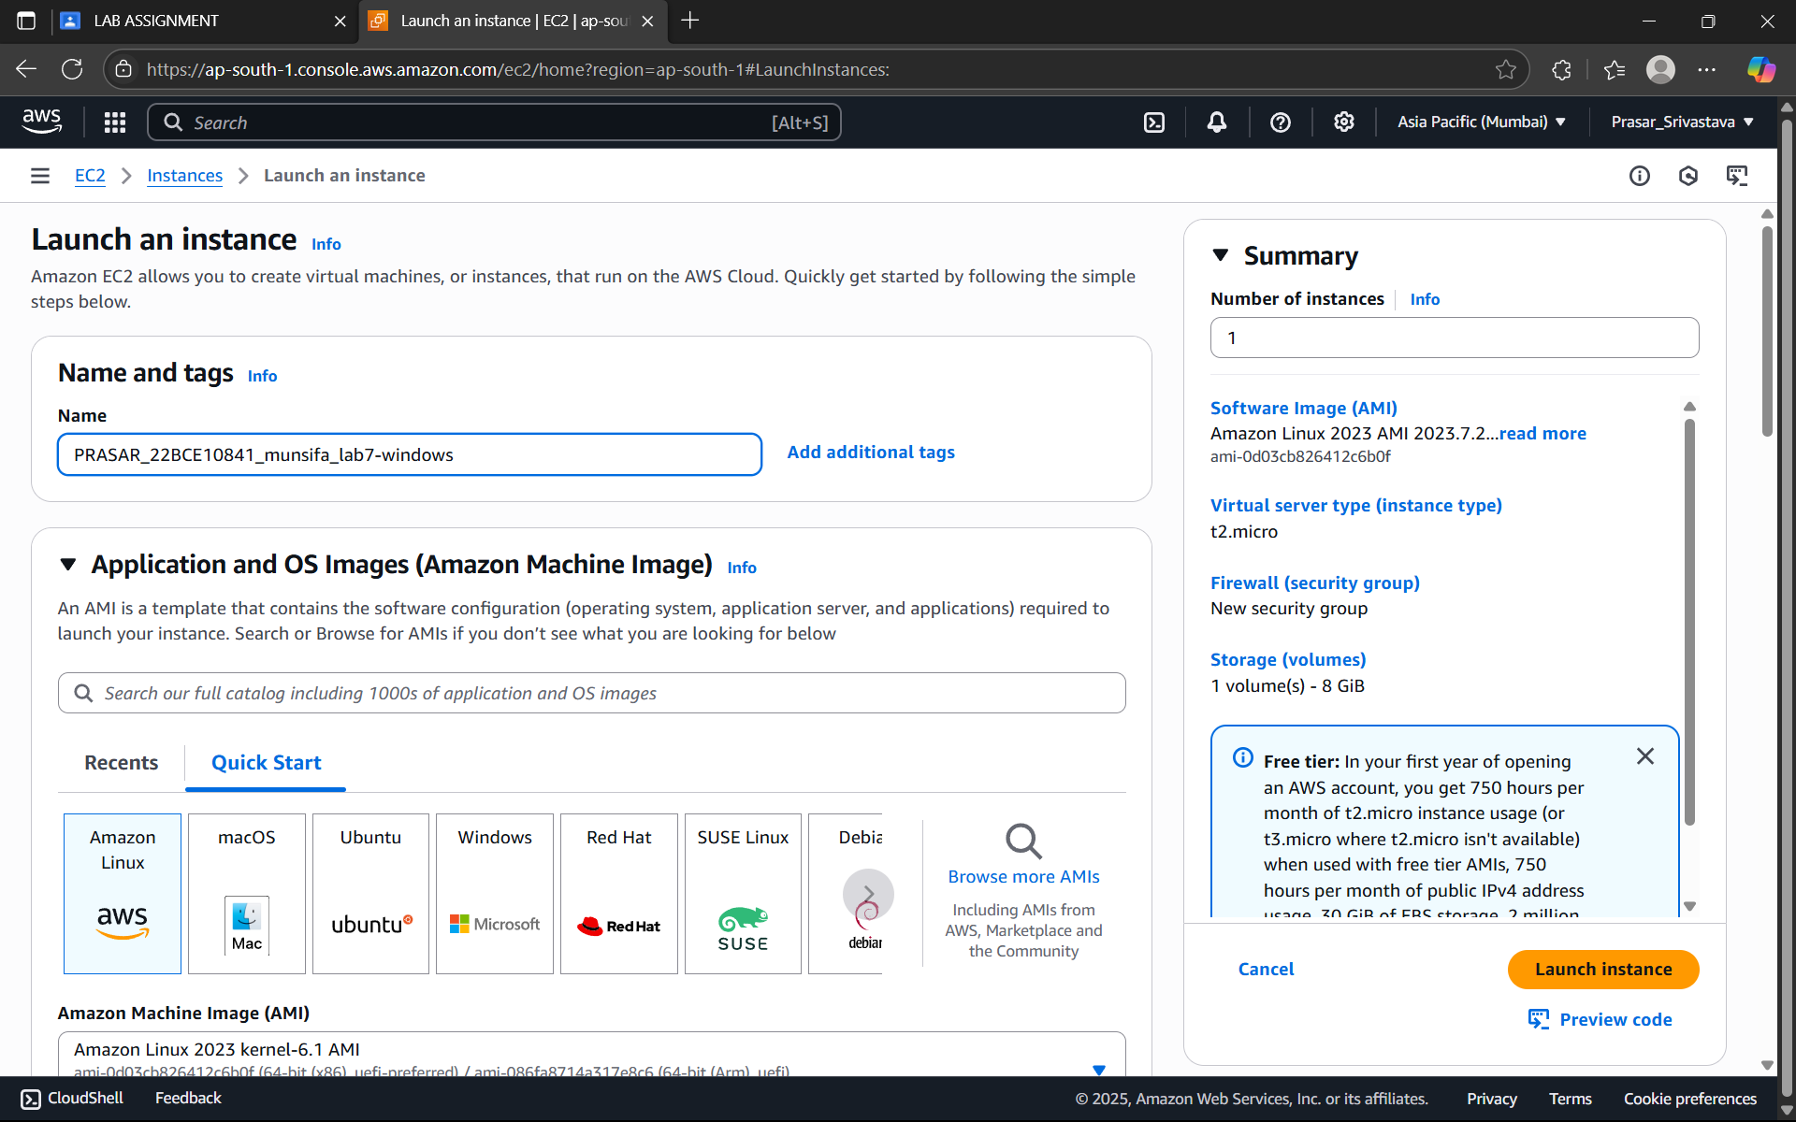

STEP3: CHOOSE THE OS-WINDOWS

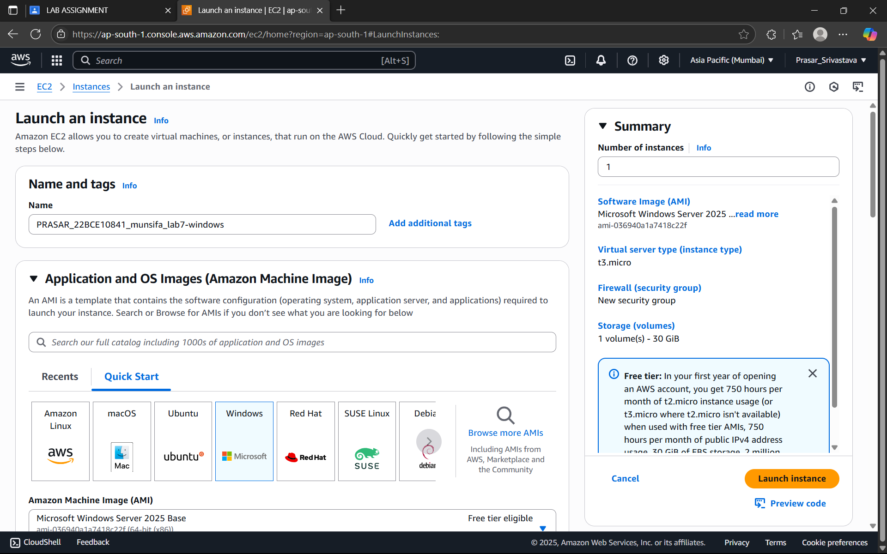

STEP4: CHOOSE THE LOCAL REGION

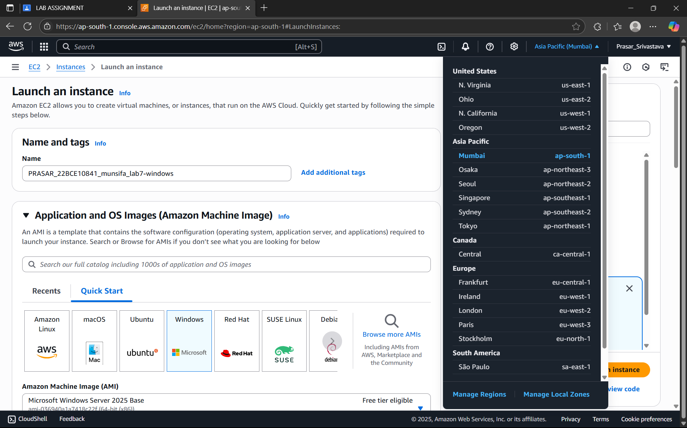

STEP5: CHOOSE THE INSTANCE TYPE AS t3 micro

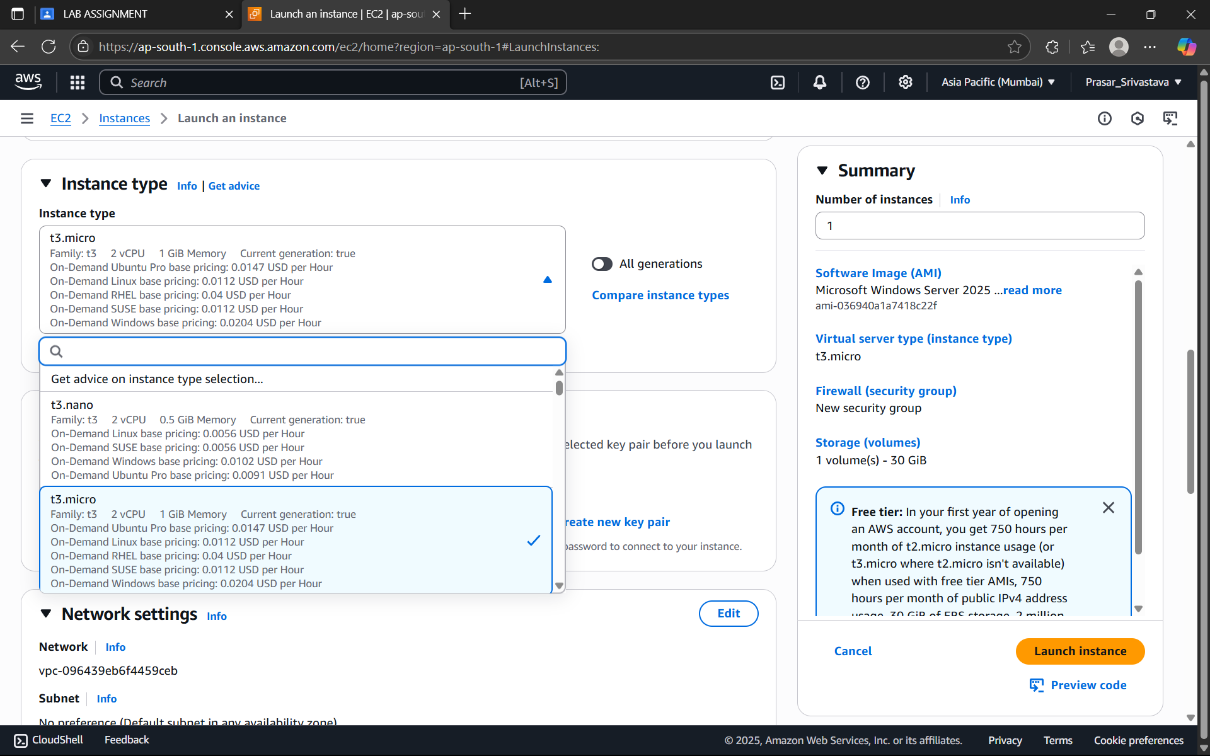

STEP6: CREATE THE KEY PAIR

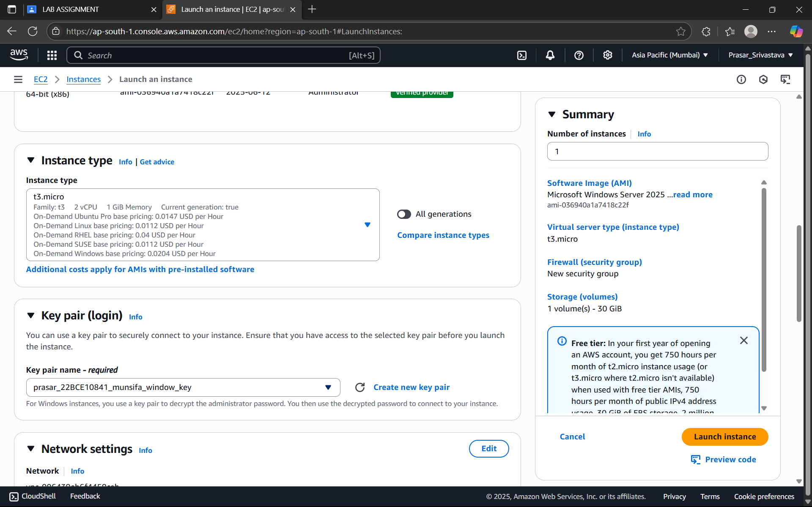

STEP7: CHOOSE THE PUBLIC KEY THAT YOU HAVE CREATED FROM THE DROP DOWN

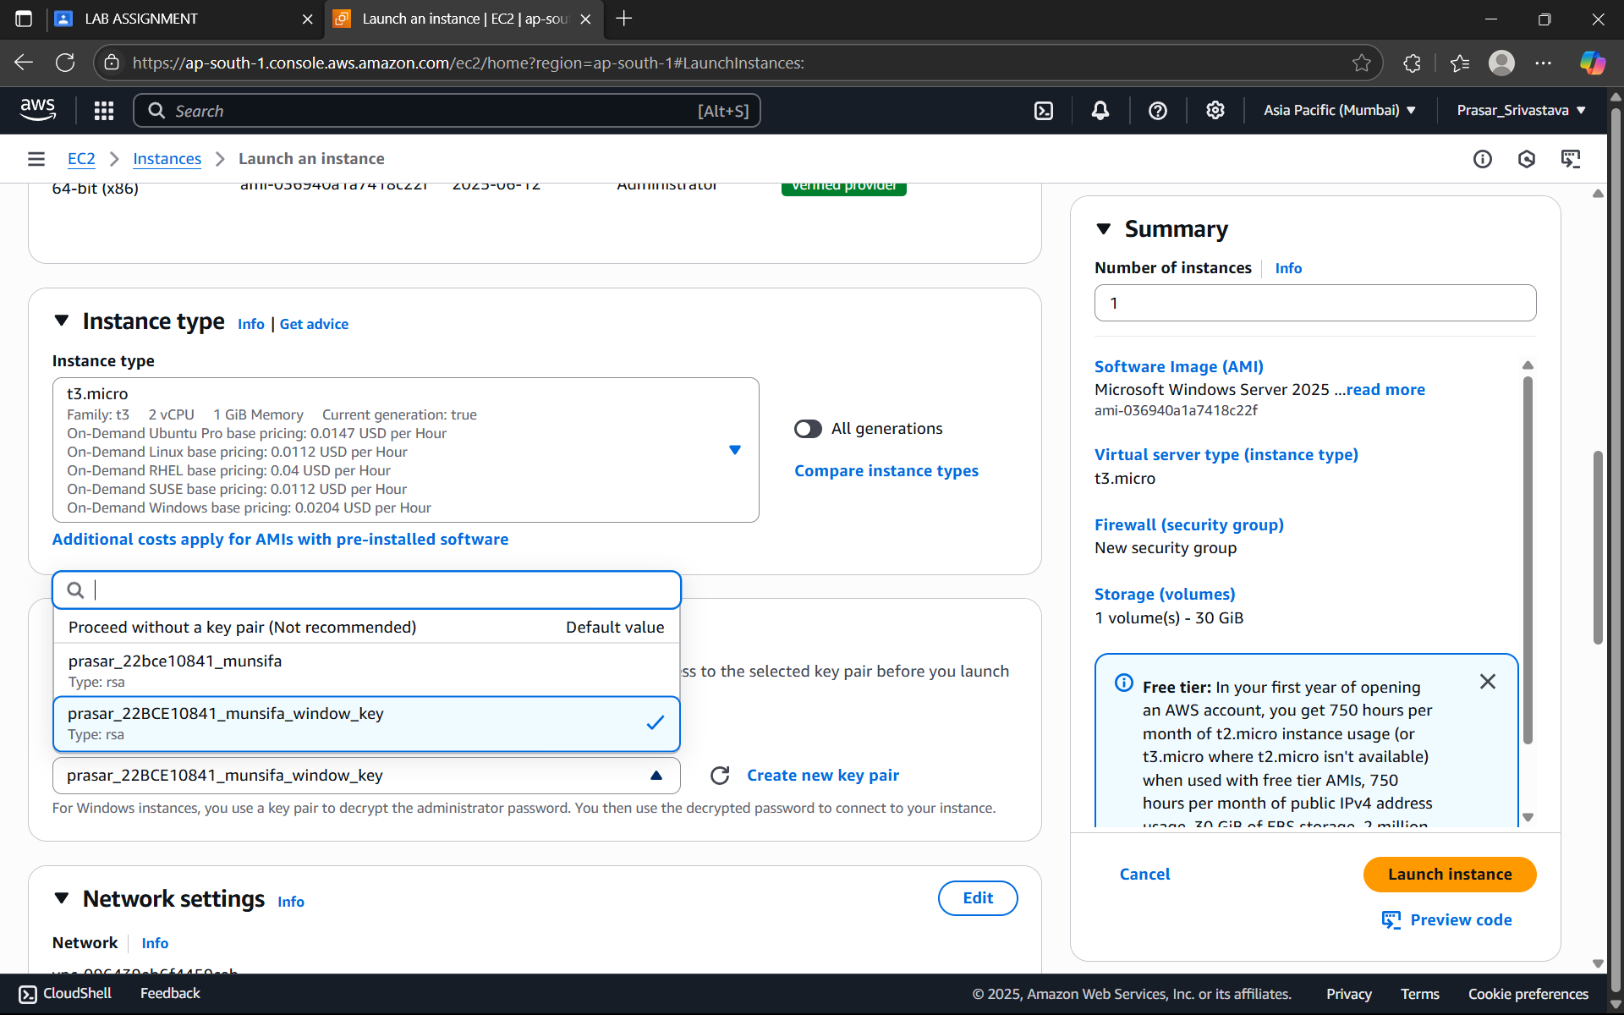

STEP8: CHOOSE FROM NETWORK SETTINGS> CREATE SECURITY GROUP> ALLOW RDP TRAFFIC FROM> ENABLE AUTO-ASSIGN PUBLIC IP

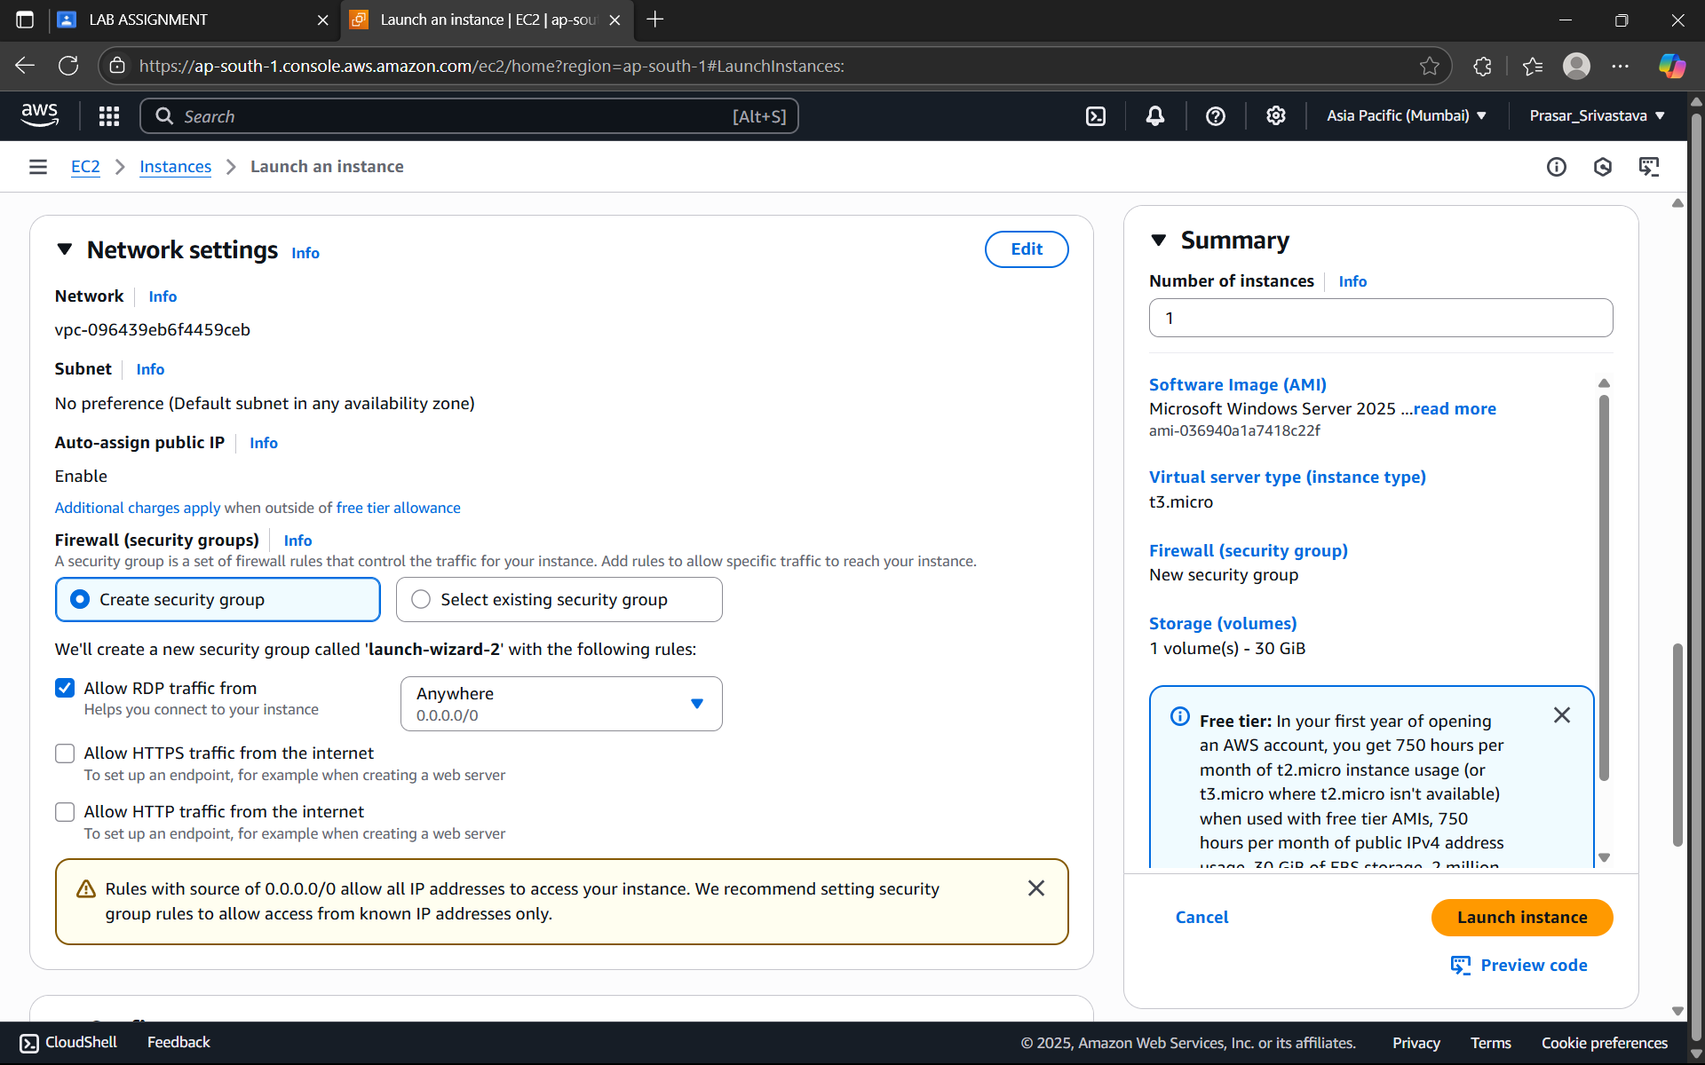

STEP9: CHOOSE 30GB FOR CONFIGURE STORAGE

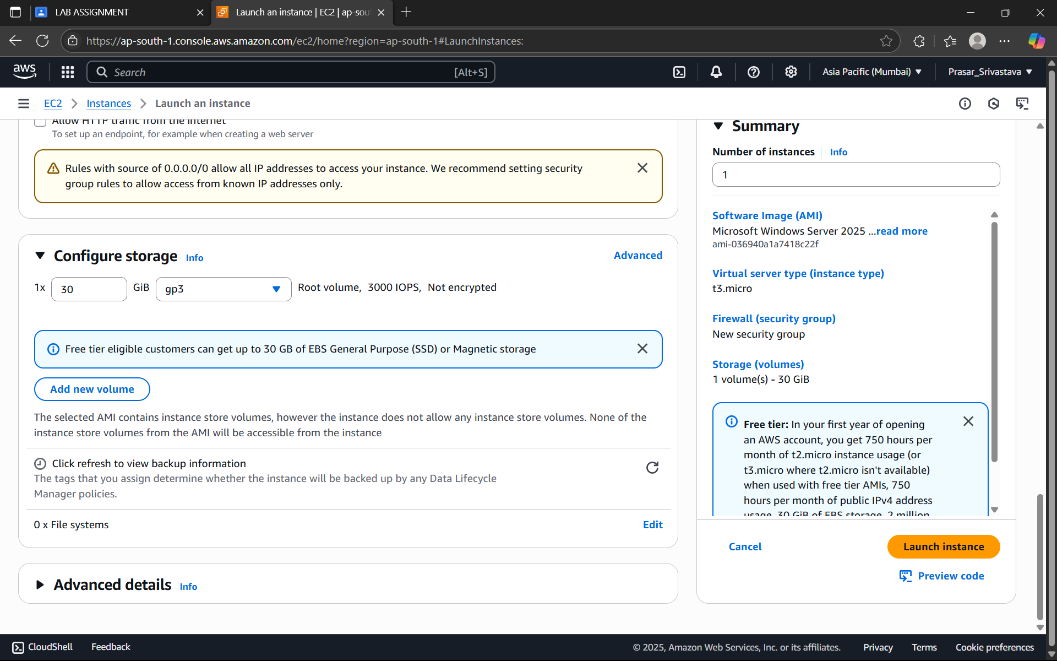

STEP10: CLICK ON LAUNCH INSTANCE

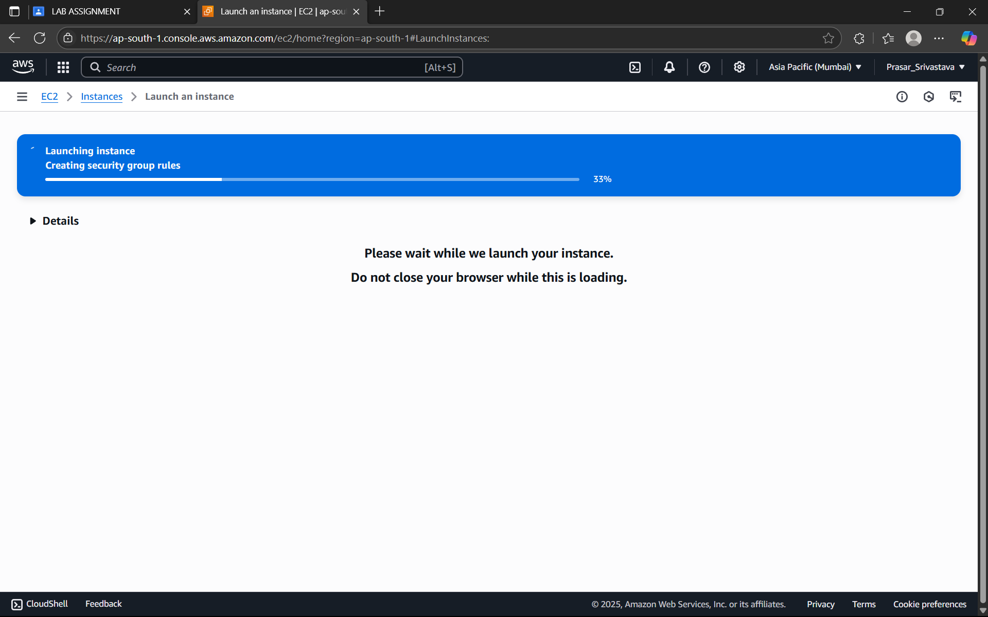

STEP11: CLICK ON THE INTANCE THAT IS CREATED

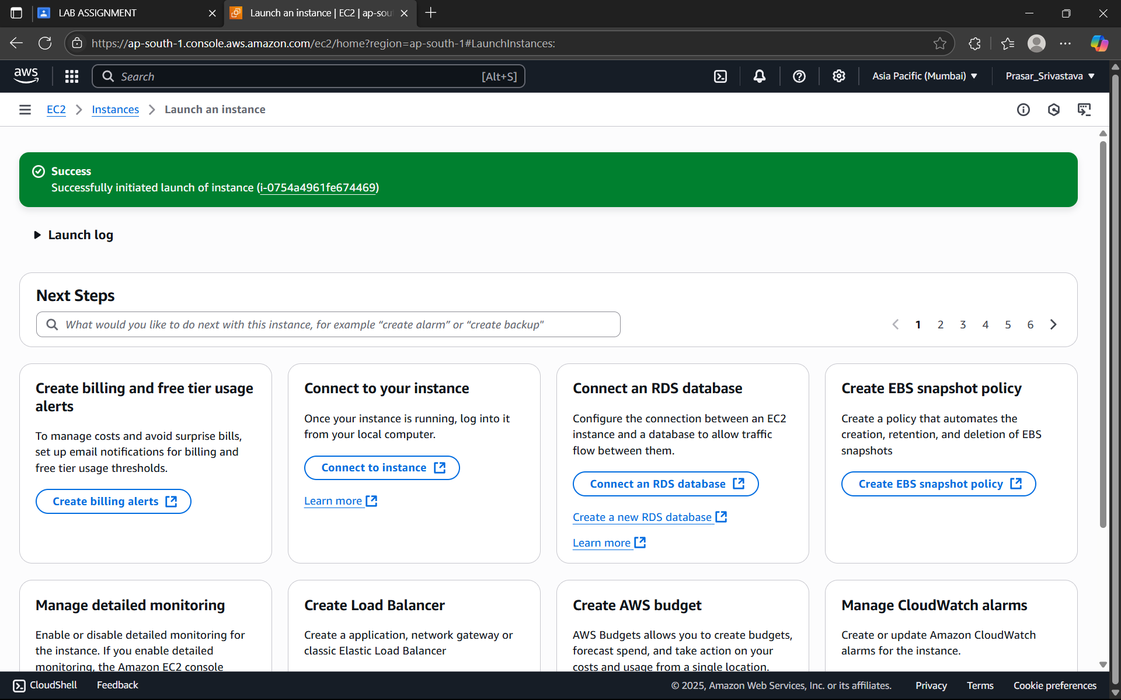

STEP12: CLICK ON CONNECT

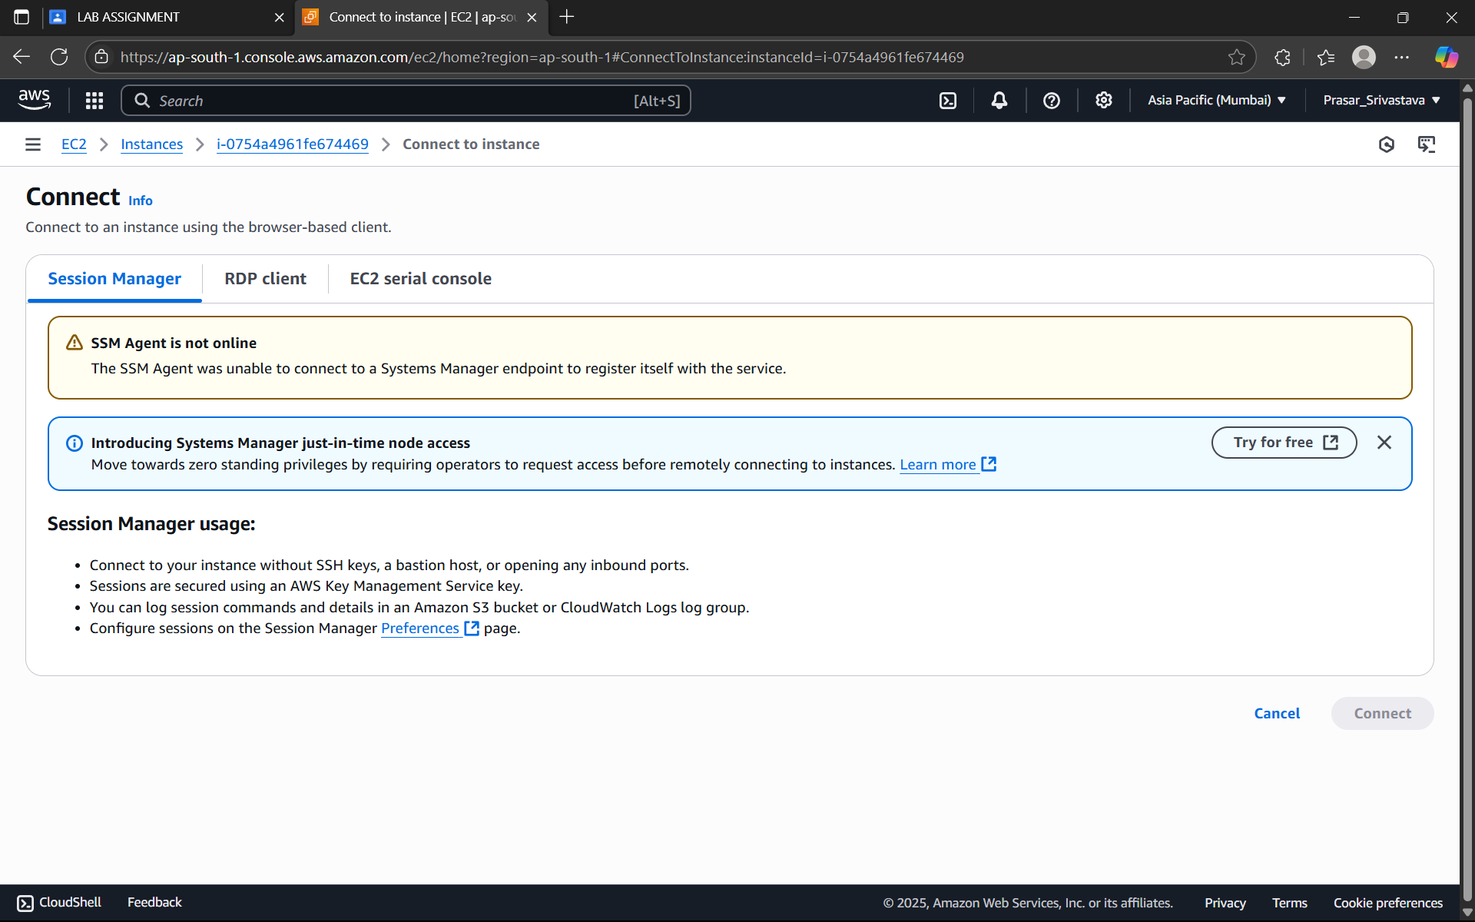

STEP13: CLICK ON RDP CLIENT>CONNECT USING RDP CLIENT> GET PASSWORD

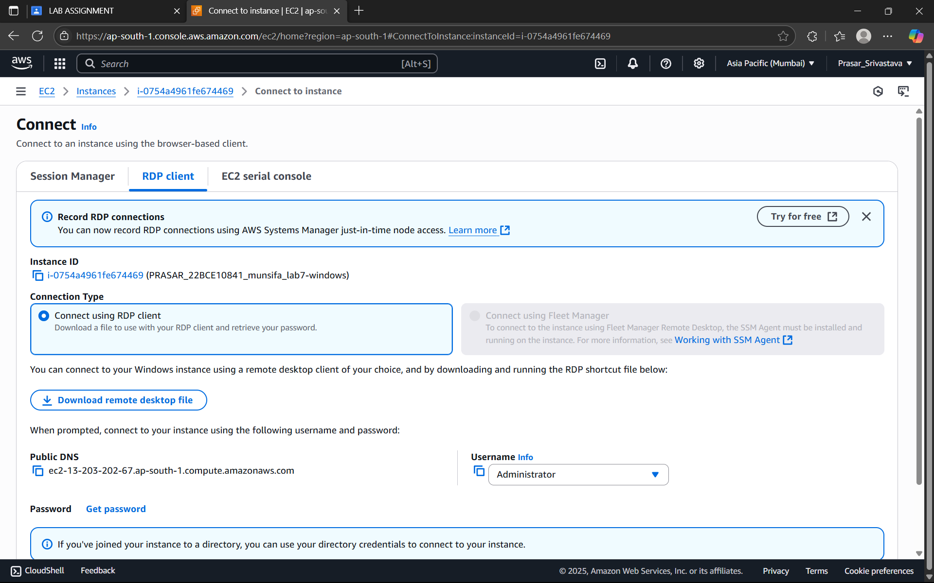

STEP14: HERE COPY & PASTE THE PRIVATE KEY THAT WAS DOWNLOADED EARLIER

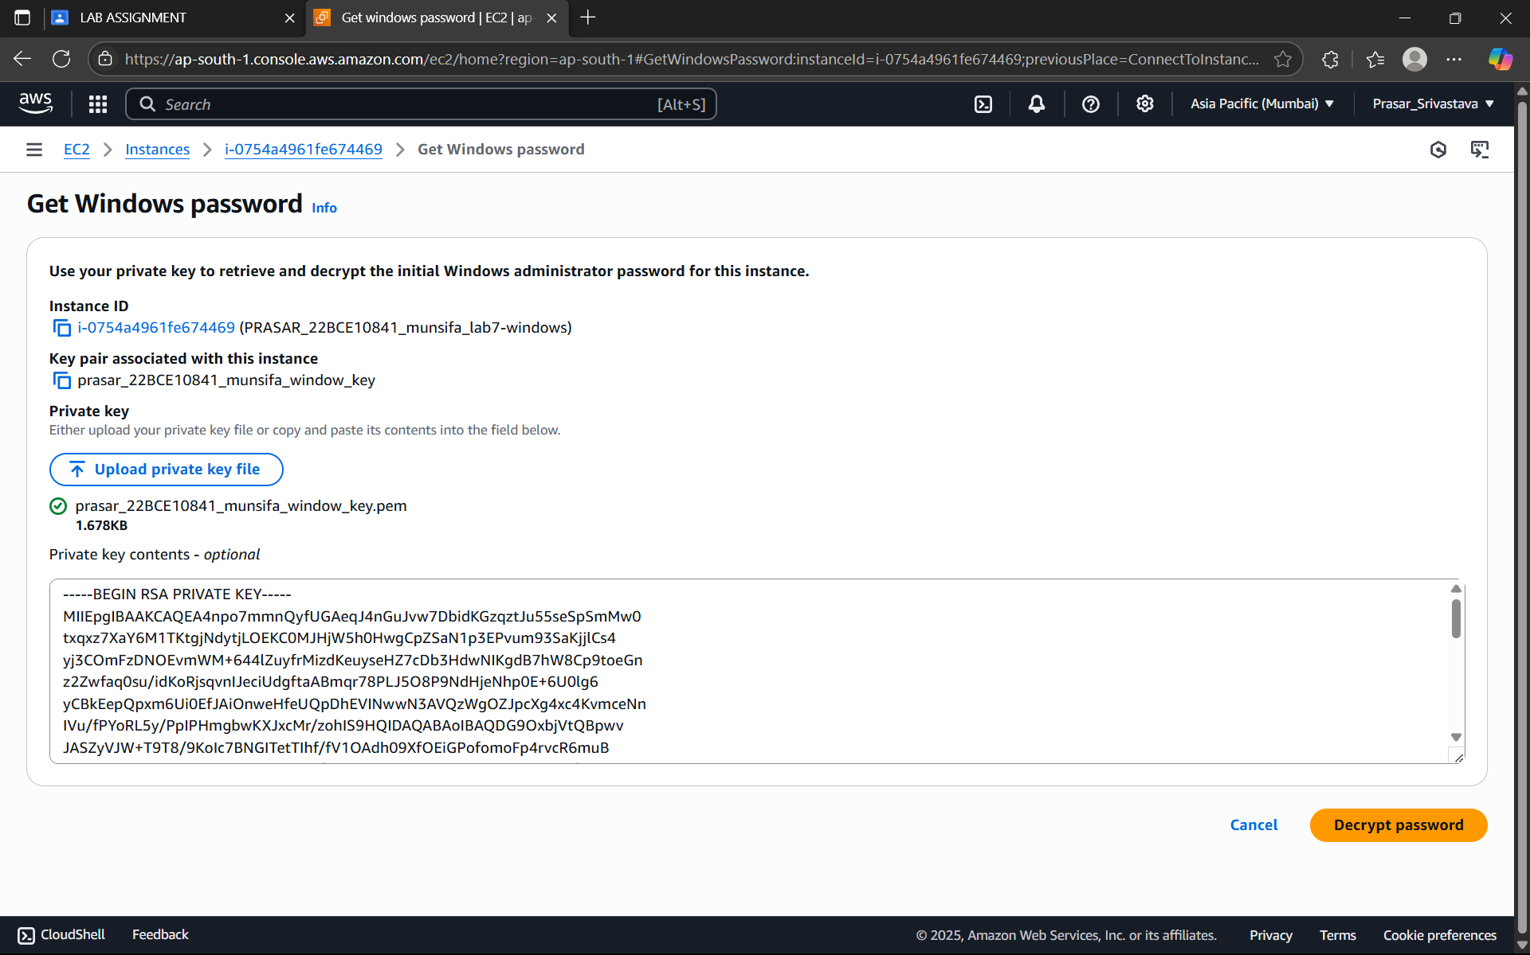

STEP15: CLICK ON DECRYPT PASSWORD



STEP16: COPY THE USERNAME, PASSWORS AND PUBLIC DNS IN A SEPARATE FILE

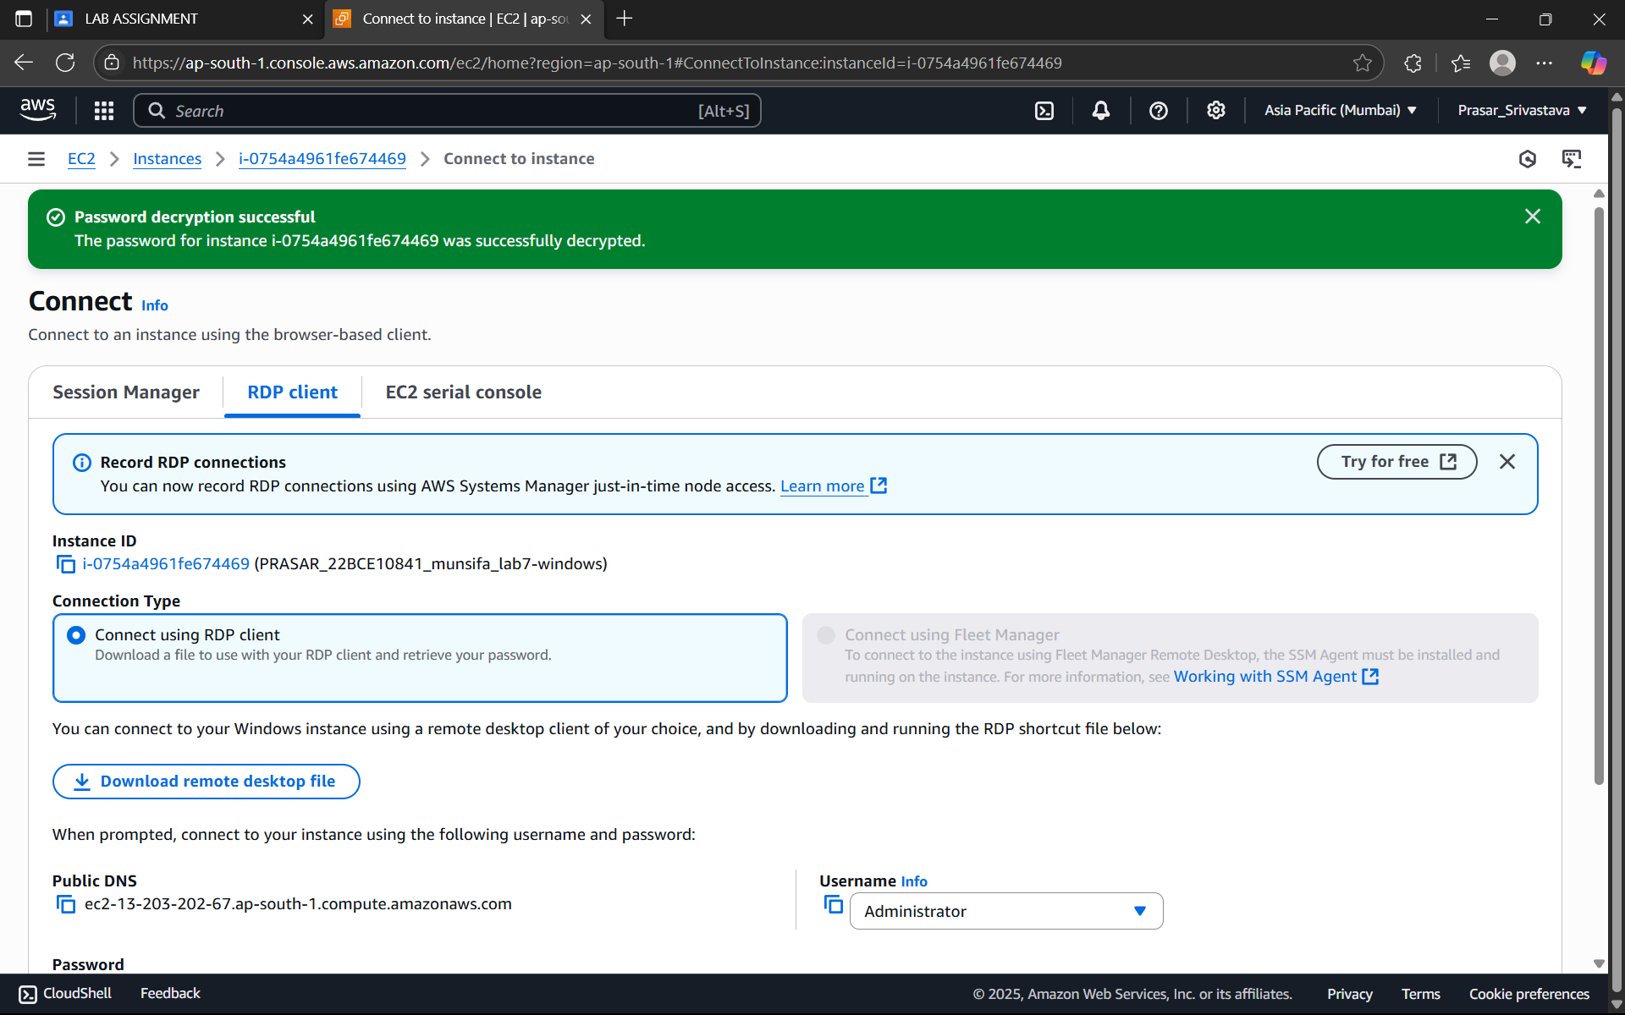

STEP17: ENABLE REMOTE DESKTOP IN YOUR MACHINE AND TYPE/PASTE PUBLIC DNS IN COMPUTER AND CLICK ON CONNECT

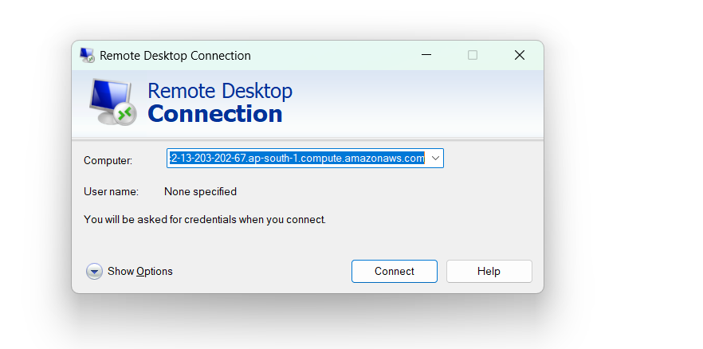

STEP18: TYPE USER NAME AND PASSWORD THAT IS SAVED EARLIER AND CLICK OK. YOUR

REMOTE DESKTOP MACHINE FOR WINDOWS WILL OPEN

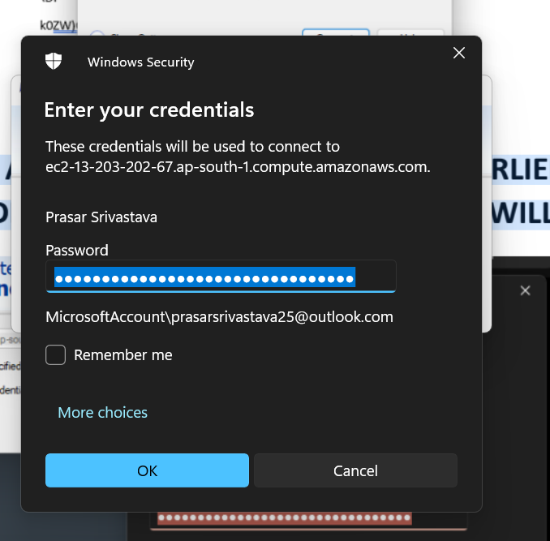

***Lab 9***

***HOW TO LAUNCH AN EC2 INSTANCE WITH TEMPLATE***

STEP1: OPEN THE EC2 DASHBOARD AND CLICK ON LAUNCH TEMPLATES>CREATE LAUNCH TEMPLATE

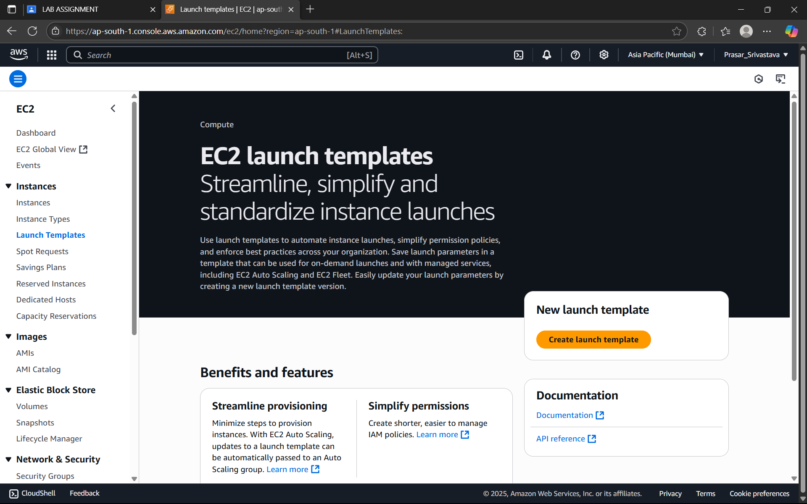

STEP2: GIVE A SUITABLE NAME AND DESCRIPTION TO THE TEMPLATE

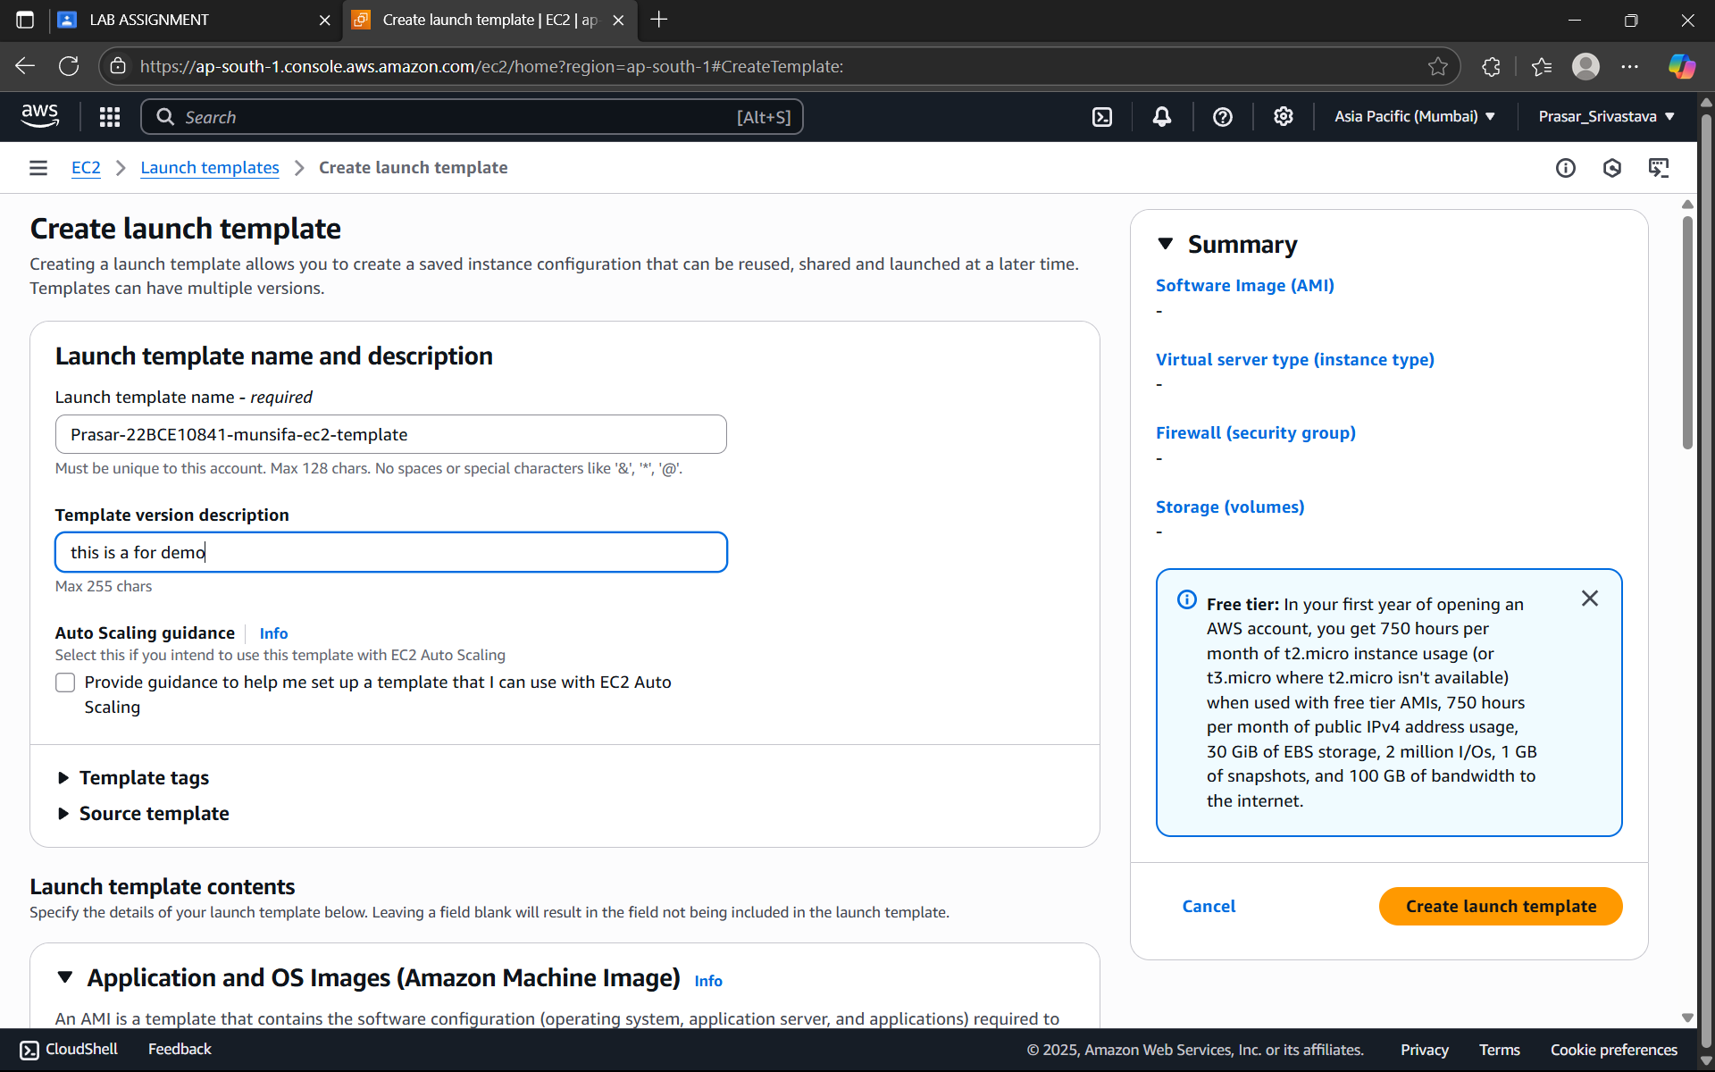

STEP3: CLICK ON TEMPLATE TAGS>ADD TAGS>INFO:NAME>VALUE:ANY NAME

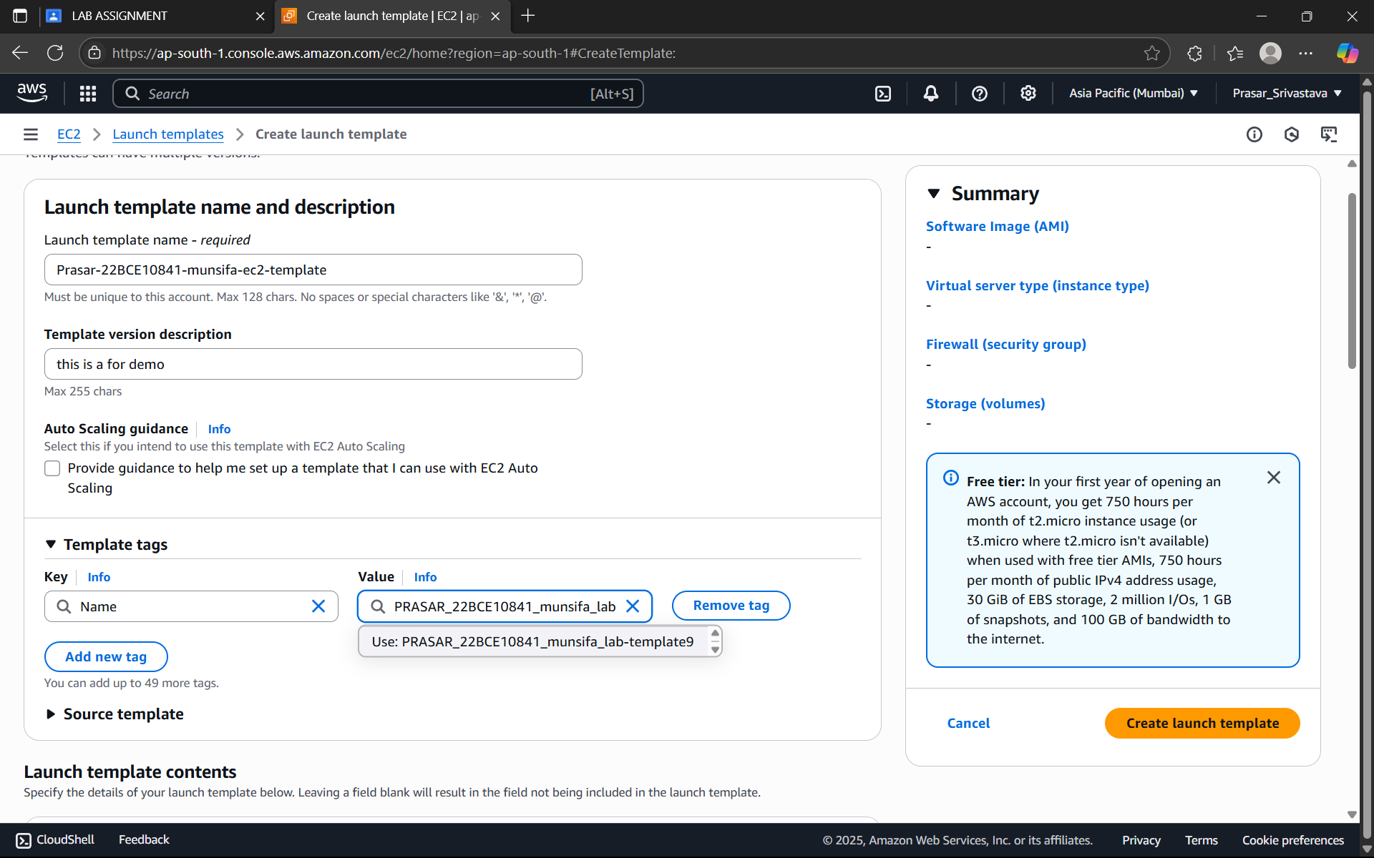

STEP4: CLICK ON BROWSE MORE AMI

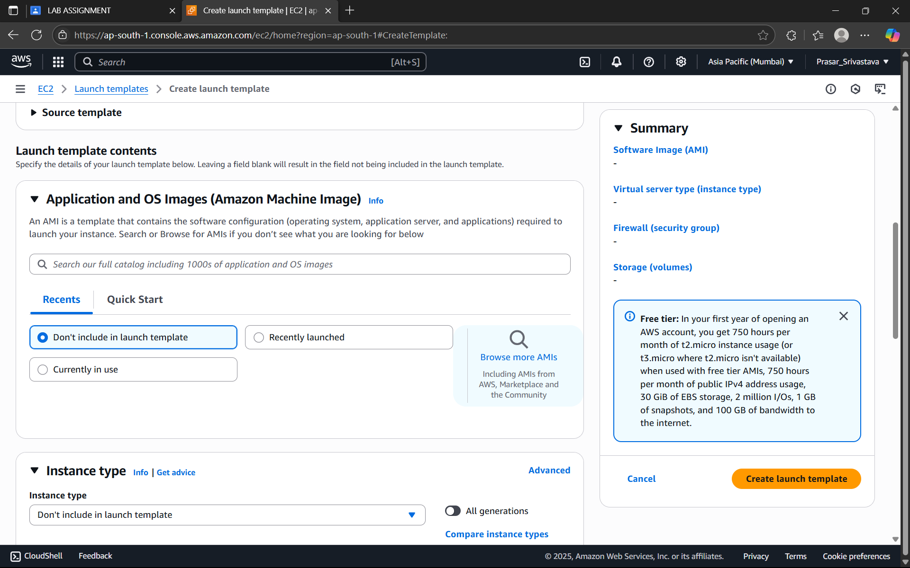

STEP5: SELECT UBUNTU FROM THE LIST

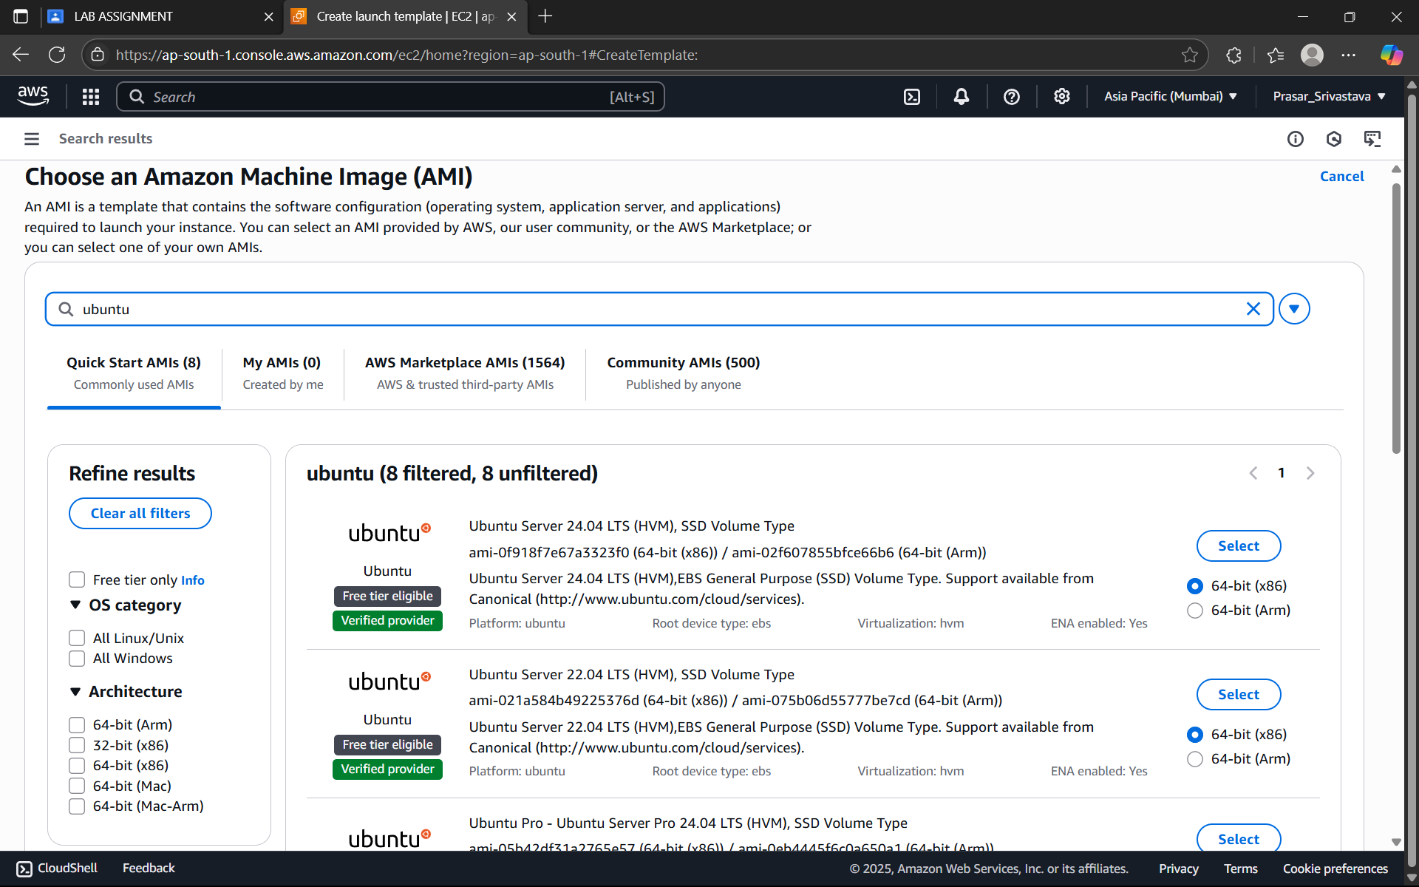

STEP6: SELECT THE INSTANCE TYPE:t2 micro (FREE TIER)

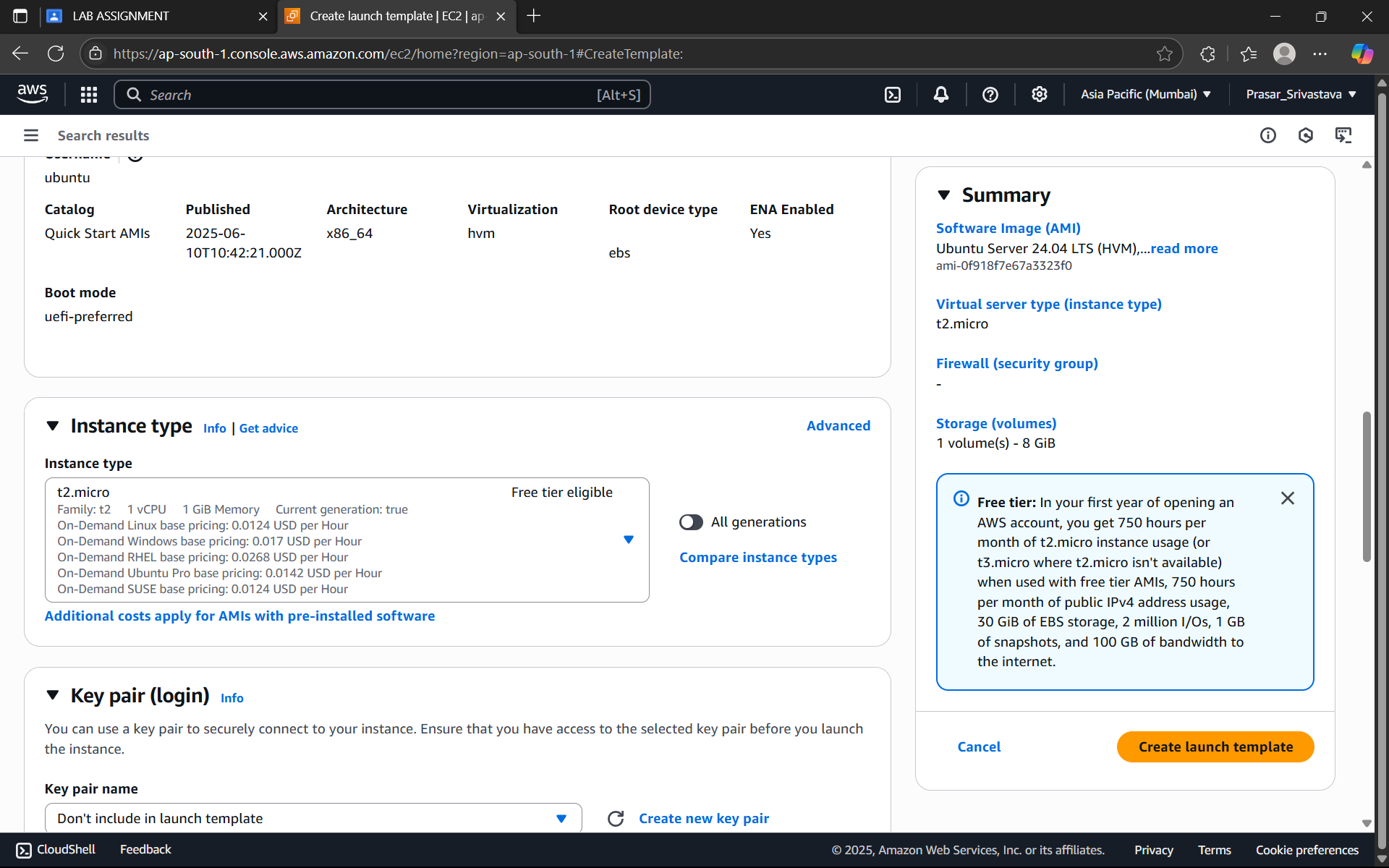

STEP7: CREATE KEY PAIR

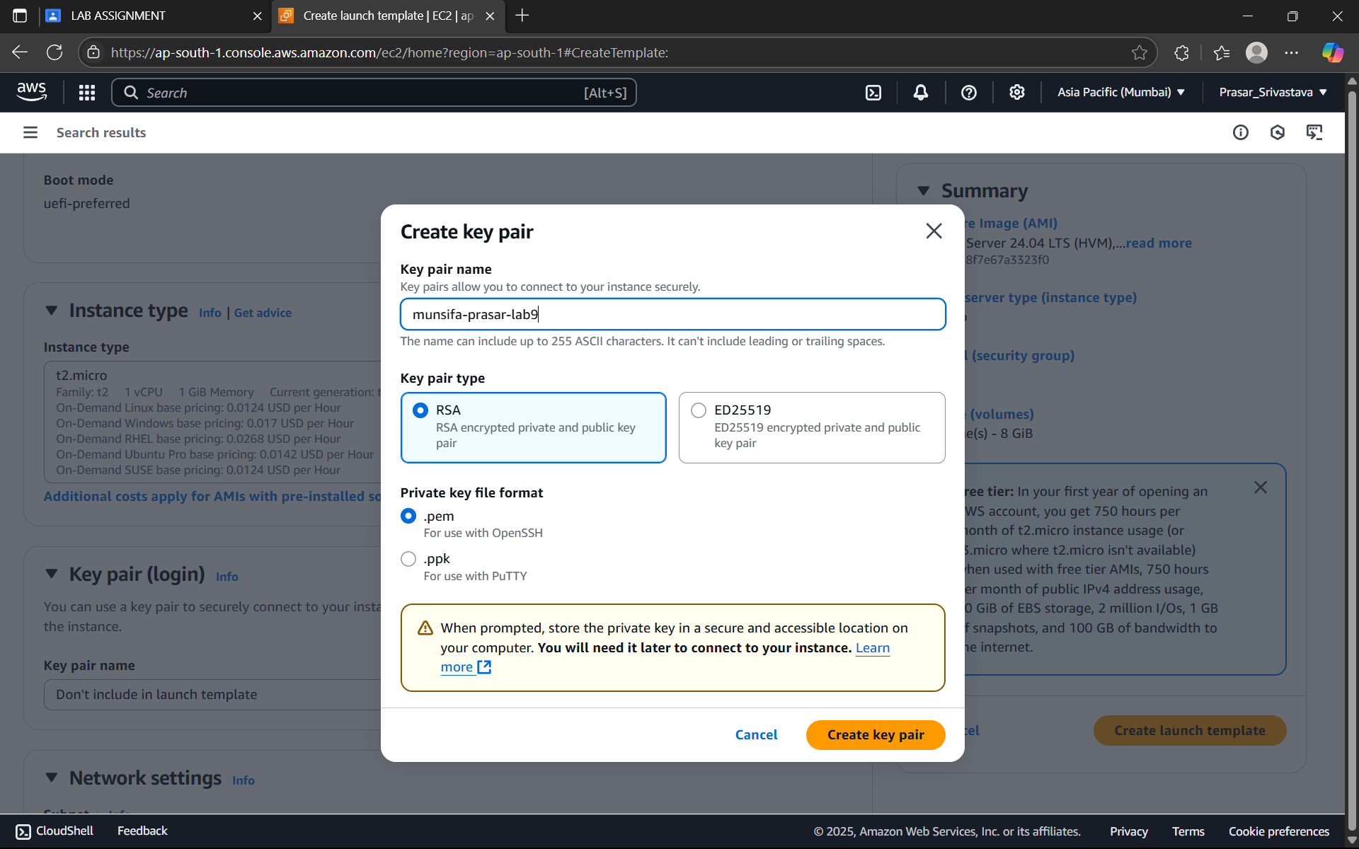

STEP8: SELECT CREATE SECURITY GROUP> WRITE THE SECURITY GROUP NAME>DESCRIPTION> CLICK ON ADD SECURITY GROUP RULE

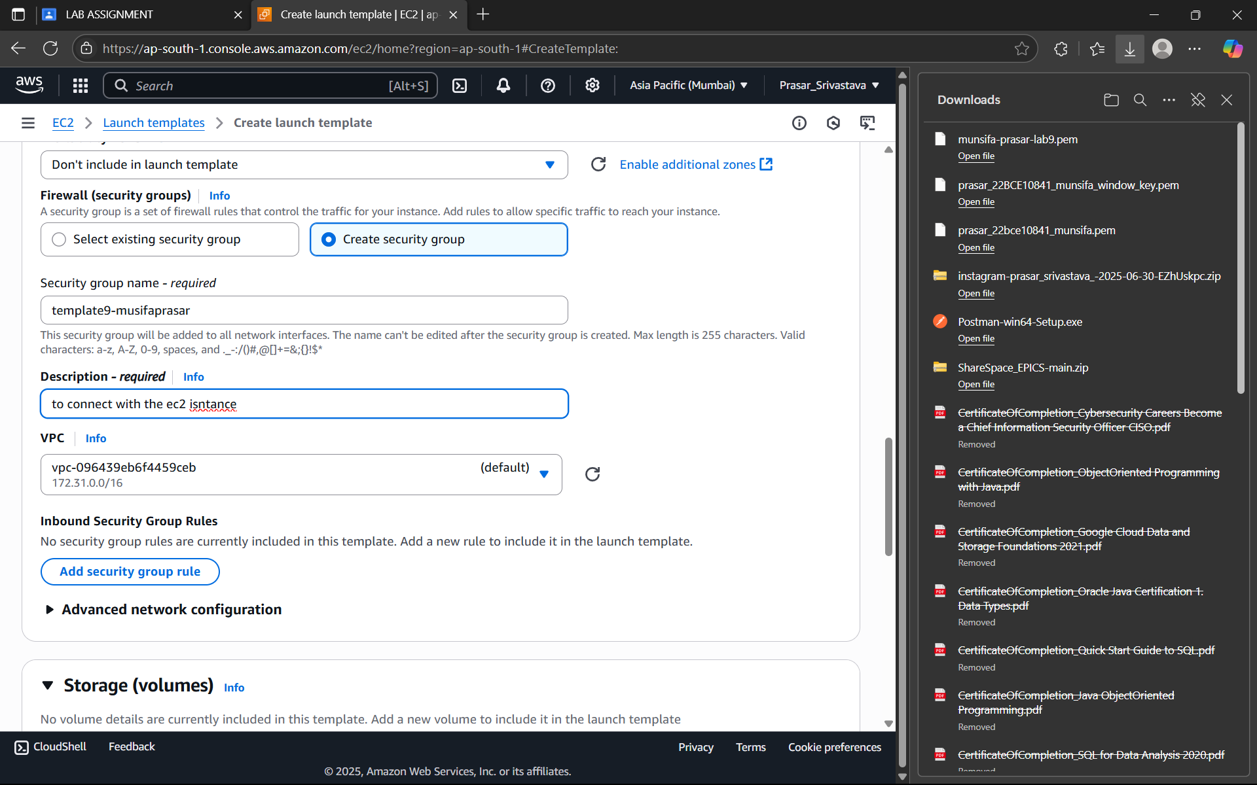

STEP9: CHOOSE TYPE:SSH> SOURCE TYPE: ANYWHERE

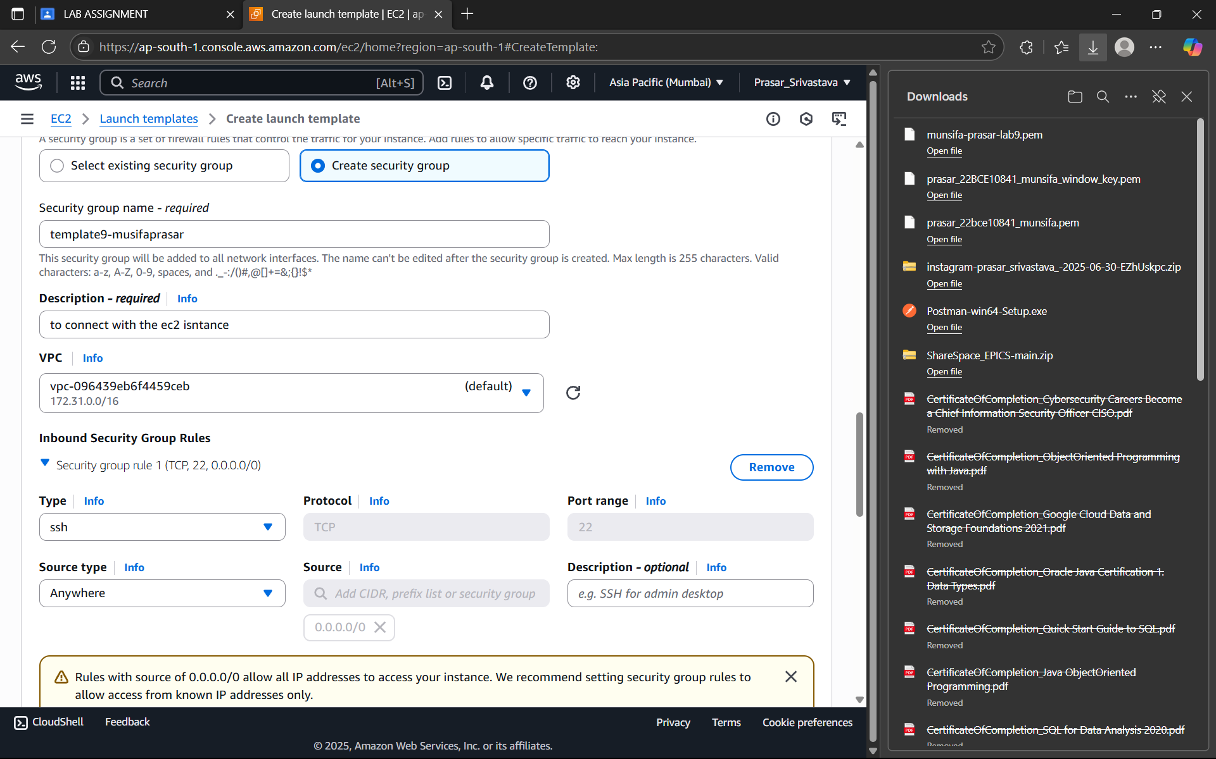

STEP 10: CLICK ON CREATE LAUNCH>LAUNCH TEMPLATE IS CREATED>CLICK ON VIEW TEMPLATE

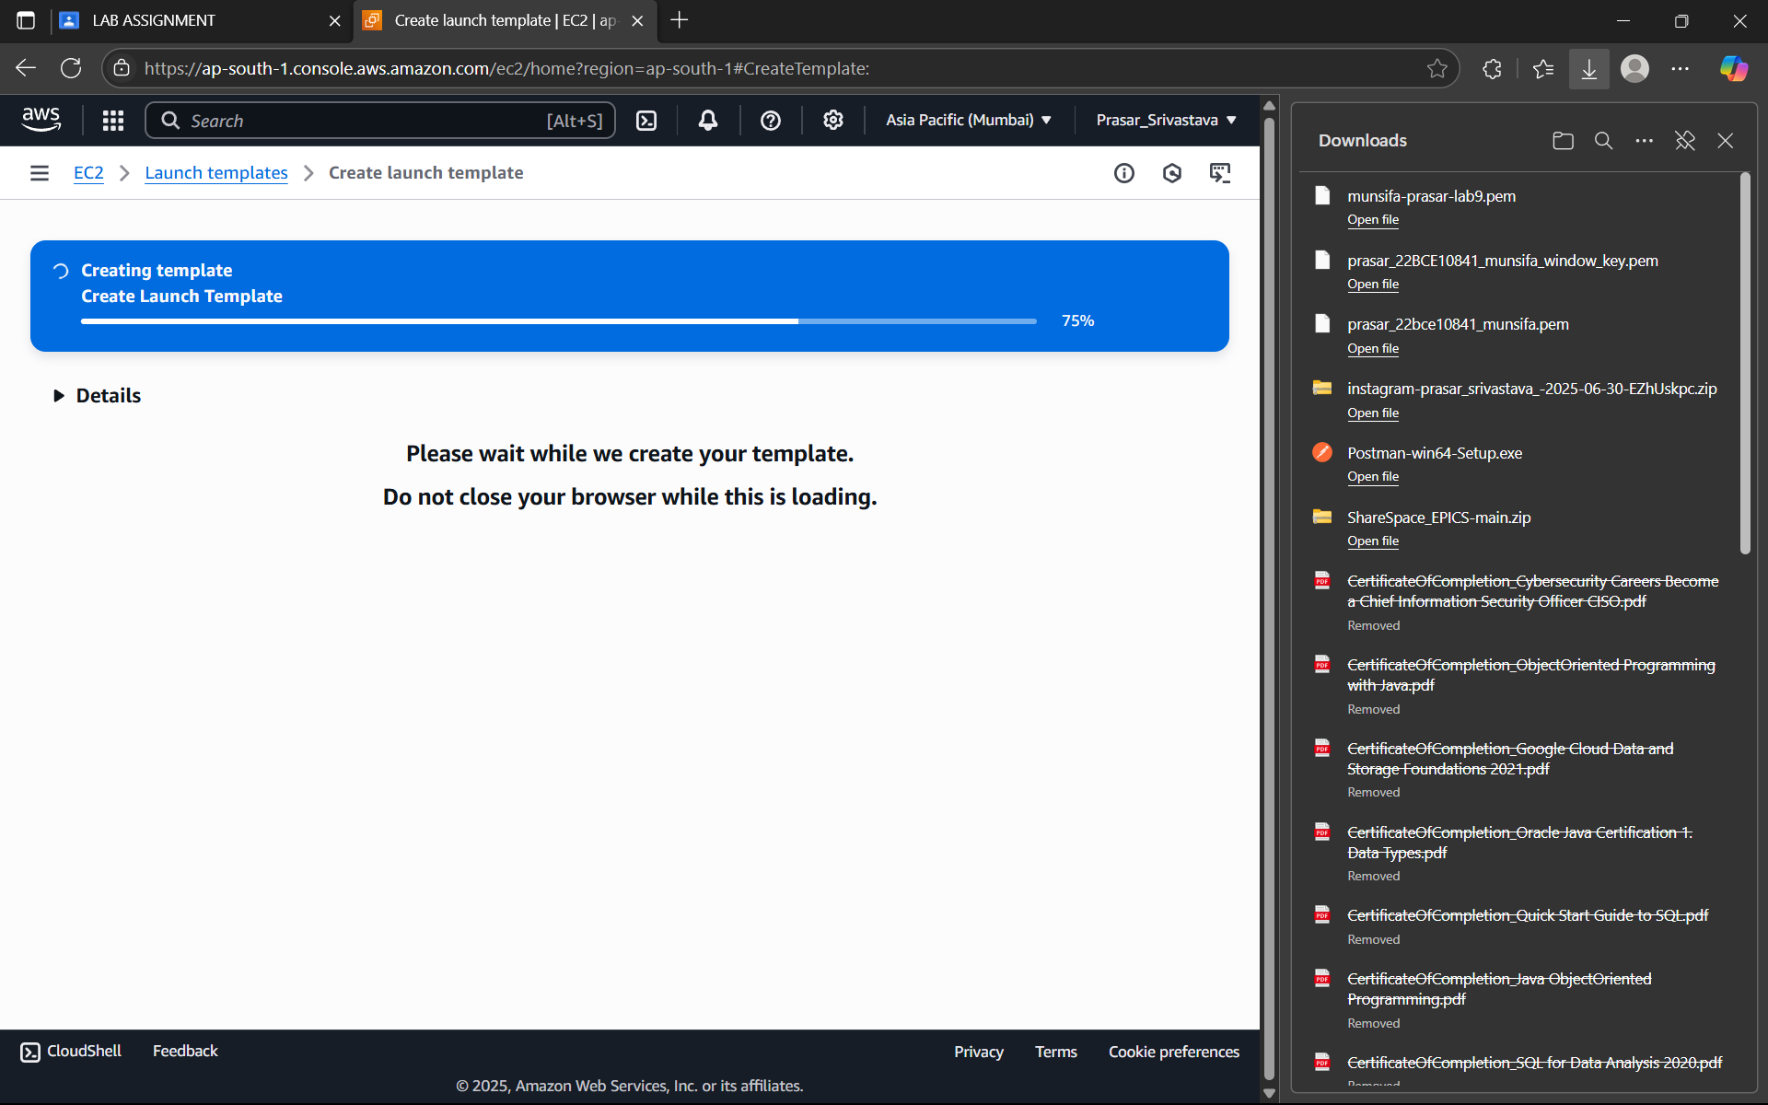

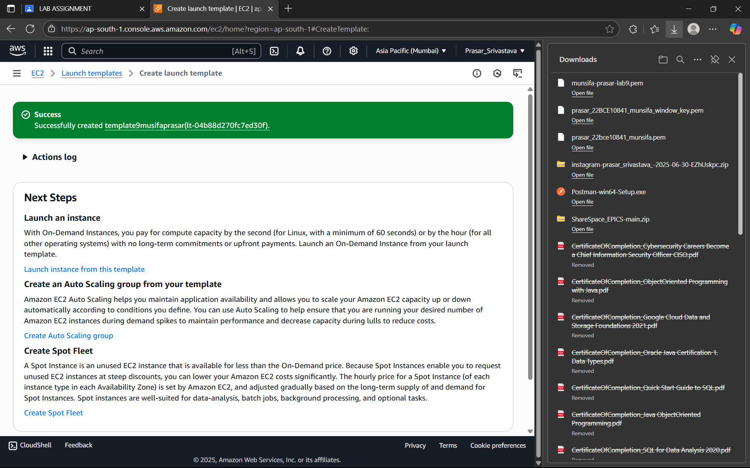

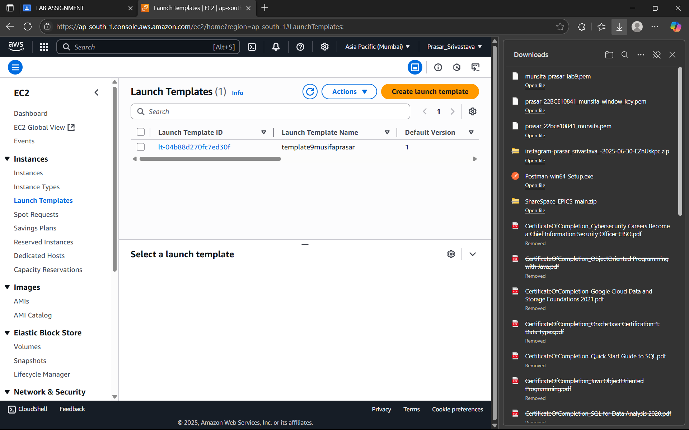

STEP 10: CLICK ON INSTANCES >CLICK ON LAUNCH INSTANCES>LAUNCH INSTANCE FROM

TEMPLATE

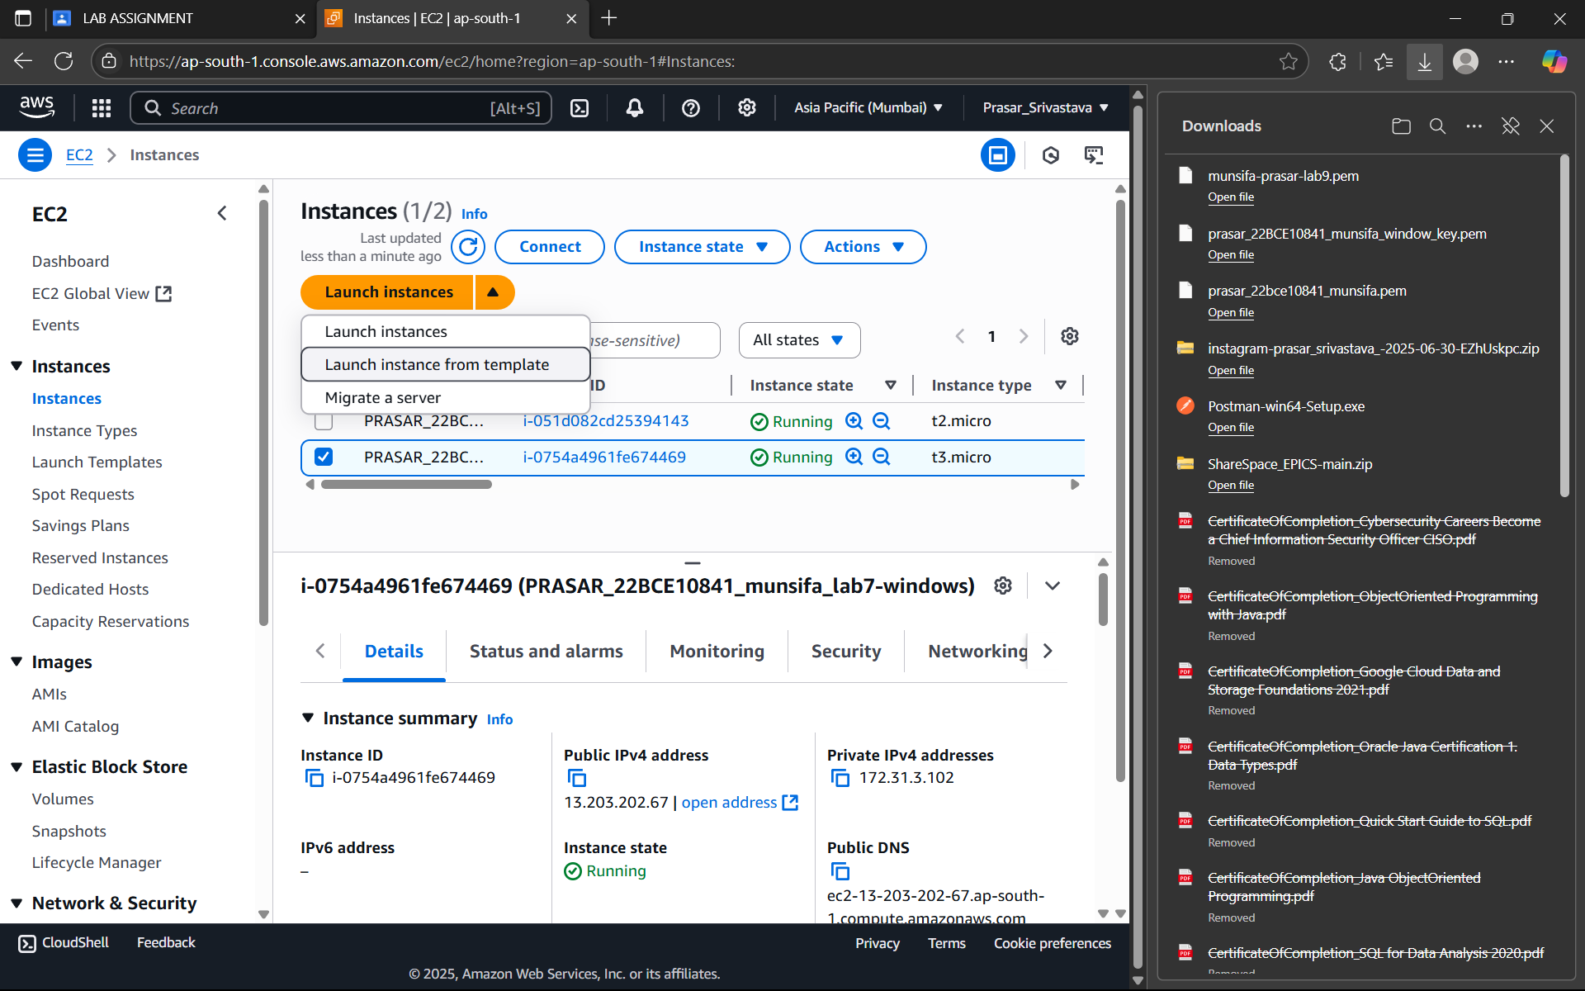

STEP 12: SELECT THE TEMPLATE THAT YOU HAVE CREATED>CLICK ON LAUNCH INSTANCE

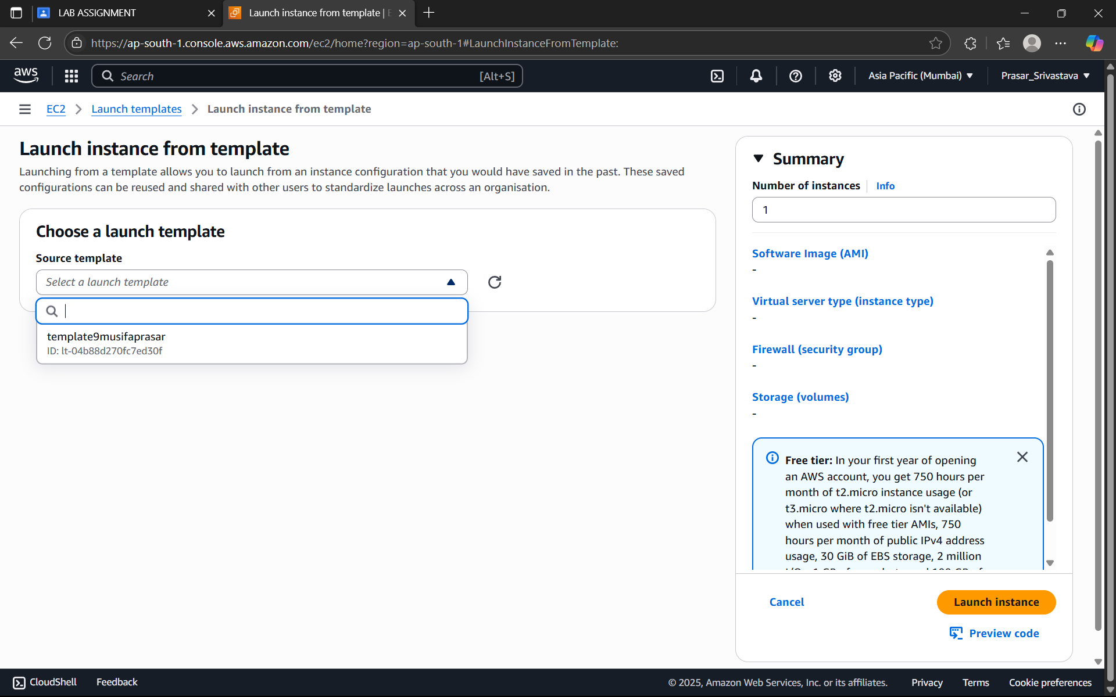

STEP 13: INSTANCE IS CREATED>CLICK ON THE INSTANCE THAT YOU HAVE CREATED

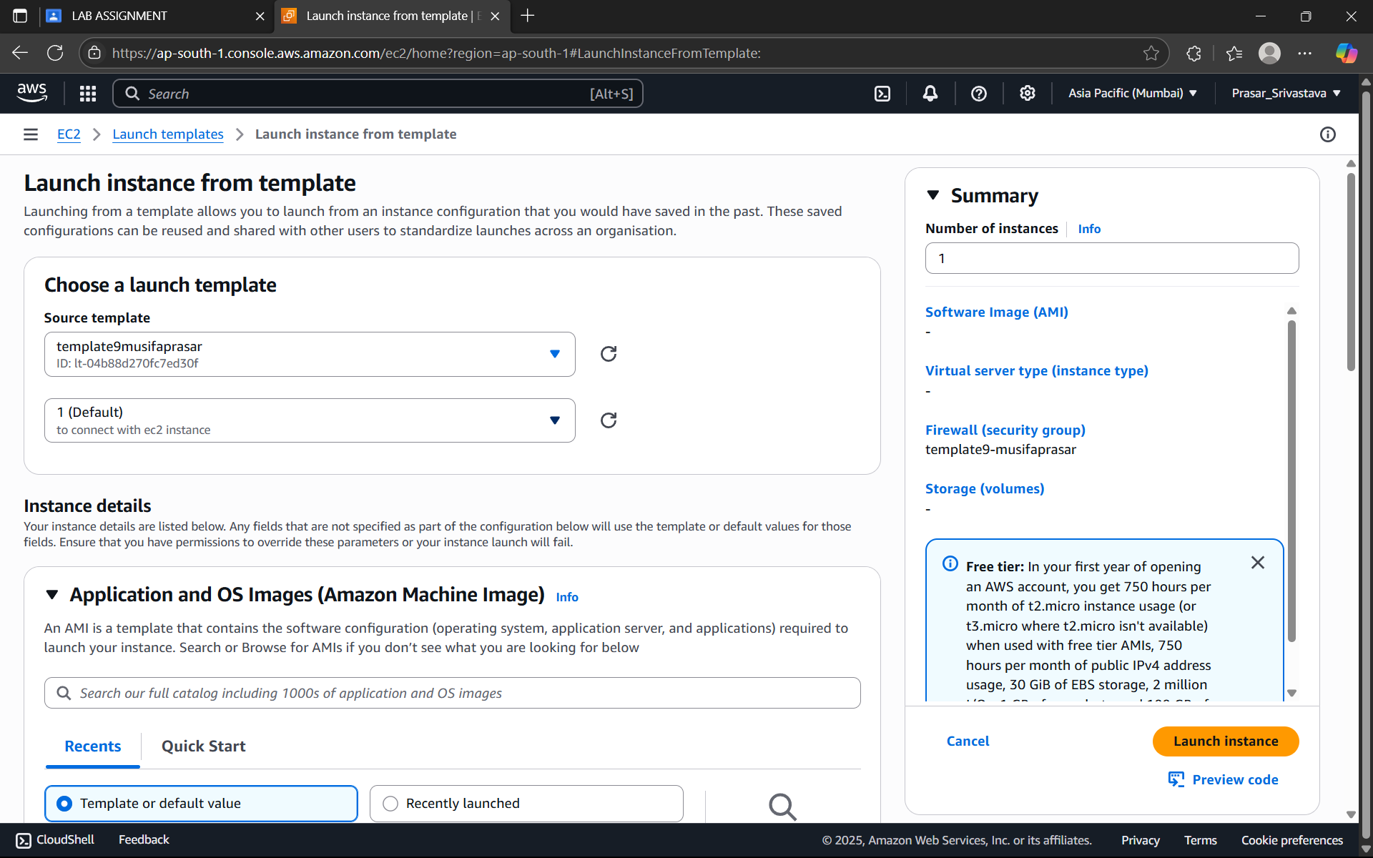

STEP 14: CLICK ON CONNECT

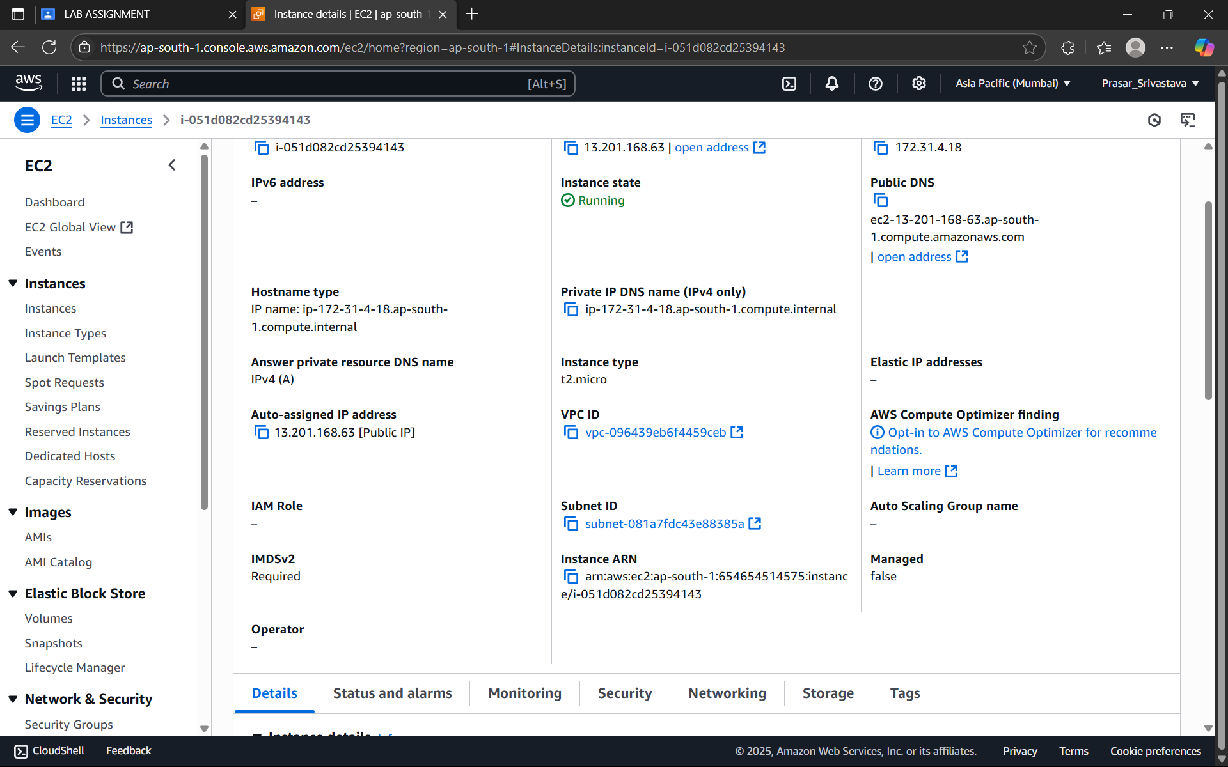

STEP 15: CLICK ON CONNECT TO INSTANCE

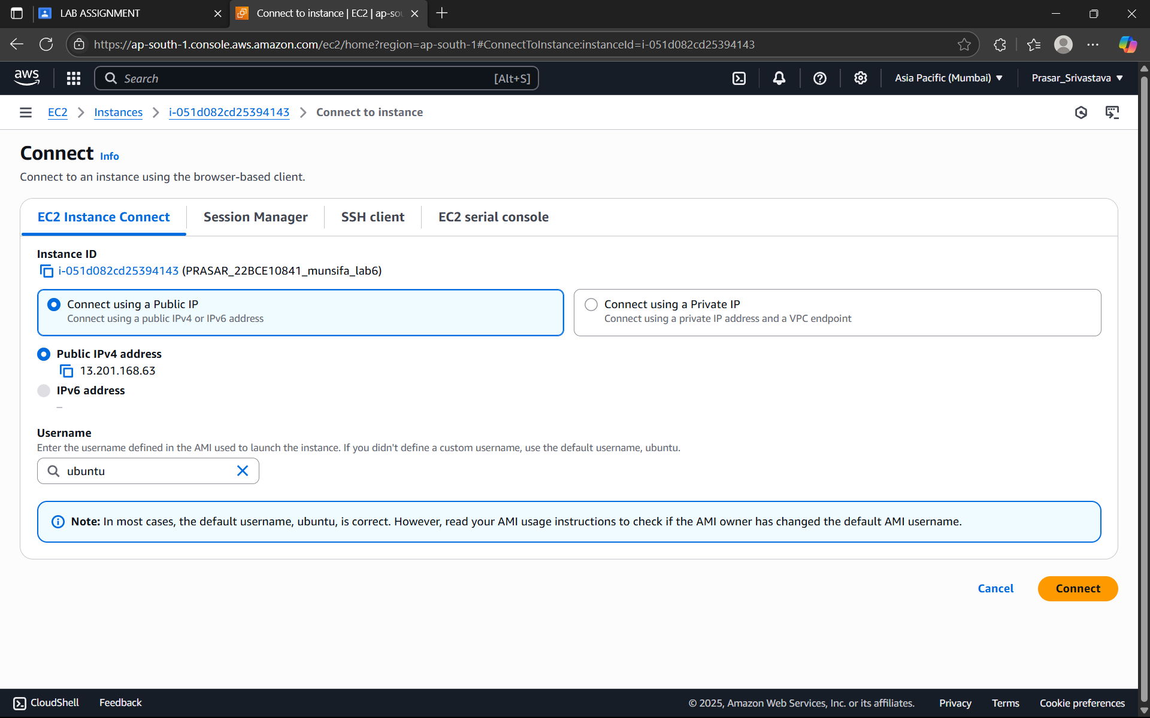

STEP 16: EC2 INSTANCE IS CONNECTED

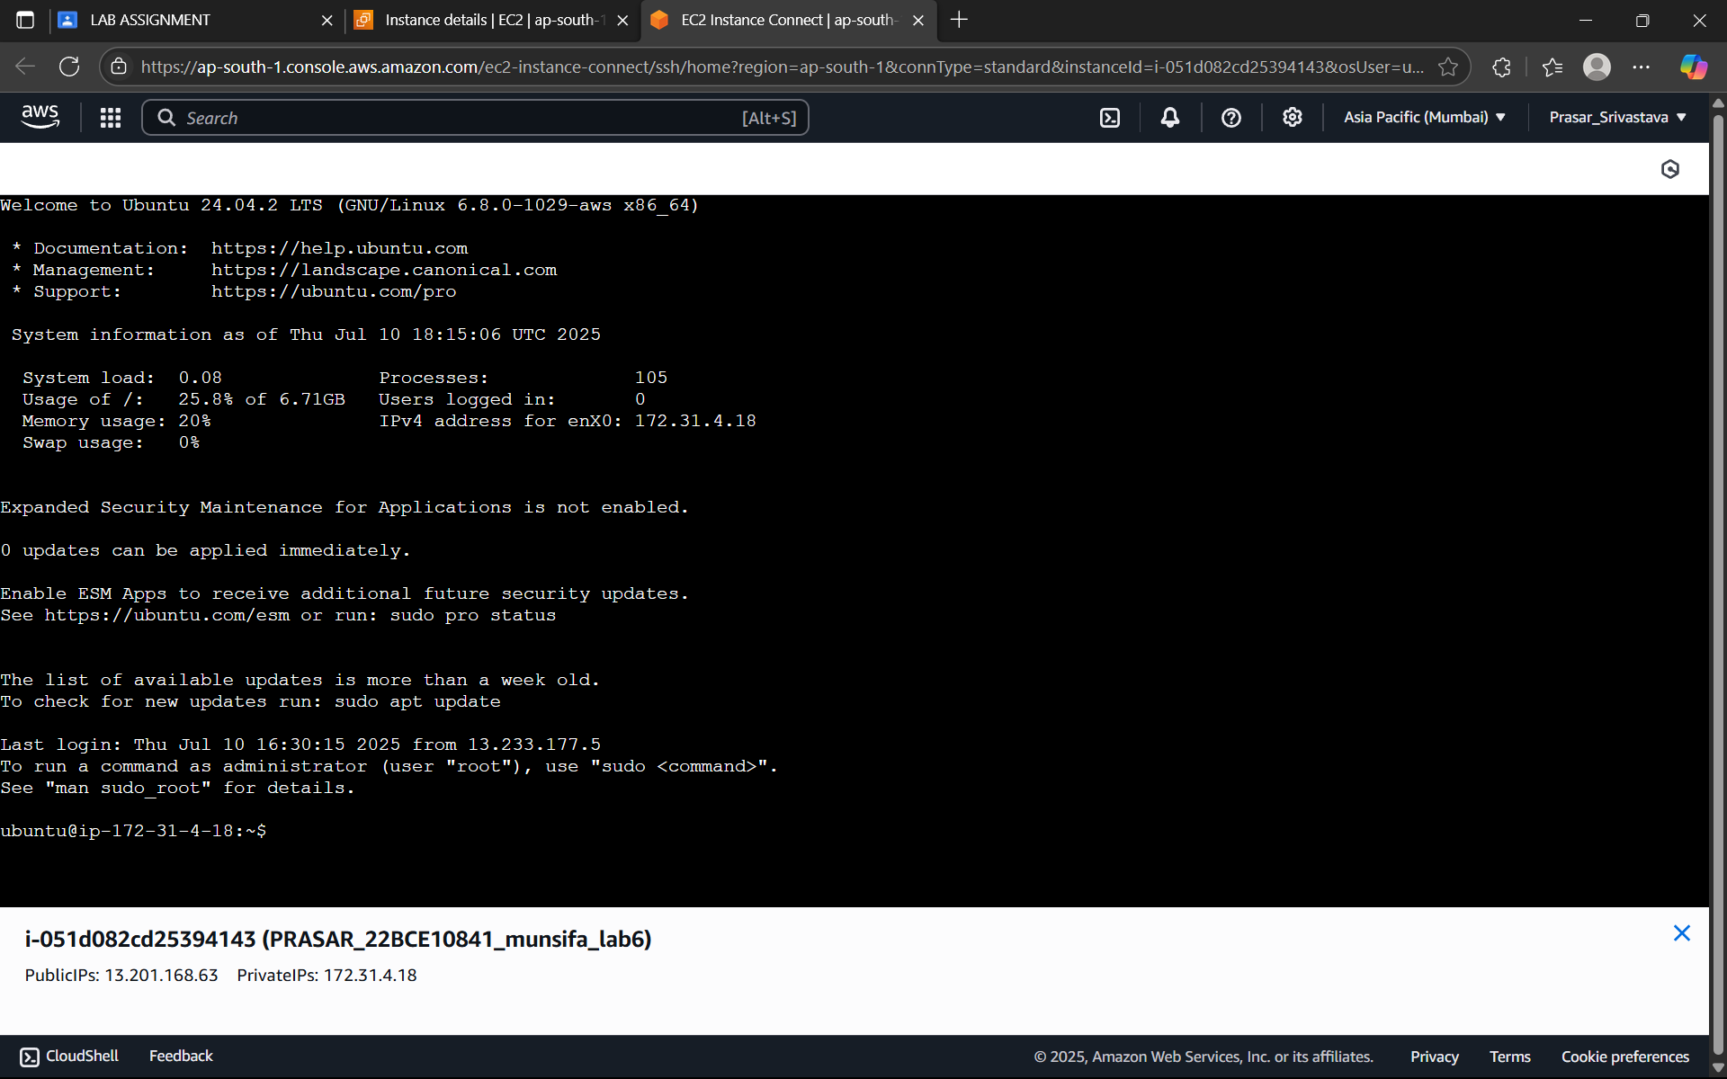

***LAB 3:- Amazon S3 ( Bucket creation, creating URL and S3 Life cycle Management)***

Step 1: -Get in storage and then in storage dashboard.

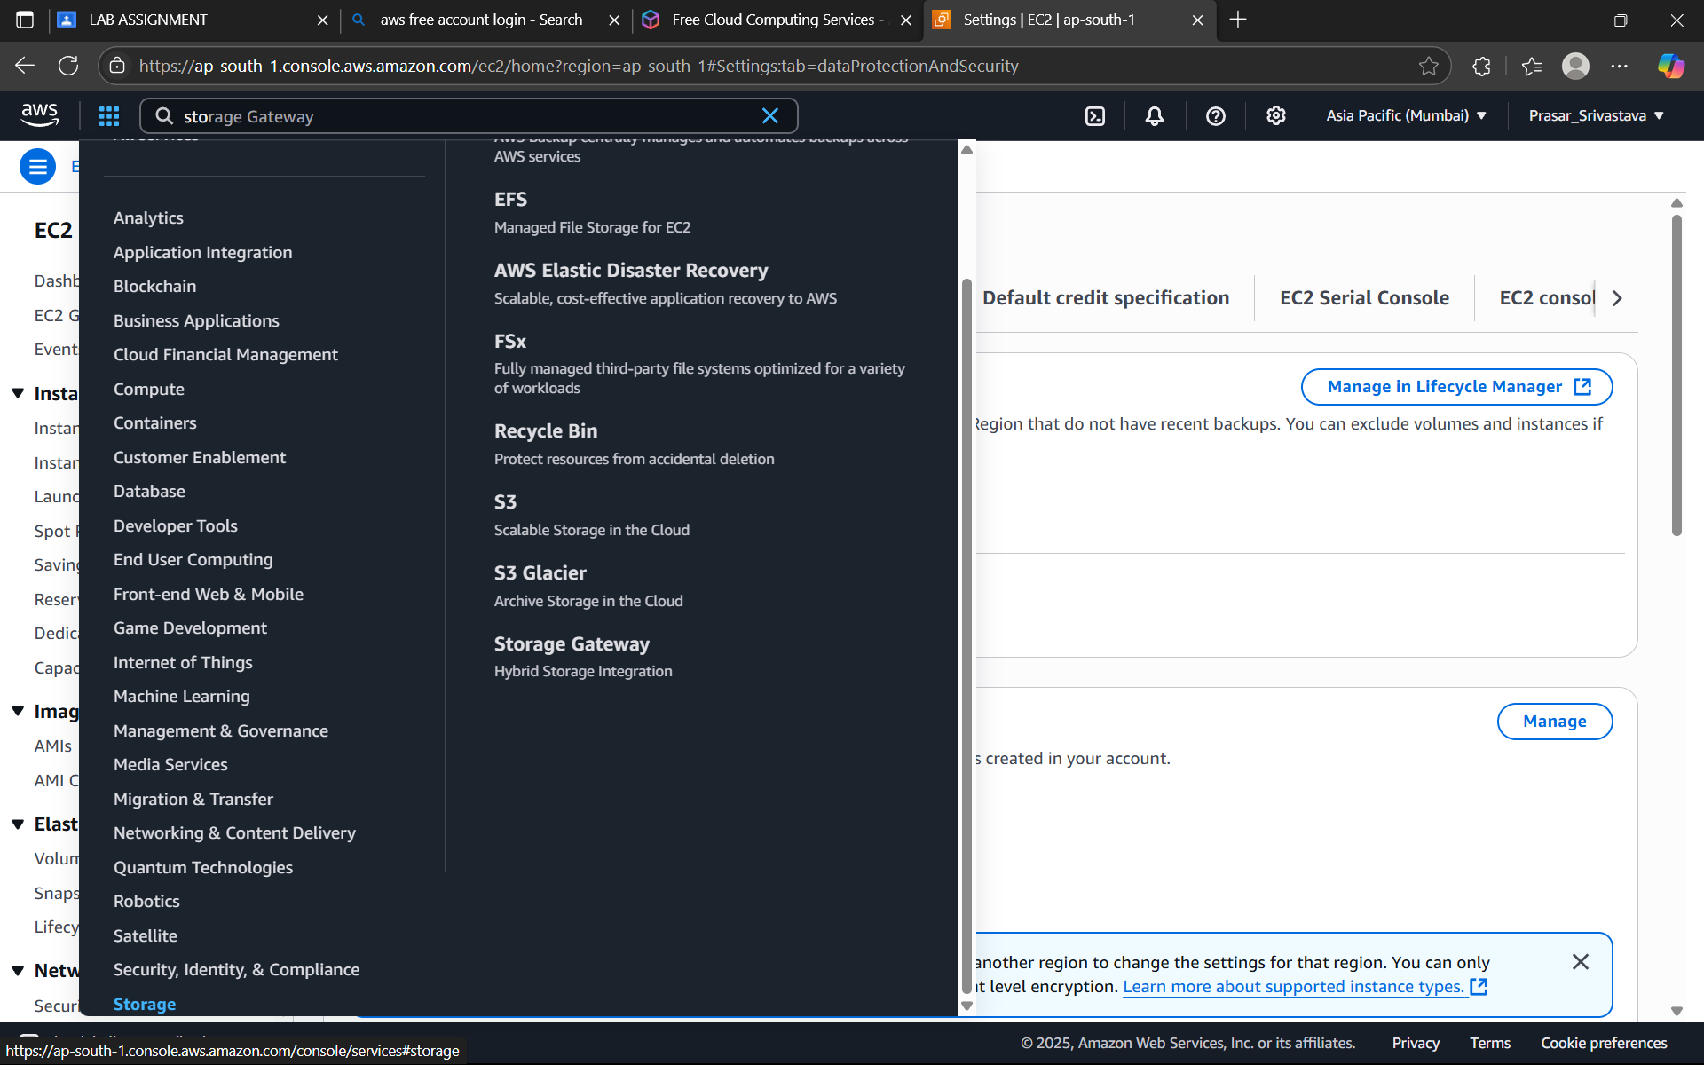

Step 2: - Since no bucket is created so click on create bucket.

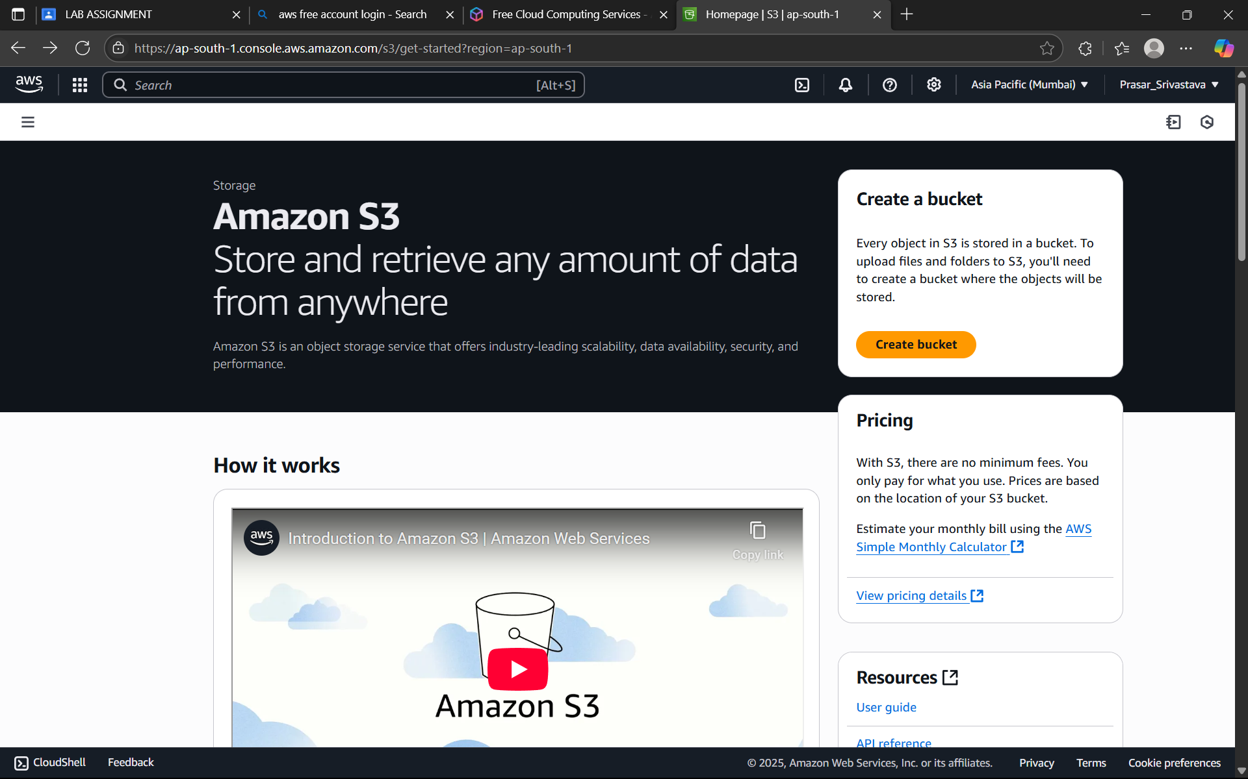

Step 3: -Since the AWS region is already selected.

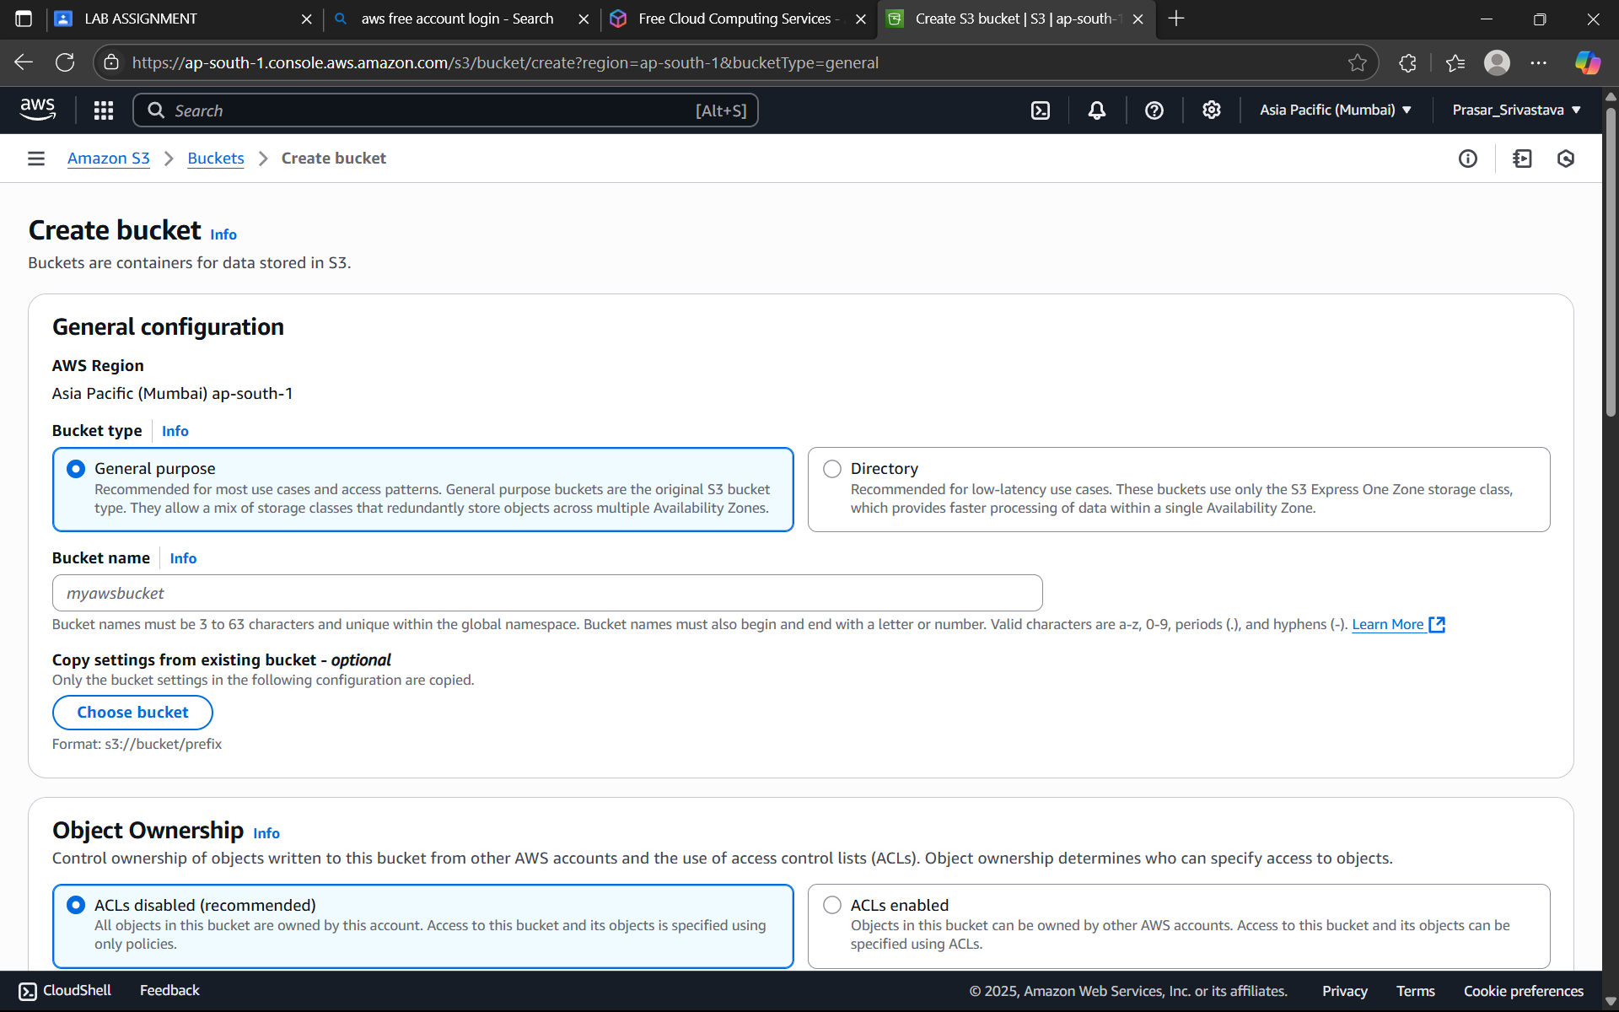

Step 4: - Now creating a bucket with unique name which does not contain caps.

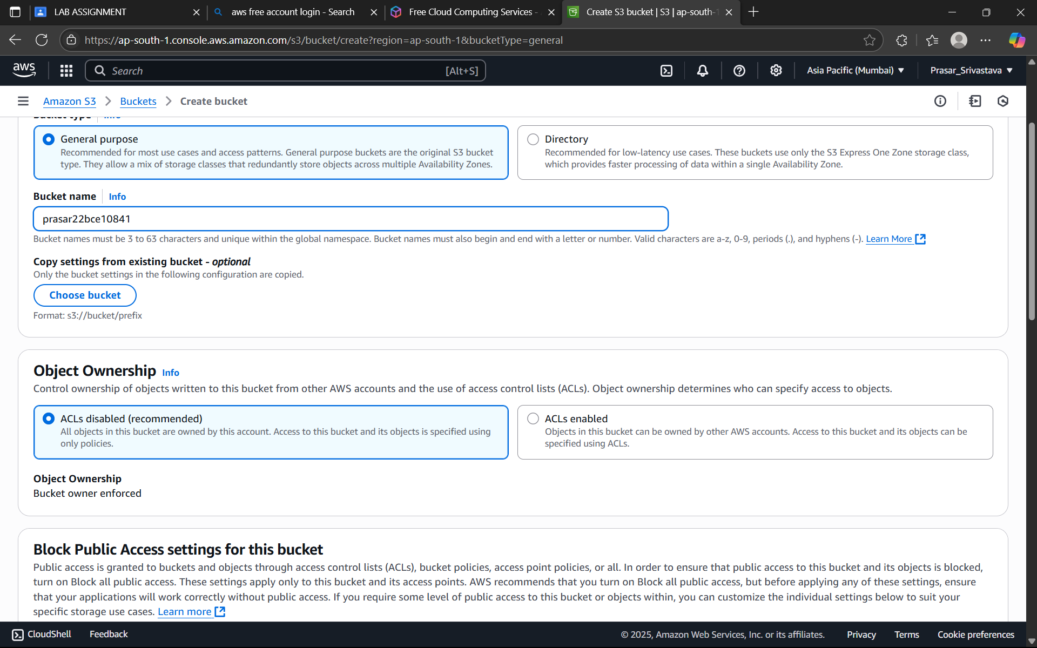

Step 5: - Now for giving the security we provide encryption to Bucket.

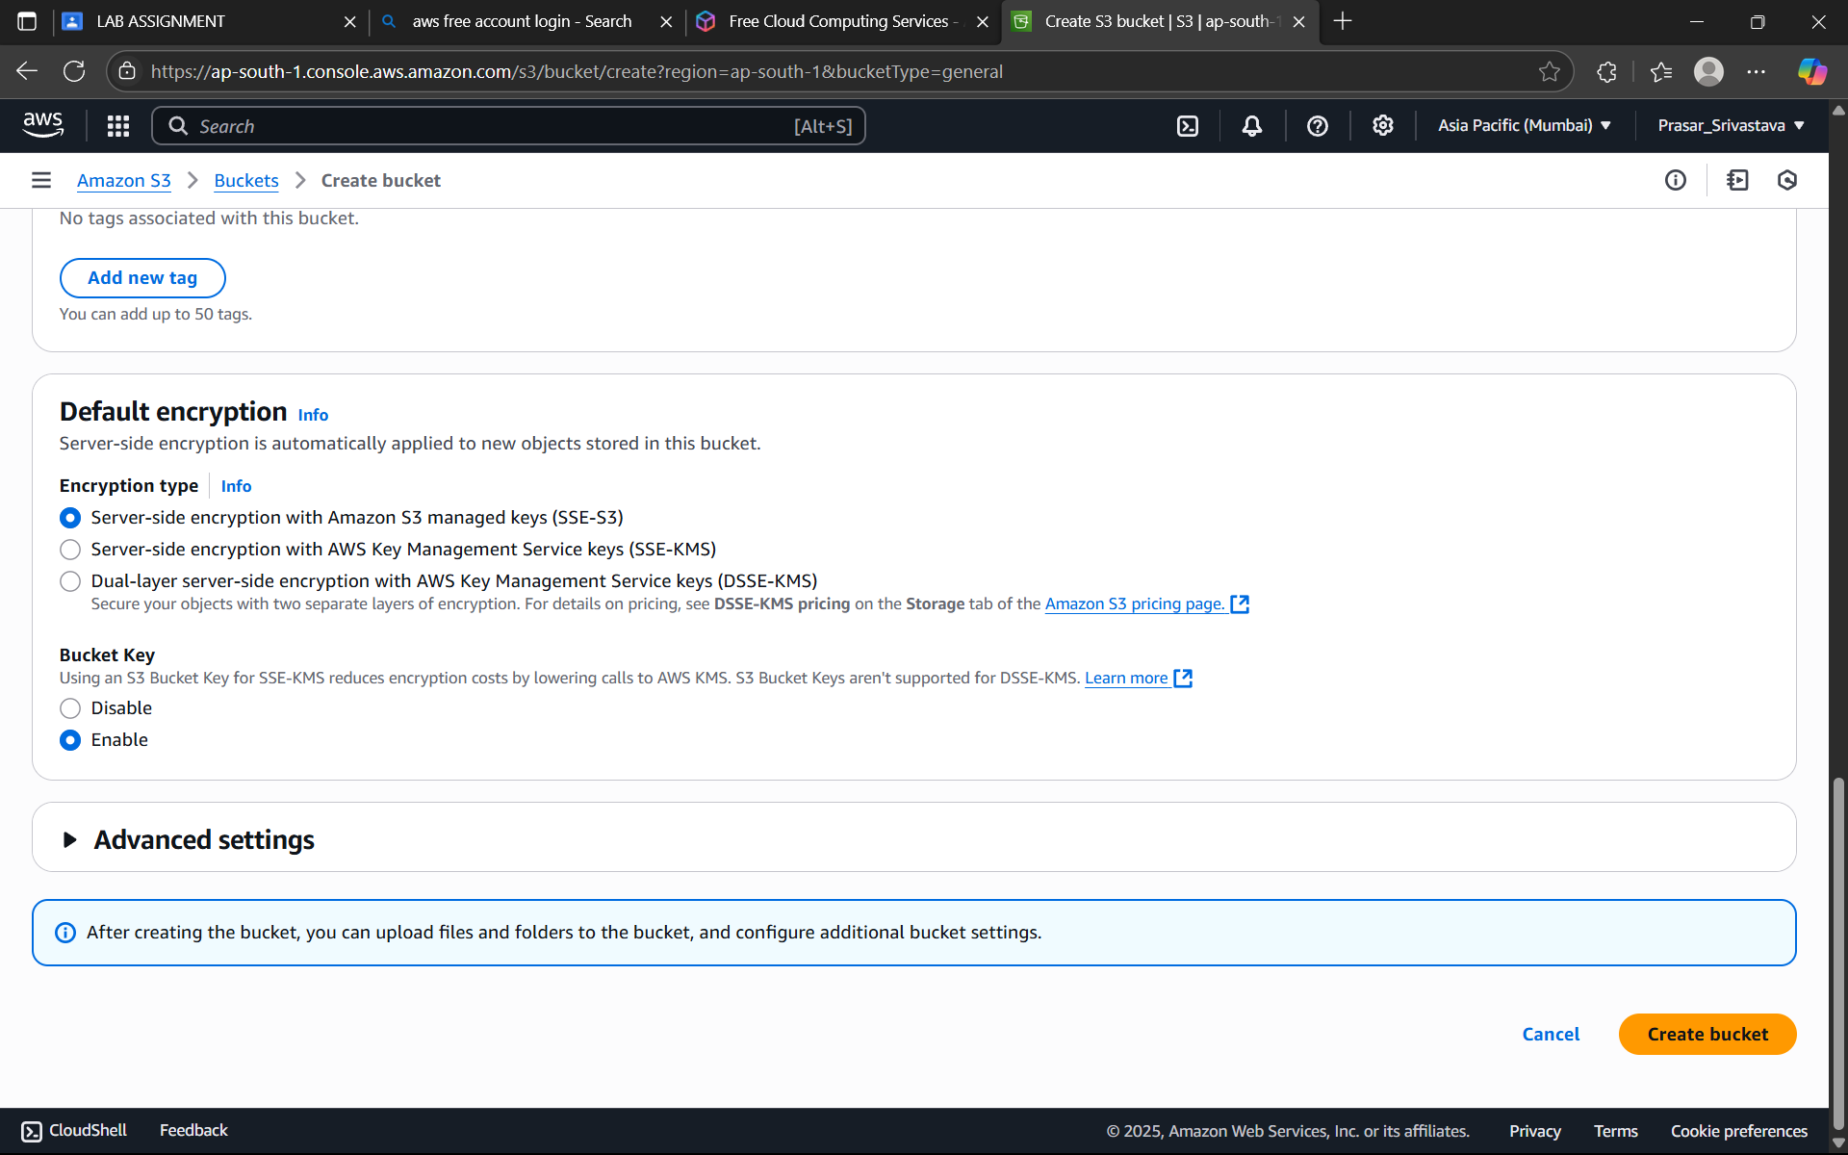

Step 6: -Now in thisstep bucket is created with name prasar22bce10841

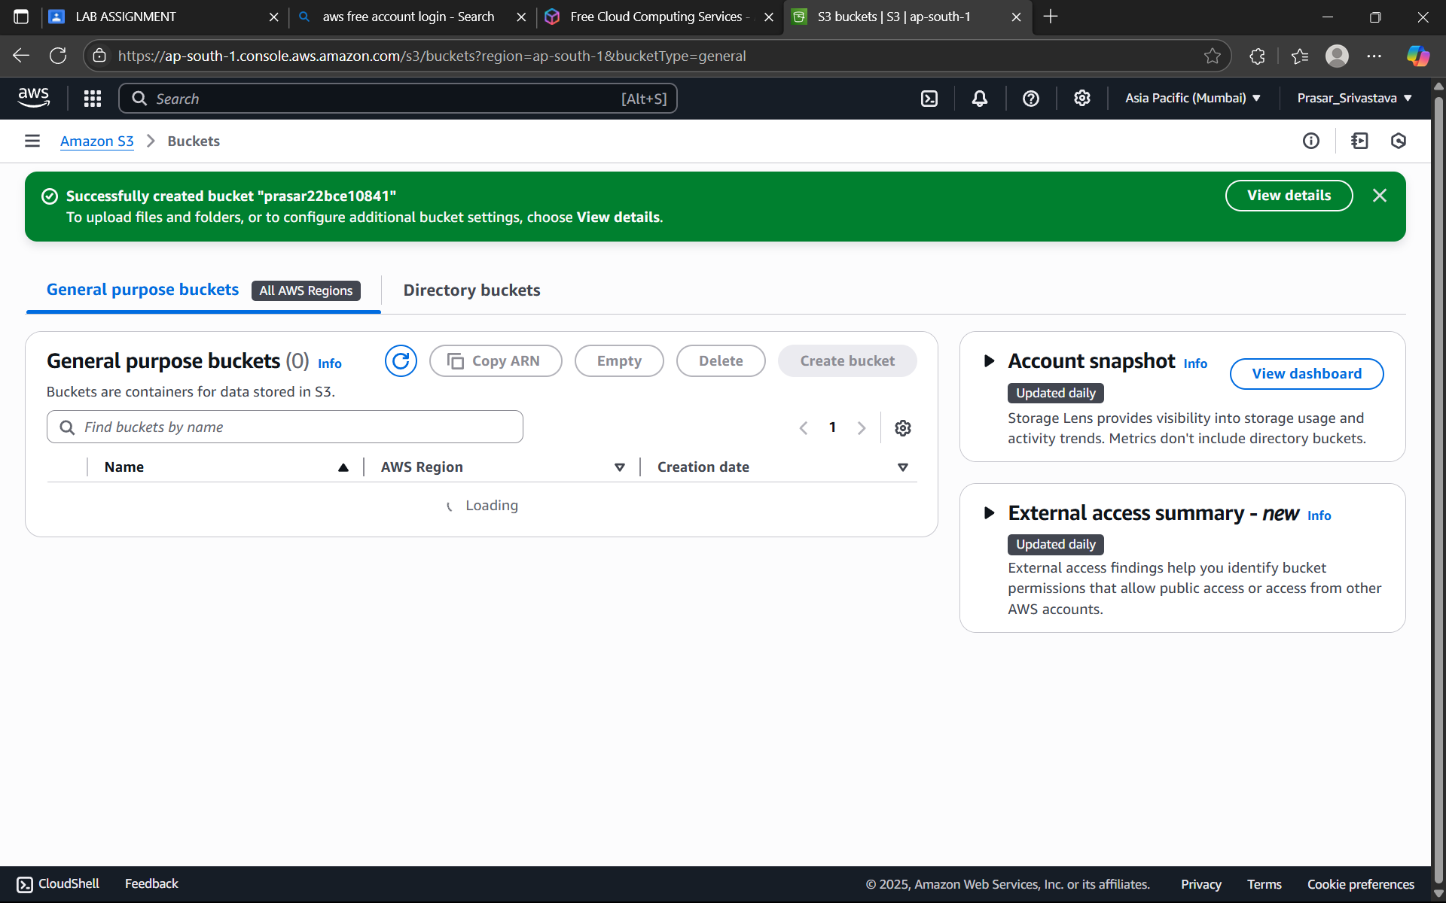

Step 7: -Now we upload file by clicking upload.

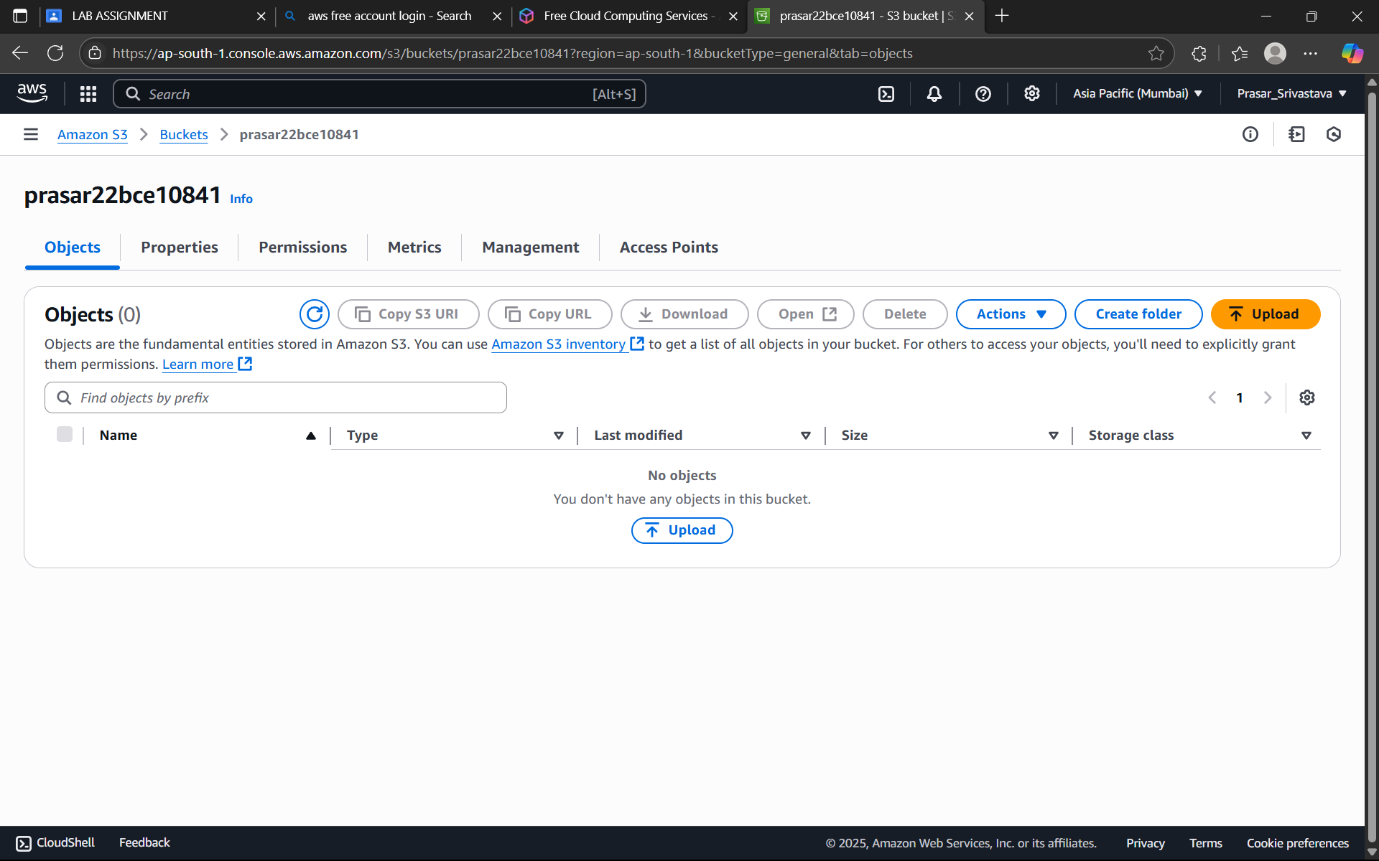

Step 8:-Now under upload section we can upload the file as well as folder.

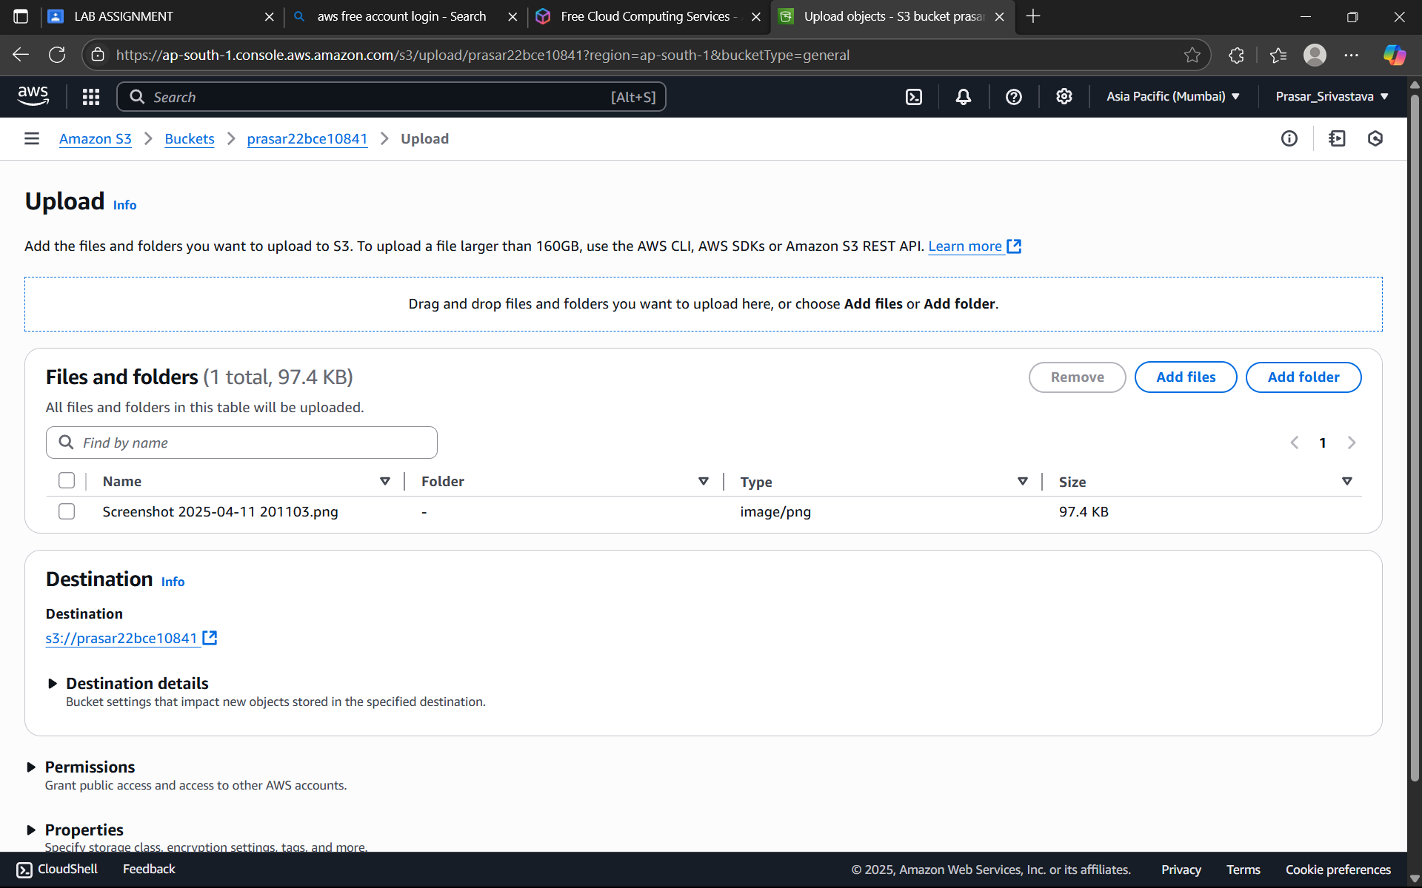

Step 9:- In storage class there are different types so choose any one as per use.

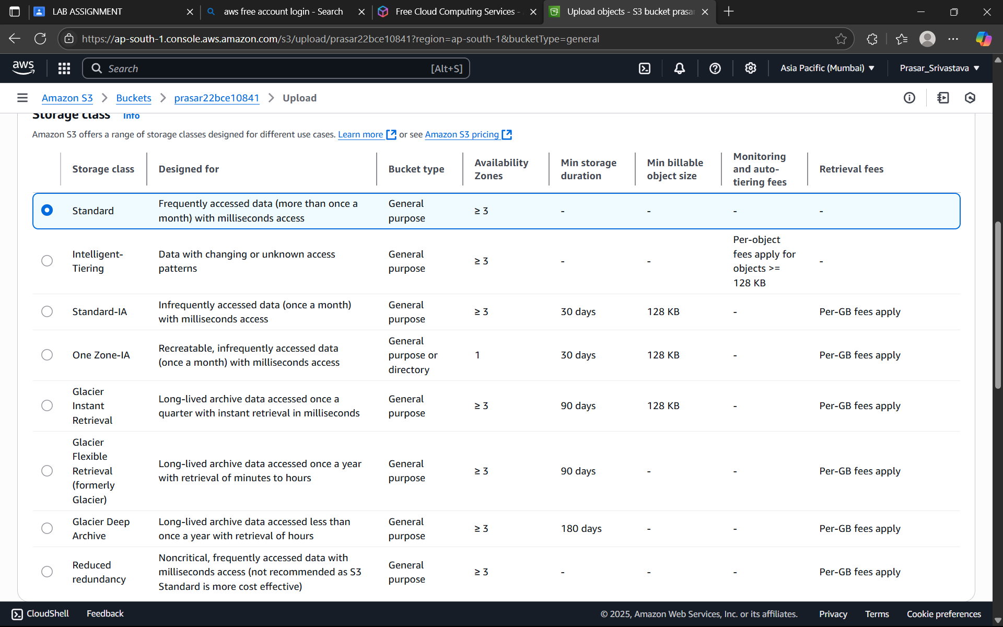

Step 10: -Now click on upload it show success.

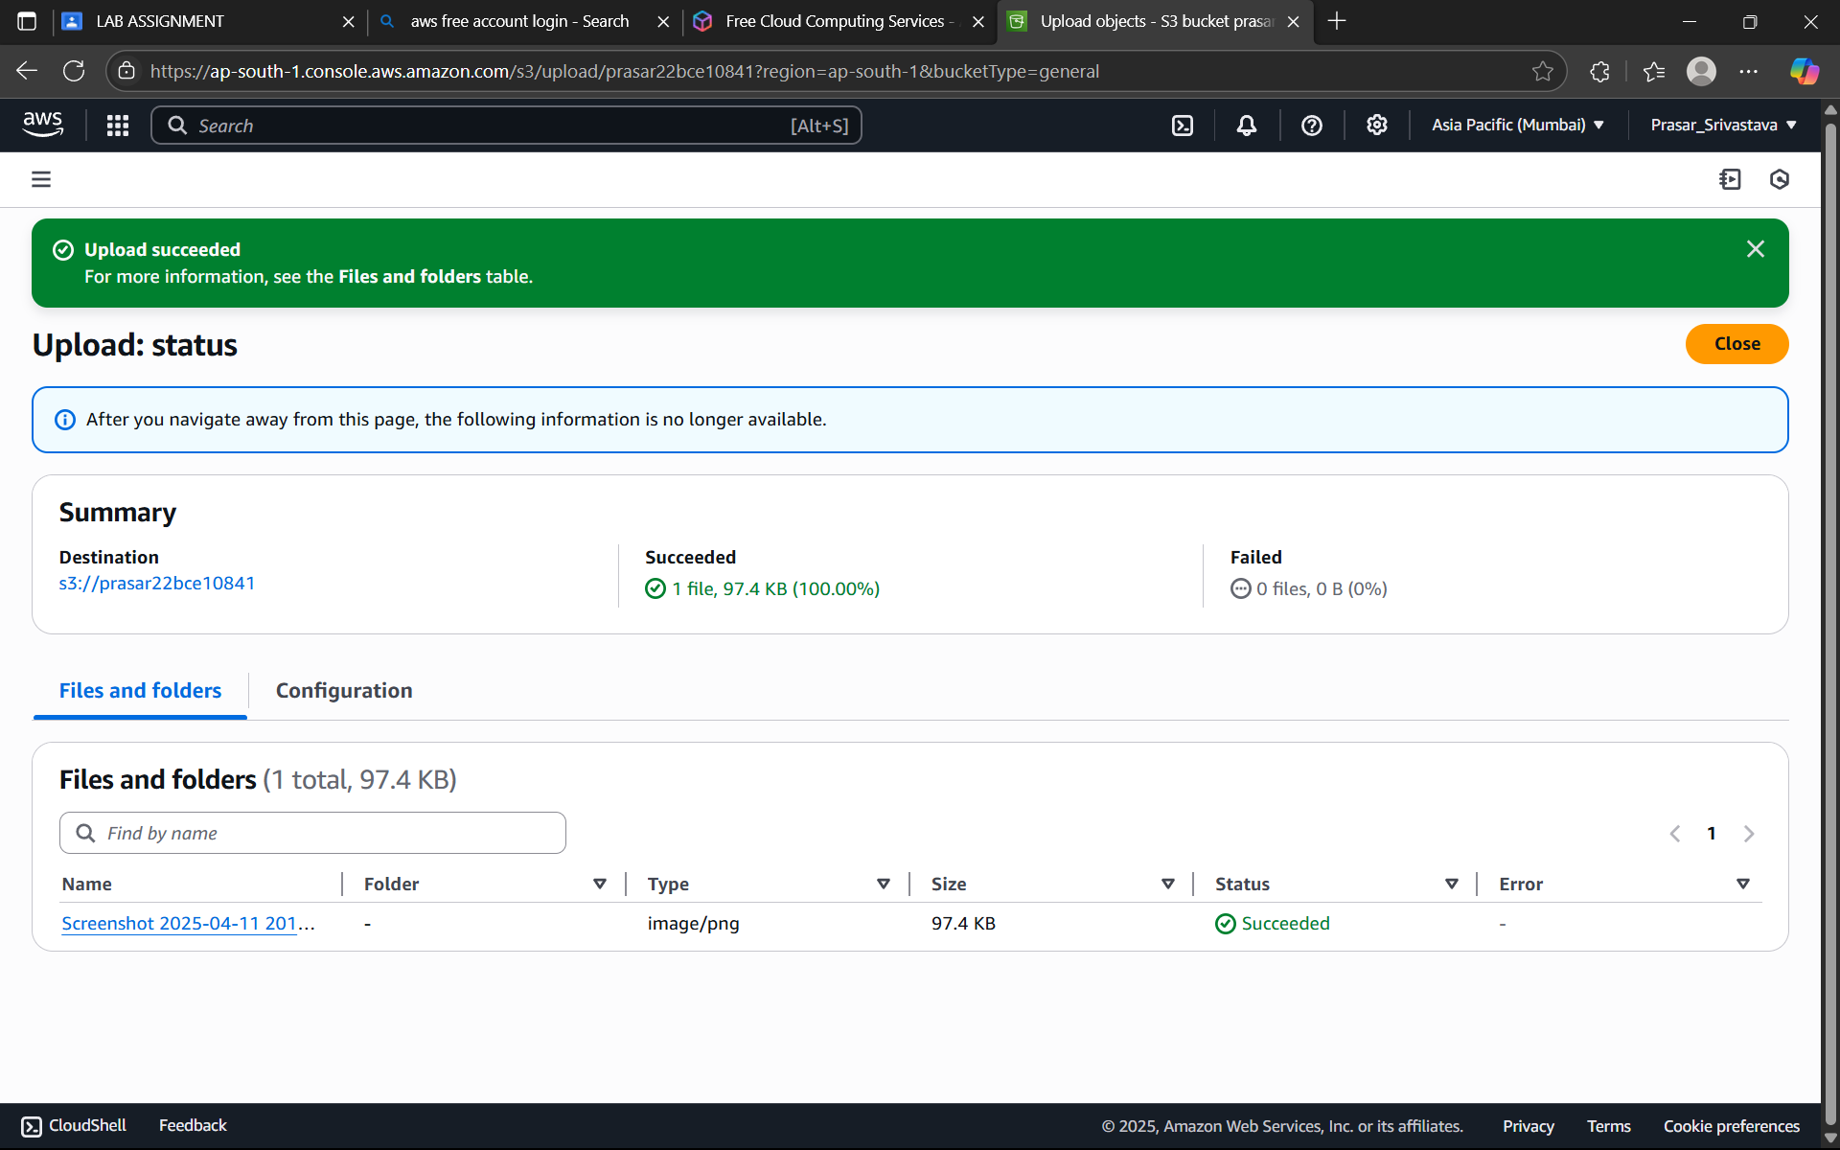

Step 11: -Now open the file and we can see everything as shown in fig.

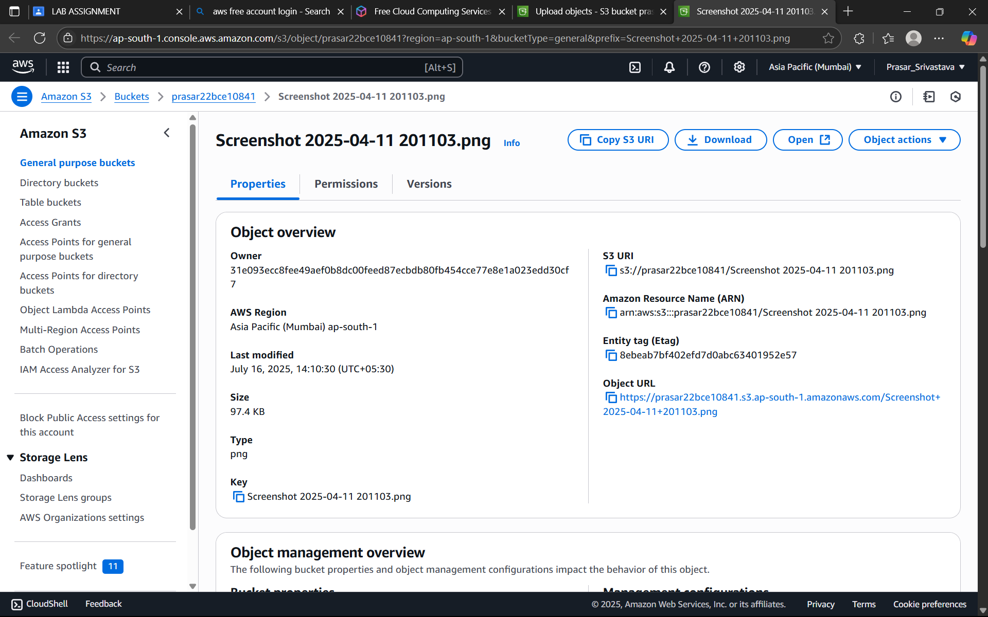

Step 12: -Since public access is not given so the url will not open to access this we move to permission in bucket.

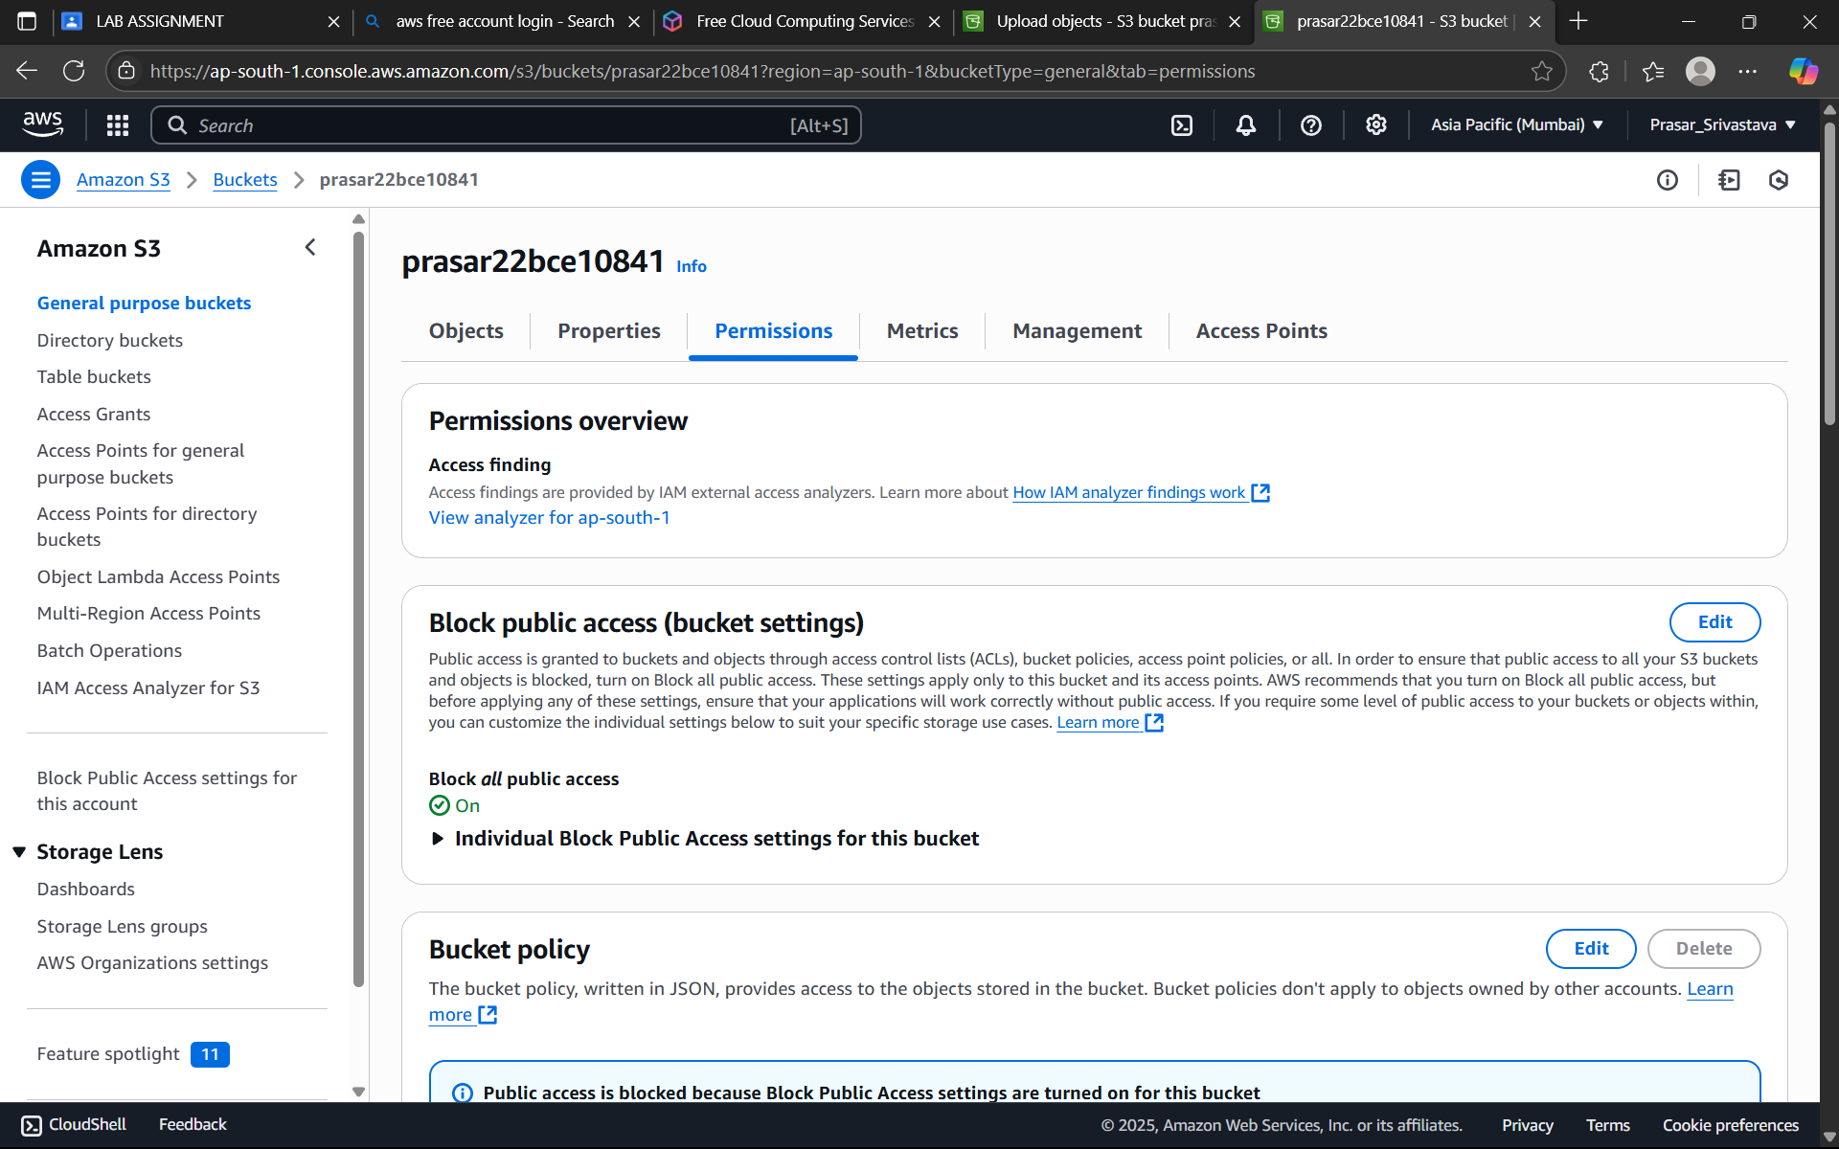Step 13: -Under block public access we will edit the access crieteria.

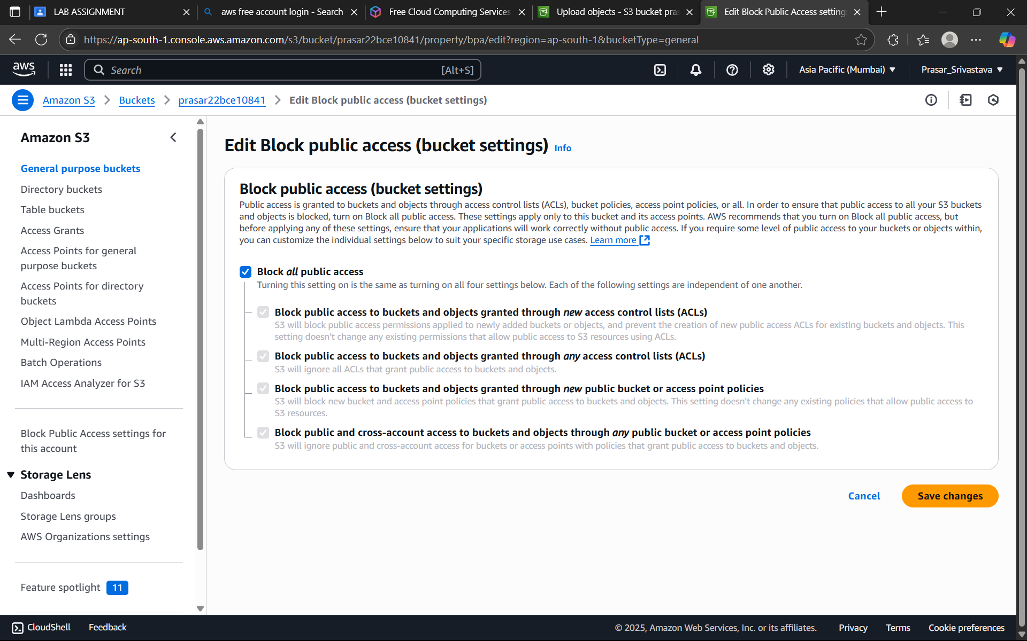

Step 14: -now click on confirm. Then also its not open because public policy is not mentioned.

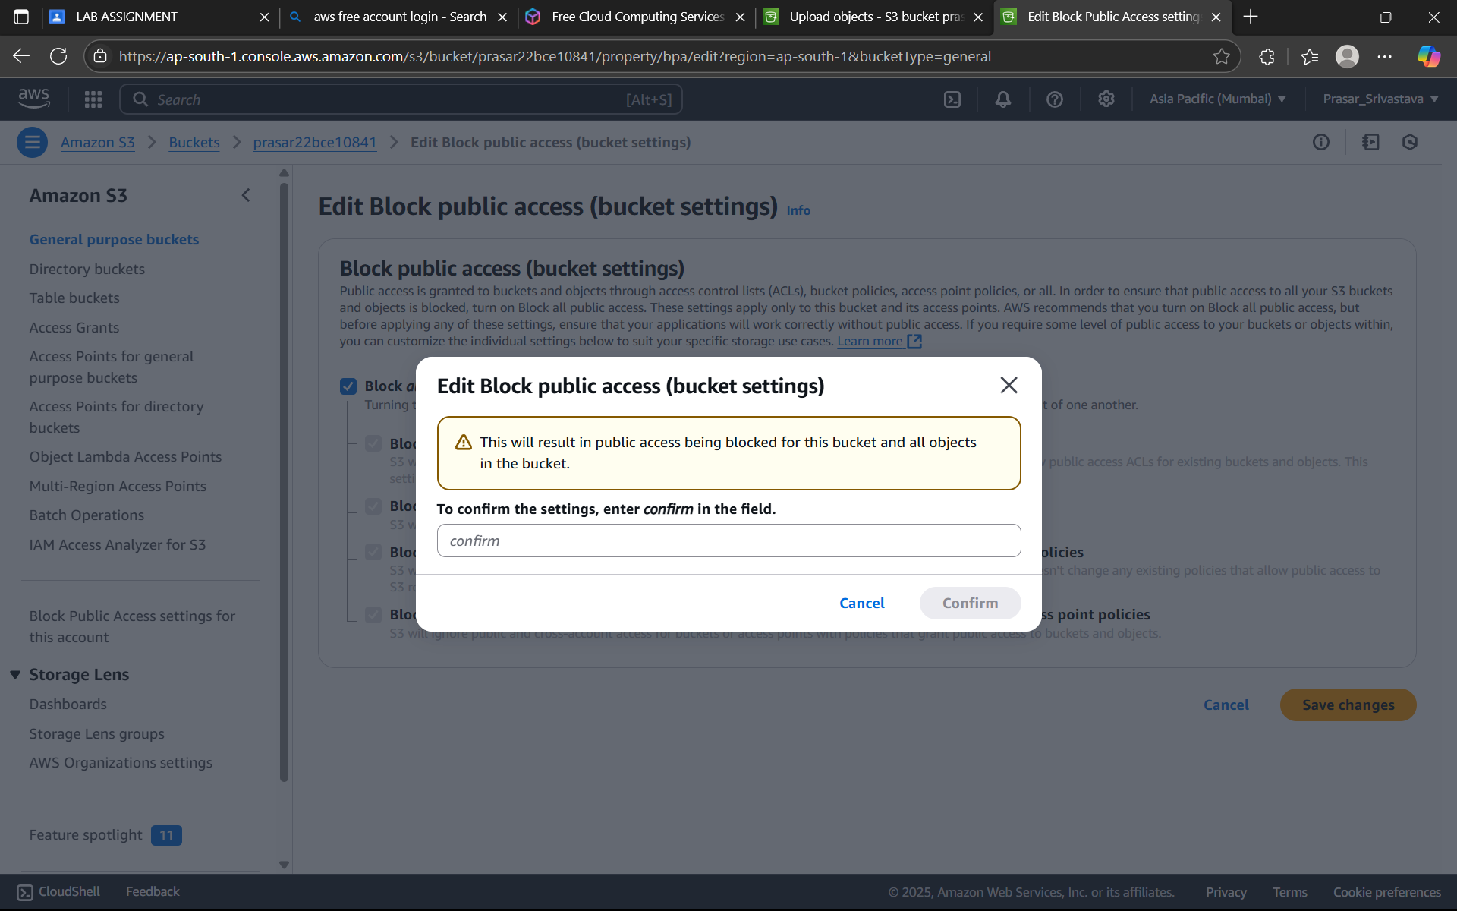

Step 15: -Now writing the code for policy for accessing the file of bucket. And after the file is viewed by everyone.

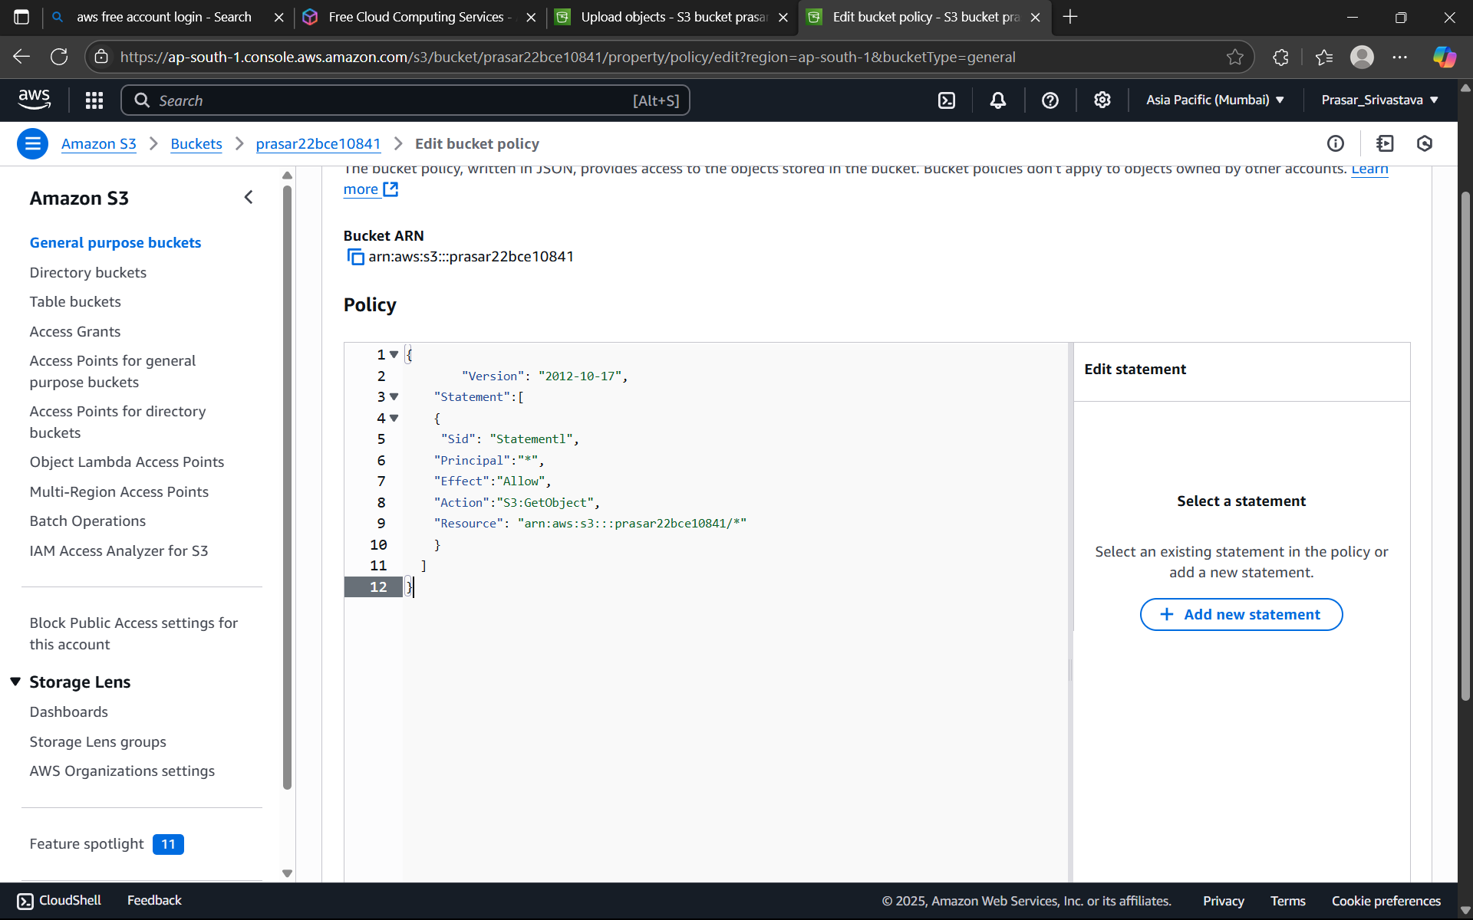

Step 16: -Now in this step we will understand the use of version id in this if upload same file format with same name then it is differentiated using version id as shown

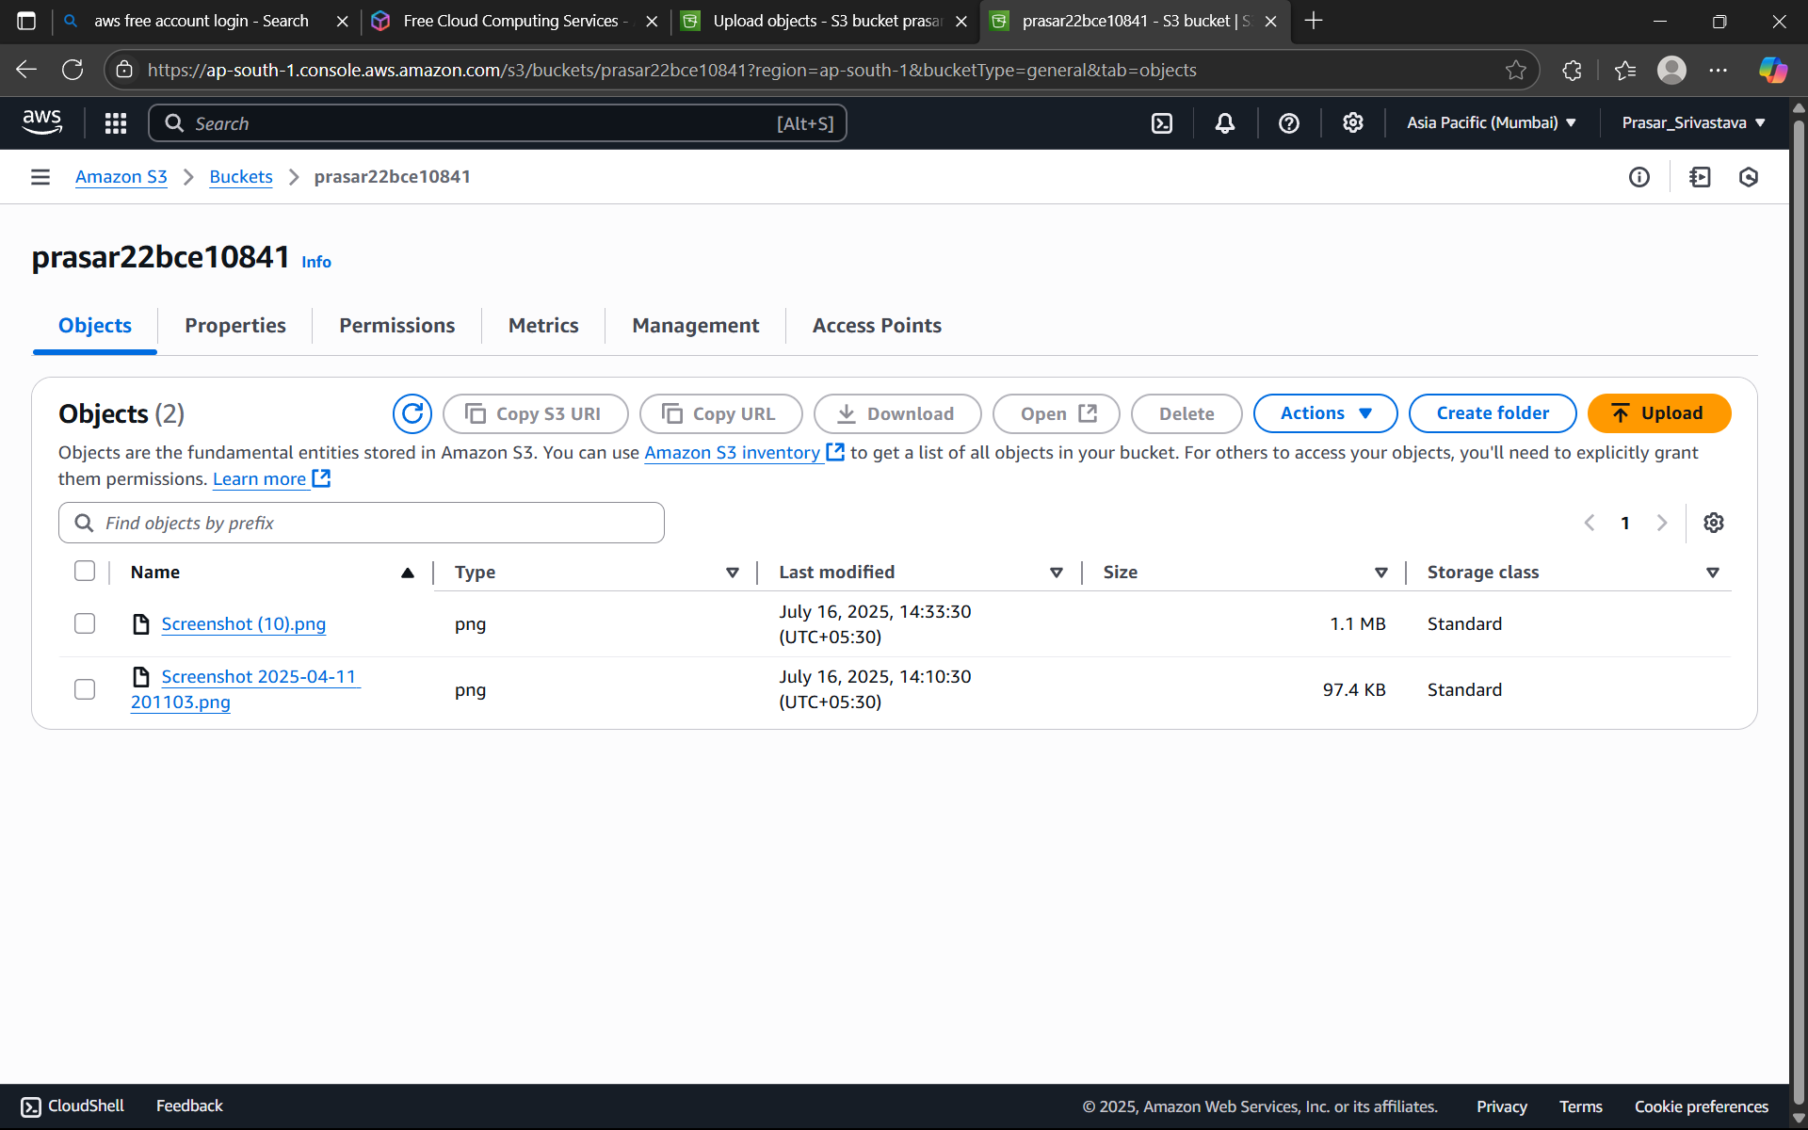

Step 17: -Here we will see about life cycle rule of bucket by giving time period .

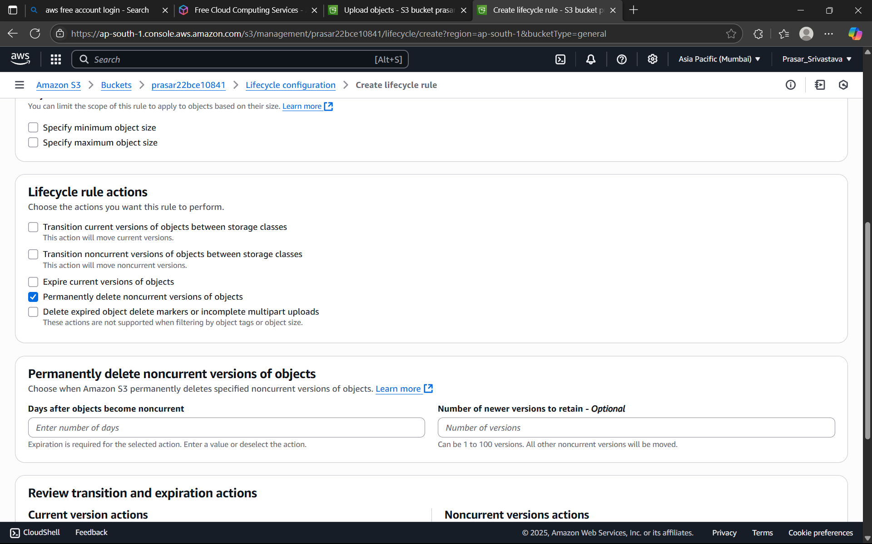

Step 18: -Now in this we will see how to delete the object in bucket. Clicking on the object which we have to delete.

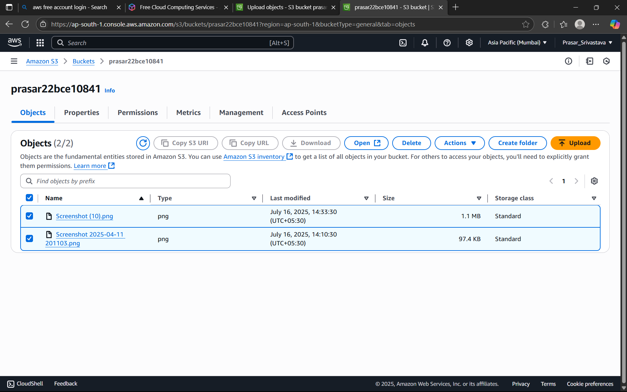

Step 19: -Now click on delete option and type delete to delte the object and empty the bucket.

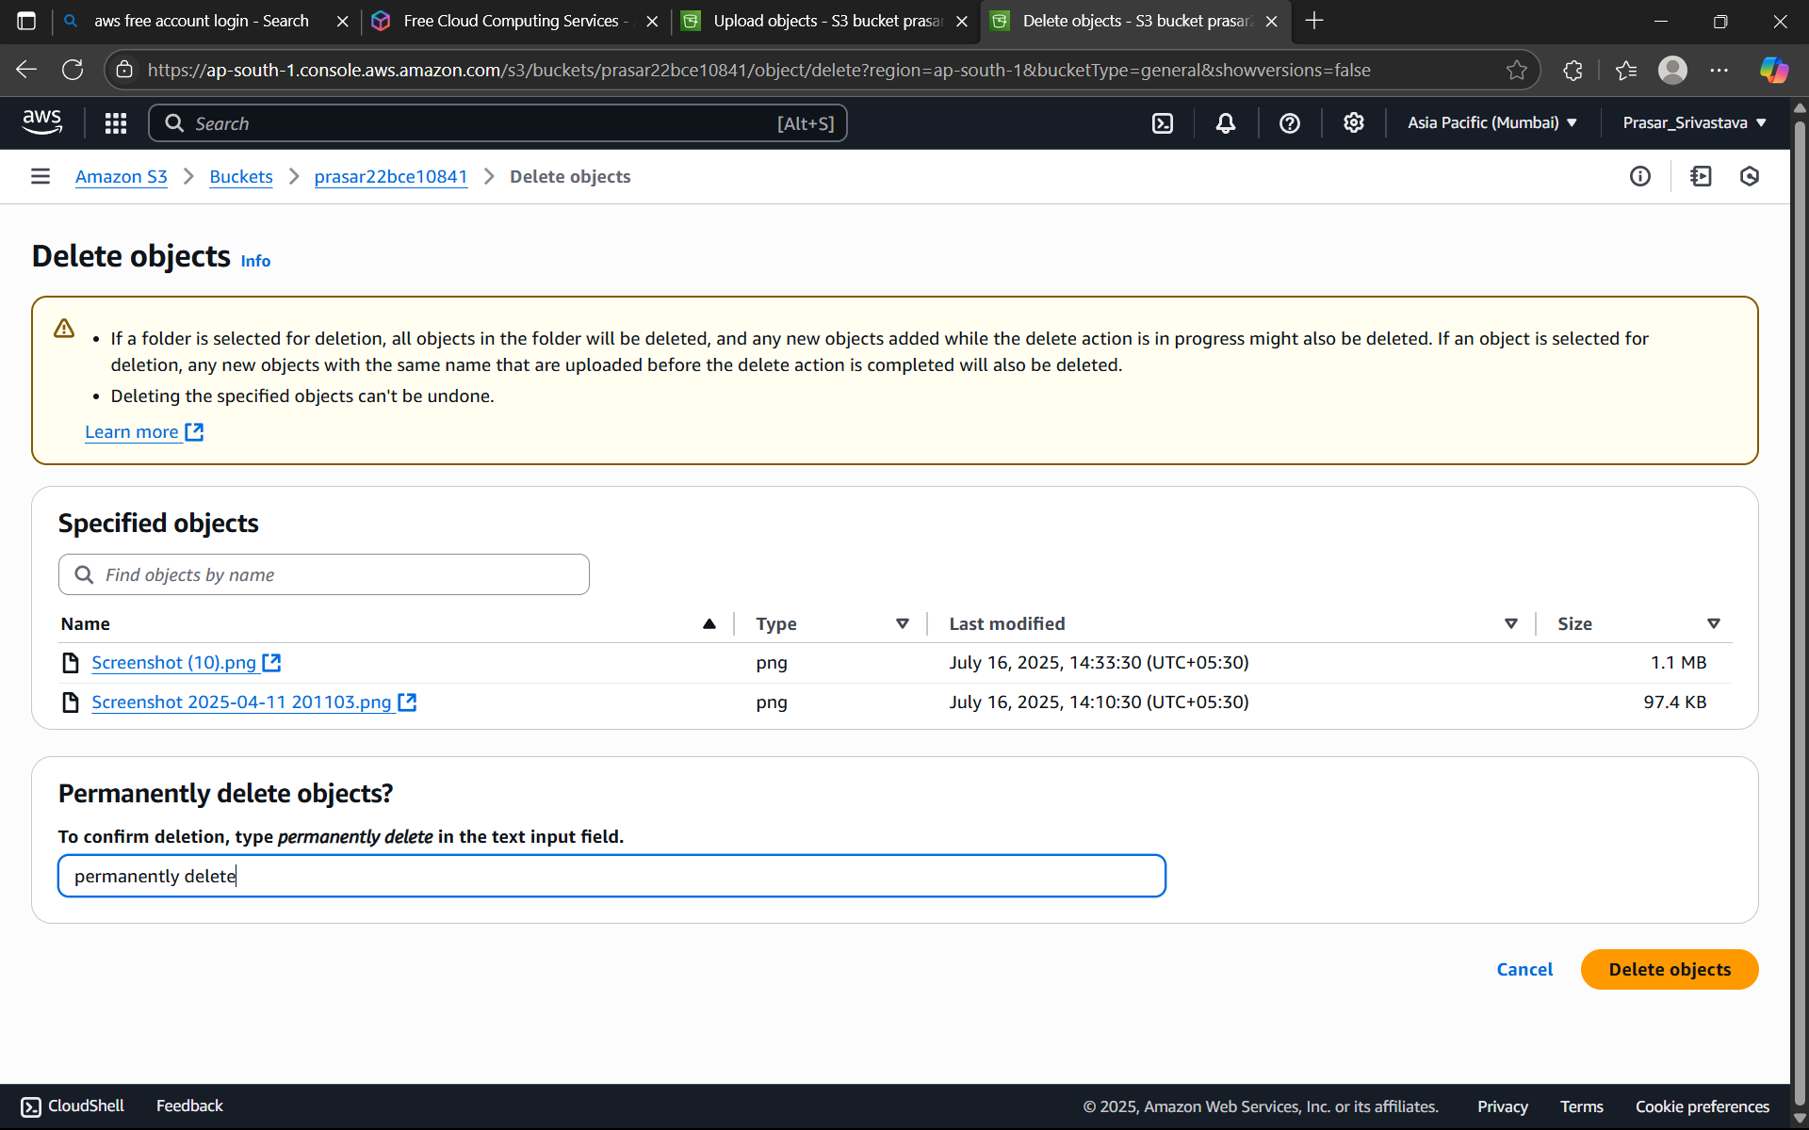

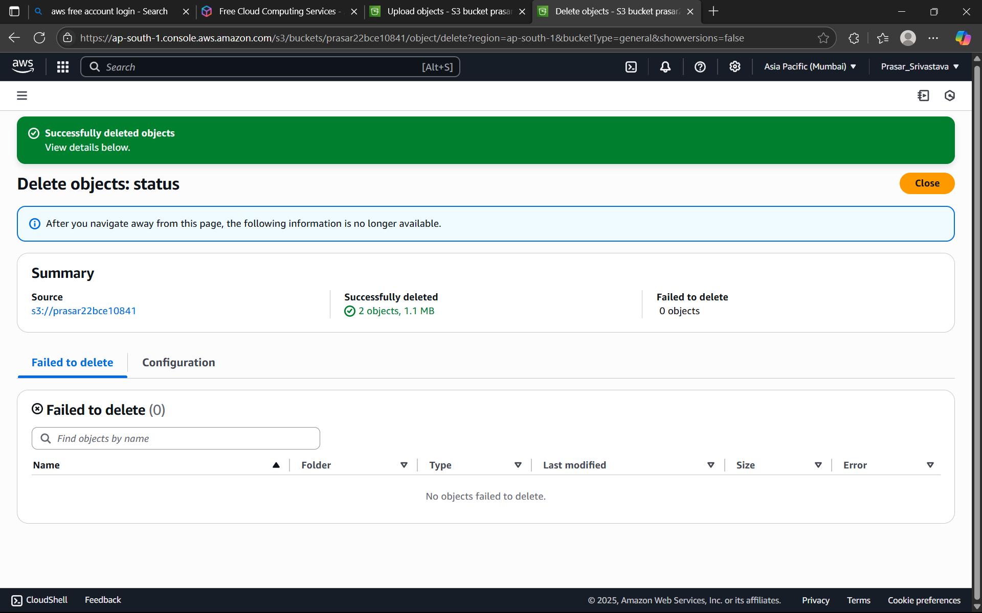

Step 20: -Now in this we will delete the bucket which we have created .For this the most important part is the bucet must be empty .

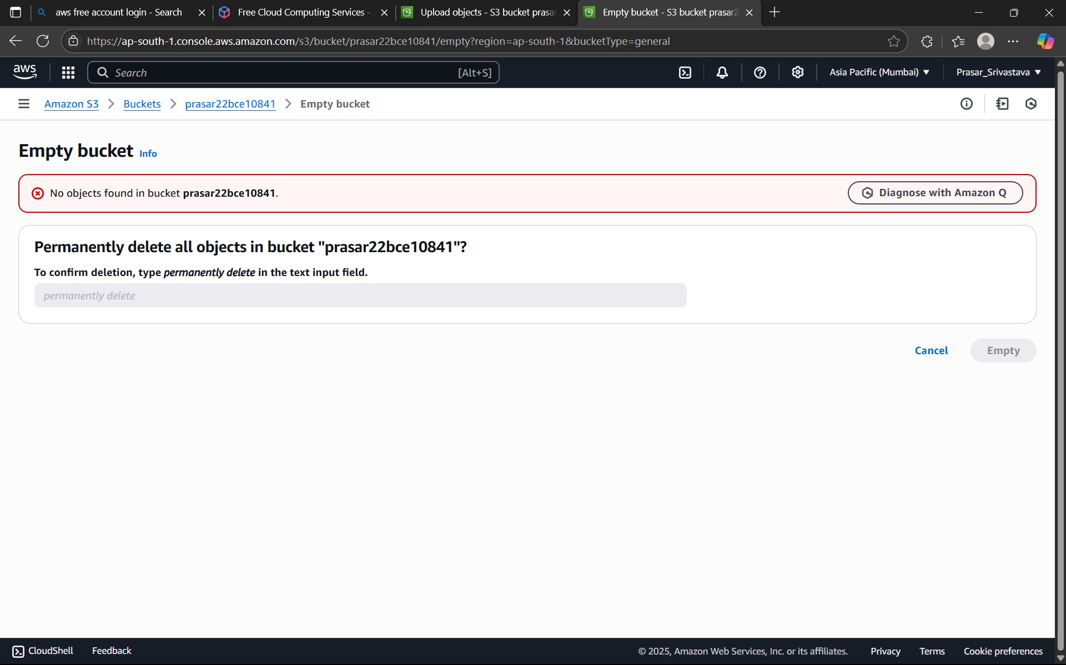

Step 21: - After selecting delete option click on delete option and type bucket name to delete then click on delete the bucket will successfully be deleted.

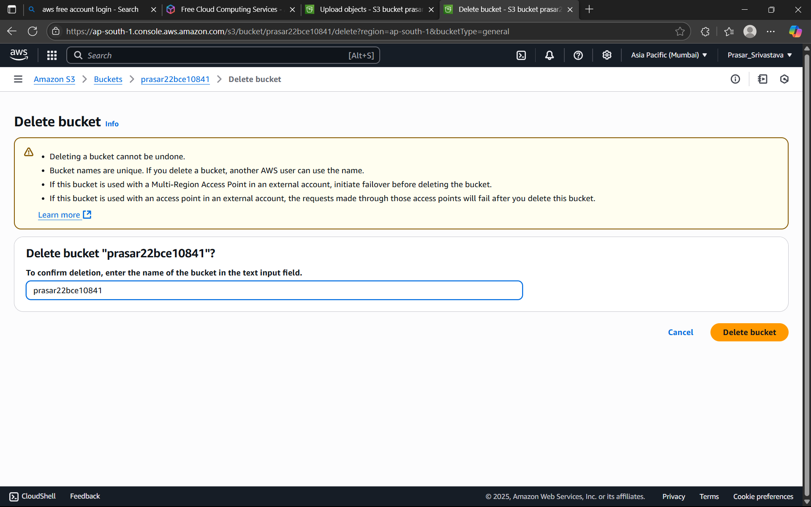

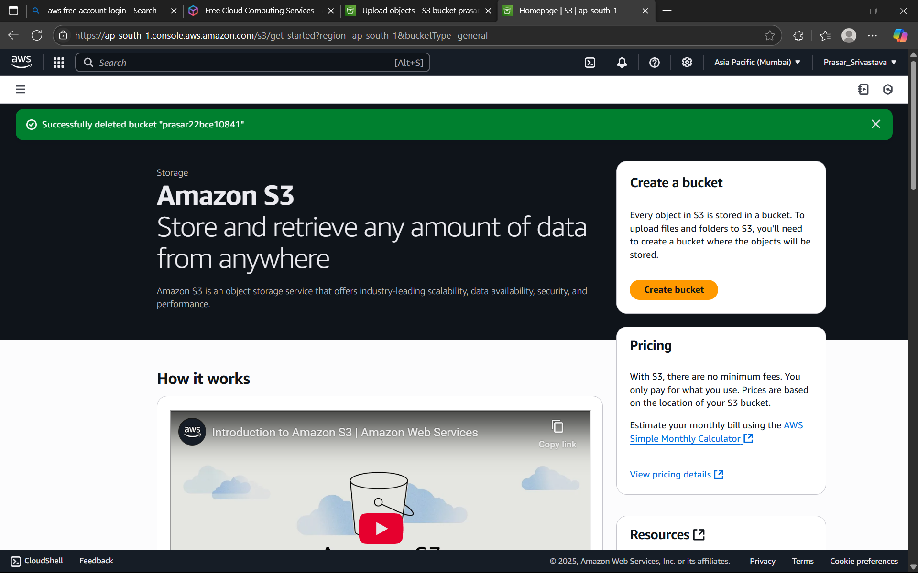

***LAB 11-HOW TO CREATE EBS AND ATTACH TO EC2 INSTANCE, MODIFY SIZE AND CREATE A SNAPSHOT CREATION OF FIRST EC2 INSTANCE***

STEP1: GO TO EC2 DASHBOARD>CLICK ON INSTANCES>CLICK ON LAUNCH INSTANCE>TYPE THE

NAME OF THE INSTANCE>CHOOSE THE UBUNTU

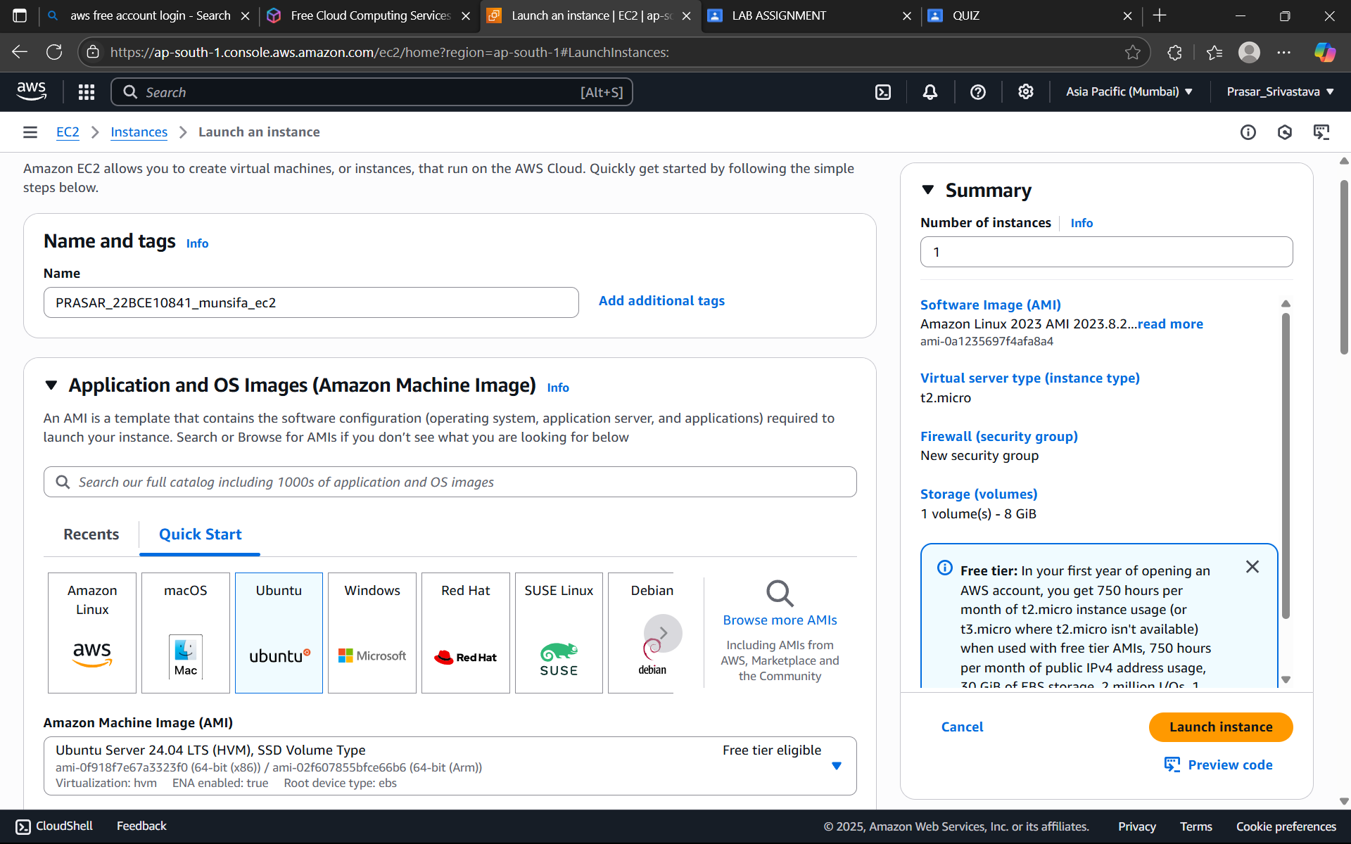

STEP2: CREATE A KEY PAIR

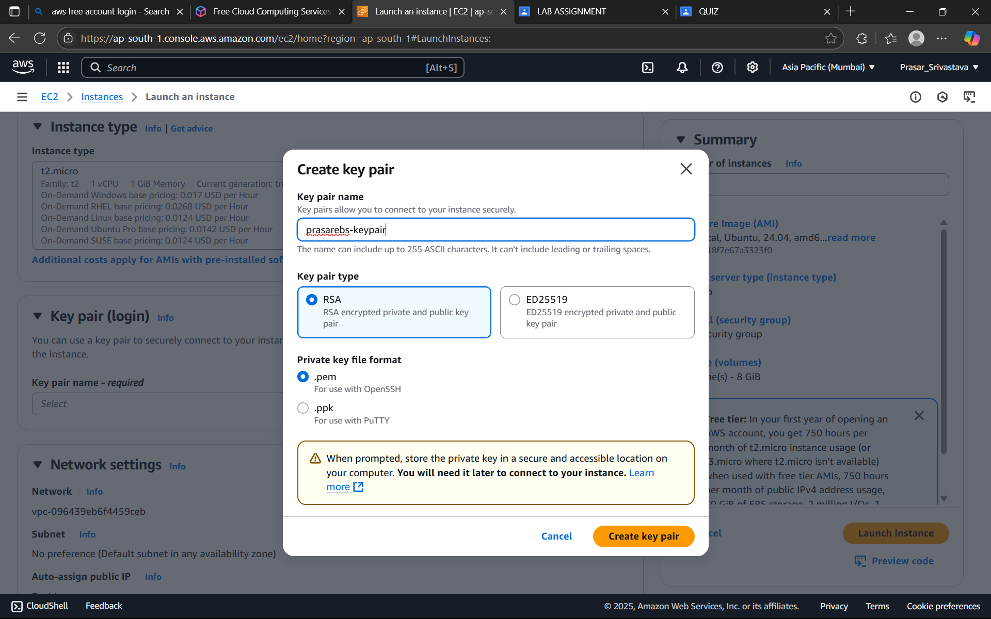

STEP3: EDIT THE NETWORK SETTING> SELECT THE VPC CREATED>CHOOSE THE PUBLIC SUBNET>ENABLE AUTO-ASSIGN PUBLIC IP>CREATE SECURITY GROUP

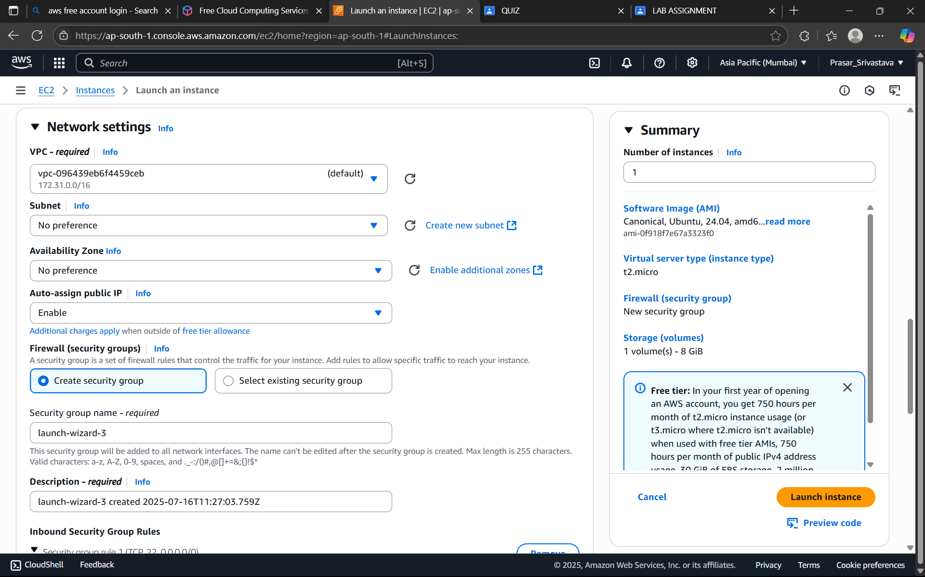

STEP4: SET TYPE: SSH IN THE SECURITY GROUP>CLICK ON LAUNCH INSTANCE

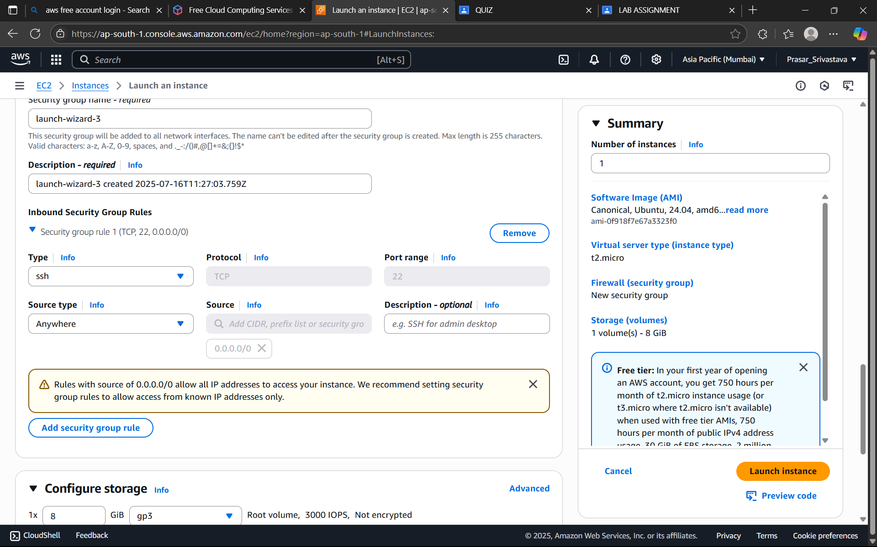

STEP5: CLICK ON THE EC2 INSTANCE CREATED>CLICK ON CONNECT

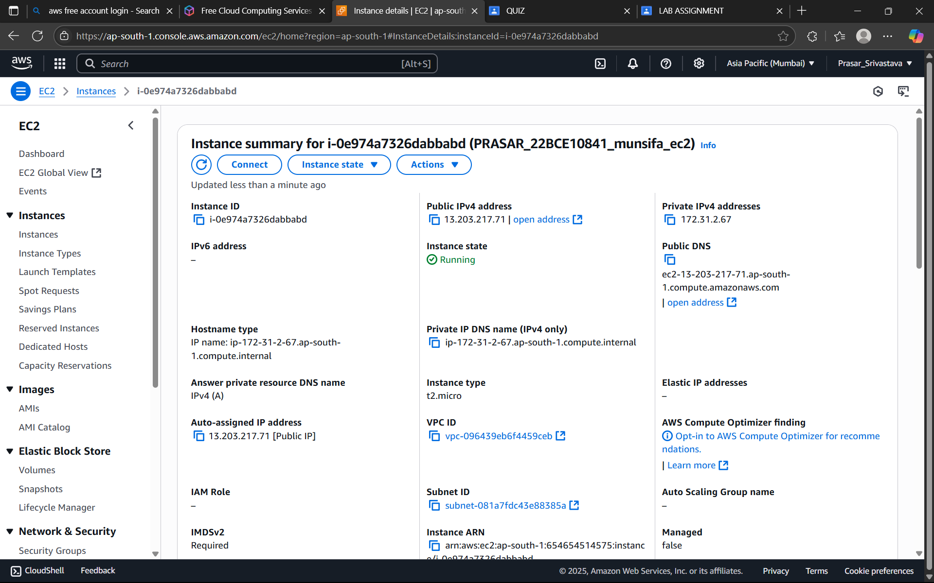

STEP6: CLICK ON EC2 INSTANCE CONNECT

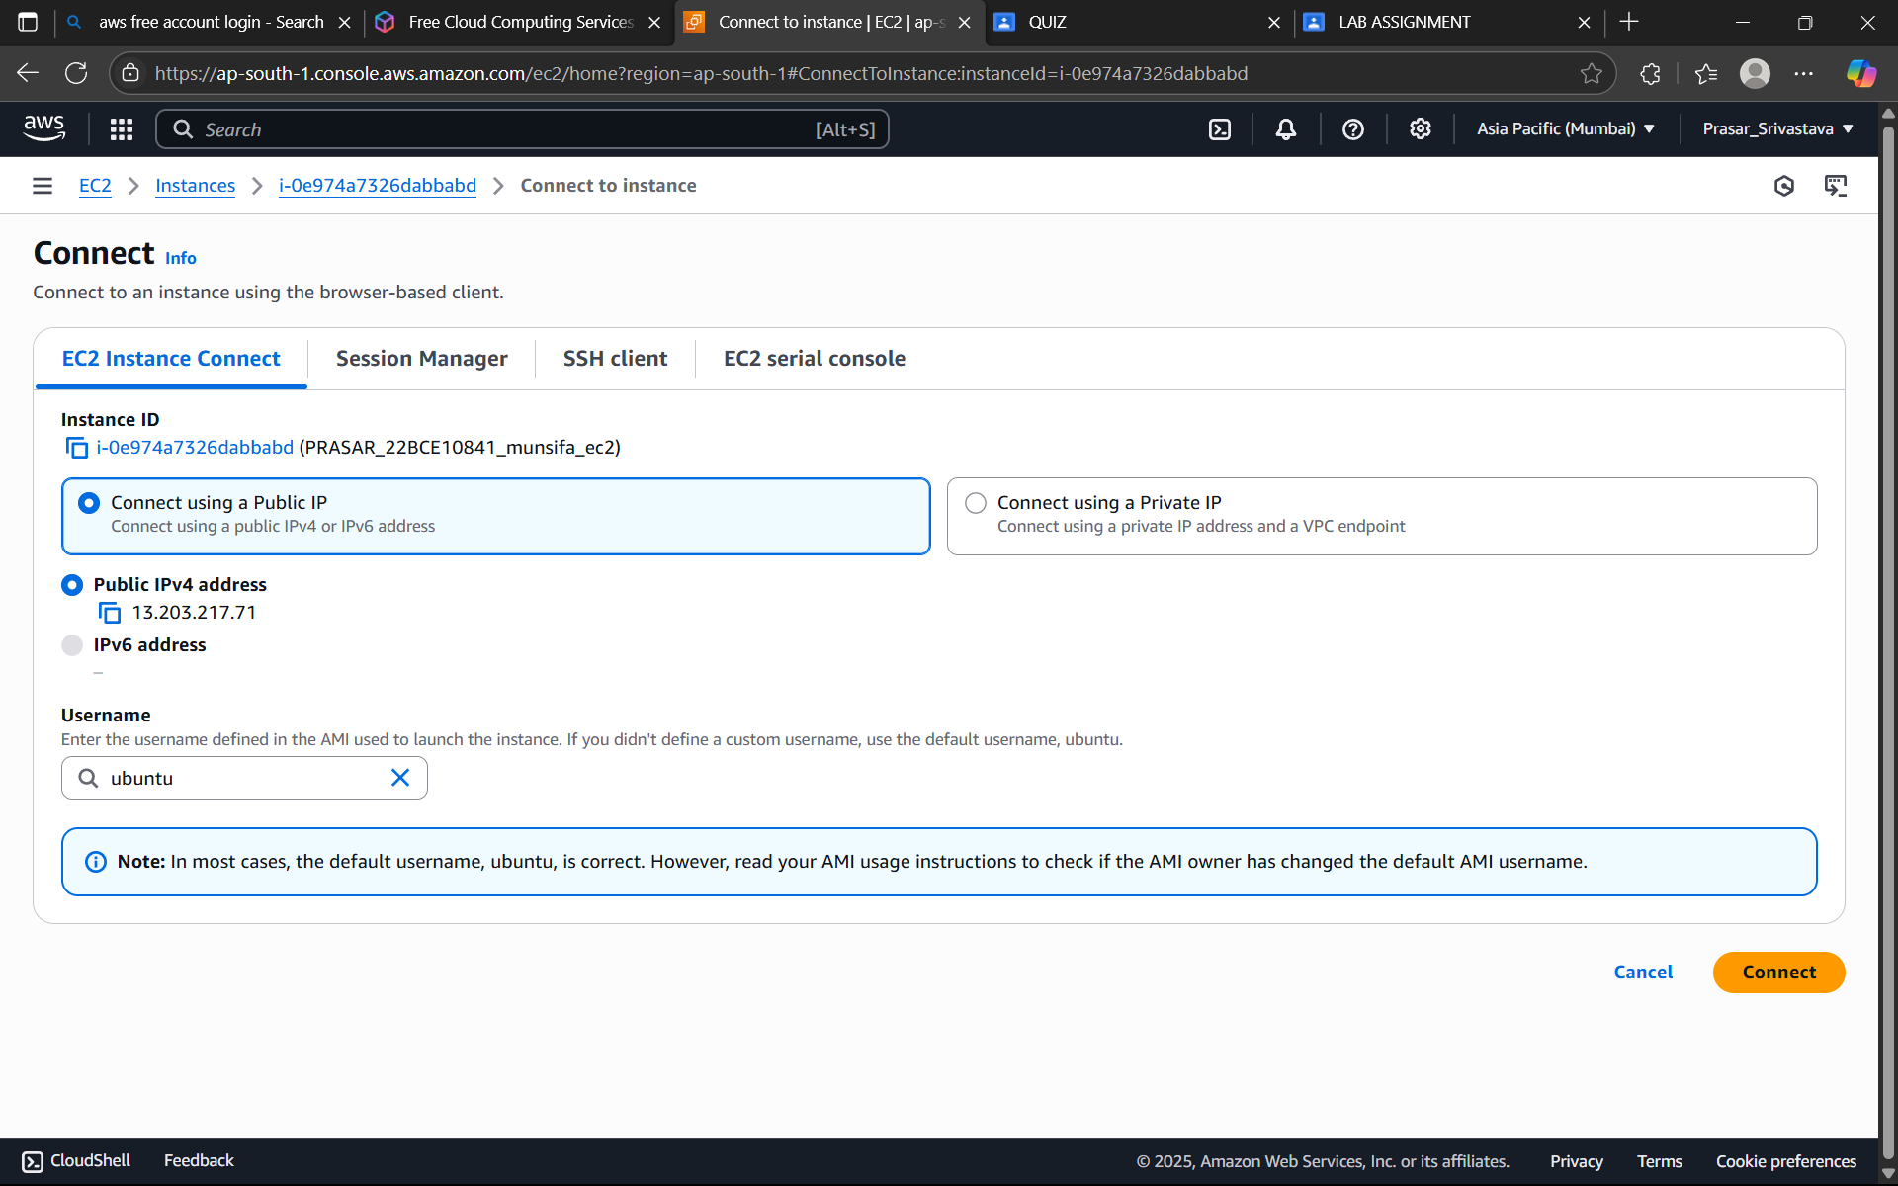

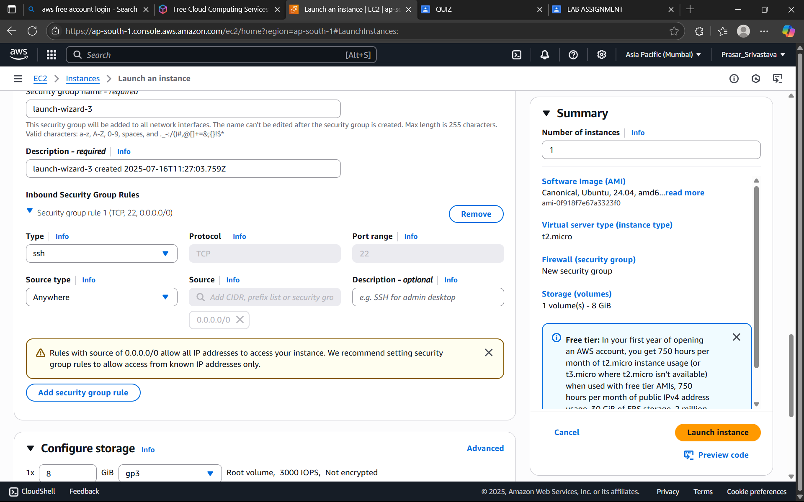

STEP7: EC2 INSTANCE IS CONNECTED

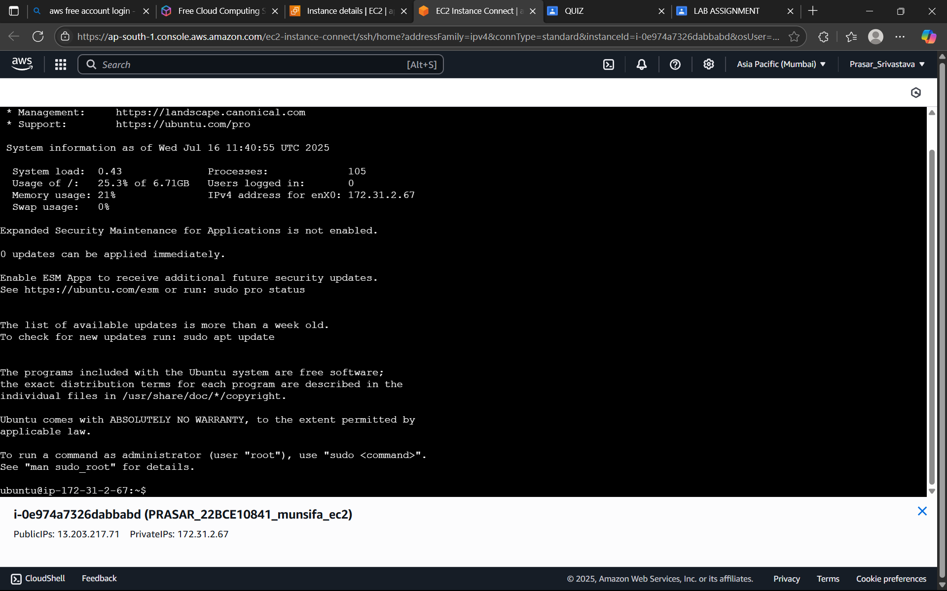

STEP 8: TYPE “lsblk” COMMAND IN THE TERMINAL. IT WILL SHOW YOU HOW MANY VOLUMES ARE ATTACHED TO THE EC2 INSTANCE. IT SHOWS THE DEFAULT 8G VOLUME WHICH WE SET WHILE CREATING EC2 INSTANCE.

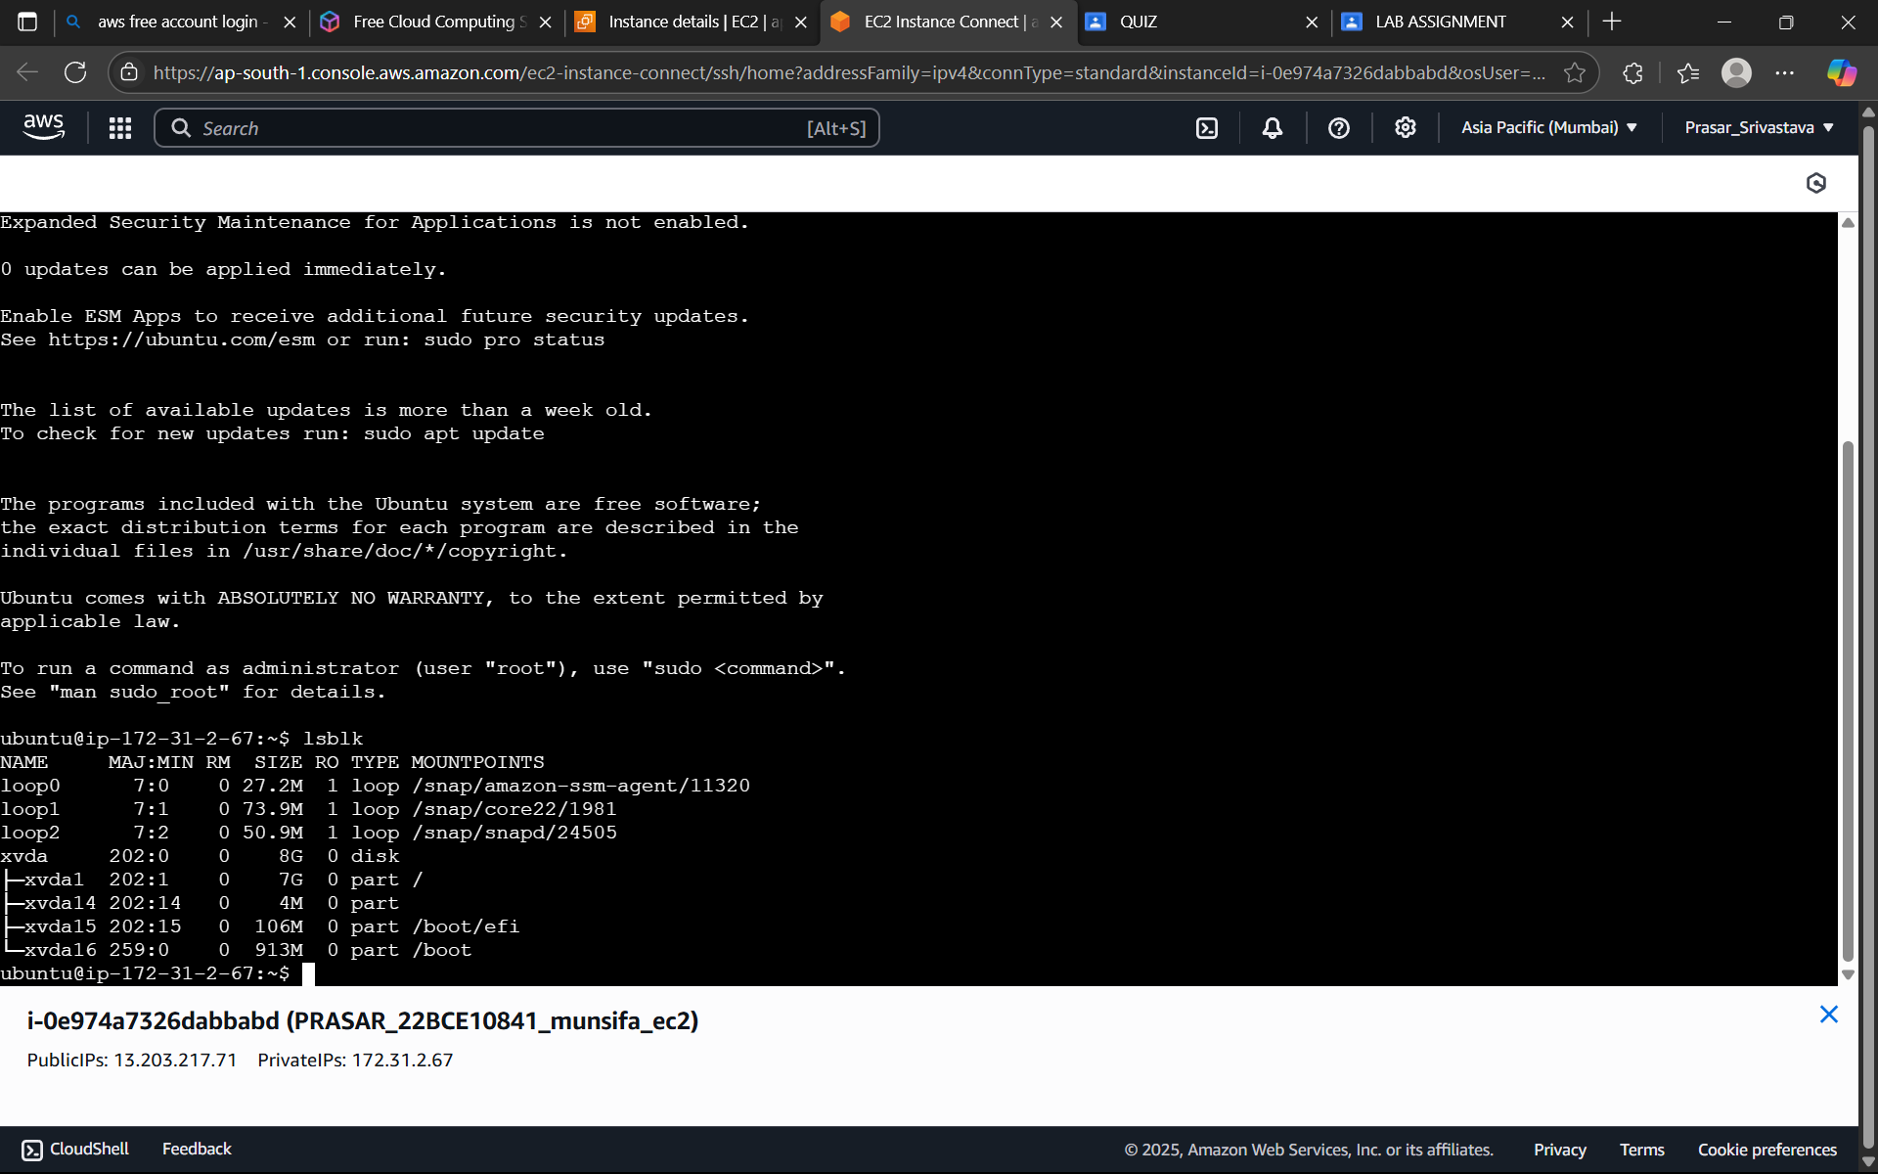

STEP 9: NOW CREATE EBS VOLUME FROM EC2 DASHBOARD: ELASTIC BLOCK

STORE>VOLUMES>CREATE VOLUME

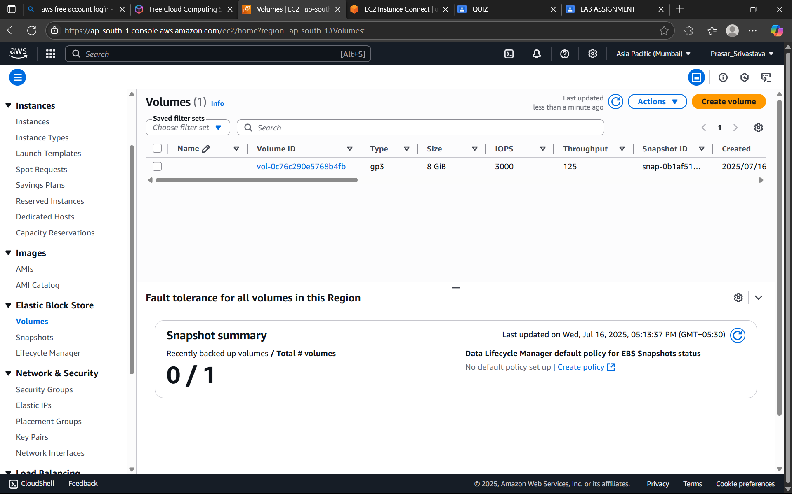

**CREATION OF EBS VOLUME**

STEP 9: YOU CAN CHOOSE ANY OF THE VOLUME TYPES FROM THE DROP-DOWN >SELECT gp3

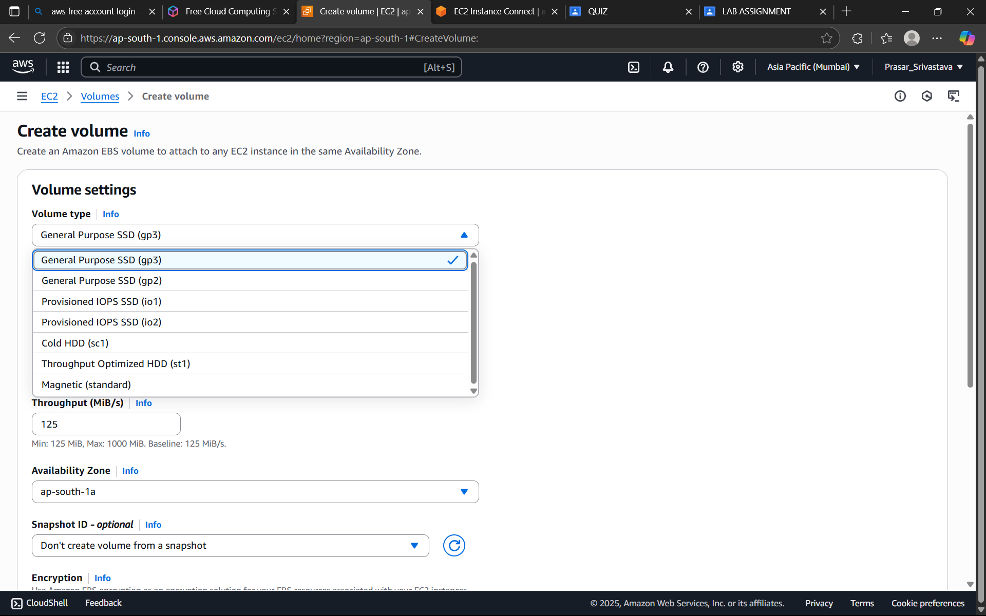

STEP 10: KEEP THE DATA AS SHOWN

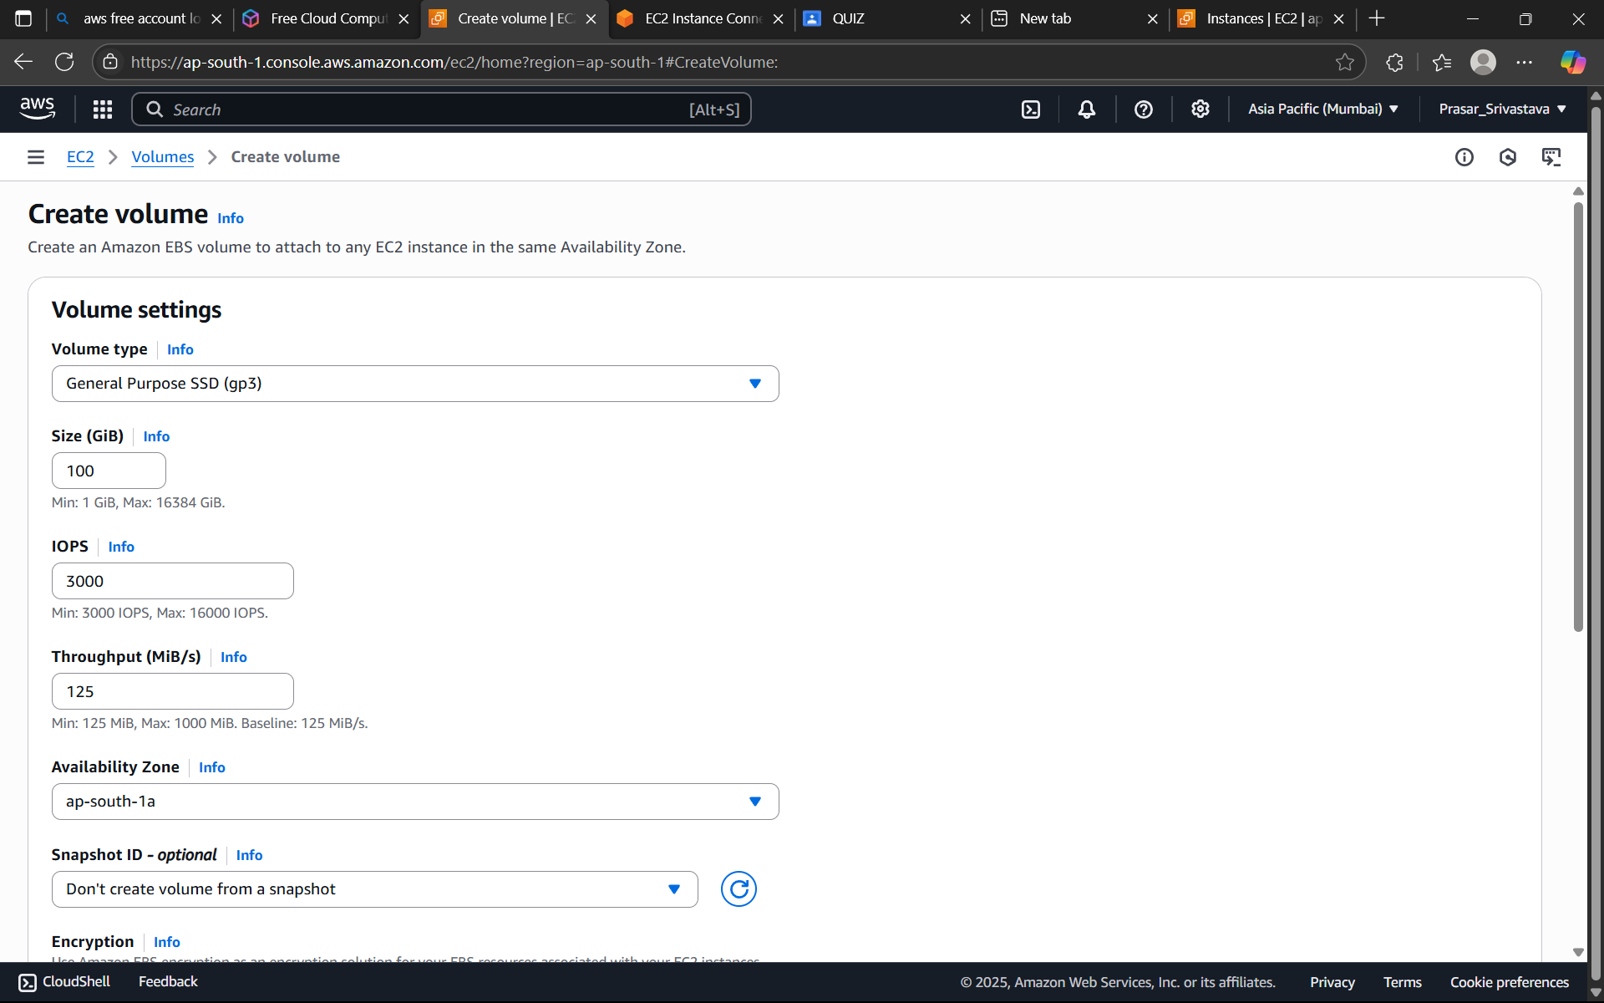

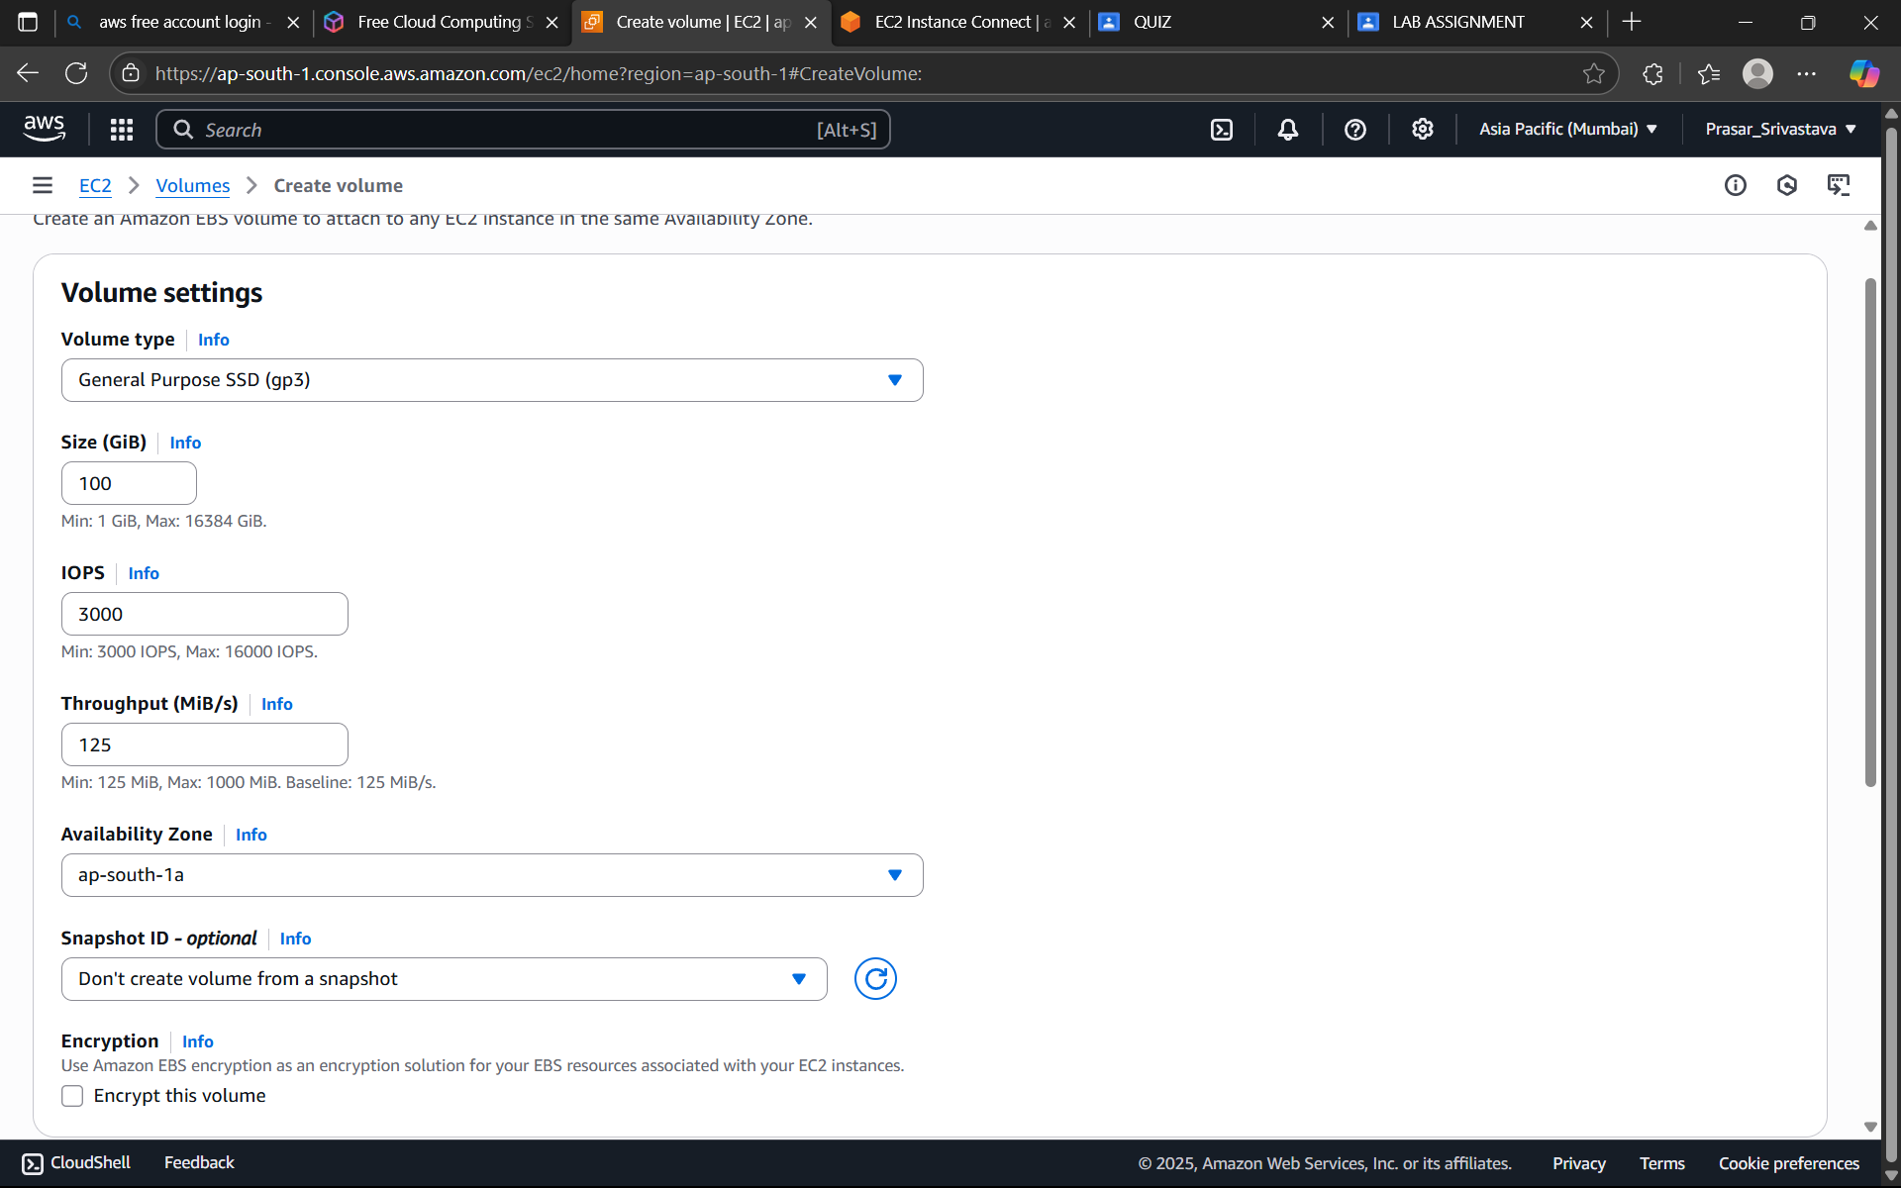

STEP 11: CLICK ON CREATE VOLUME.

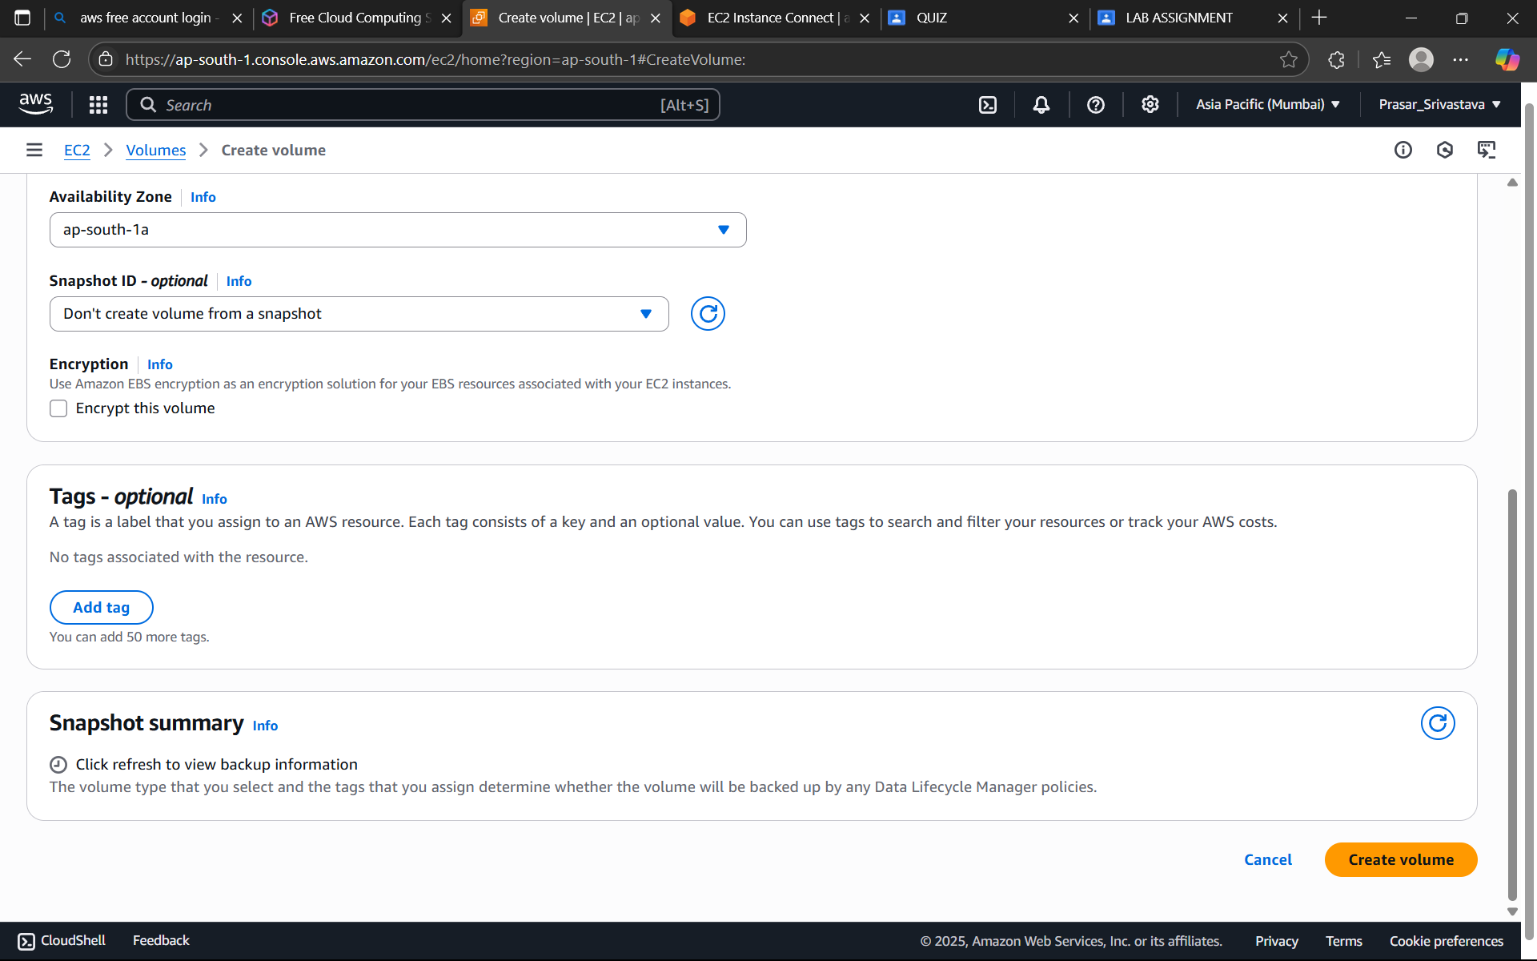

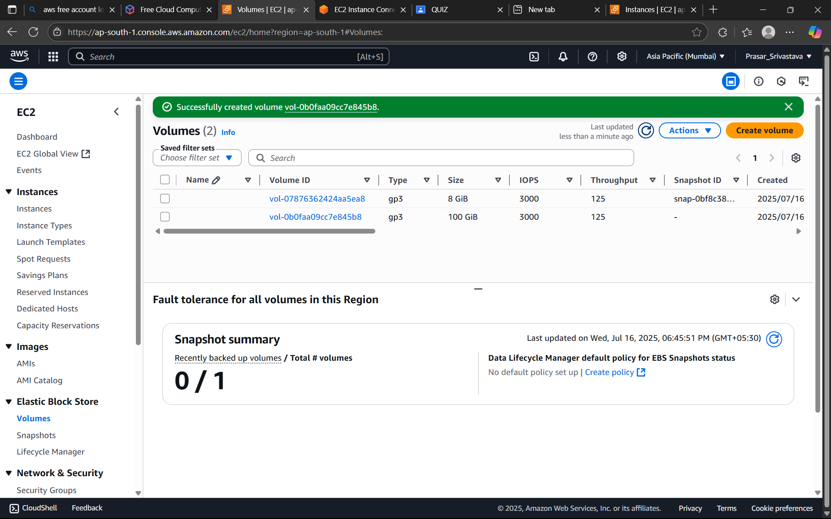

STEP 12: EDIT THE VOLUME NAME BY CLICKING ON IT>CLICK ON THE VOLUME THAT YOU HAVE

CREATED

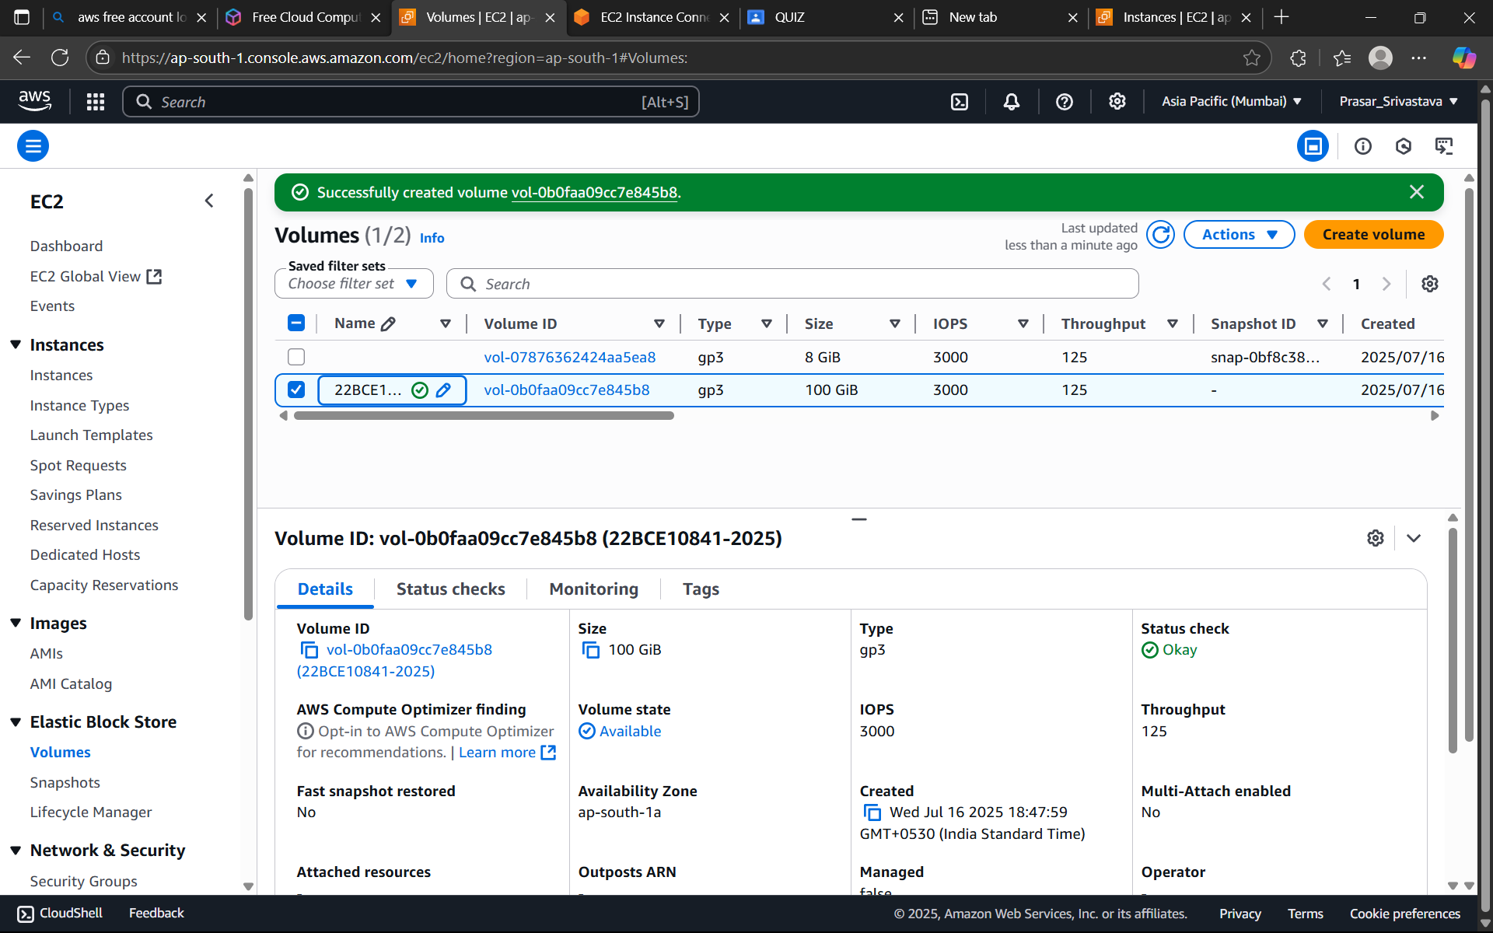

STEP 13: CLICK ON ACTIONS>ATTACH VOLUME

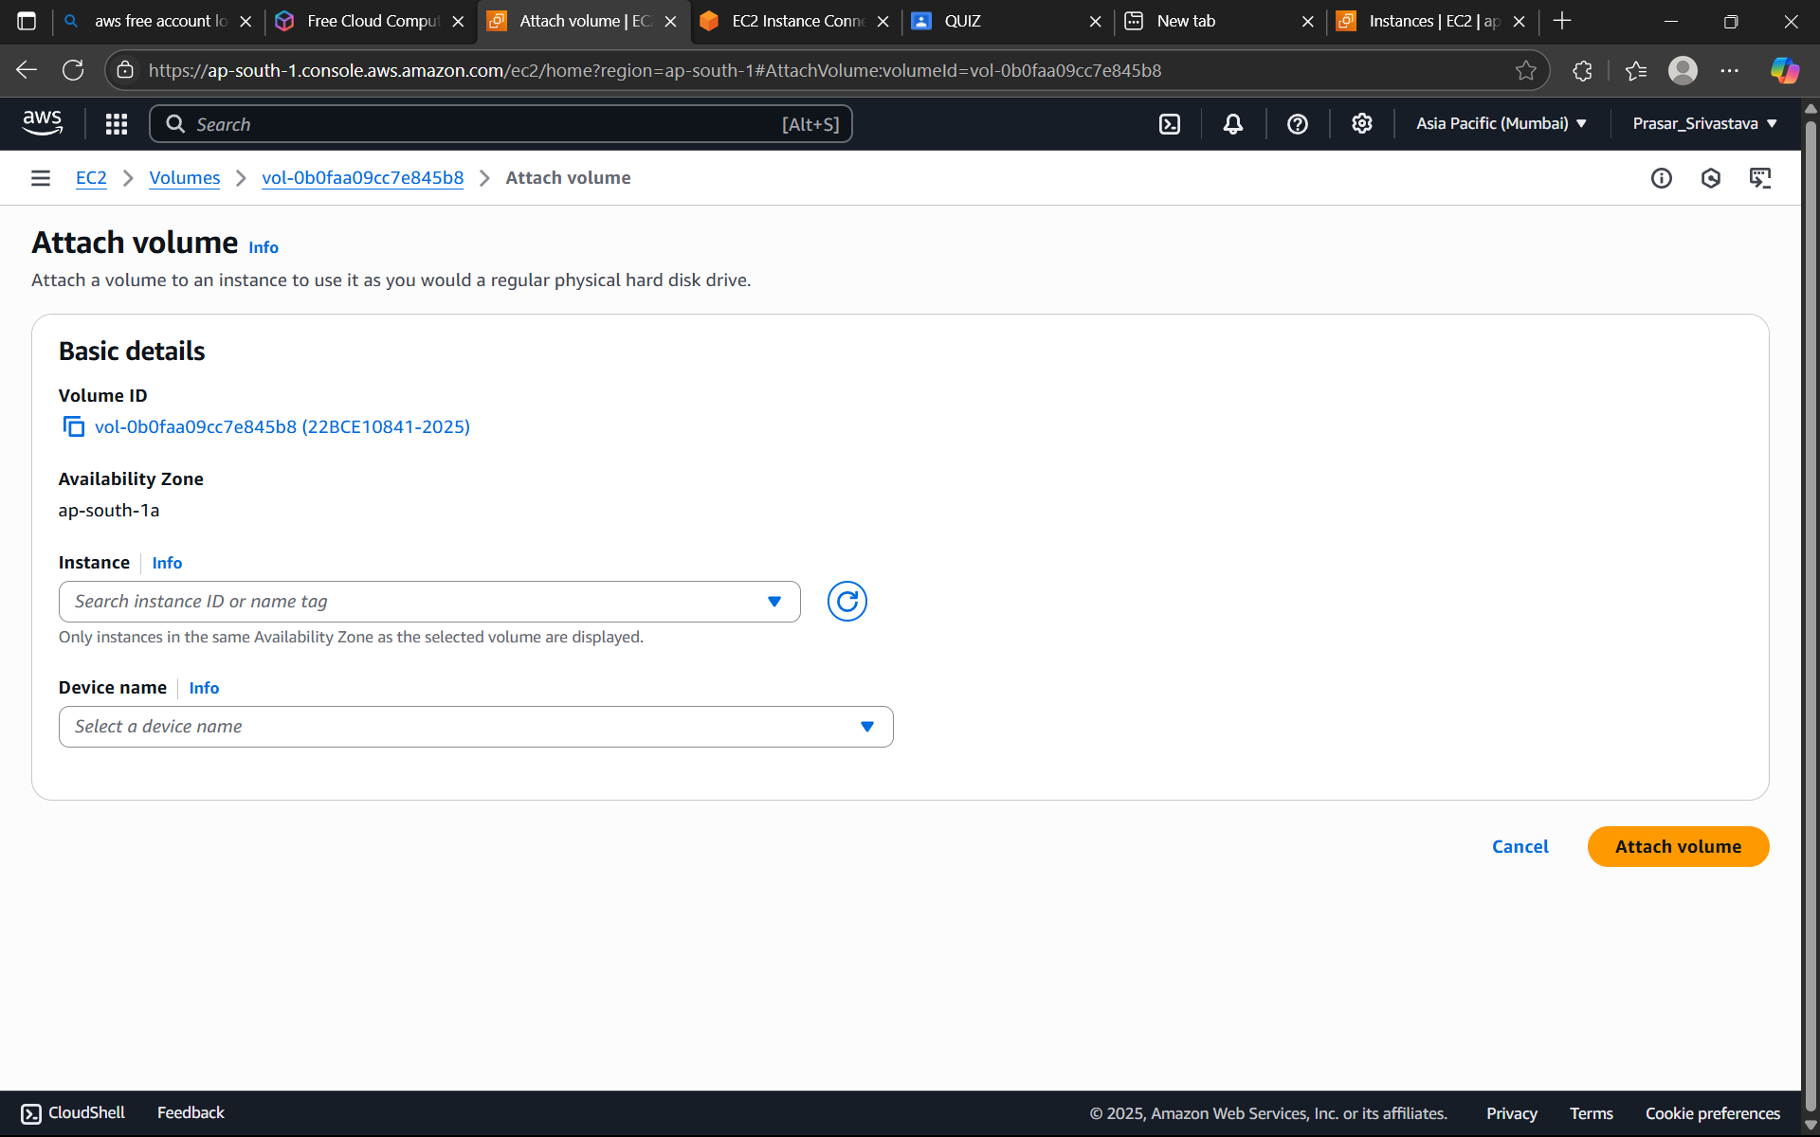

STEP 14: SELECT INSTANCE THAT YOU HAVE CREATED>CHOOSE THE DEVICE:/dev/sdk>CLICK ON

ATTACH VOLUME

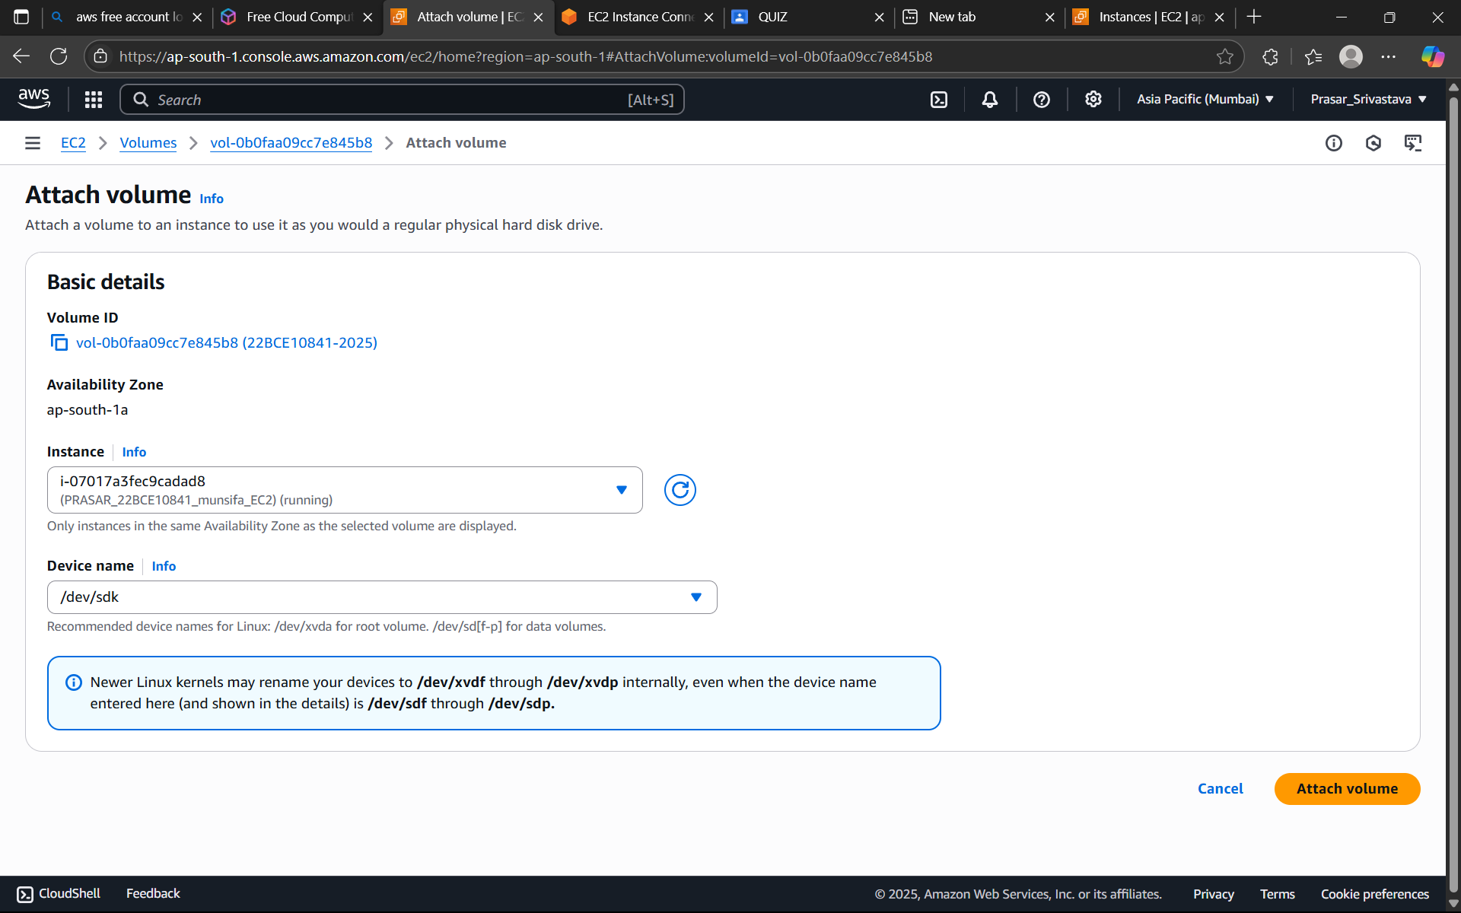

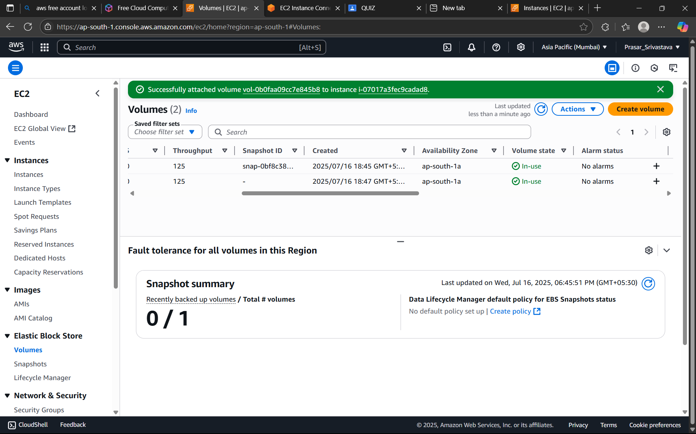

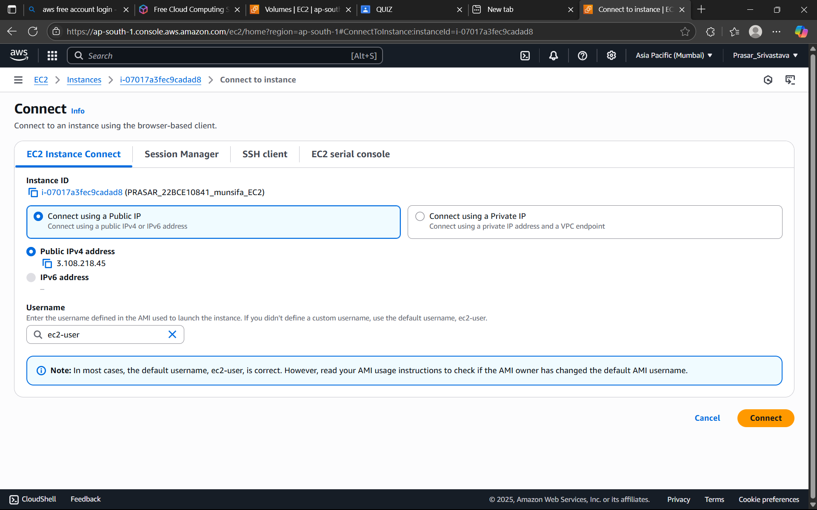

STEP 15: NOW GO TO EC2 TERMINAL AND TYPE:lsblk>IT WILL LIST ALL THE VOLUME(100G IS

SHOWN BELOW)

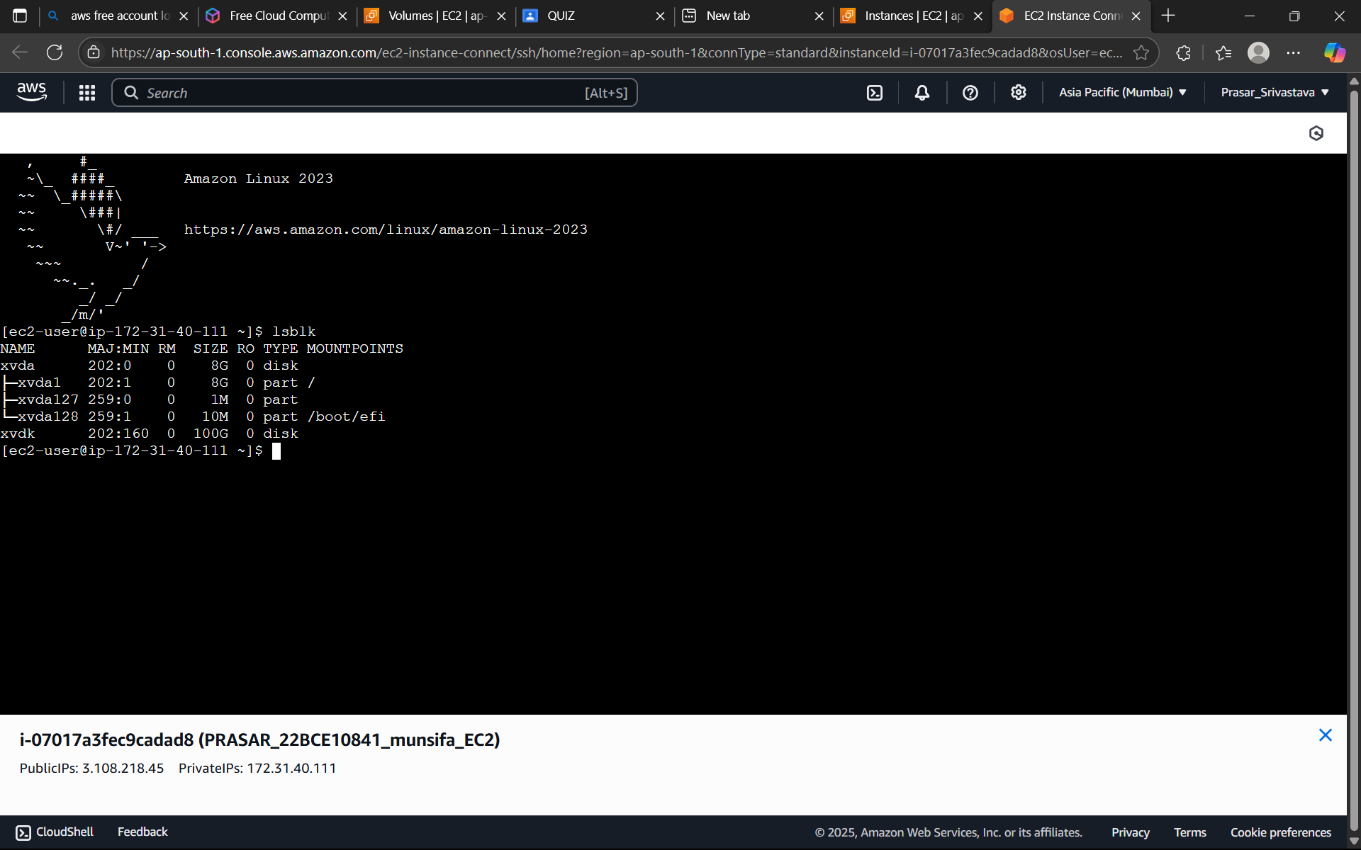

STEP 16: TYPE sudo fdisk -l (IT WILL LIST OUT ALL THE DISK PARTITION)

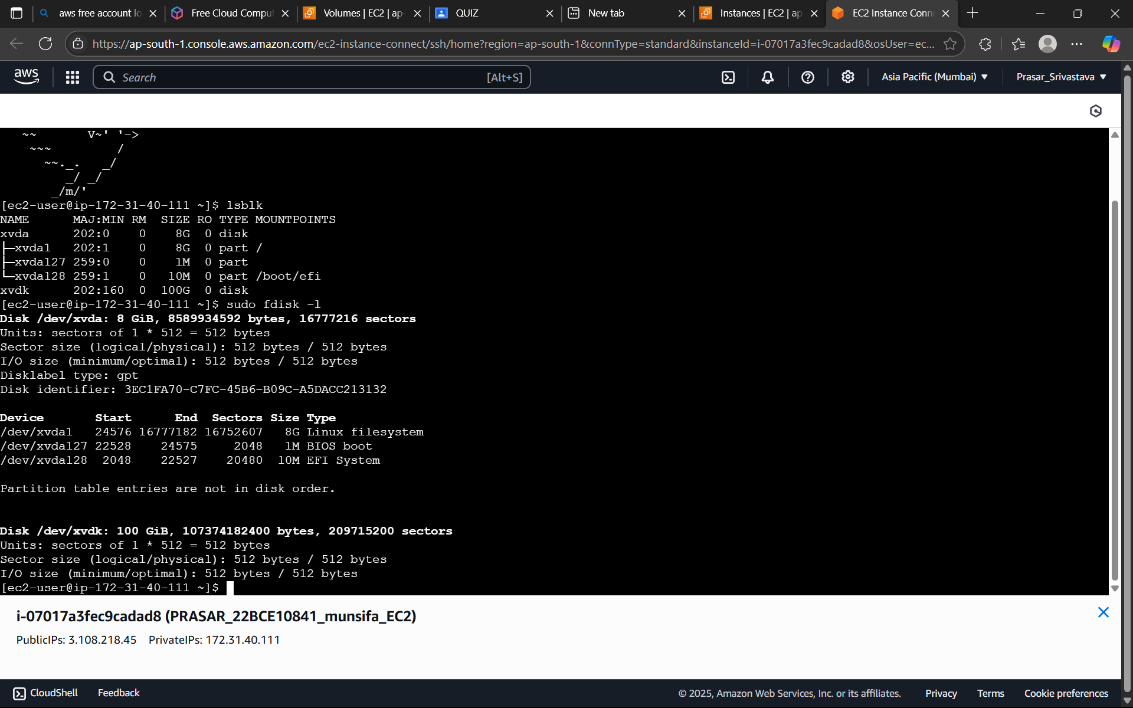

STEP 17: TYPE sudo file -s /dev/xvdk (IT WILL SHOW “DATA” WHICH MEANS THERE IS NO FILE

SYSTEM CREATED FOR THIS EBS VOLUME)

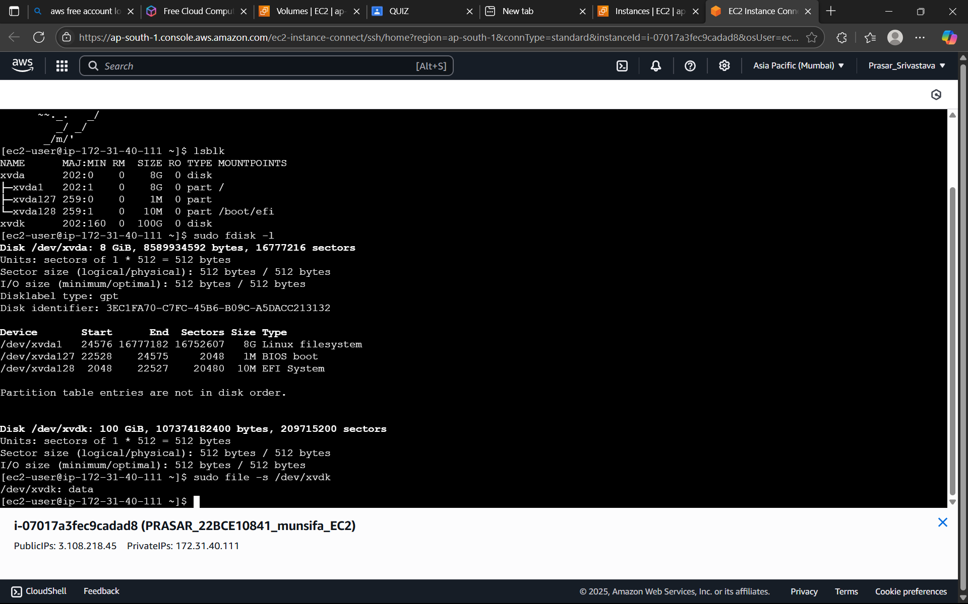

STEP 18: WE NEED TO CREATE FILE SYSTEM FOR EBS VOLUME: TYPE sudo mkfs -t xfs /dev/xvdk

(FILE SYSTEM CREATED)

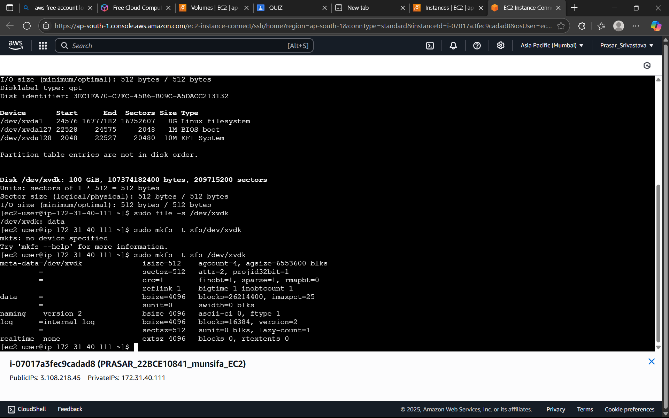

STEP 19: NOW AGAIN TYPE sudo file -s /dev/xvdk TO CHECK THE FILE SYSTEM (ITS SHIWS EBS

VOLUME HAS xfs FILESYSTEM)

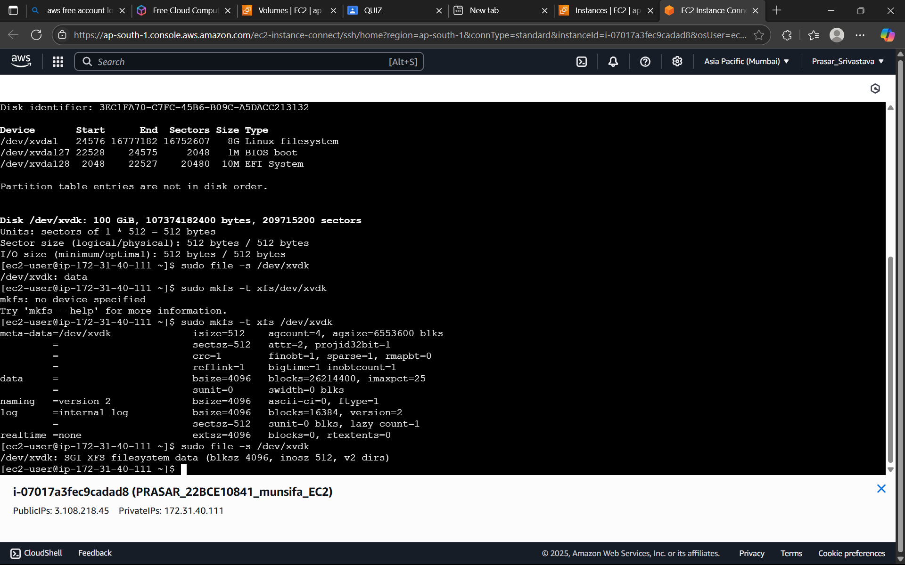

STEP 20: CREATE A DIRECTORY:

a. TYPE sudo mkdir /munsifaebsvol

b. NEXT TYPE sudo mount /dev/xvdk / munsifaebsvol

c. TYPE ls -lart /munsifaebsvol

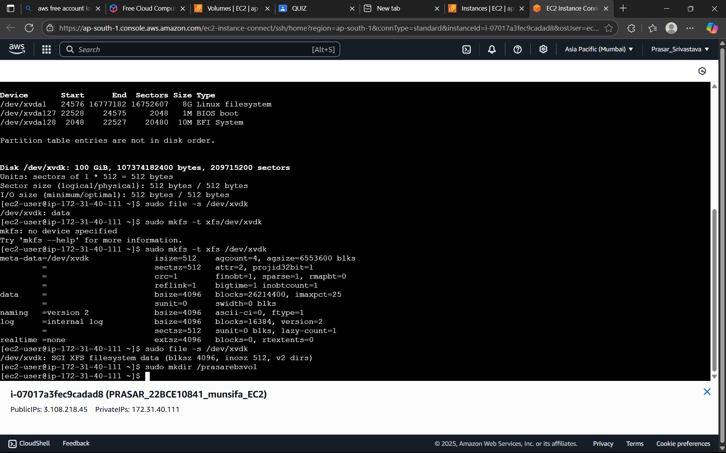

STEP 19: NOW AGAIN TYPE sudo file -s /dev/xvdk TO CHECK THE FILE SYSTEM (ITS SHIWS EBS

VOLUME HAS xfs FILESYSTEM)

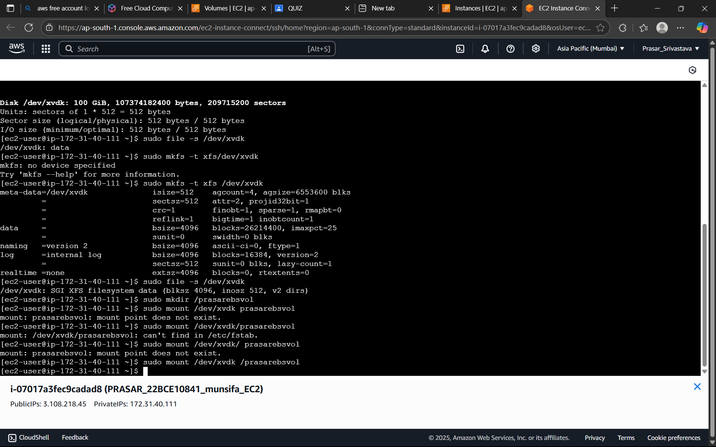

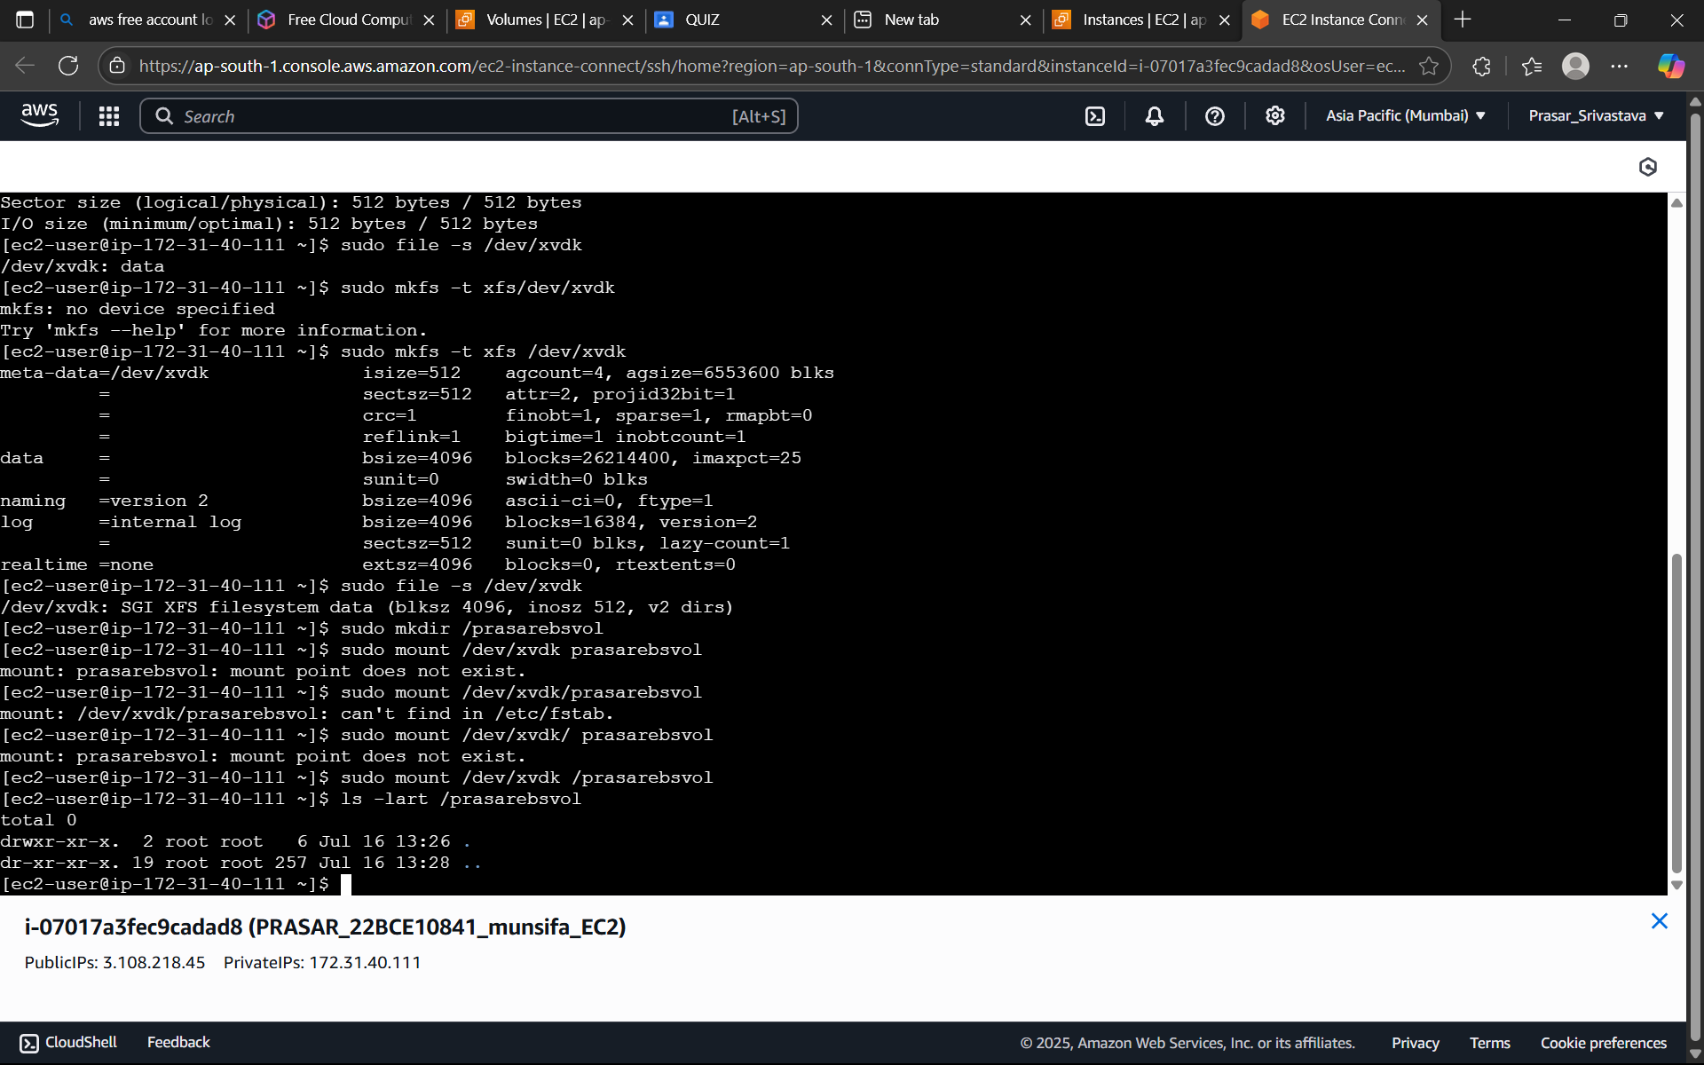

STEP 21: NOW TYPE df -h (IT WILL SHOW THAT EBS VOLUME HAS BEEN MOUNTED TO DIRECTORY “prasarebsvol”)

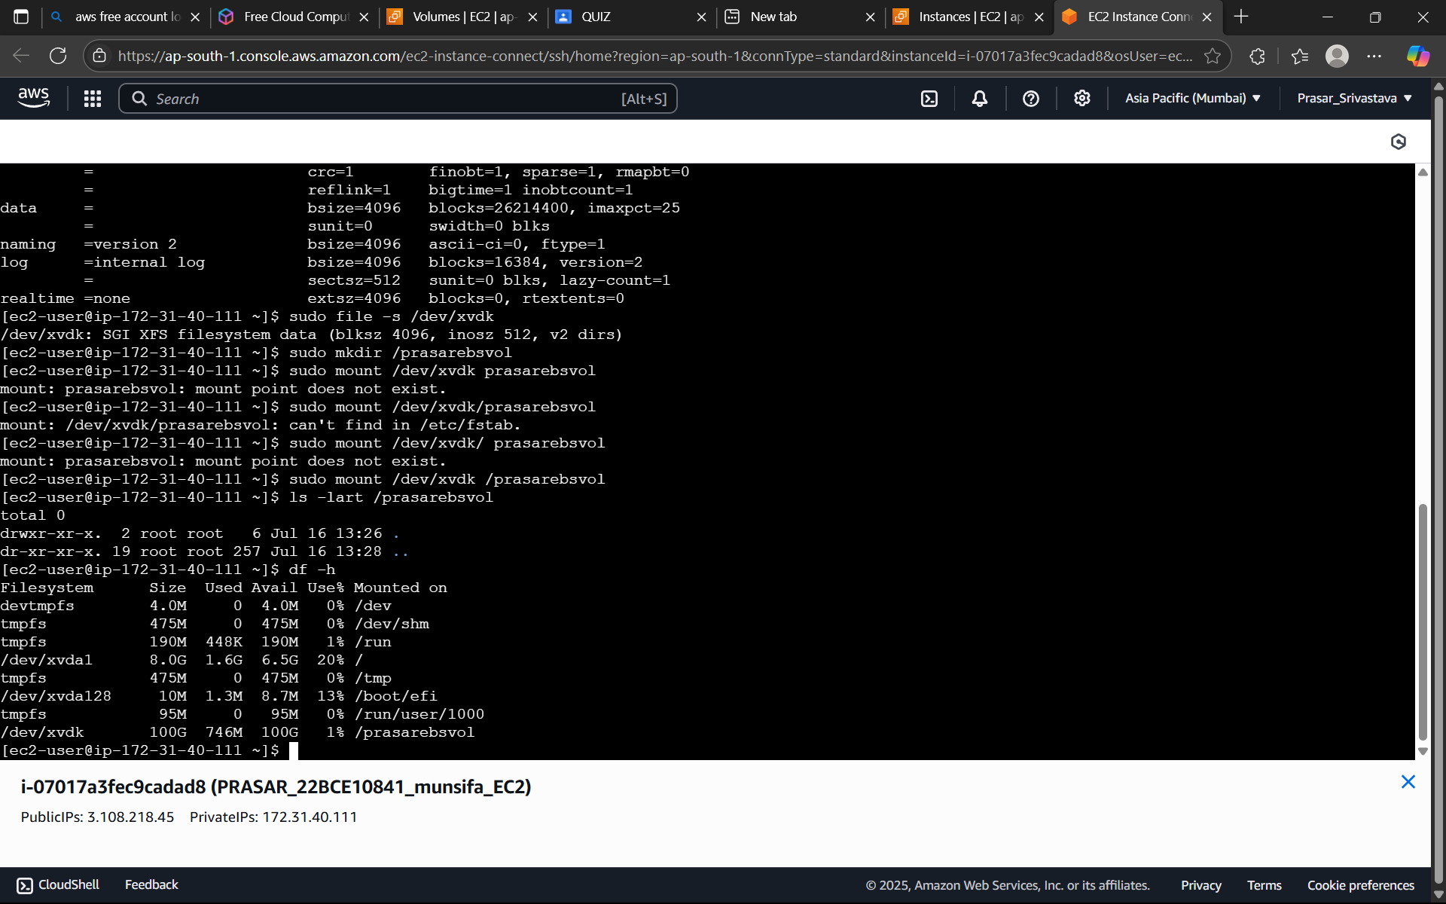

***MODIFY VOLUME SIZE***

STEP 22: NOW NEXT GO TO EBS VOLUME TO INCREASE THE VOLUME(NOTE THAT EBS VOLUME CAN BE INCREASED BUT YOU CANNOT REDUCE THE VOLUME SIZE ONCE AN EBS VOLUME IS CREATED BECAUSE THERE IS A PROBABILITY OF DATA LOSS)

a. CLICK ON EBS VOLUME>SELECT THE VOLUME THAT YOU HAVE CREATED>CLICK ON MODIFY

b. INCREASE THE VOLUME SIZE FROM 100 TO 105>CLICK MODIFY

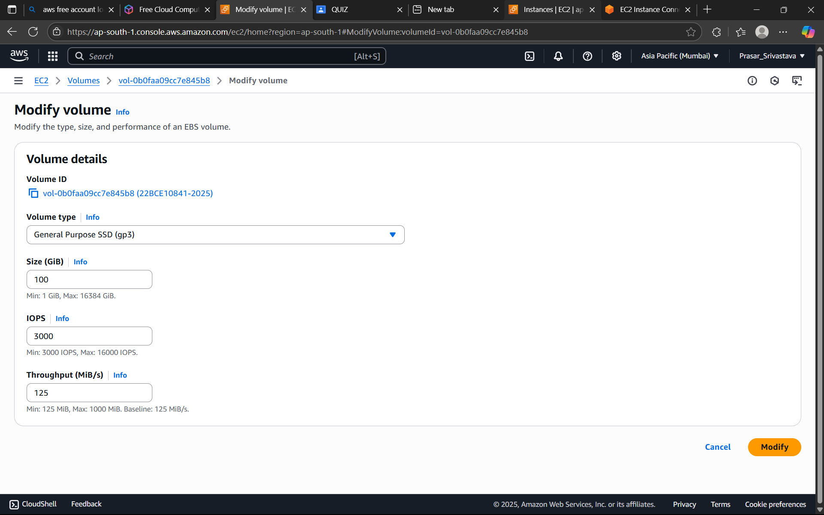

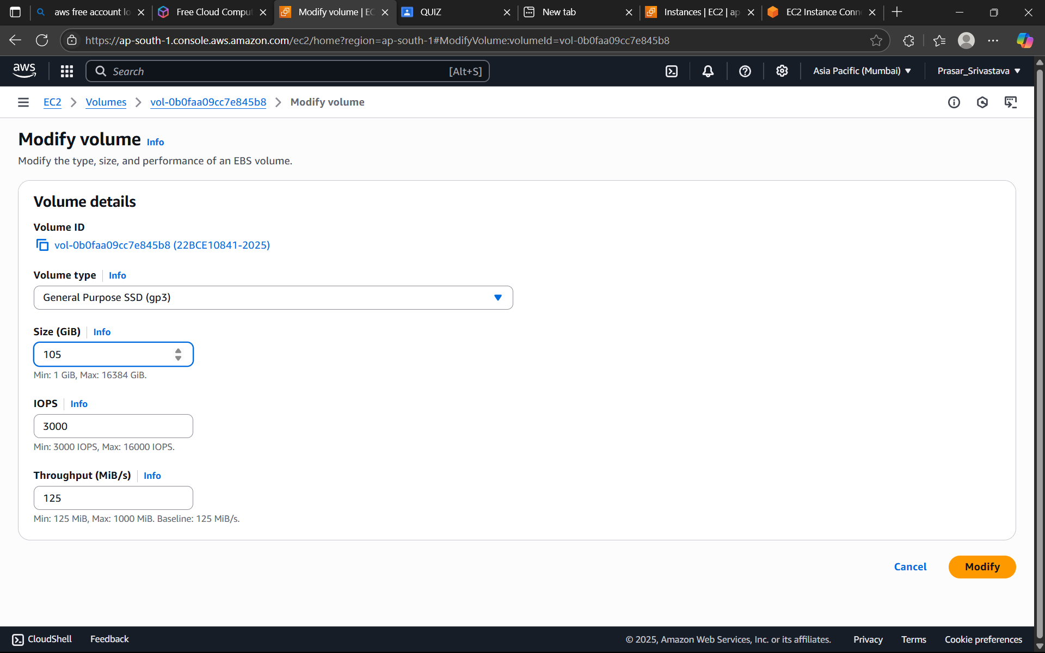

STEP 23: NOW GO TO THE EC2 TERMINAL AND VERIFY WHETHER THE DISK SIZE HAS CHANGED OR NOT. (TYPE sudo fdisk -l)

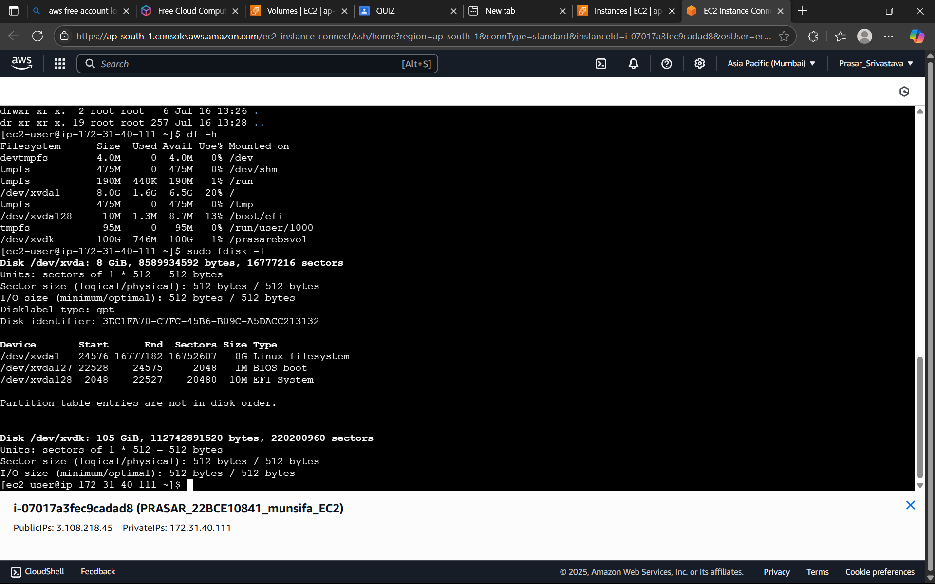

STEP 24: NOW IN THE EC2 TERMINAL GO TO EBS VOLUME DIRECTORY AND CREATE FILES.

a. TYPE cd /munsifaebsvol (GO TO EBS VOLUME DIRECTORY)

b. TYPE sudo touch 1.txt (CREATE FILE1)

c. TYPE sudo touch 2.txt (CREATE FILE2)

d. TYPE ls -lart (TO VERIFY WHETHER FILES ARE THERE OR NOT)

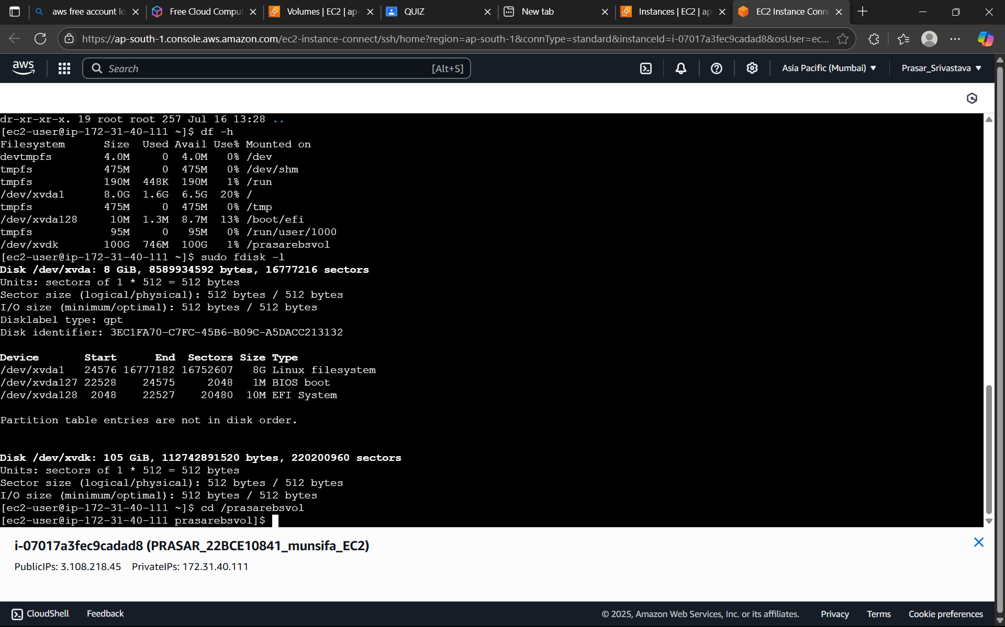

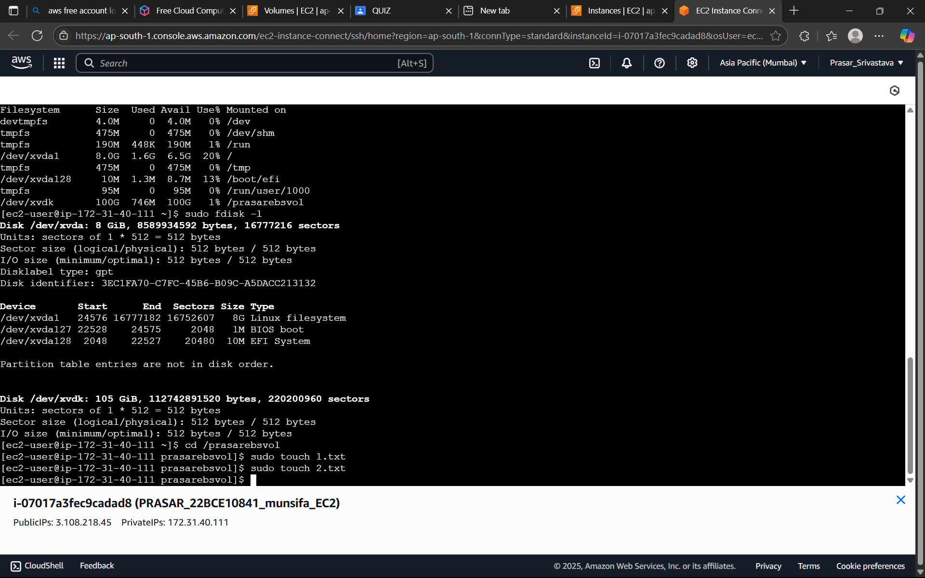

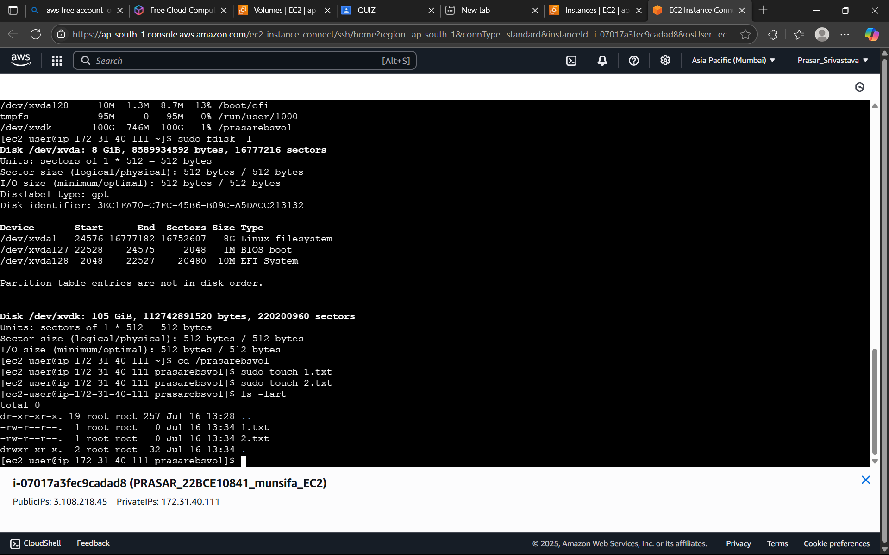

STEP 24: CREATE SECOND EC2 INSTANCE (CREATE IN A SIMILAR MANNER LIKE YOU HAVE

CREATED FOR EC1 )>CONNECT EC2 INSTANCE. THEN CHECK THE DISK SIZE OF EC2 INSTANCE

(TYPE sudo fdisk -l) IT SHOWS THE DEFAULT 8G

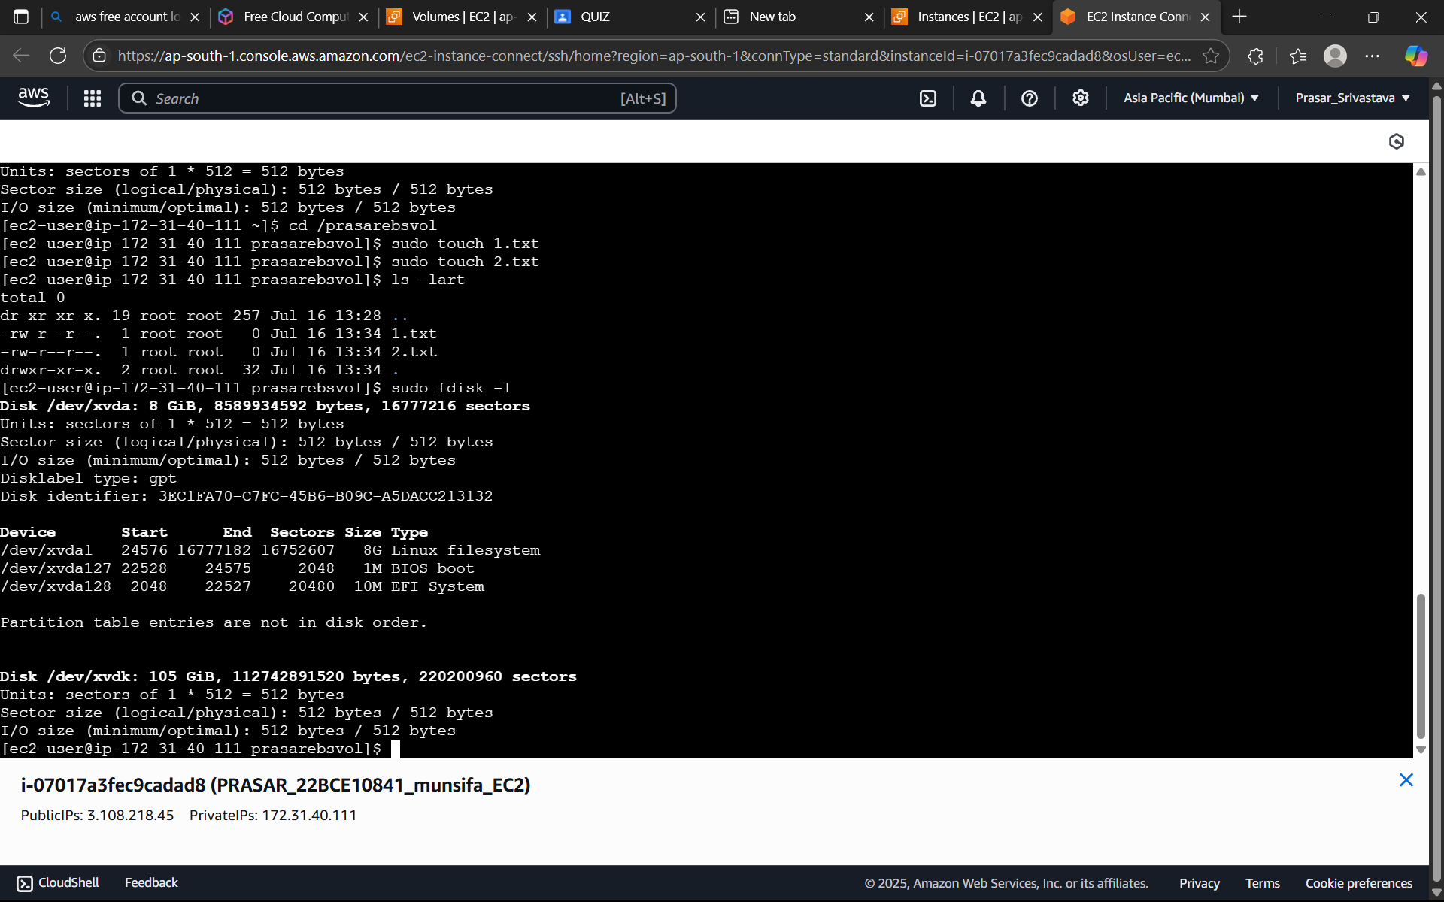

STEP 25: NOW TO CREATE A SNAPSHOT GO TO EC2 DASHBOARD:

a. EBS VOLUME>CLICK ON THE VOLUME THAT YOU HAVE CREATED>CLICK ON ACTIONS>CLICK

ON CREATE SNAPSHOT

b. TYPE THE DESCRIPTION>CLICK ON CREATE A SNAPSHOT

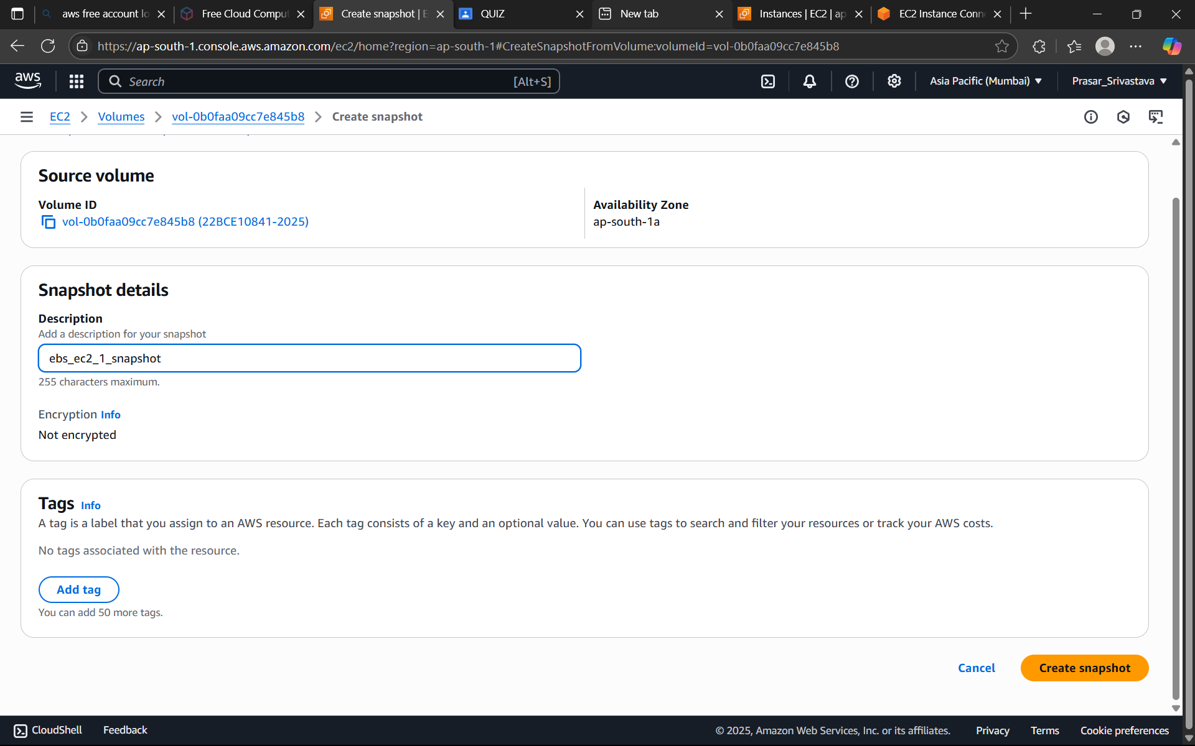

STEP 26: NOW GO TO SNAPSHOT>CLICK ON THE SNAPSHOT THAT YOU HAVE CREATED>CLICK ON ACTIONS>CREATE VOLUME FROM SNAPSHOT

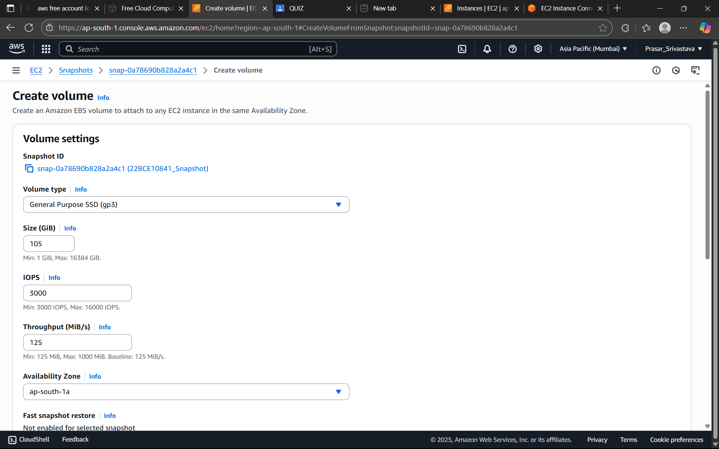

STEP 27: KEEP THE DATA SAME>CLICK ON TAG>GIVE A NAME>CLICK ON CREATE SNAPSHOT.

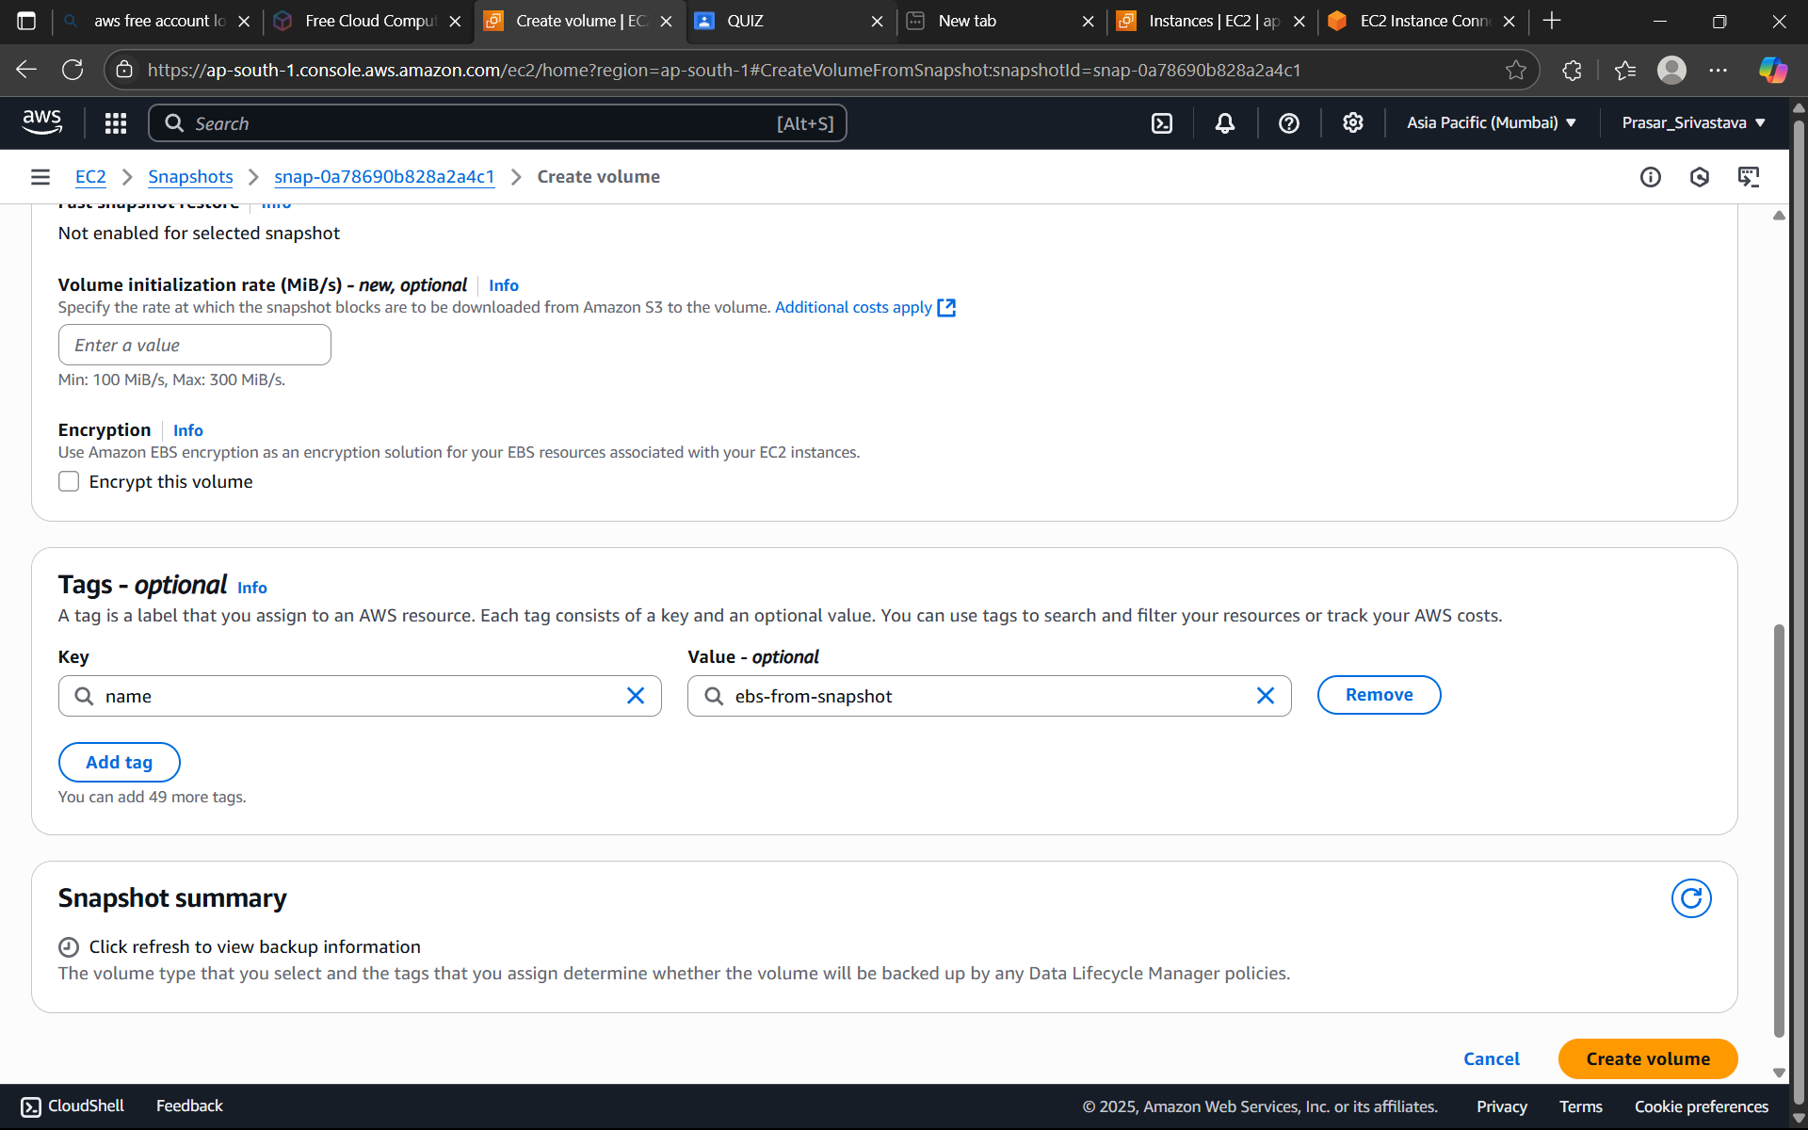

STEP 28: NOW GO TO VOLUME>MODIFY THE VOLUME NAME

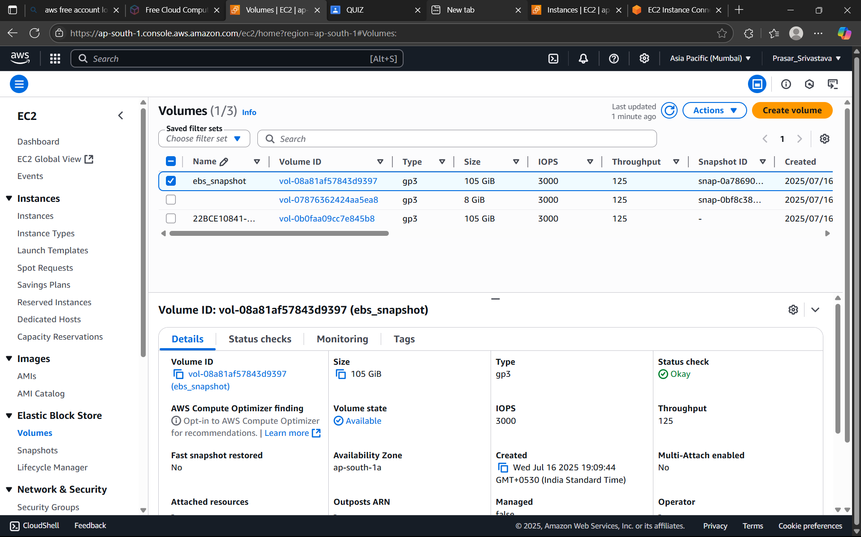

STEP 29: CLICK ON THE VOLUME>CLICK ON ACTION>CLICK ON ATTACH VOLUME

STEP 30: SELECT EC2 INSTANCE>SELECT sdk IN DEVICE>CLICK ON ATTACH VOLUME

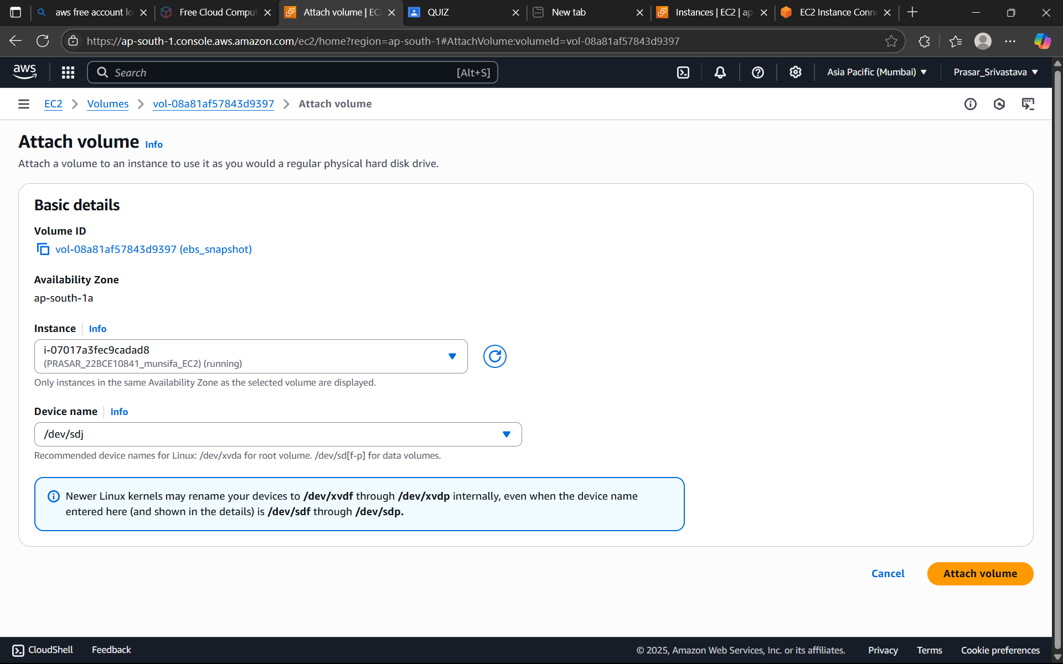

STEP 31: GO TO EC2 TERMINAL>TYPE sudo fdisk -l TO CHECK WHETHER THE NEW VOLUME IS

ADDED OR NOT. 105G IS ADDED AS SHOWN BELOW

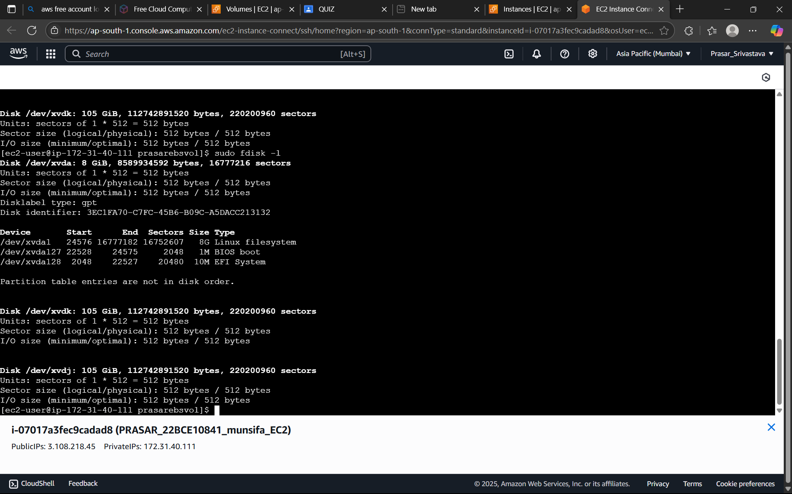

STEP 32: NOW CHECK WHETHER FILE SYSTEM IS ATTACHED OR NOT. TYPE sudo file -s /dev/xvdk

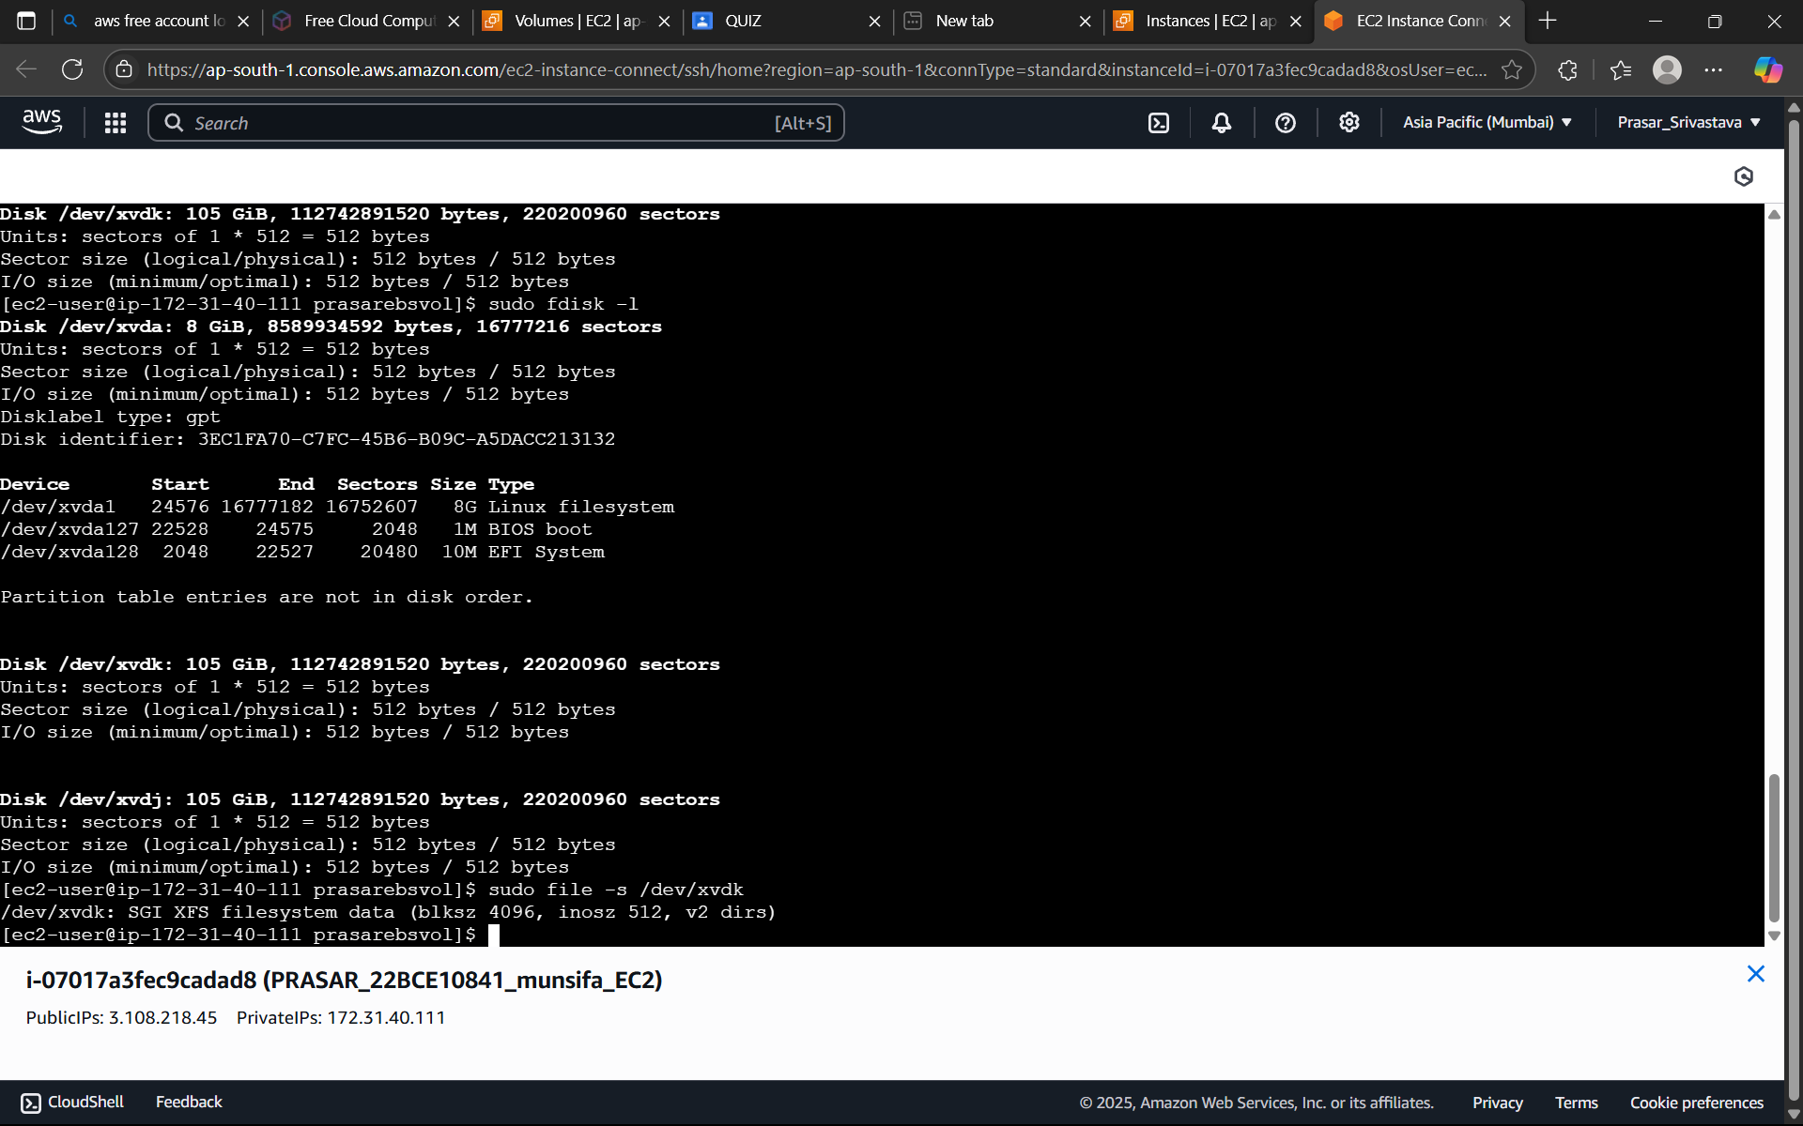

STEP 33: NOW CREATE A DIRECTORY:

a. TYPE sudo mkdir /munsifaebsvol2

b. MOUNT THE FILE, TYPE sudo mount /dev/xvdk /munsifaebsvol2

c. TYPE ls -lart /munsifaebsvol2

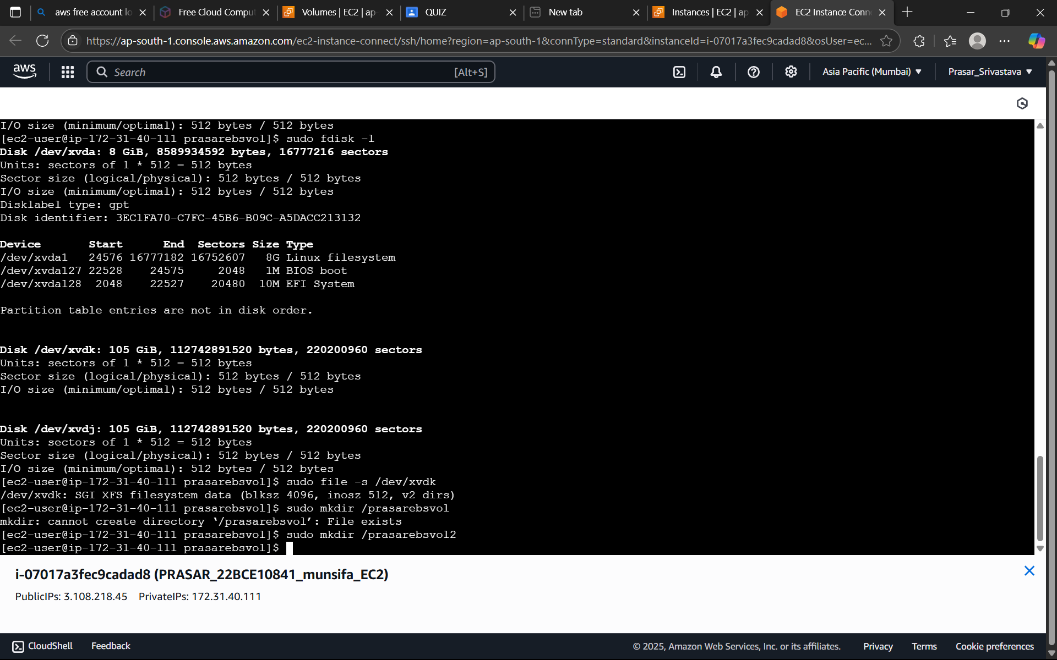

STEP 34: NOW YOU CAN CHECK IN BOTH EC2 INSTANCES, FILE1 AND FILE2 IS PRESENT

a. TYPE ls (EC2 1)

b. TYPE cd \munsifaebsvol2 > ls (EC2 2)

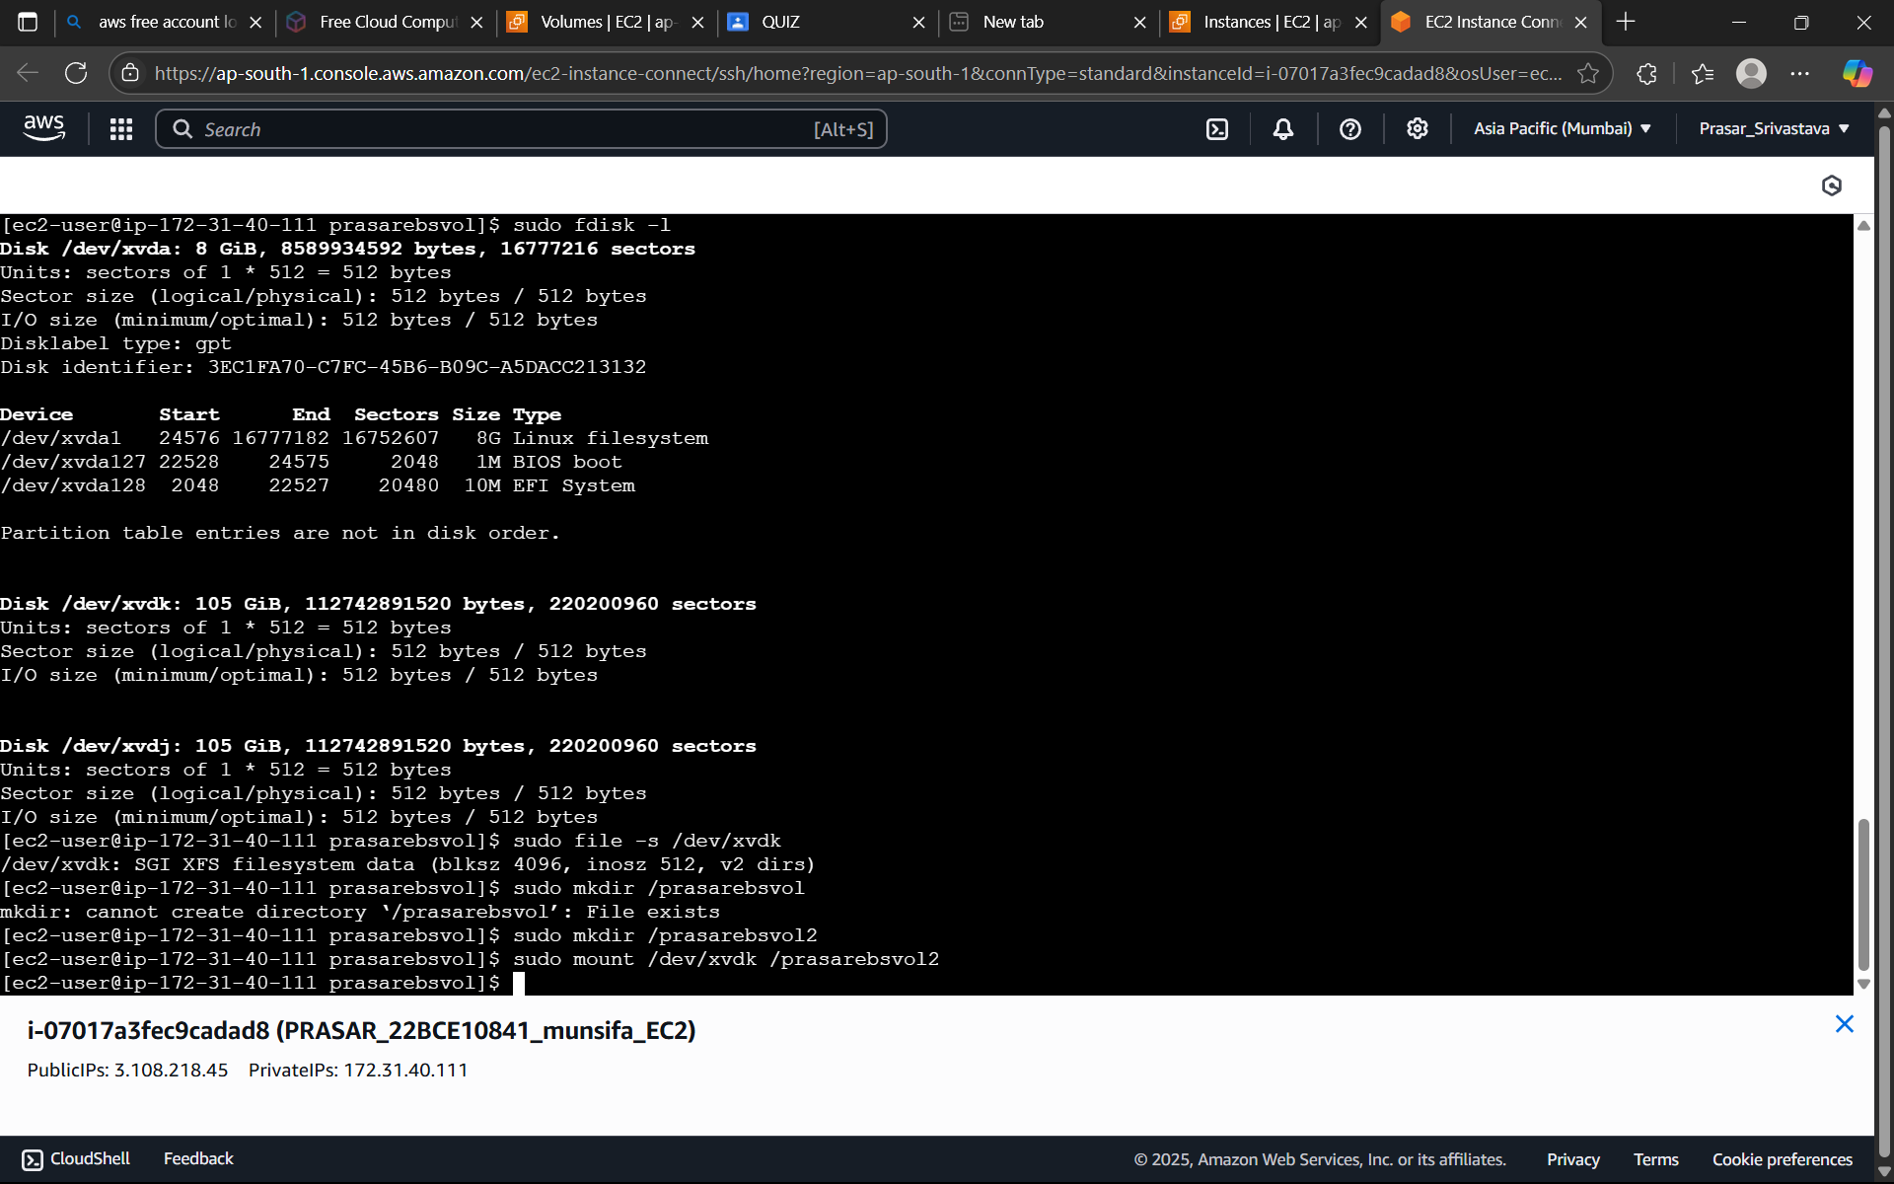

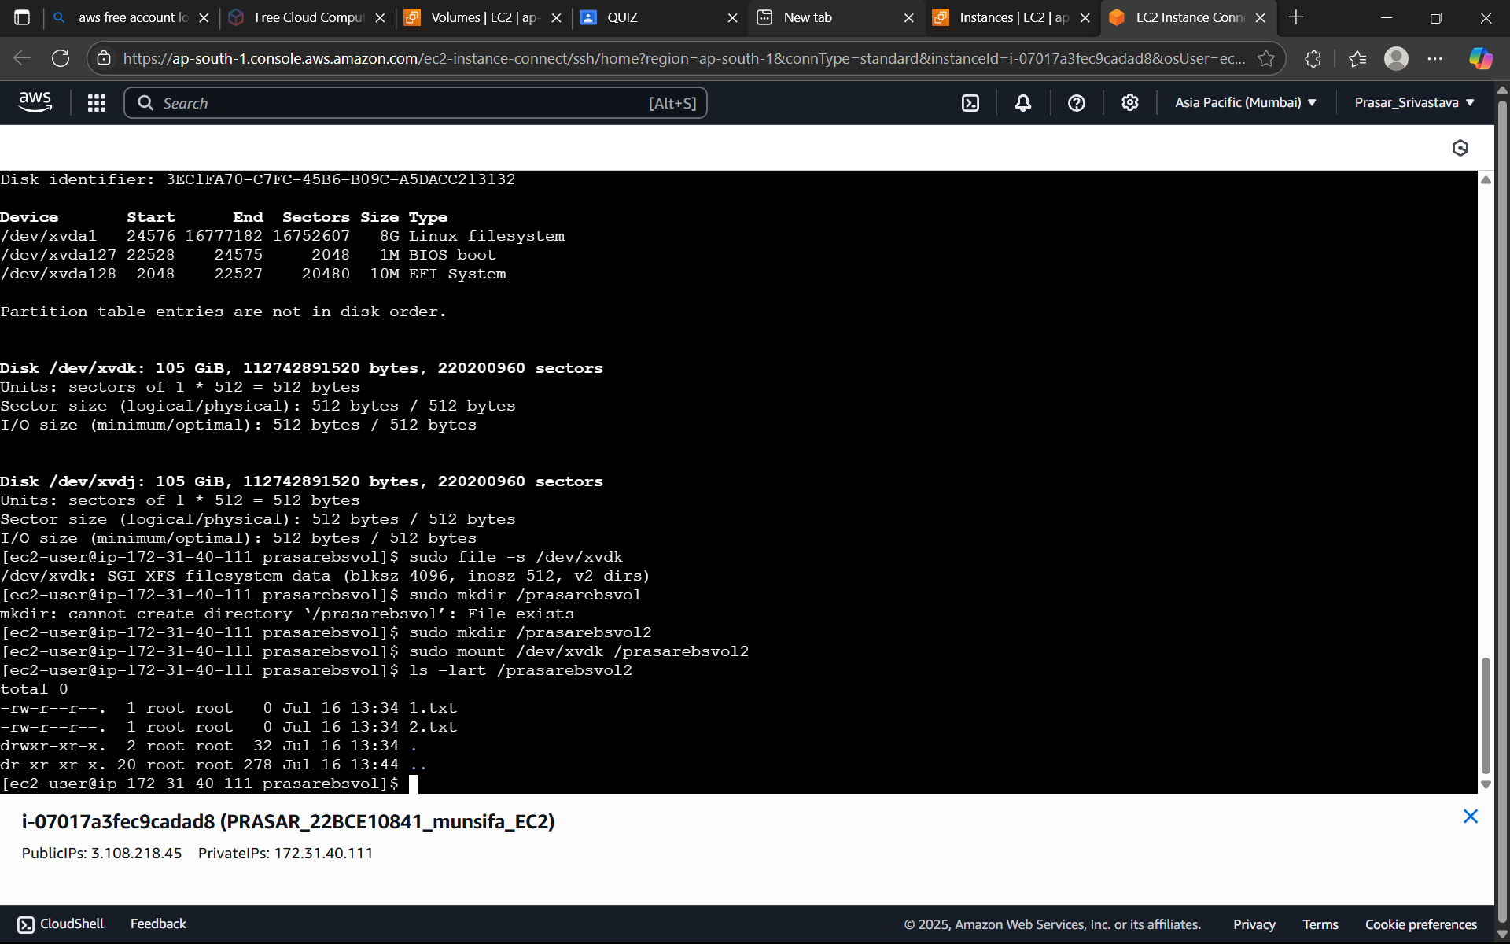

STEP 35: IF YOU CREATE ANOTHER FILE IN FIRST EC2 INSTANCE, IT WILL NOT REFLECT IN

THE SECOND EC2 INSTANCE.

a. TYPE sudo touch 3.txt in FIRST EC2 INSTANCE

b. CHECK WITH ls (FIRST EC2 INSTANCE-IT WILL DISPLAY ALL THE THREE TEXT TILES.)

c. TYPE ls in SECOND EC2 INSTANCE (IT WILL ONLY DISPLAY TWO TEXT FILES)

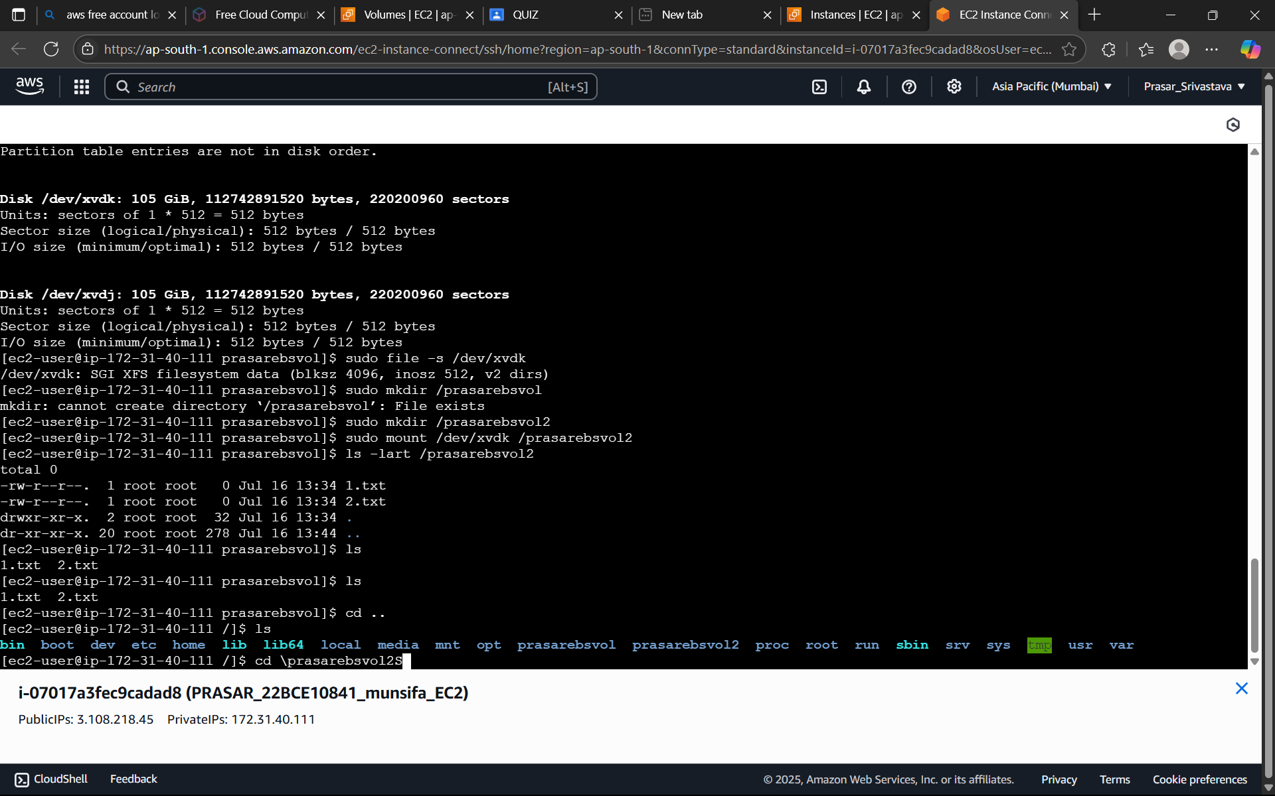

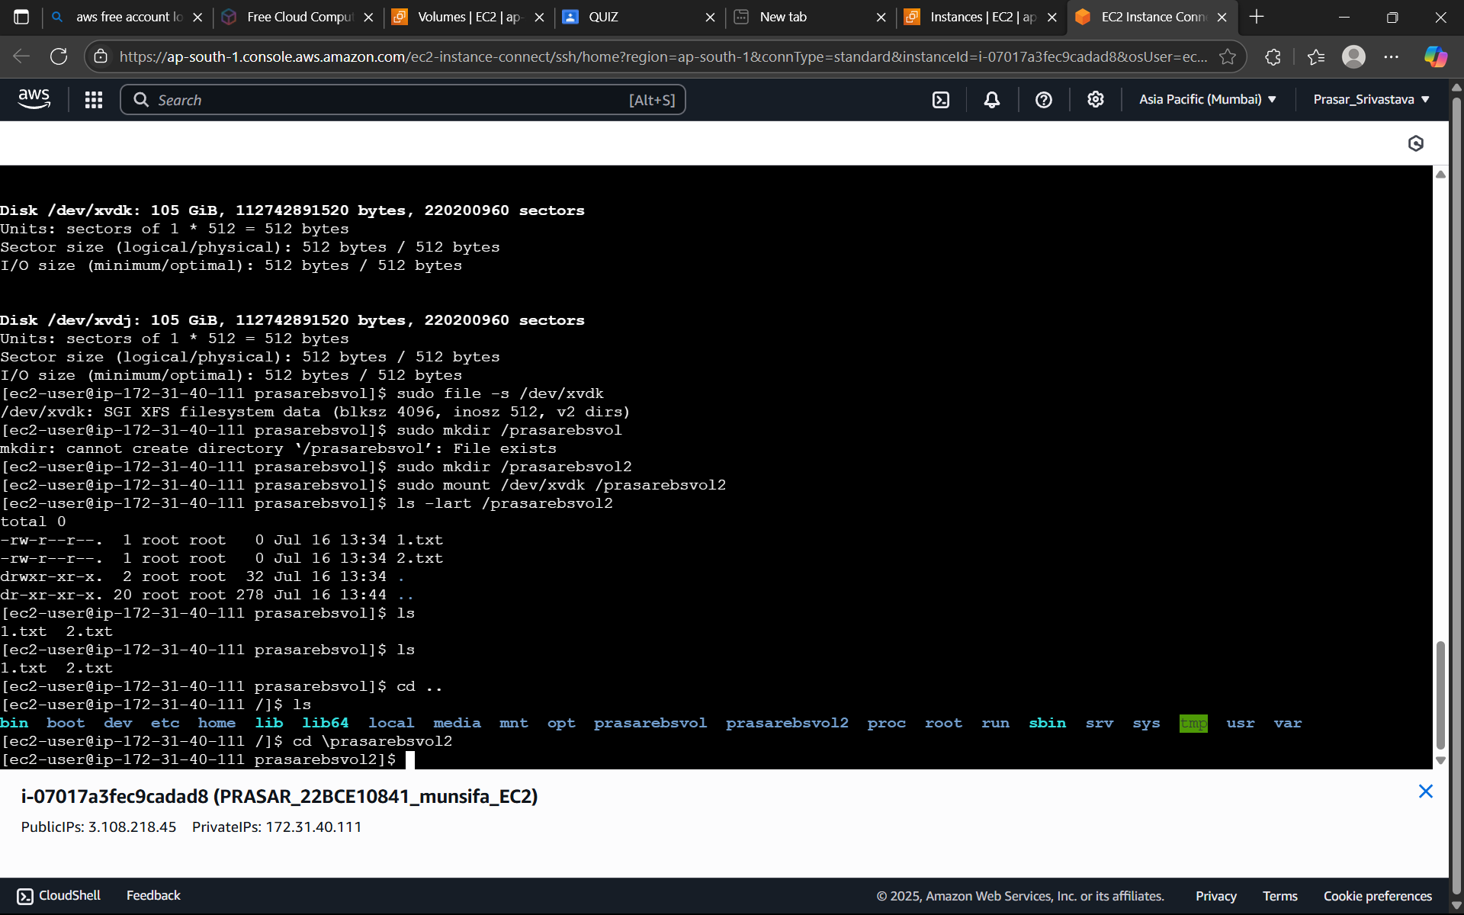

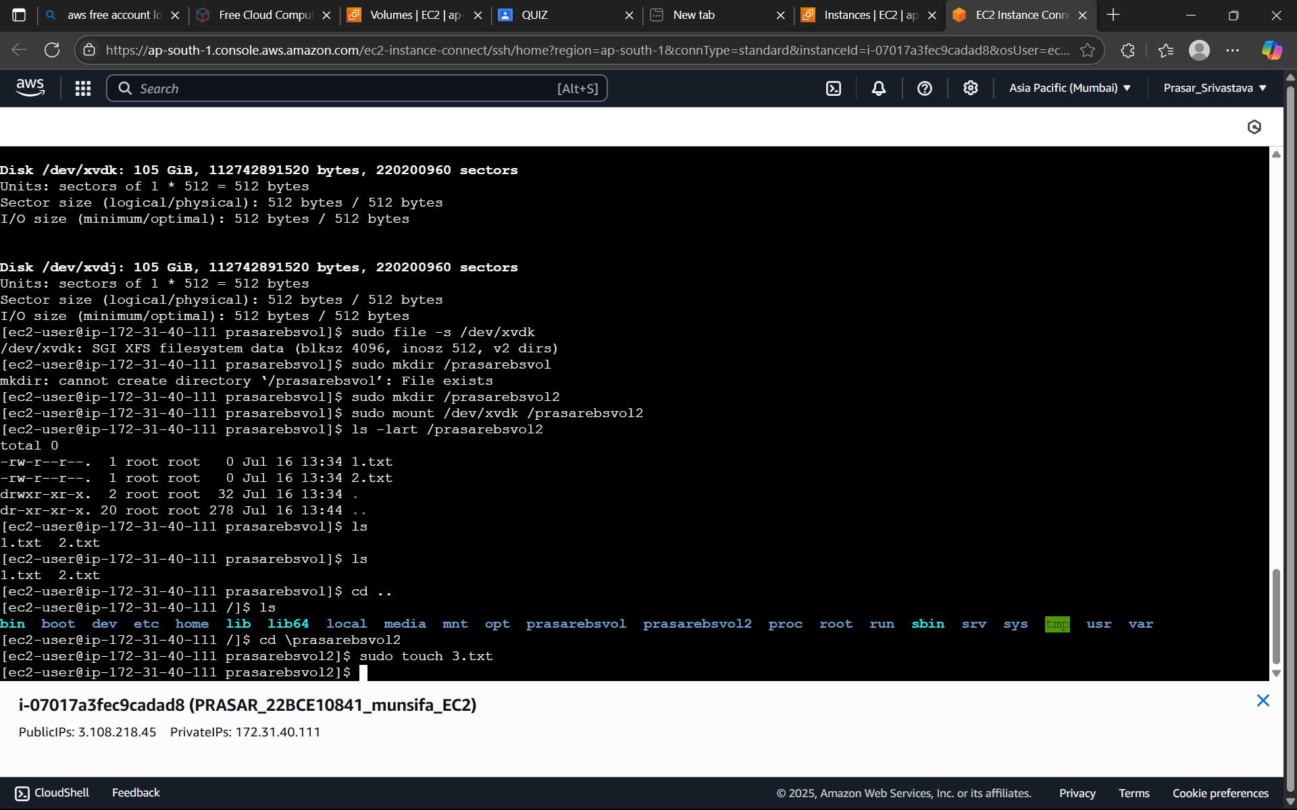

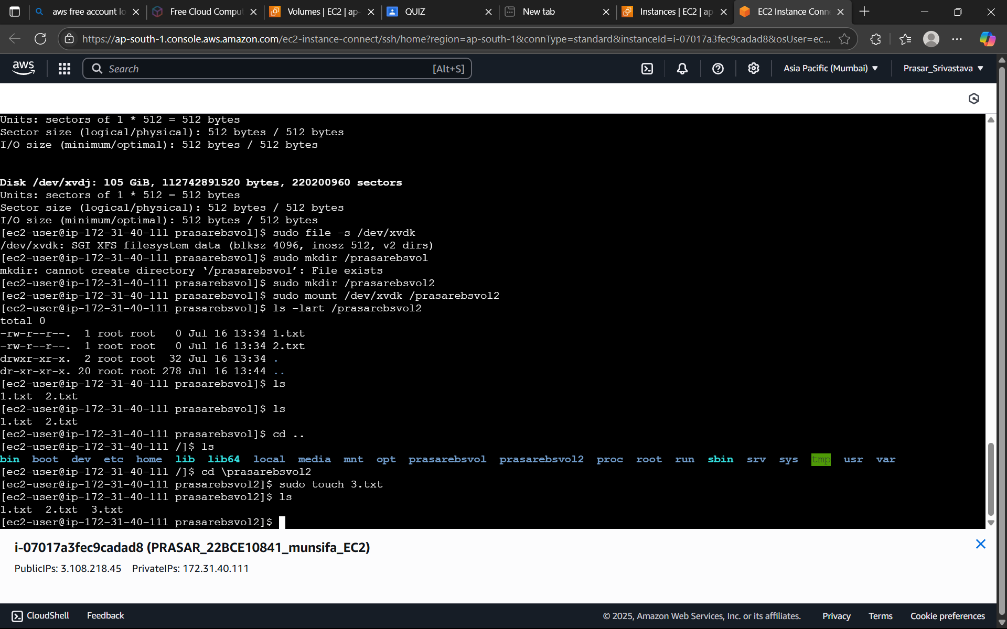

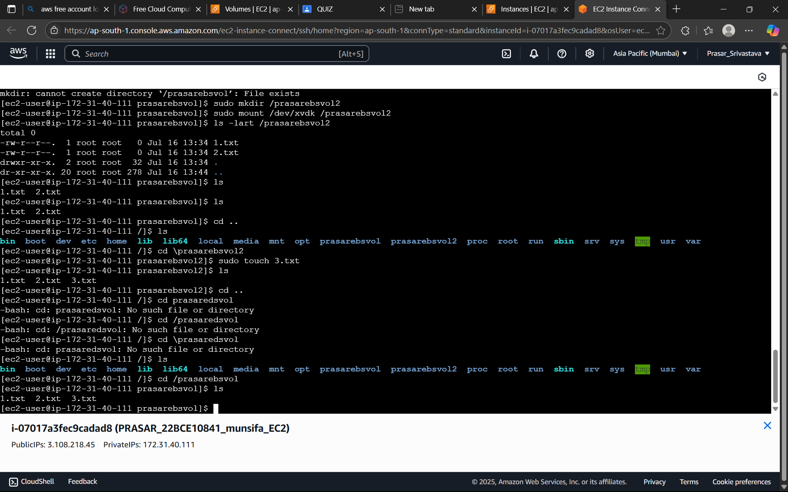

***HOW TO CREATE A STATIC WEBSITE IN S3***

STEP1: GO TO AWS CONSOLE AND SEARCH FOR S3 AND CLICK ON CREATE A BUCKET.

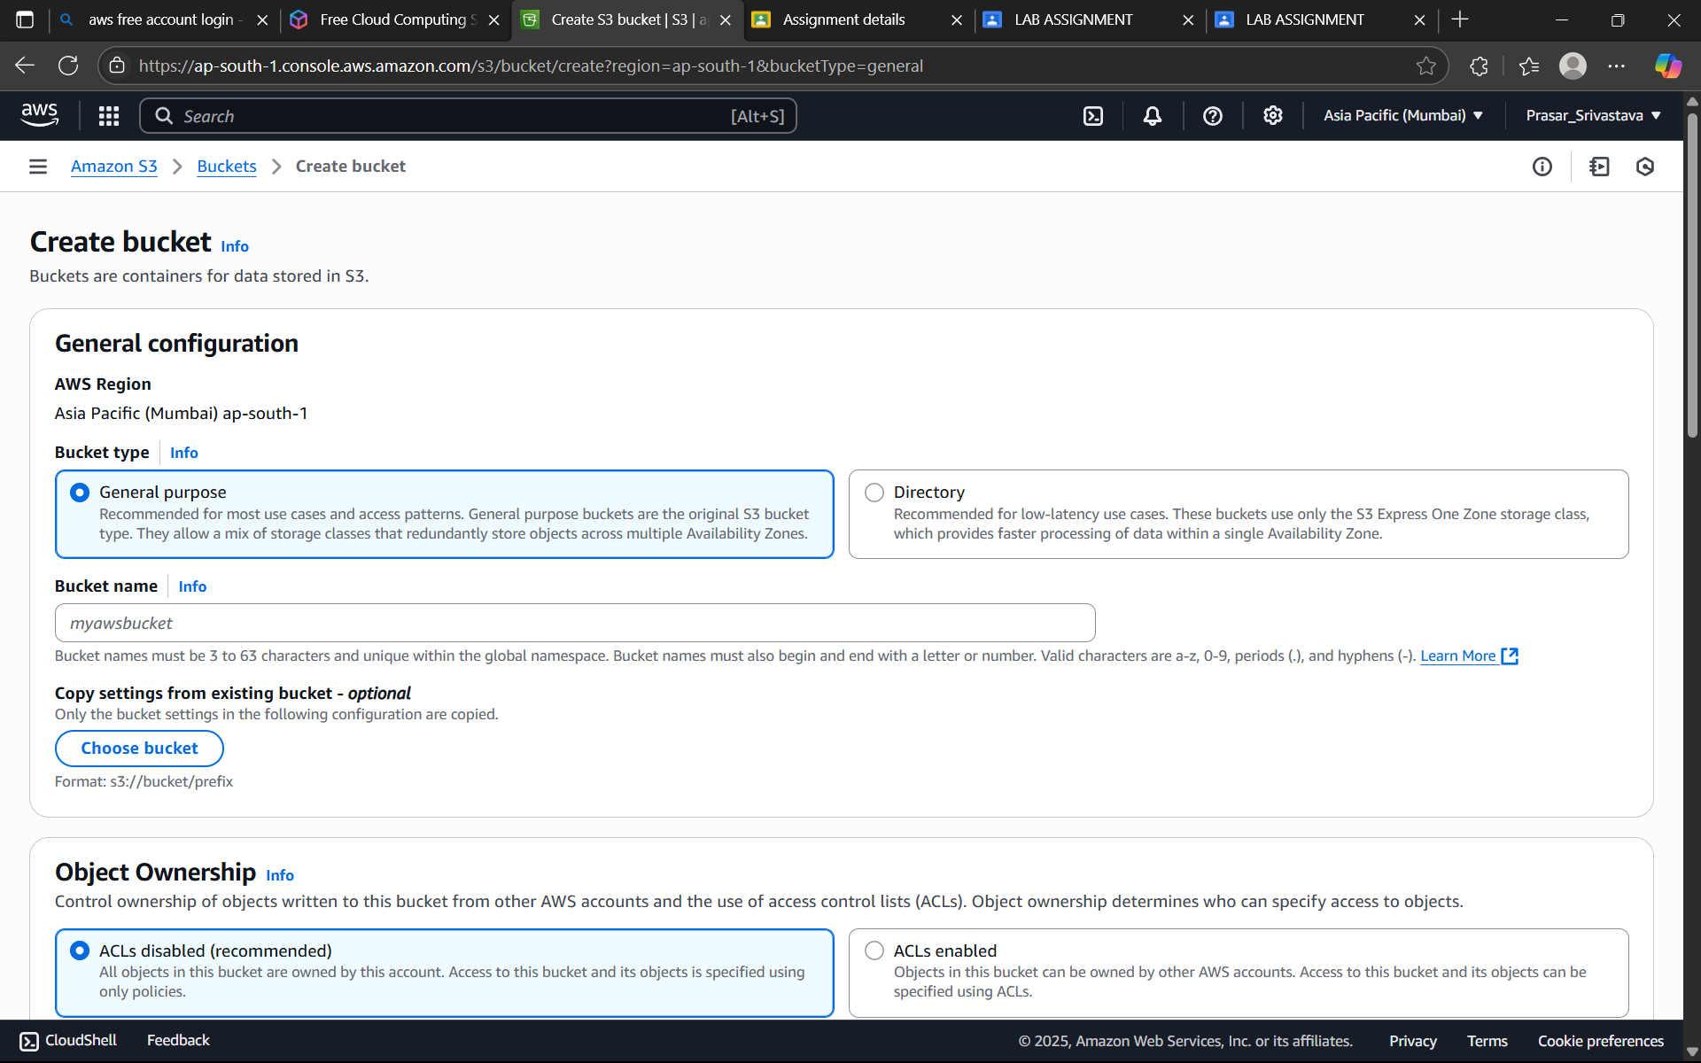

STEP2: GIVE THE BUCKET NAME AND KEEP THE REMAINING DEFAULT AND CLICK ON CREATE BUCKET

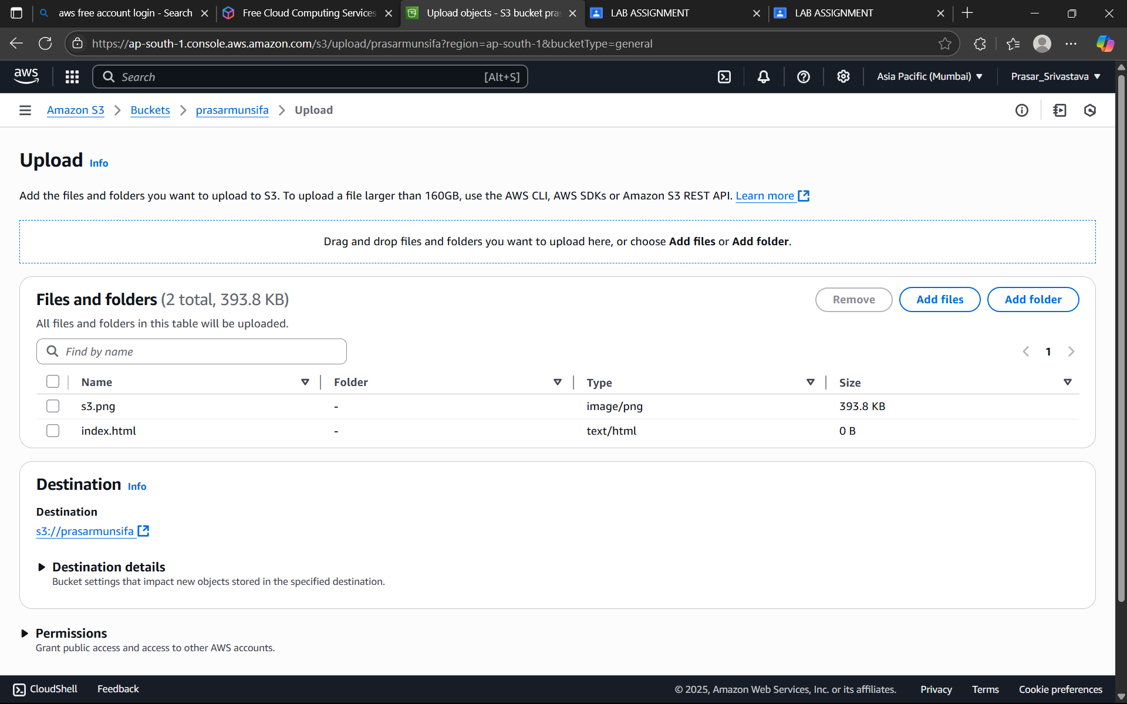

STEP3: ONCE THE BUCKET IS CREATED CLICK ON THE BUCKET TO UPLOAD FILES. Upload html file and image file.



a. The HTML code in file (index.html) is given below:

<html xmlns="http://www.w3.org/1999/xhtml" >

<head>

<title>My First Website</title>

</head>

<body>

<h1>My first S3 static website!</h1>

<p>I'm hosted on Amazon S3!</p>

<img src="s3.png">

</body>

</html>

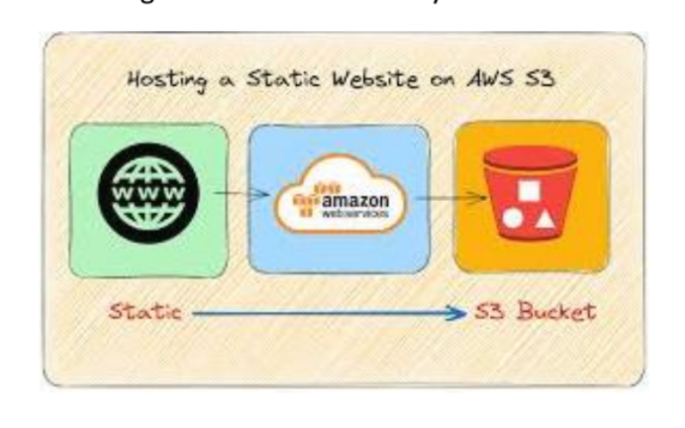

STEP4: ONCE THE FILES ARE UPLOADED. CLICK ON PROPERTIES AND CREATE AMPLIFY APP

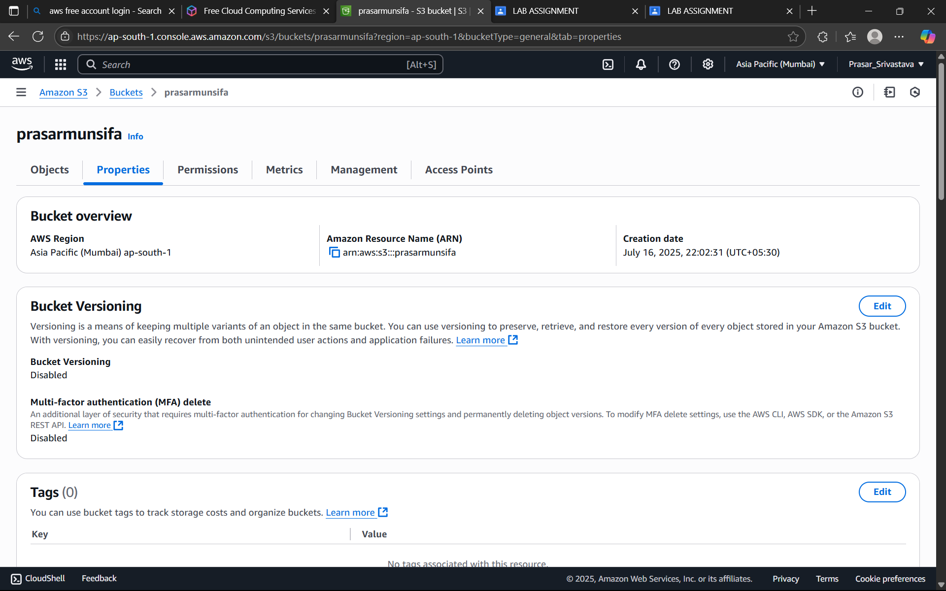

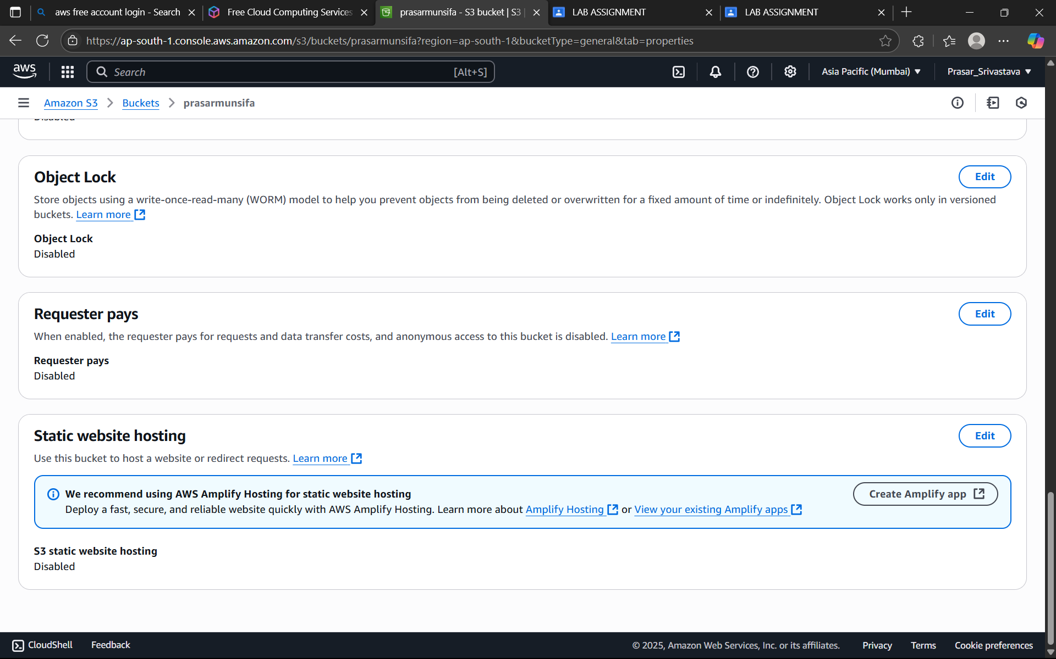

STEP5: IT WILL LAND YOU TO AMPLIFY WINDOW. CLICK ON SAVE AND DEPLOY

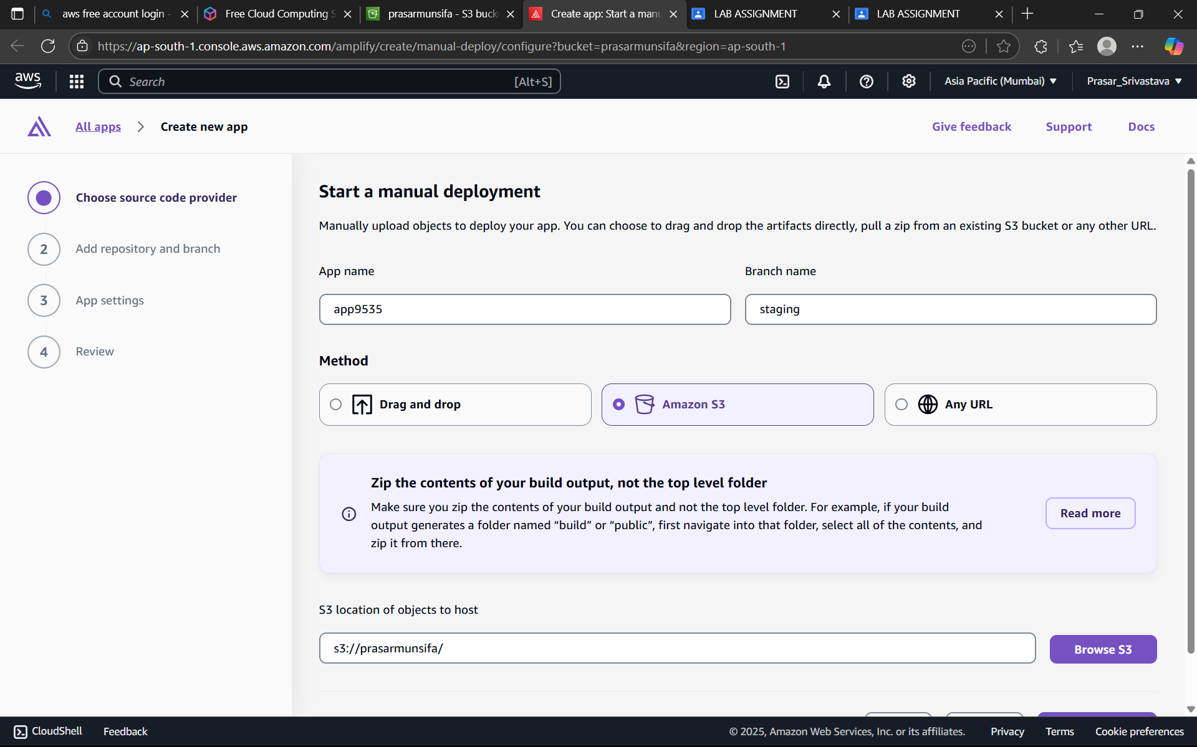

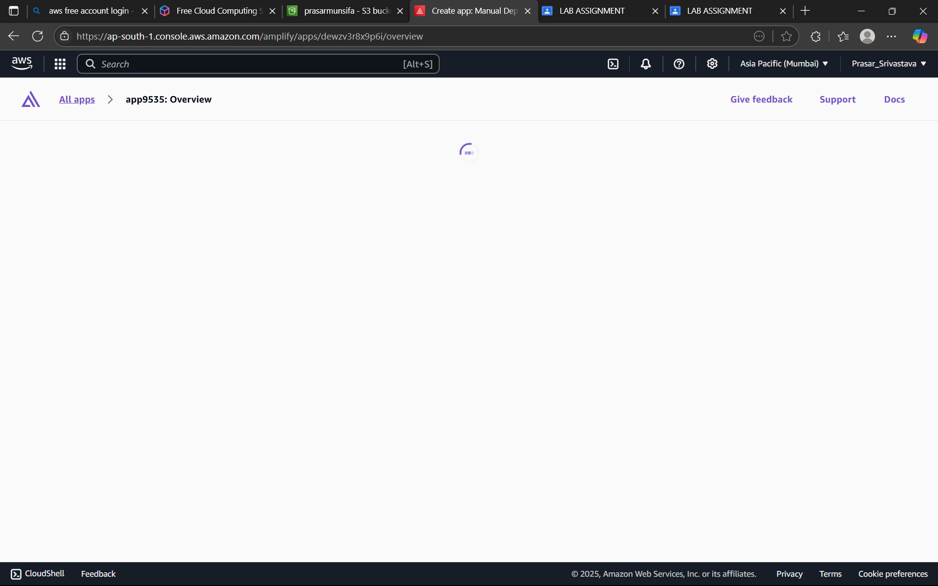

STEP6: CLICK ON THE LINK BELOW.

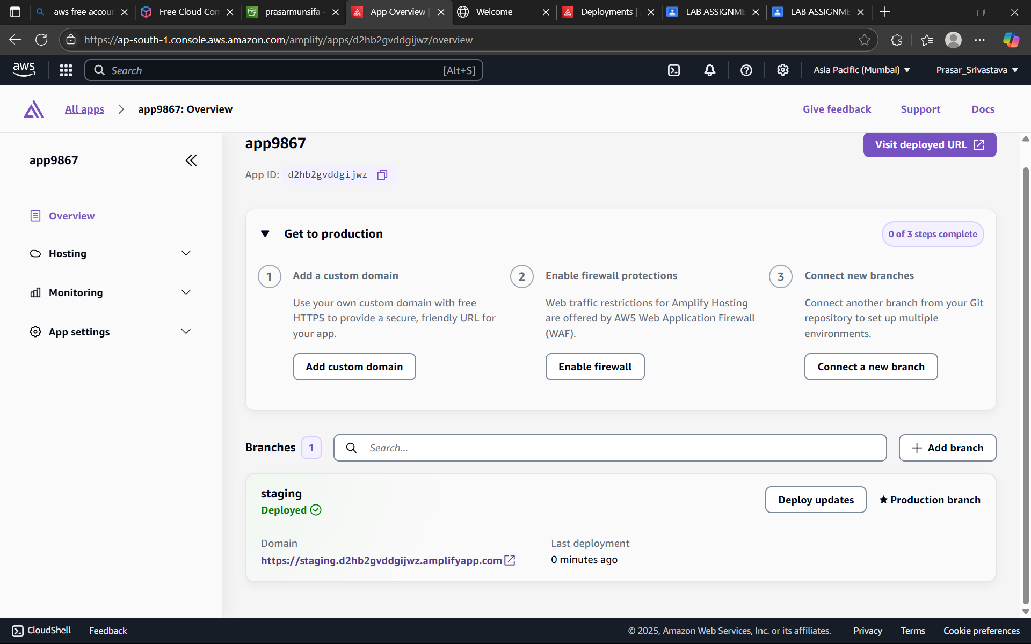

STEP7: IT WILL LAND YOU TO YOUR STATIC WEBSITE

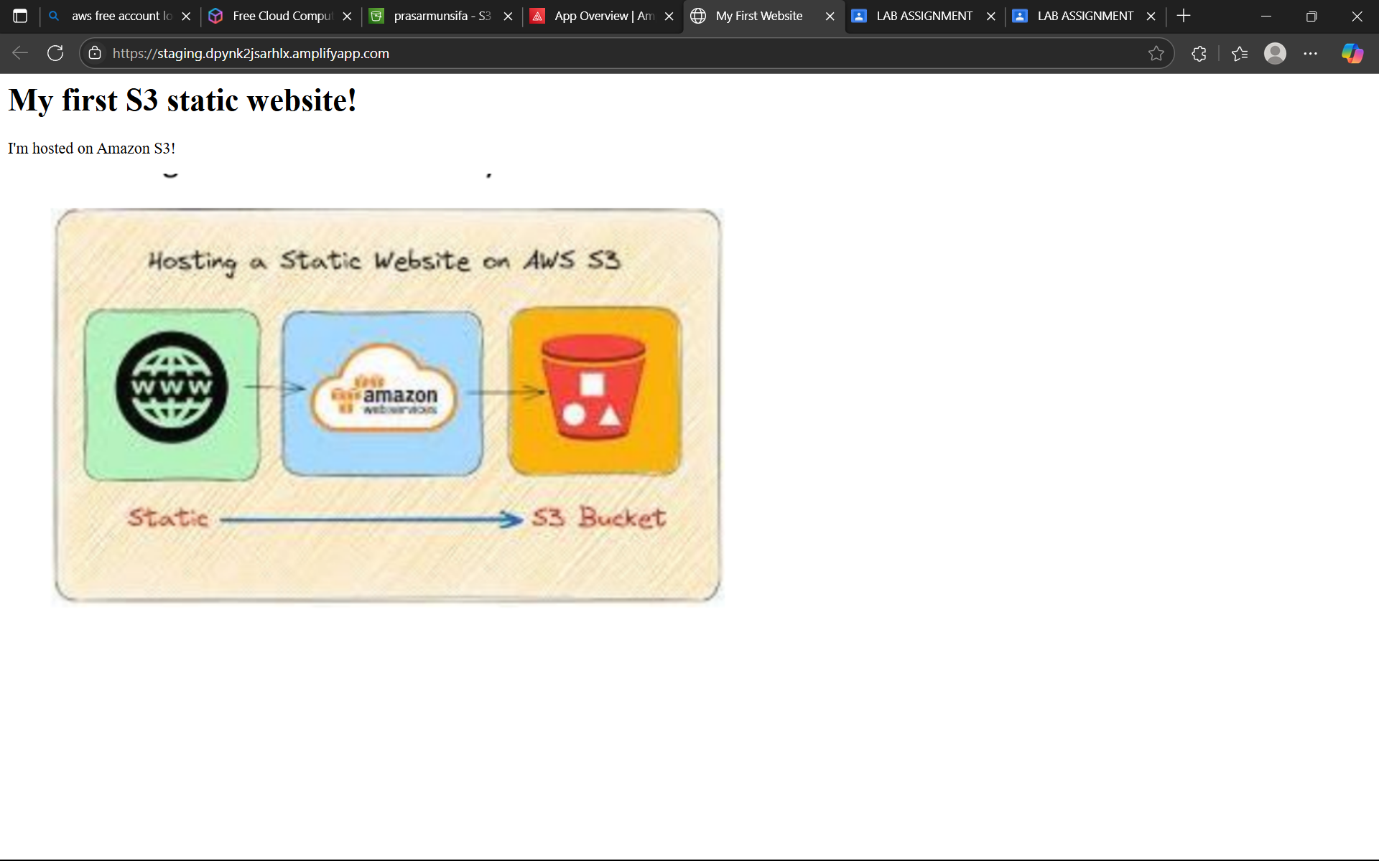

Prasar Srivastava  
22BCE10841  
AWS CLOUD Architect CSE3016  
Submitted To-Dr. Munsifa Firdaus Khan

STEP1: LOGIN AS A ROOT USER AND SEARCH FOR VPC IN THE CONSOLE

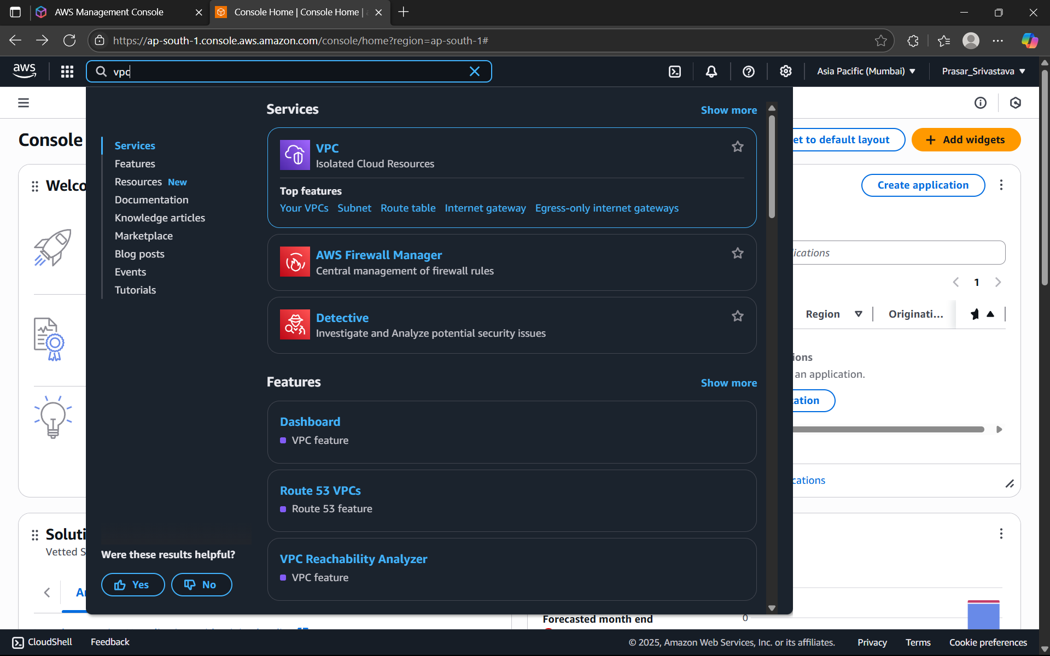

STEP2: CLICK ON CREATE VPC

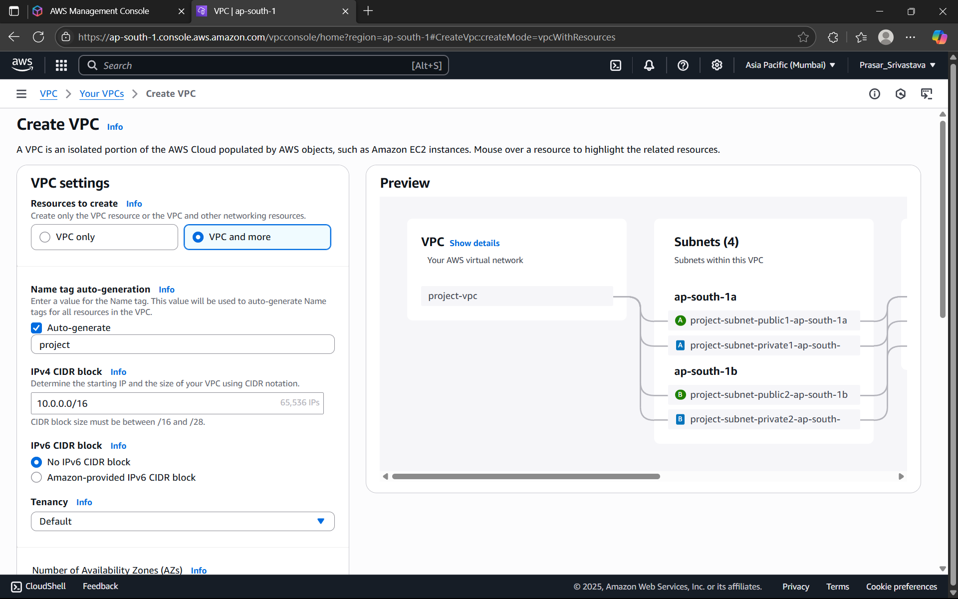

STEP3: SELECT VPC ONLY> TYPE THE VPC NAME> IPv4CIDR-11.0.0.0/16

NOTE: In AWS a VPC spans a specific IP address range using CIDR (Classless Inter-Domain

Routing) blocks. The CIDR block defines the range of IP addresses that can be assigned to

resources within the VPC

For better understanding of the CIDR range, Search CIDR Range Calculator in google and

enter the range. Here its showing 65536 IP range, i.e. these are the maximum number of IP

addresses which is accessible by the VPC. If we increase from /16 to /32, it will decrease

the number of IP address and if we decrease it to /8, it will increase the number of IP

addresses. (/16 means first 16bits are locked)



STEP4: CLICK ON CREATE VPC

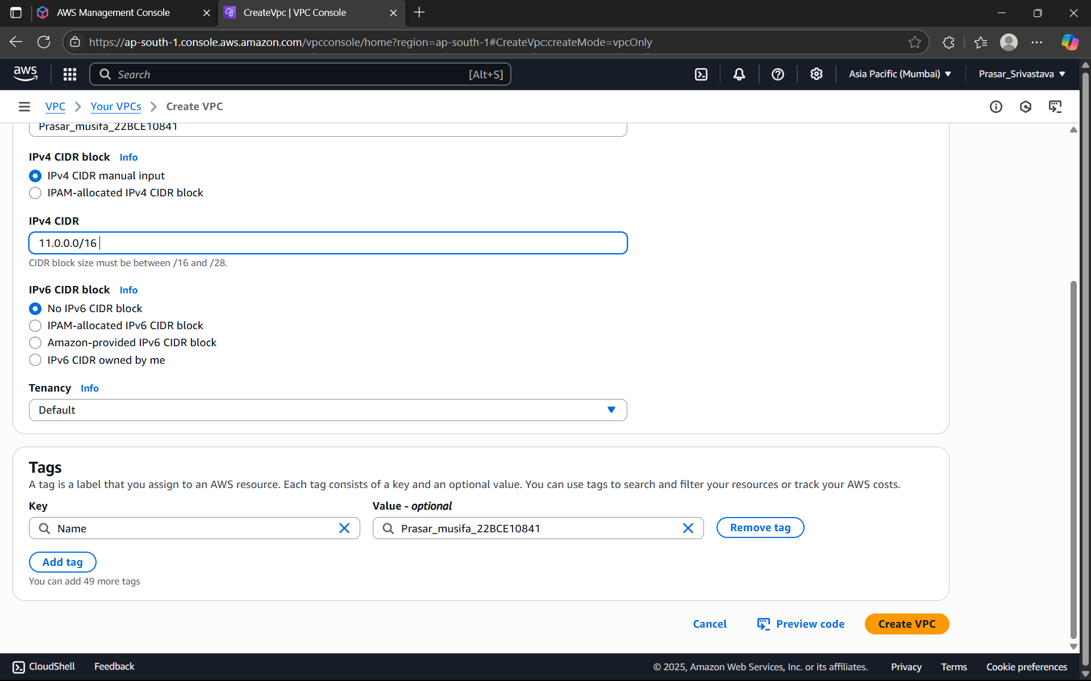

STEP5: VPC CREATED

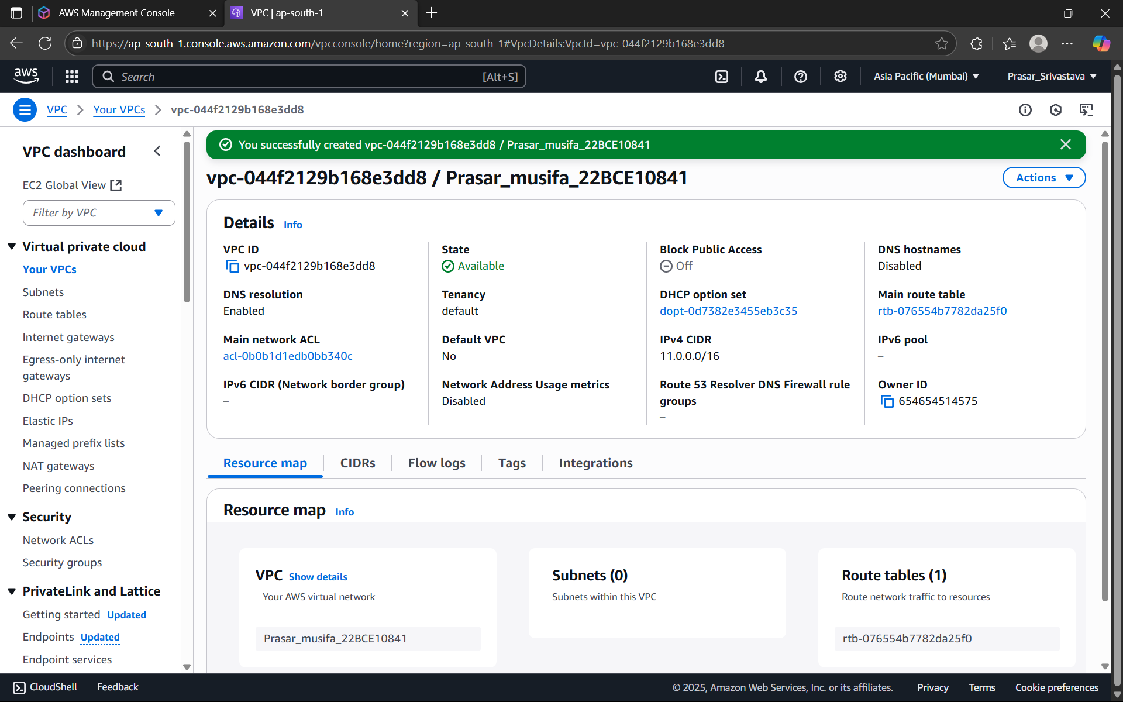

STEP6: CLICK ON SUBNET>CREATE SUBNET

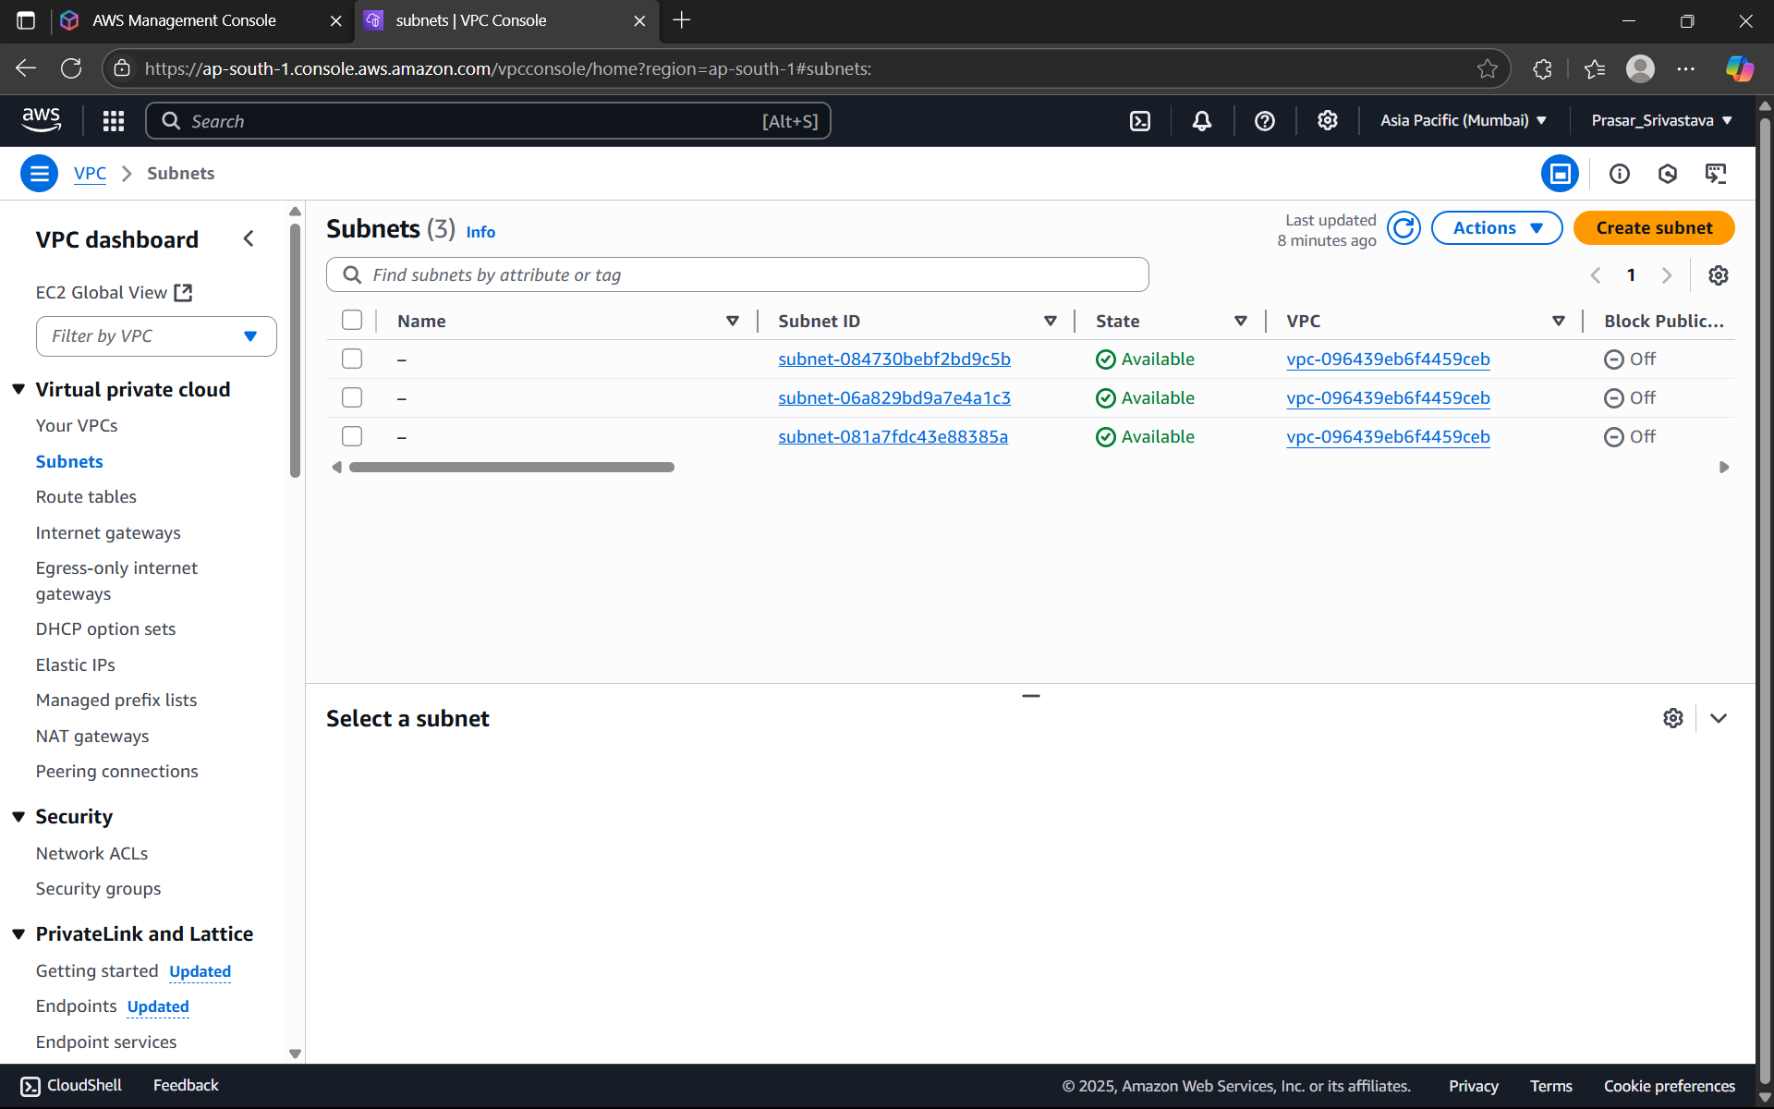

STEP7: SELECT THE VPC THAT YOU HAVE CREATED EARLIER

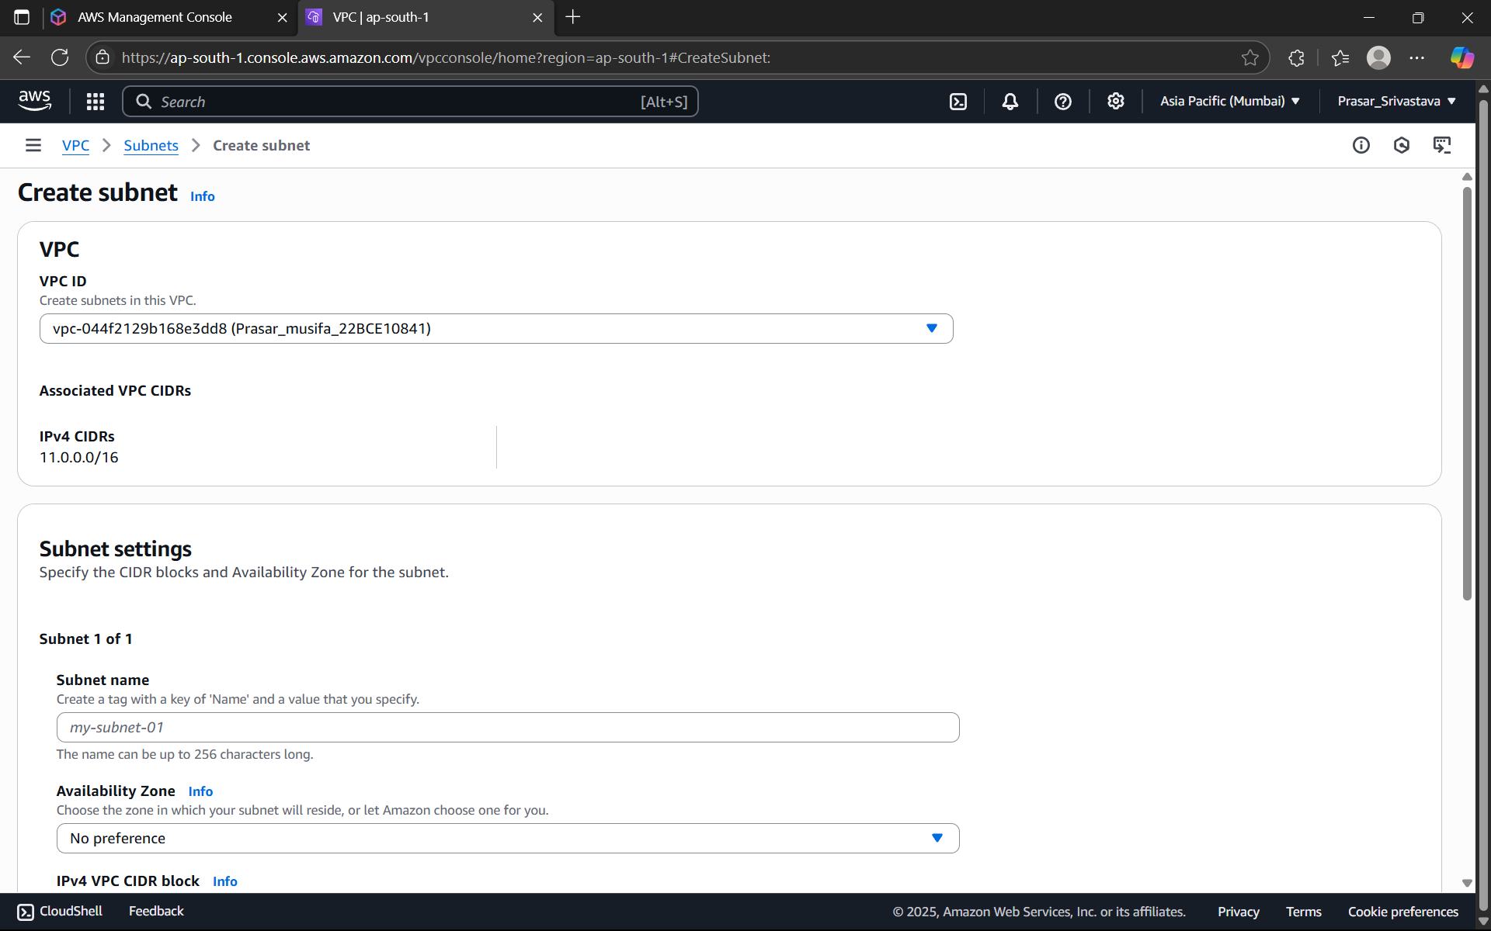

STEP8: SELECT ap-south-1a in the Availability Zone

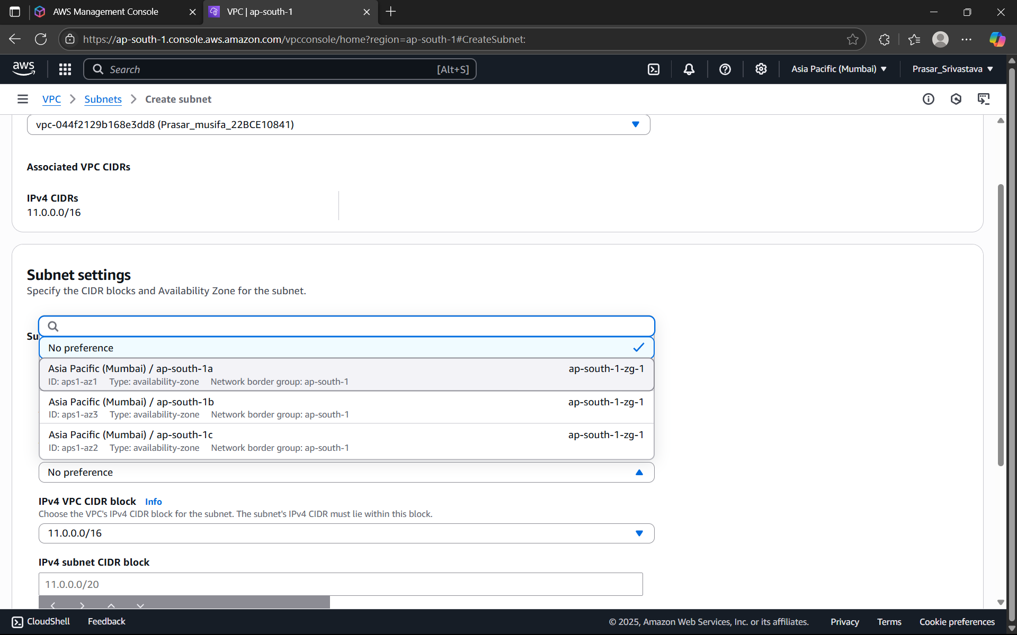

STEP9: ENTER IPv4 SUBNET CIDR BLOCK-11.0.1.0/24> CLICK ON ADD NEW SUBNET

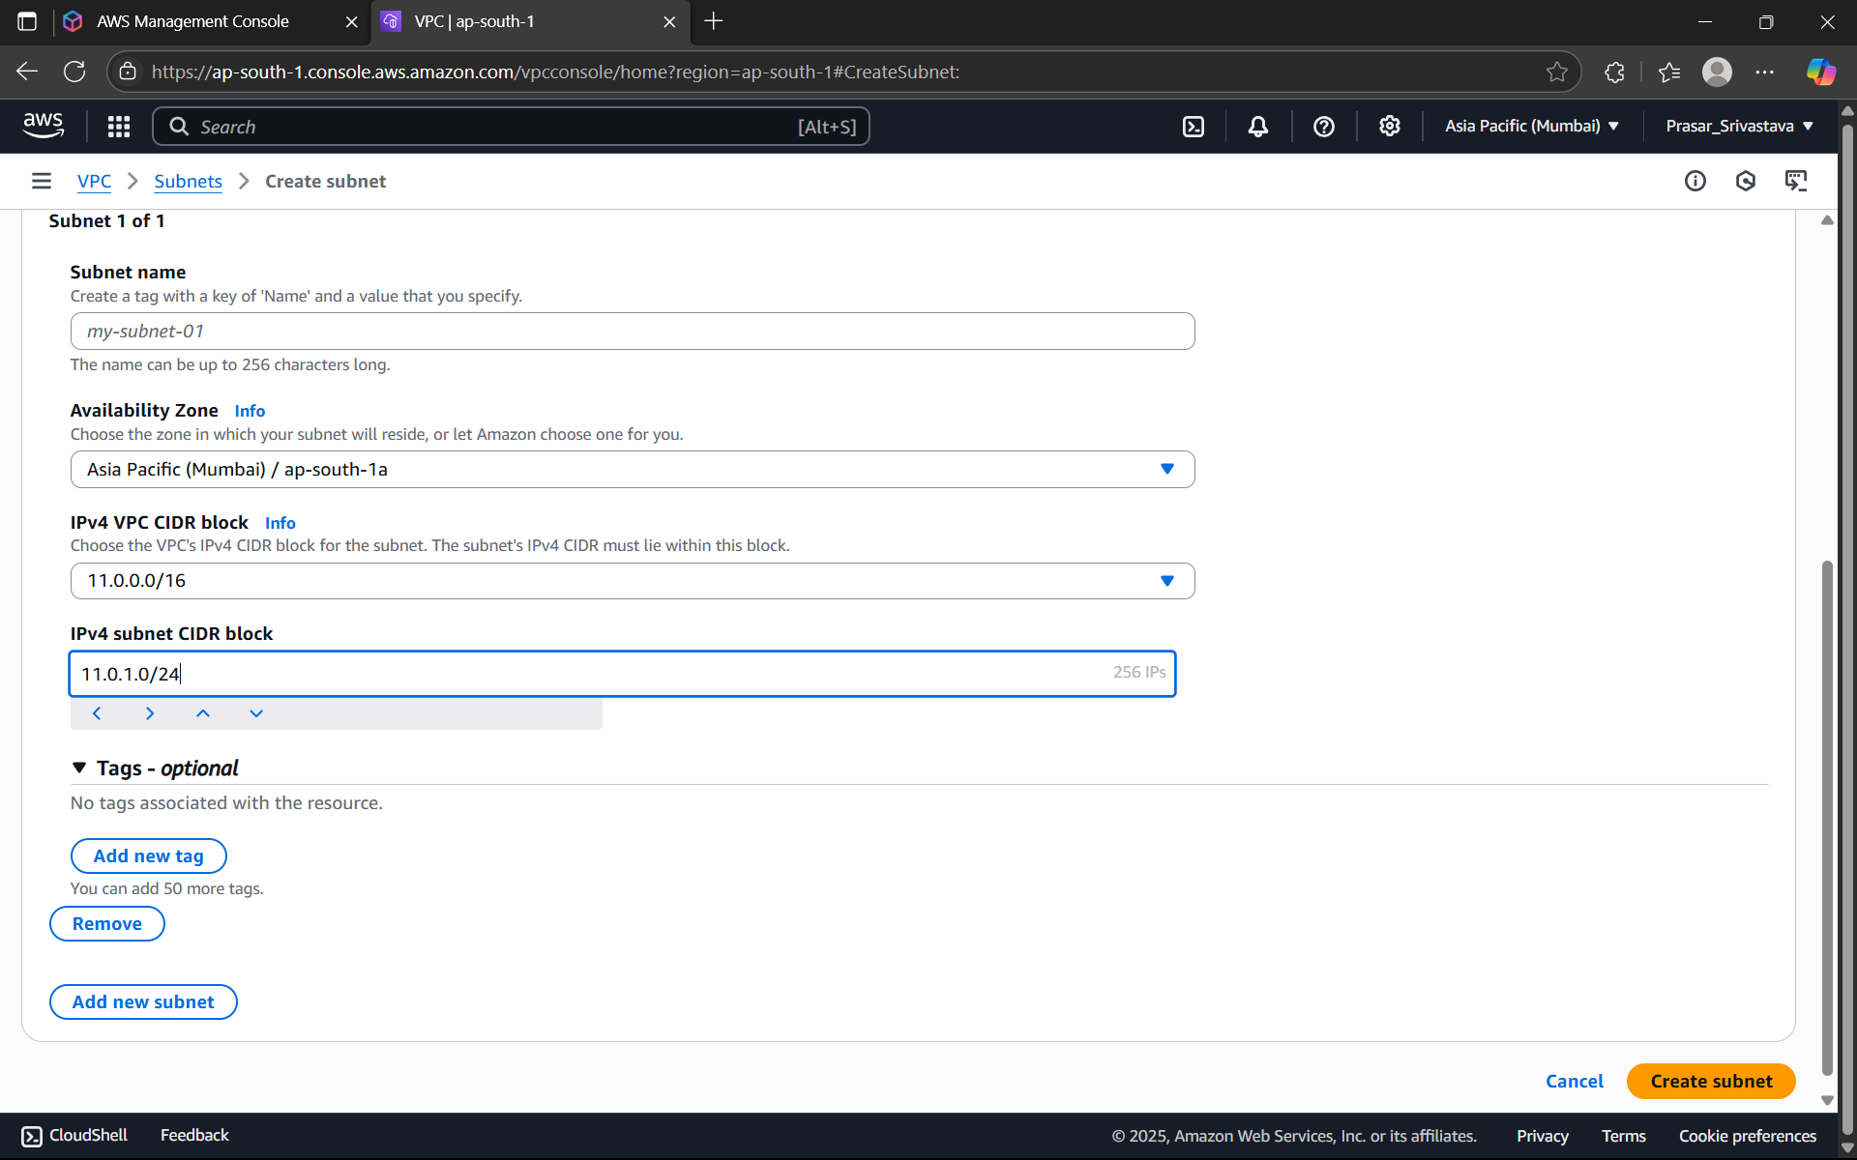

STEP9: ENTER THE NAME OF THE PRIVATE SUBNET> AVAILABILITY ZONE:ap-south-1b> IPv4

subnet CIDR Block-11.0.2.0/24> CLICK ON CREATE SUBNET

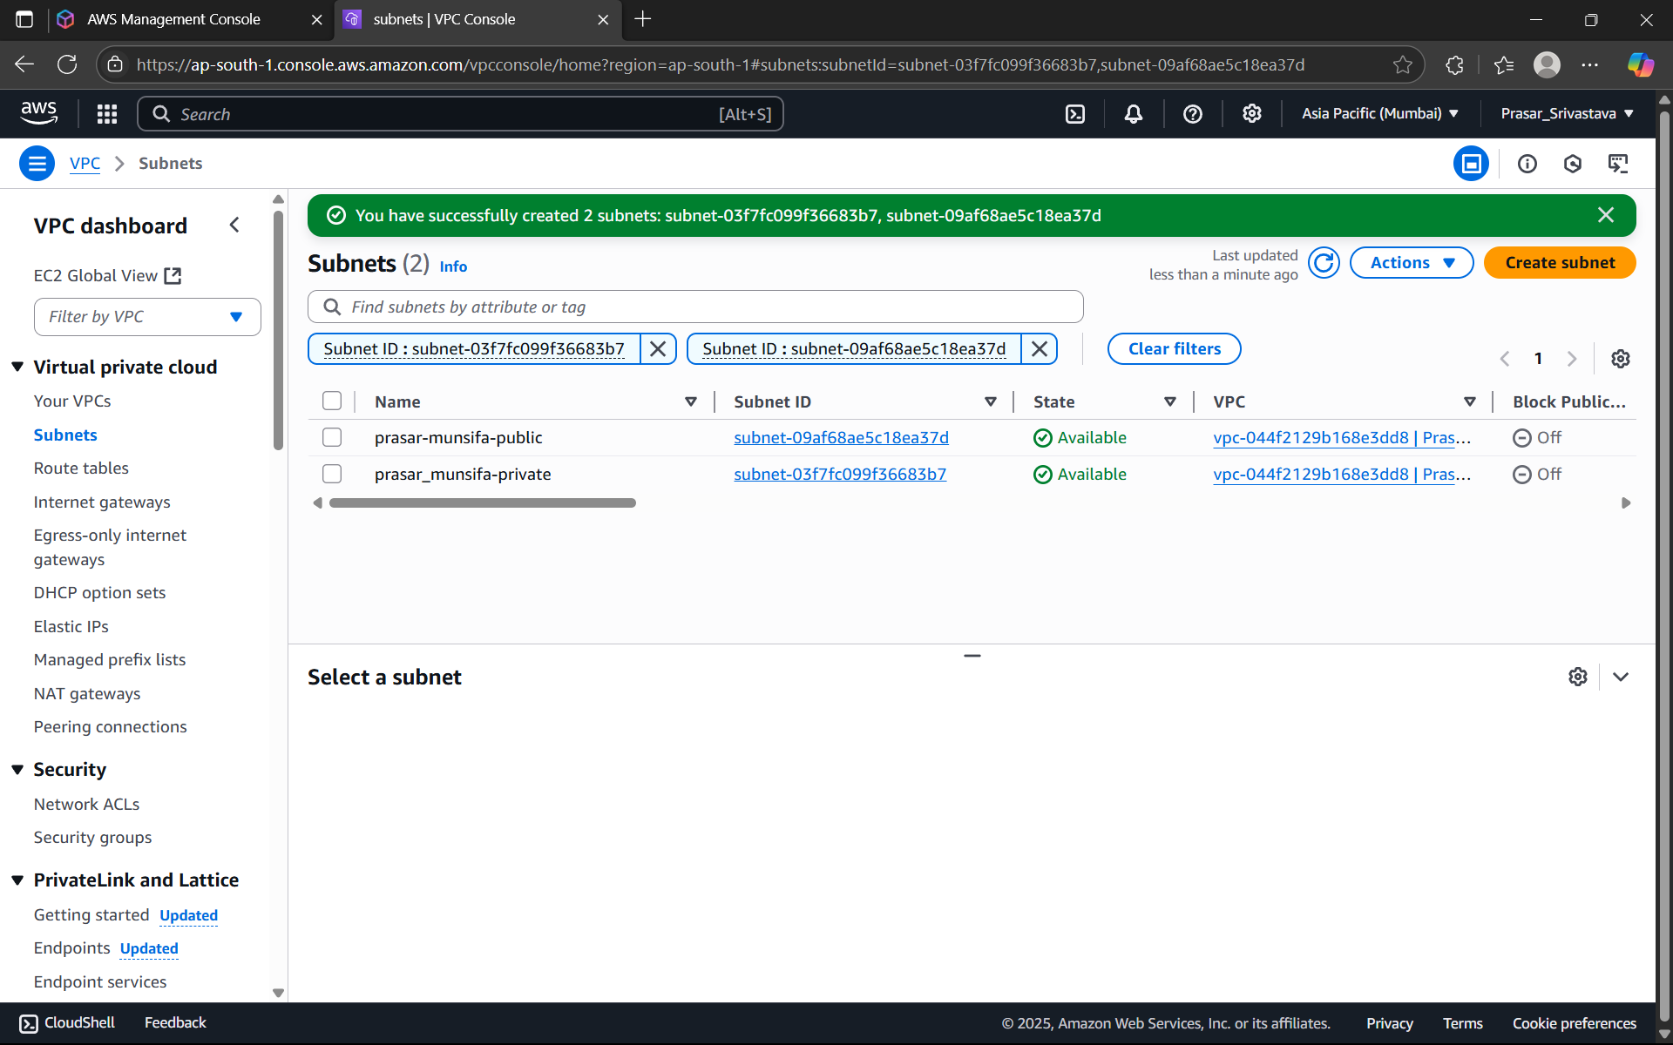

STEP10: BOTH THE PUBLIC AND PRIVATE SUBNET IS CREATED



STEP11: NOW CREATE AN INTERNET GATEWAY FOR PUBLIC SUBNET. CLICK ON INTERNET

GATEWAY FROM THE DASHBOARD> CLICK ON CREATE INTERNET GATEWAY

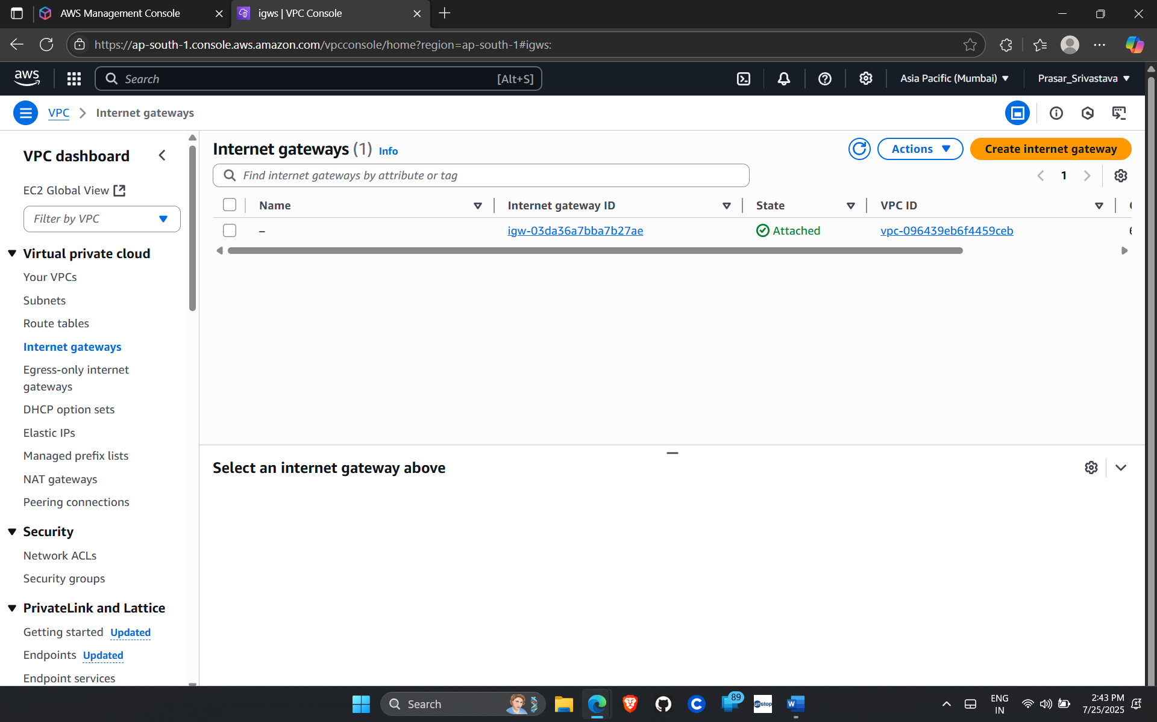

STEP12: TYPE THE NAME OF THE GATEWAY

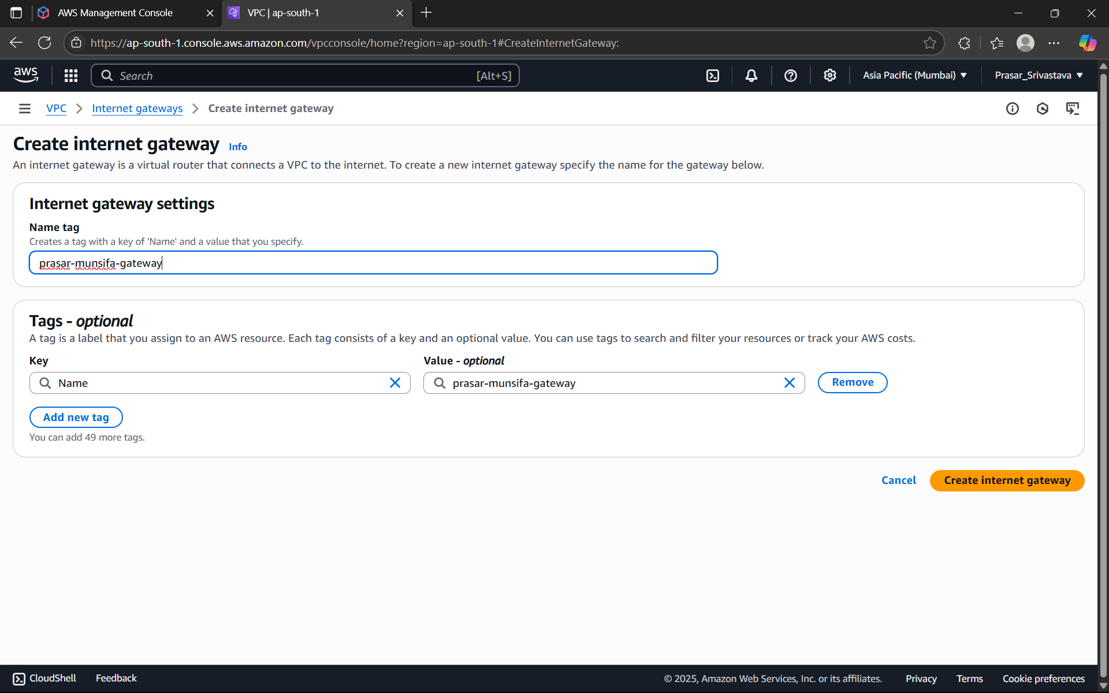

STEP13: INTERNET GATEWAY IS CREATED

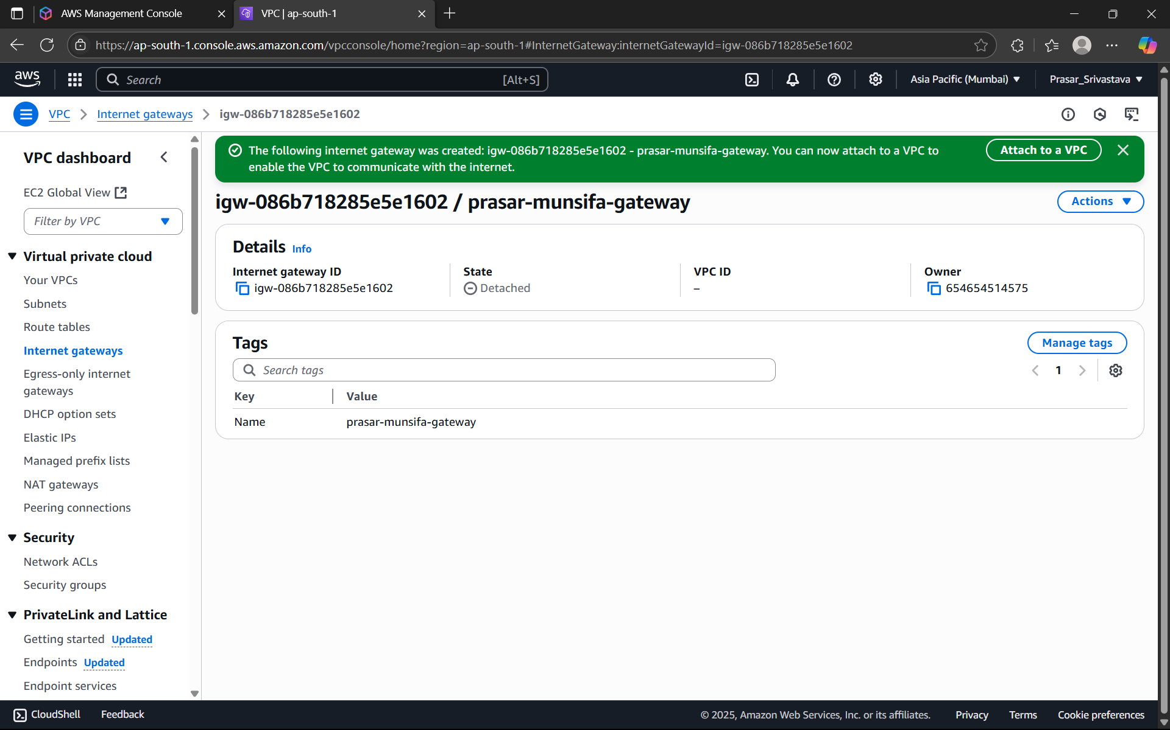

STEP14: CLICK ON ATTACH TO VPC> SELECT THE VPC CREATED EARLIER> CLICK ON ATTACH

INTERNET GATEWAY

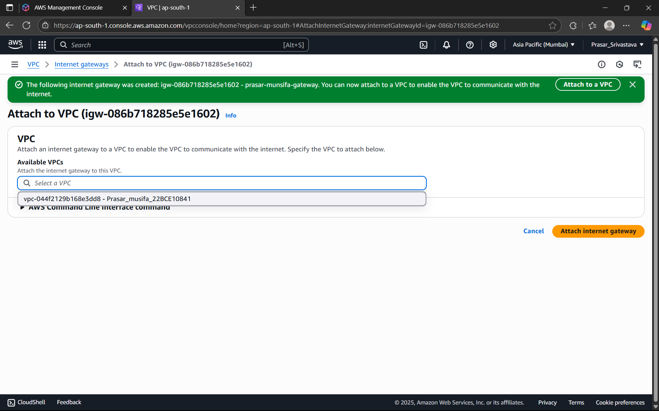

STEP15: INTERNET GATEWAY IS ATTACHED TO THE VPC

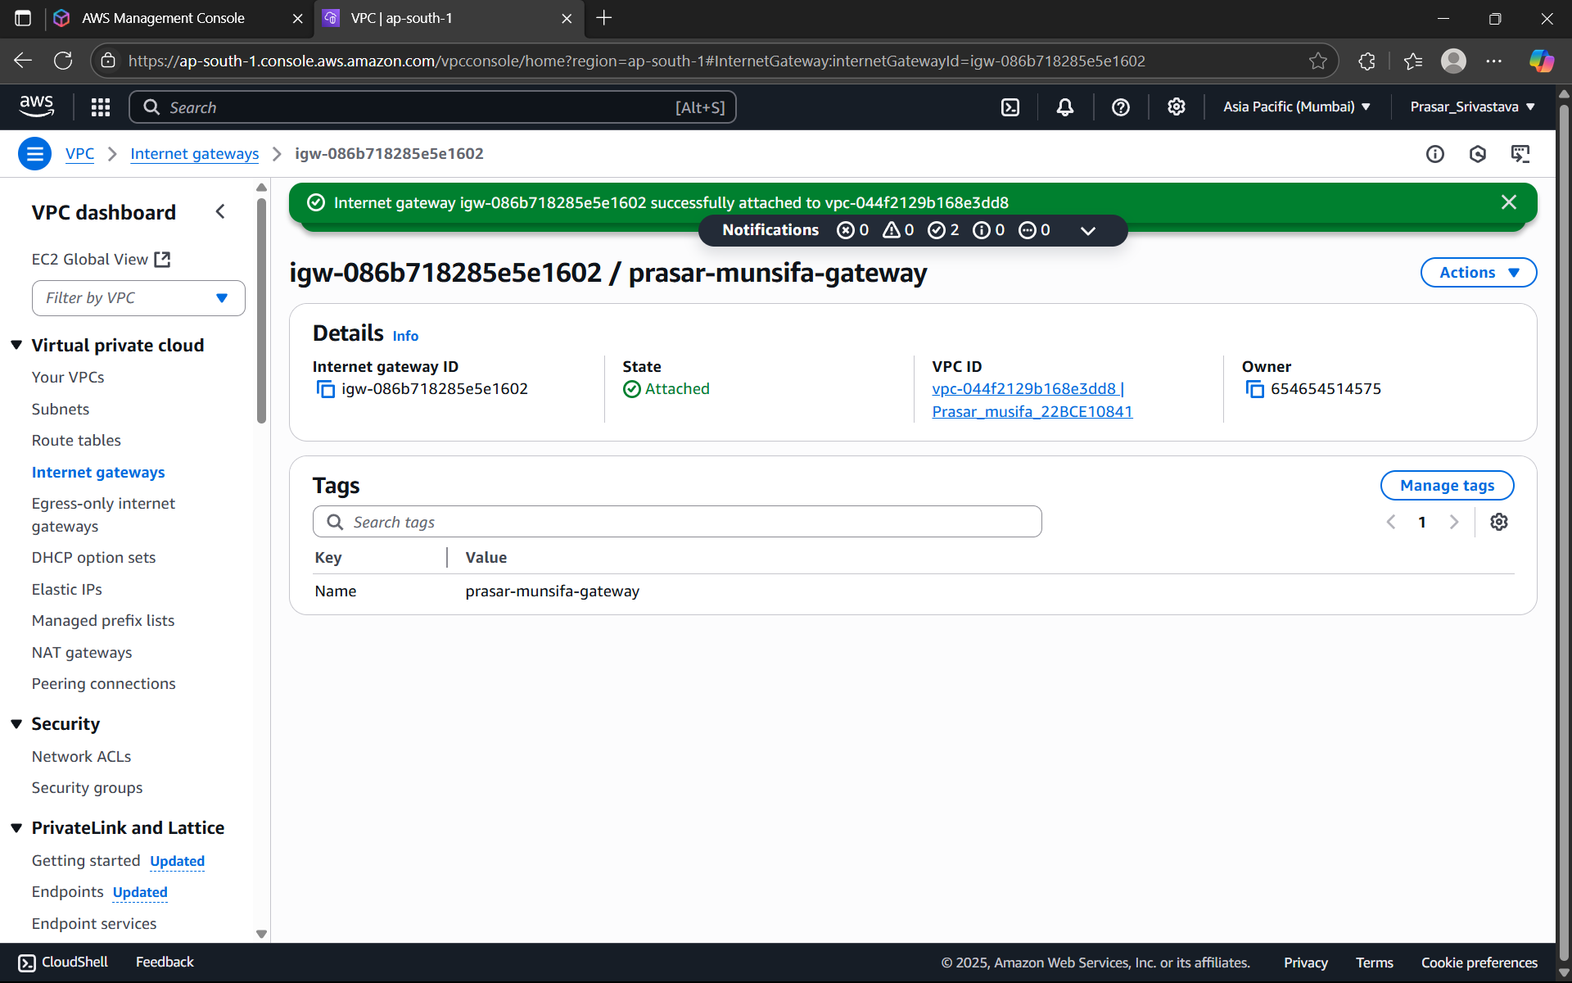

STEP16: NEXT CREATE TWO ROUTE TABLES (PRIVATE AND PUBLIC) FOR THE SUBNETS.

STEP17: TO CREATE A PUBLIC ROUTE TABLE: CLICK ON ROUTE TABLES>CREATE A ROUTE

TABLE> WRITE A SUITABLE NAME FOR THE ROUTE TABLE>CHOOSE THE VPC>CLICK ON

CREATE ROUTE TABLE

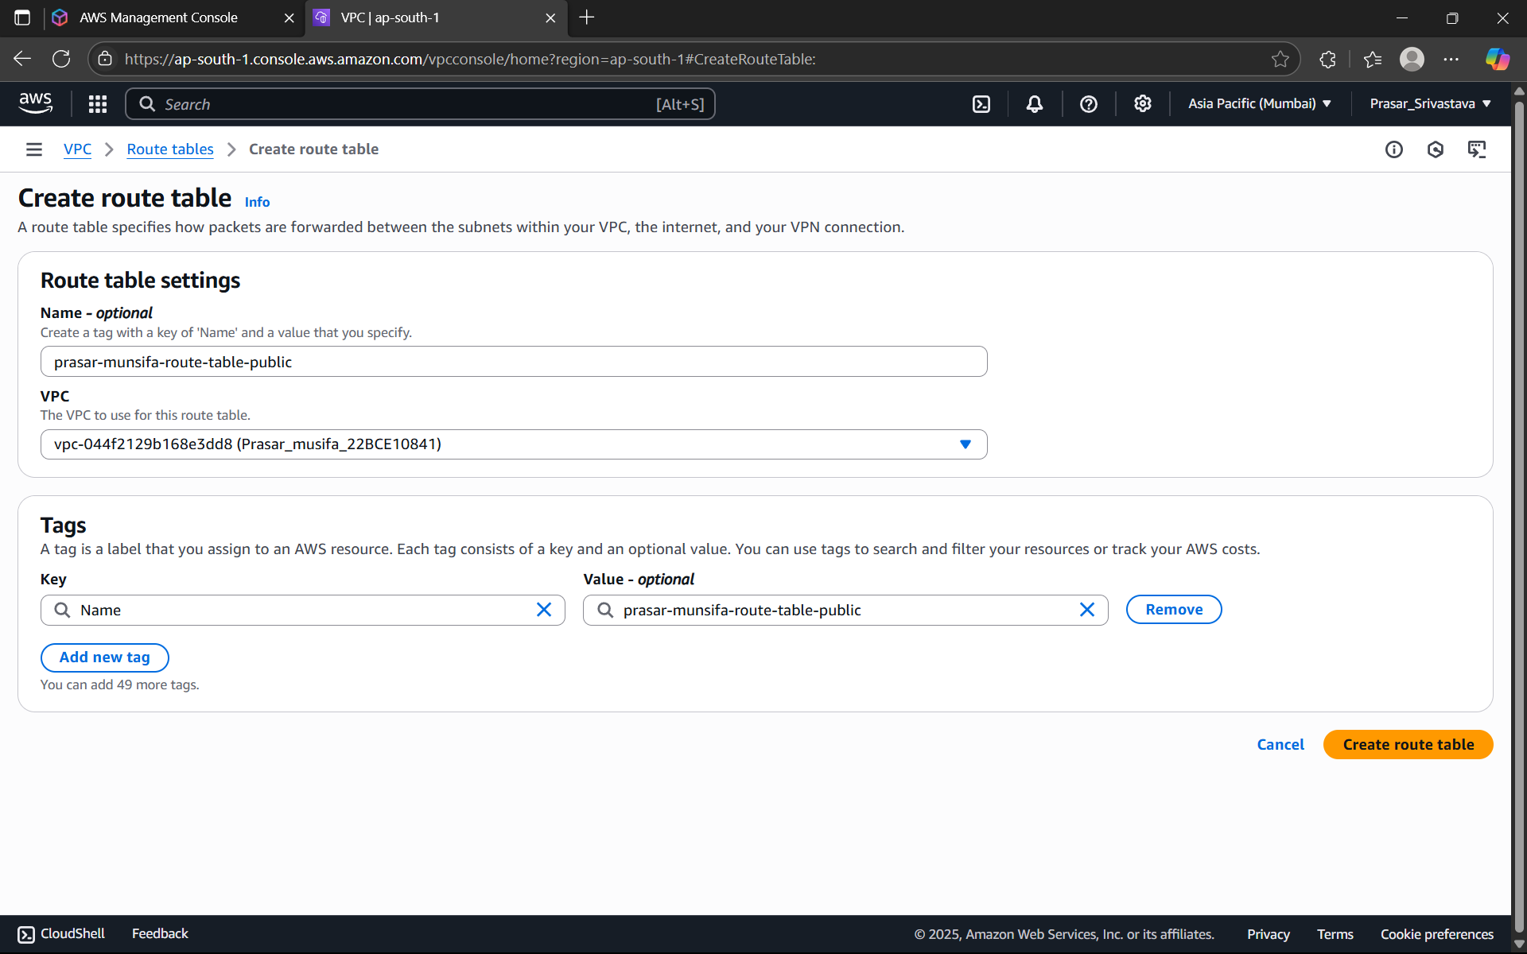

STEP18: TO CREATE A PRIVATE ROUTE TABLE: CLICK ON ROUTE TABLES>CREATE A ROUTE

TABLE> WRITE A SUITABLE NAME FOR THE ROUTE TABLE>CHOOSE THE VPC>CLICK ON

CREATE ROUTE TABLE

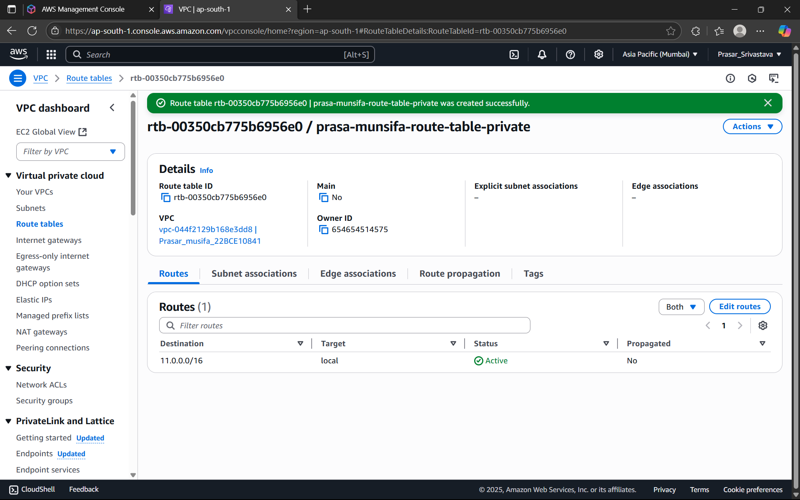

STEP19: BOTH THE PUBLIC AND PRIVATE ROUTE TABLES ARE CREATED AS SHOWN BELOW.

NOW WE NEED TO CONNECT BOTH THE ROUTE TABLES WITH THEIR CORRESPONDING

SUBNETS.

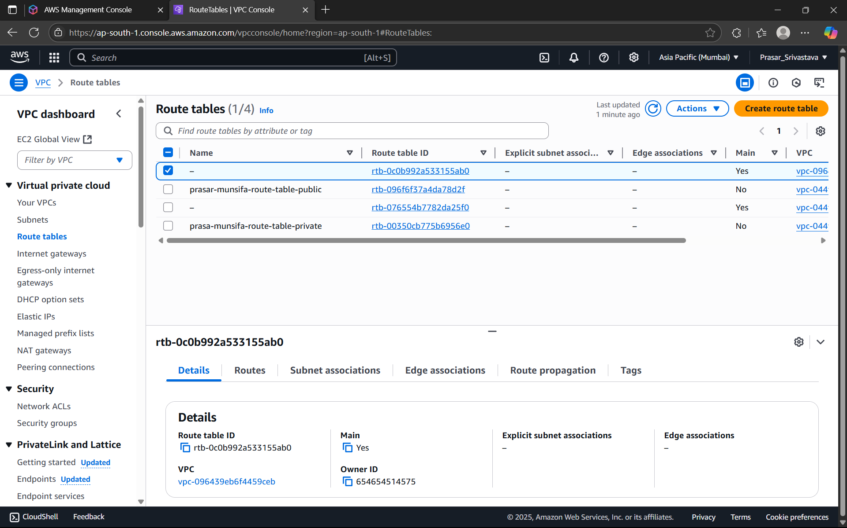

STEP20: CLICK ON THE PUBLIC ROUTE TABLE>CLICK ON SUBNET ASSOCIATIONS

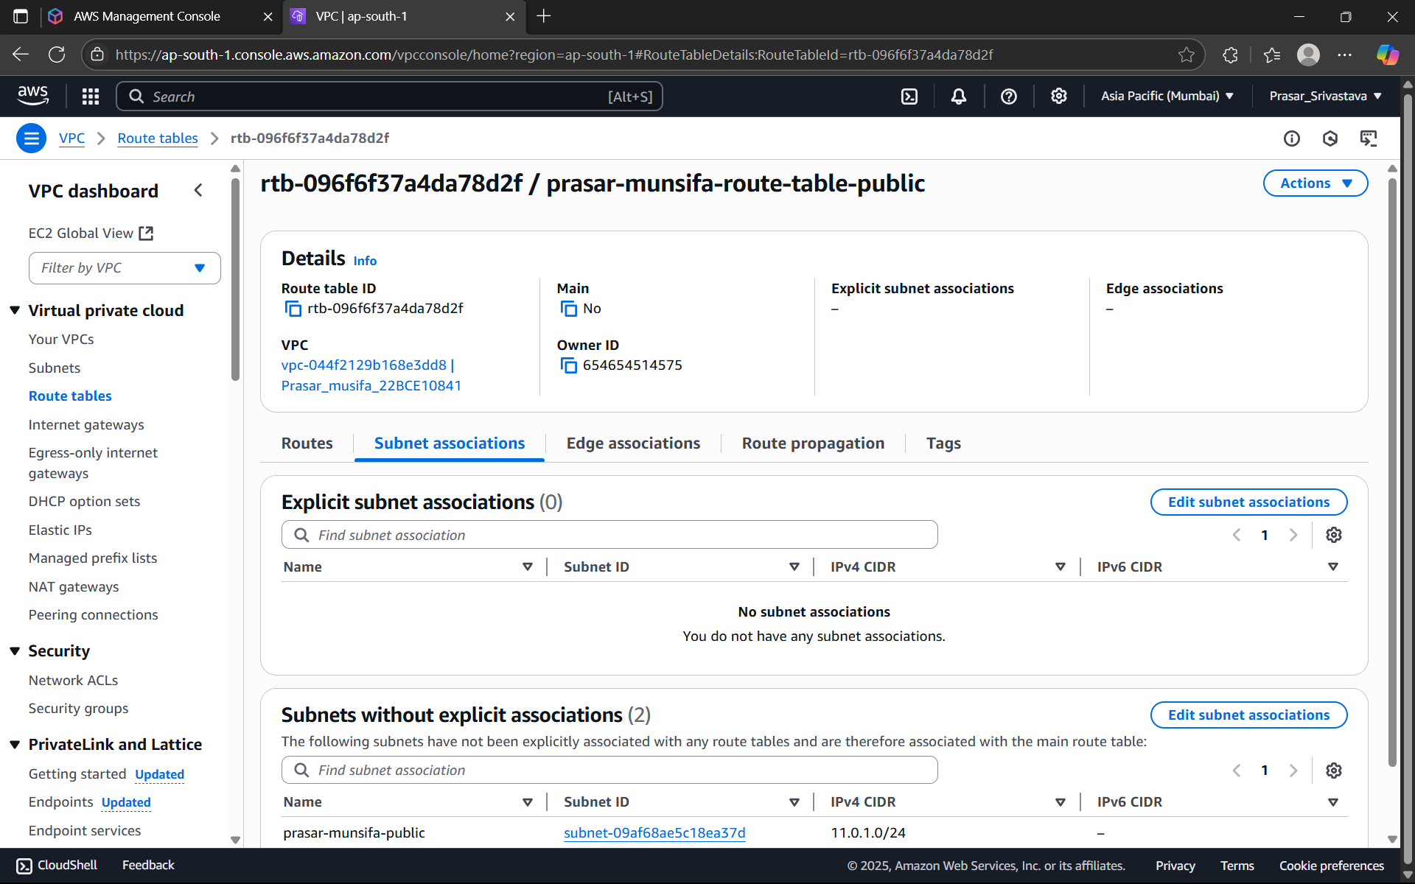

STEP 21: CLICK ON EDIT SUBNET ASSOCIATIONS > CHOOSE PUBLIC SUBNET FROM THE

OPTIONS> CLICK ON SAVE ASSOCIATIONS

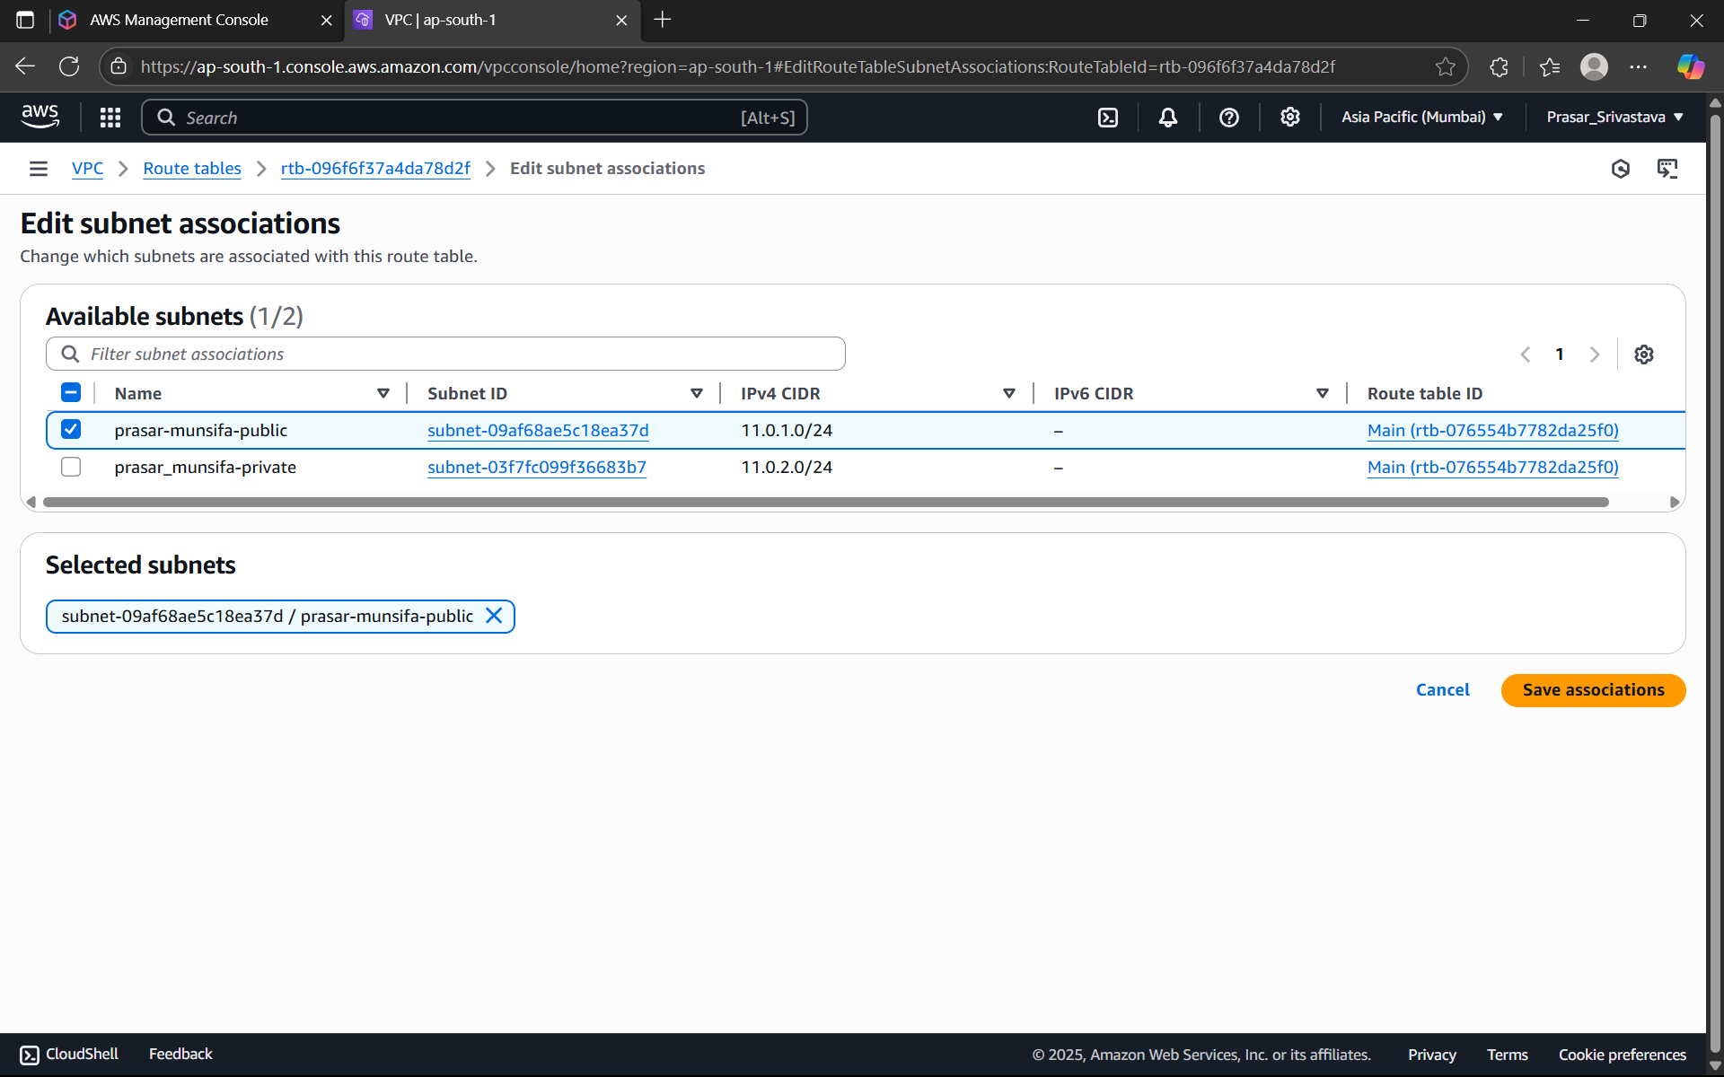

STEP 21: SUBNET ASSOCIATION IS DONE. REPEAT THE SAME STEP FOR PRIVATE SUBNET

ASSOCIATION.

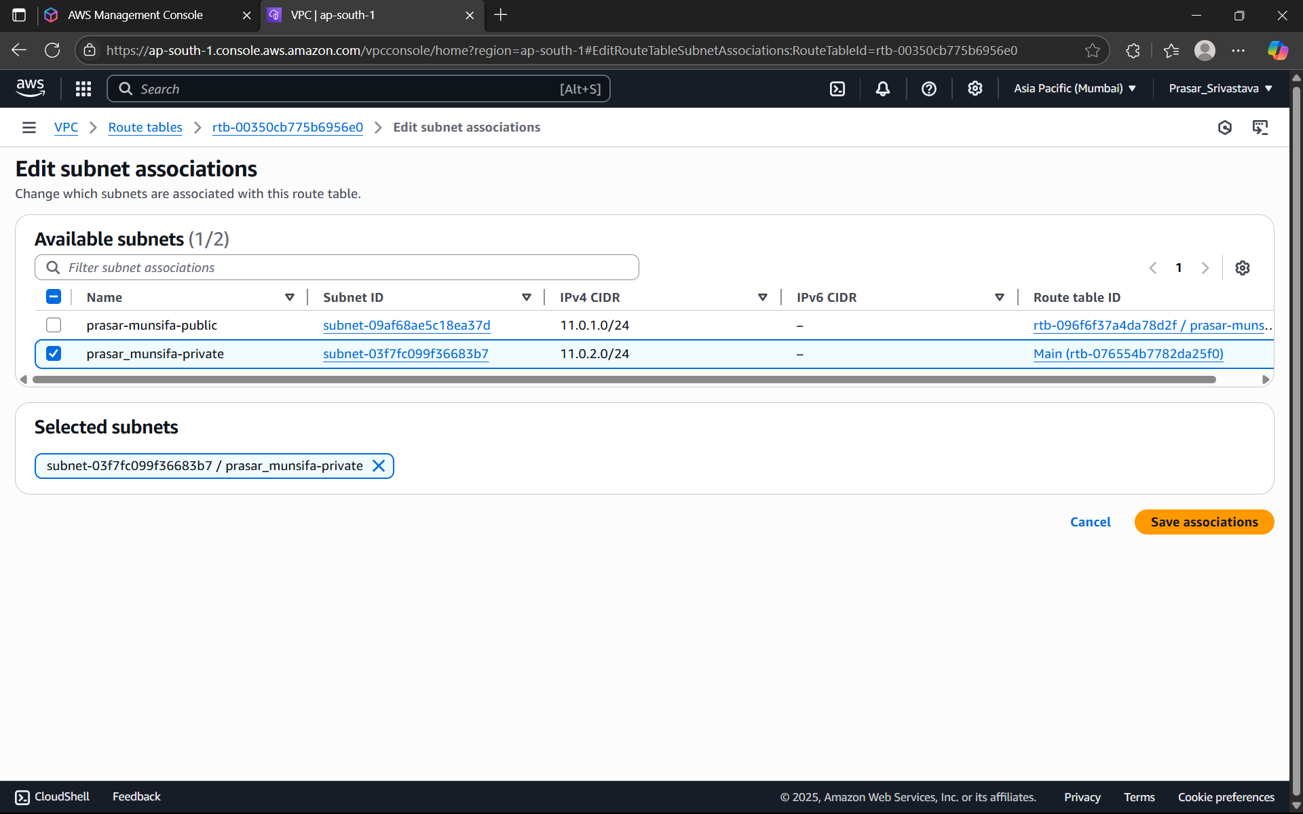

STEP22: NEXT WE NEED TO CREATE THE ROUTE SO THAT INTERNET CAN BE ACCESSED

WITH THE HELP OF INTERNET GATEWAY THROUGH THESE ROUTE TABLES.

STEP23: GO TO PUBLIC ROUTE TABLE FROM THE AWS CONSOLE> CLICK ON ROUTES>CLICK

ON EDIT ROUTES

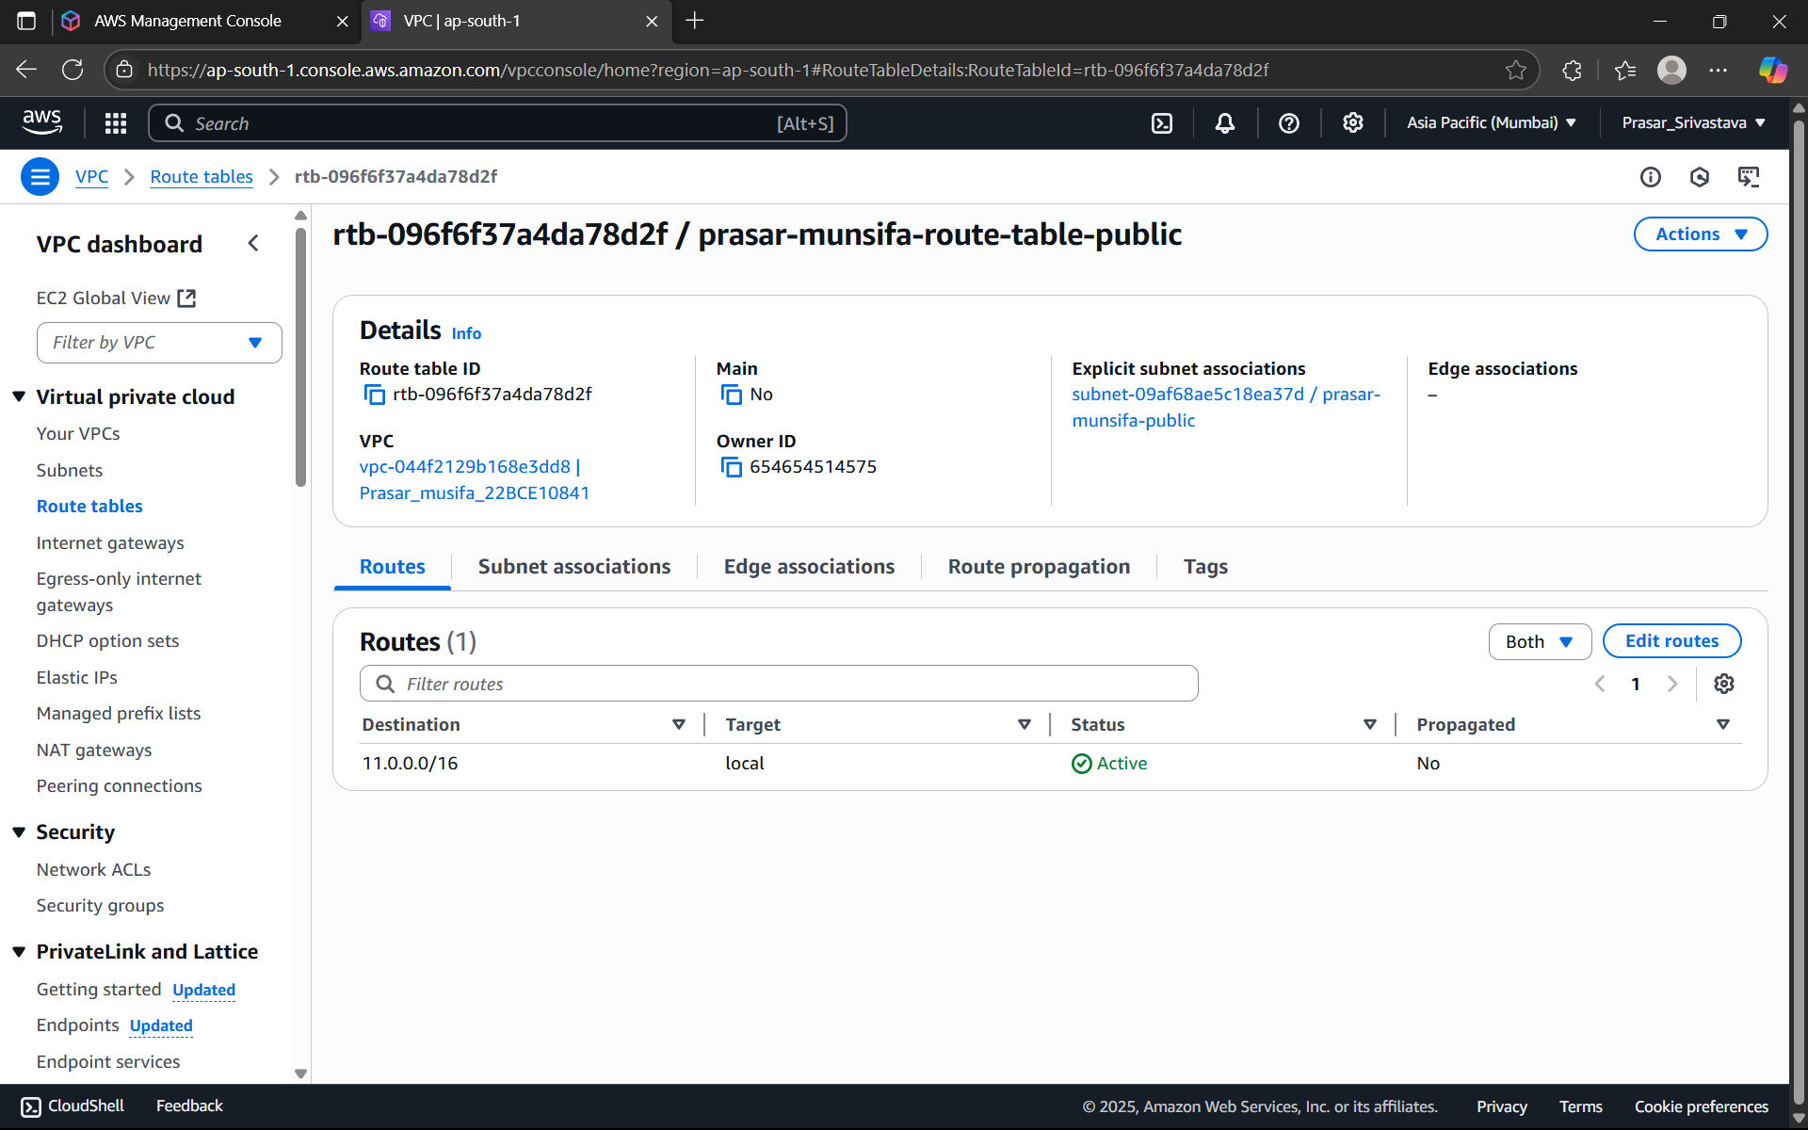

STEP24: CLICK ON ADD ROUTE>SELECT THE IP-0.0.0.0/0>CHOOSE INTERNET GATEWAY>

SELECT THE INTERNET GATEWAY THAT YOU HAVE CREATED> CLICK ON SAVE CHANGES

(NOTE:0.0.0.0/0 means it allows all the IP addresses to access the resources present in the

public subnet)

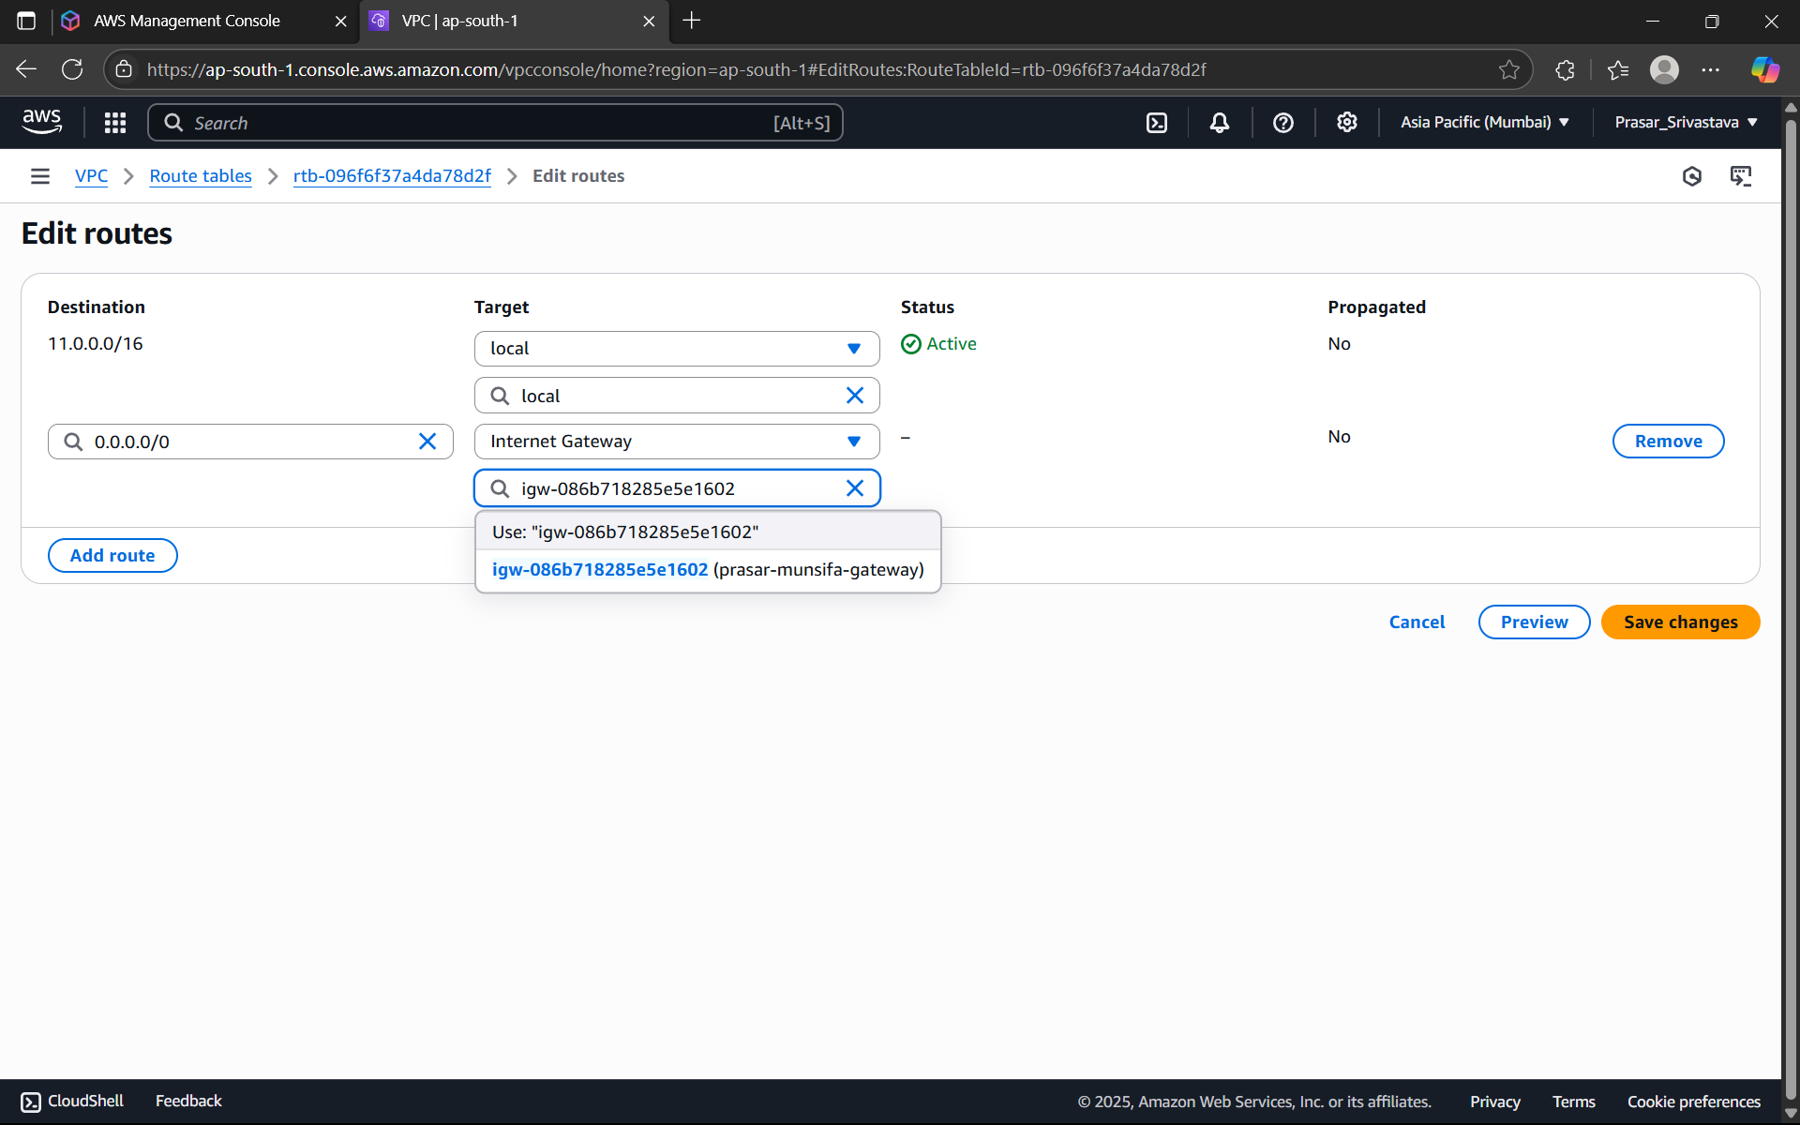

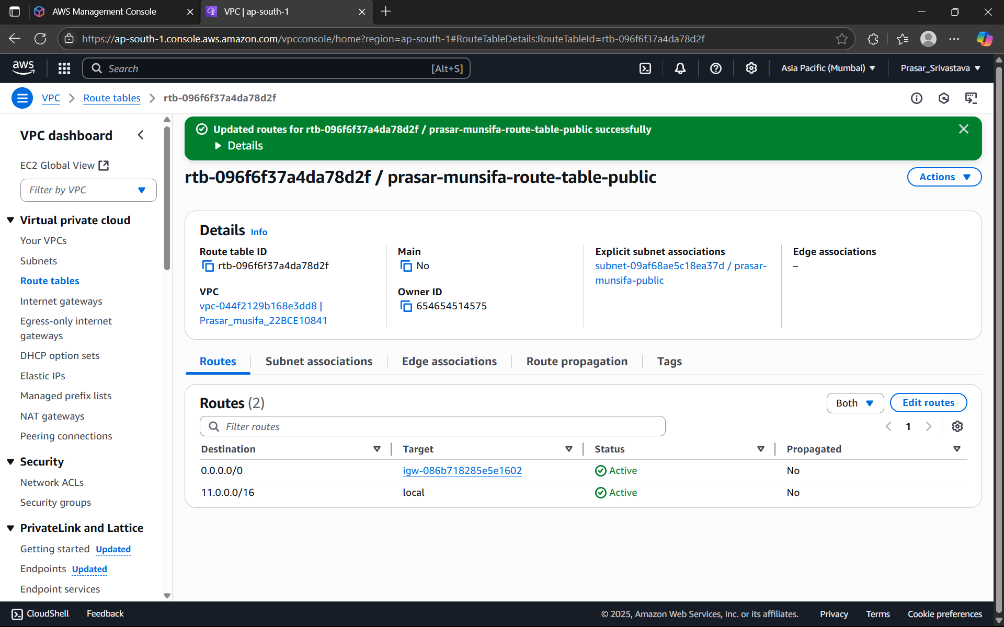

STEP25: WE NEED TO CREATE THE NAT GATEWAY FOR THE PRIVATE SUBNET SO THAT

RESOURCES PRESENT INSIDE THE PRIVATE SUBNET CAN ACCESS THE INTERNET WITH THE

HELP OF INTERNET GATEWAY.

NOTE:

1. Internet Gateway is two-way process i.e., outside world can access the resources

inside the public subnet as well as resources inside it can request for accessing

outside.

2. NAT GATEWAY is not free and its created only in public subnet.

3. Private subnet will be able to access the NAT gateway with the help of its route table

to access resources inside the public subnet.

STEP26: CLICK ON NAT GATEWAYS FROM THE DASHBOARD> CLICK ON CREATE NAT

GATEWAY.

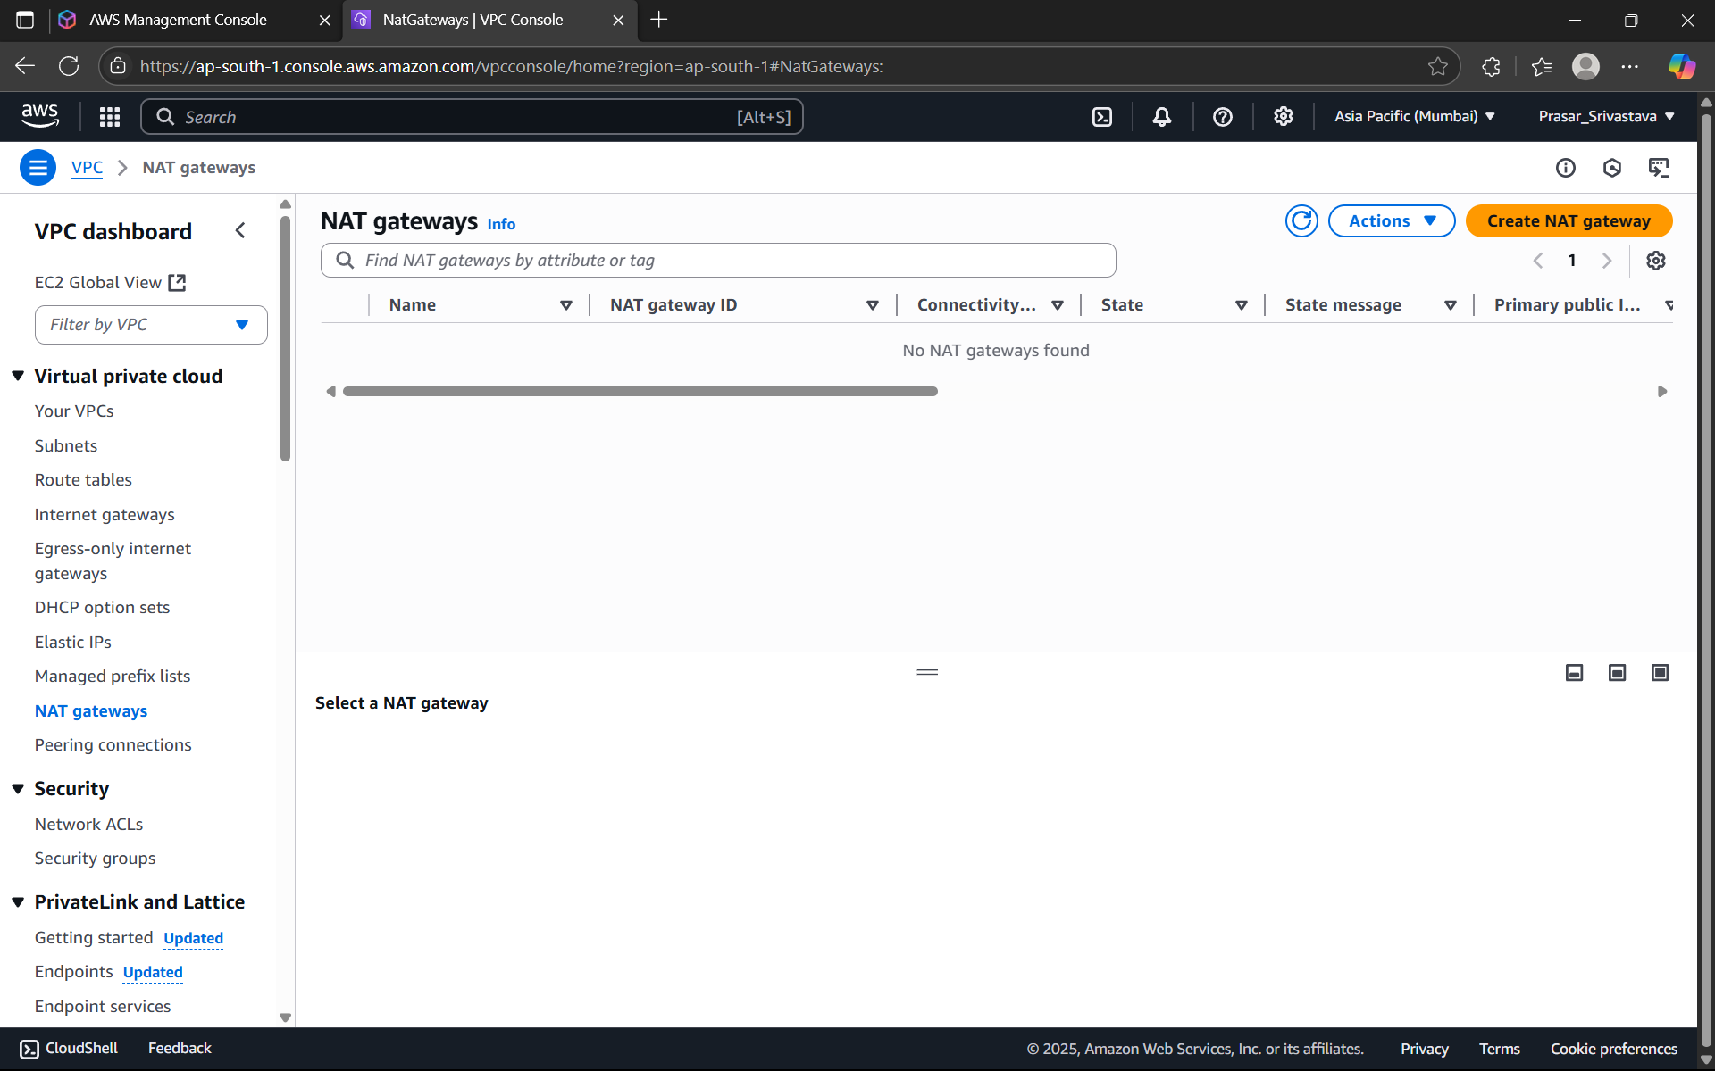

STEP27: GIVE A NAME TO THE NAT GATEWAY>CHOOSE THE PUBLIC SUBNET>ALLOCATE

ELASTIC IP> CLICK ON CREATE NAT GATEWAY.

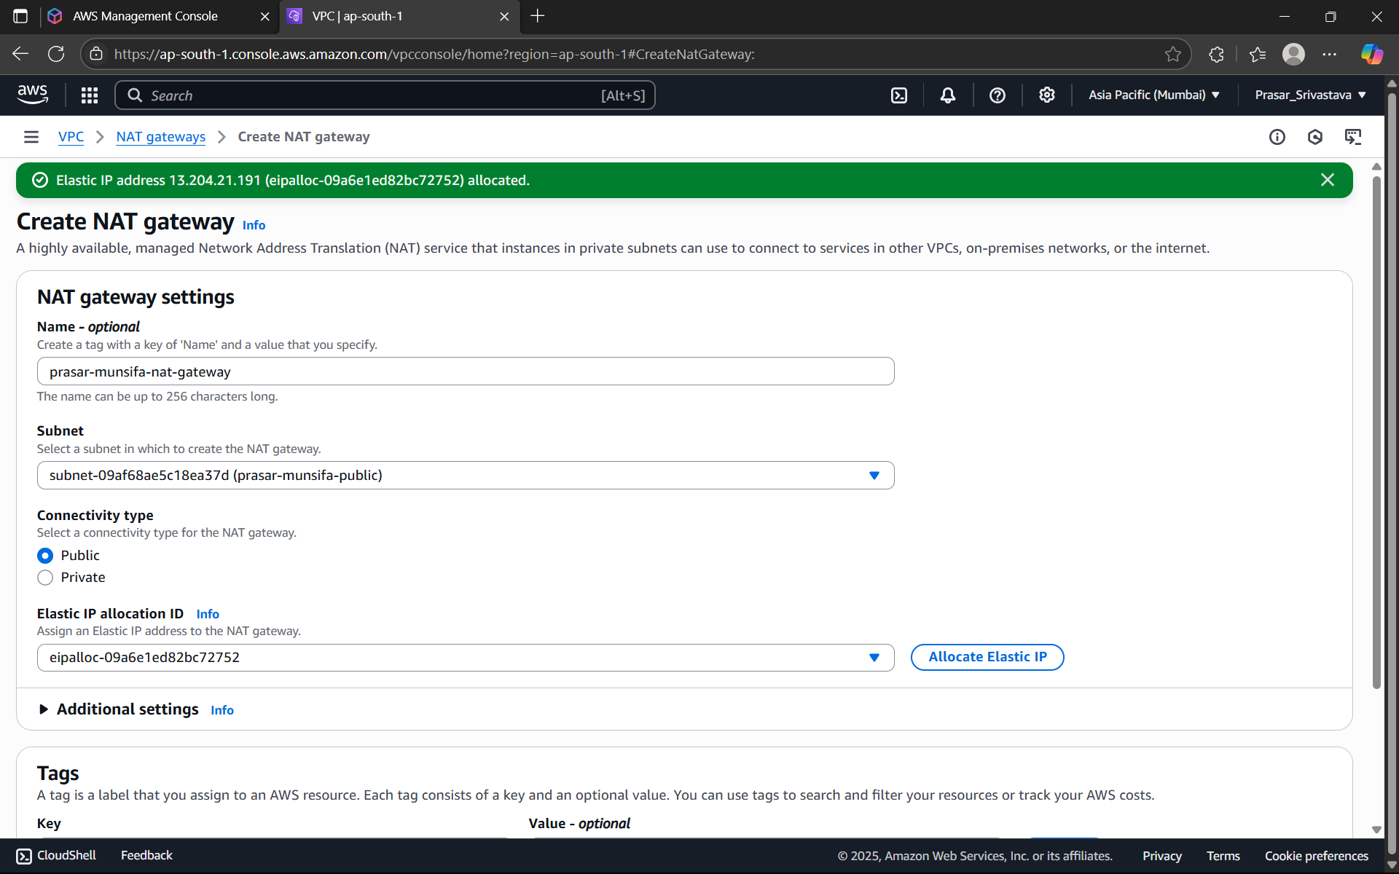

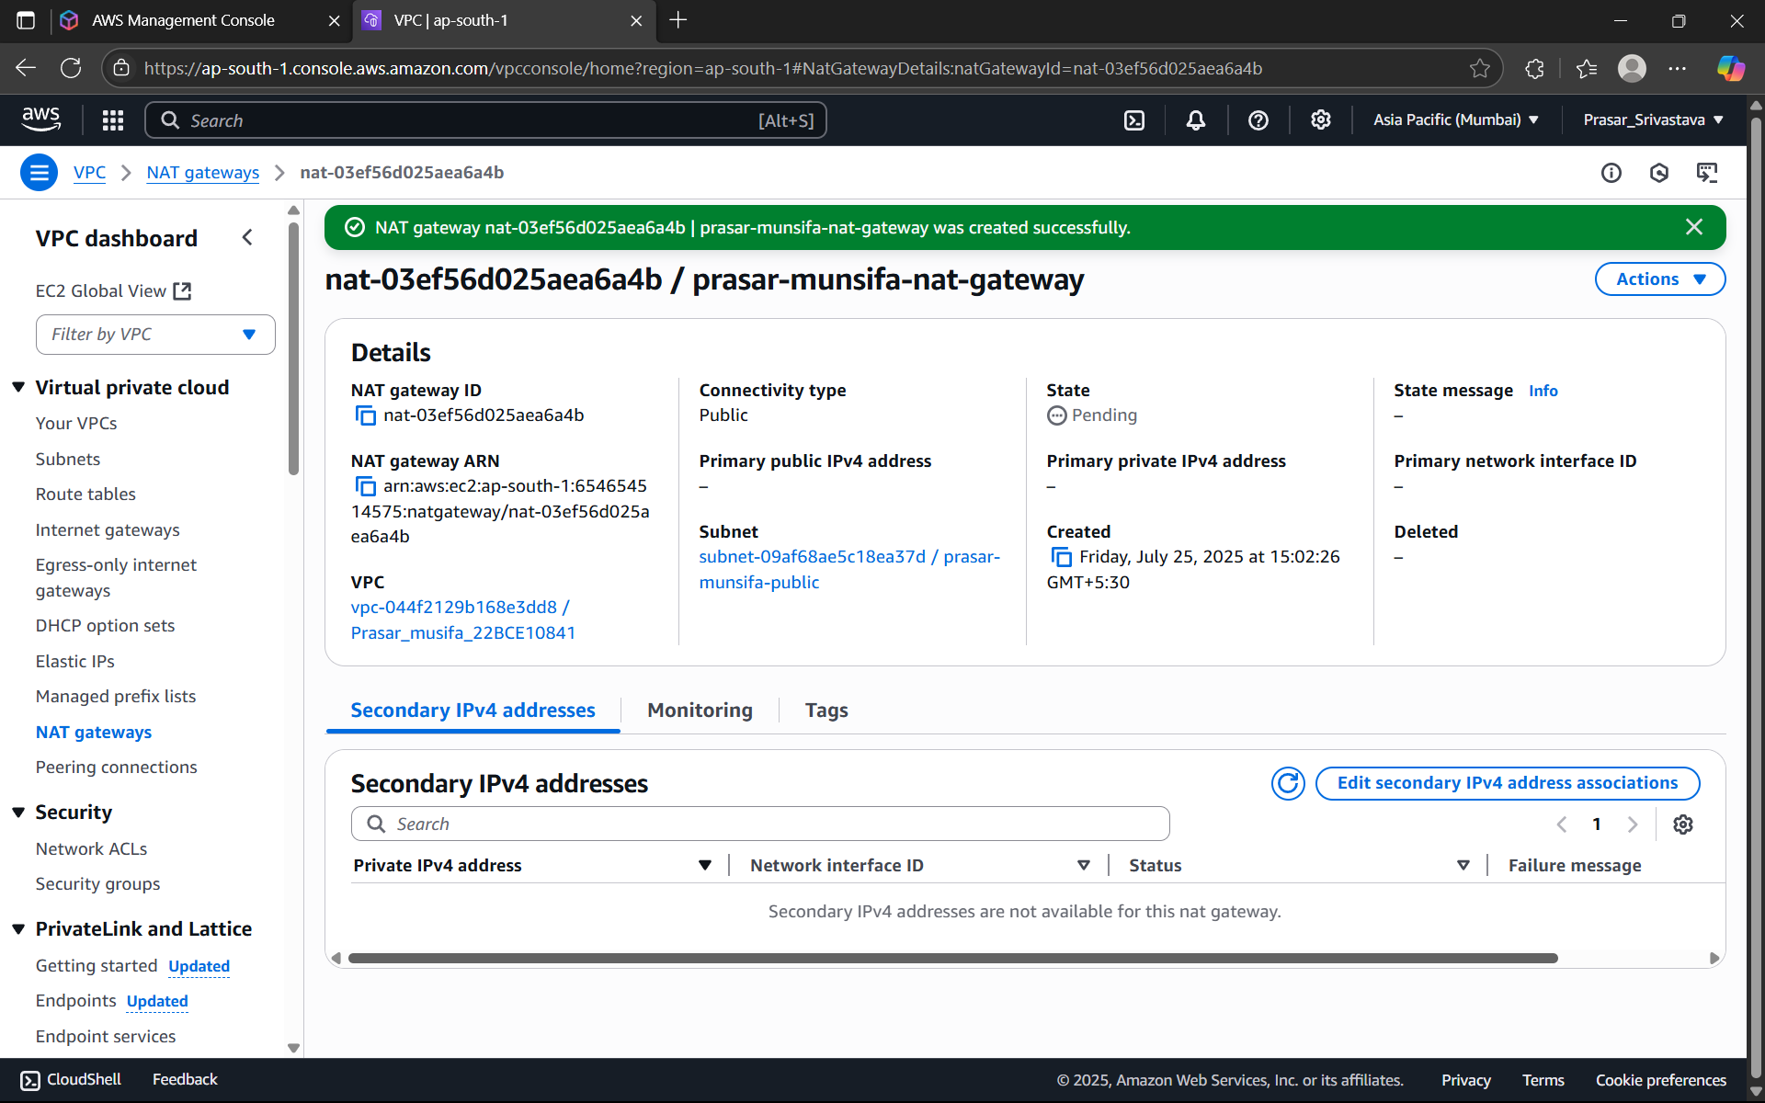

STEP28: NOW UPDATE THE PRIVATE ROUTE TABLE: CLICK ON THE ROUTE TABLES>CLICK ON

THE PRIVATE ROUTE TABLE>CLICK ON ROUTES>CLICK ON EDIT ROUTES

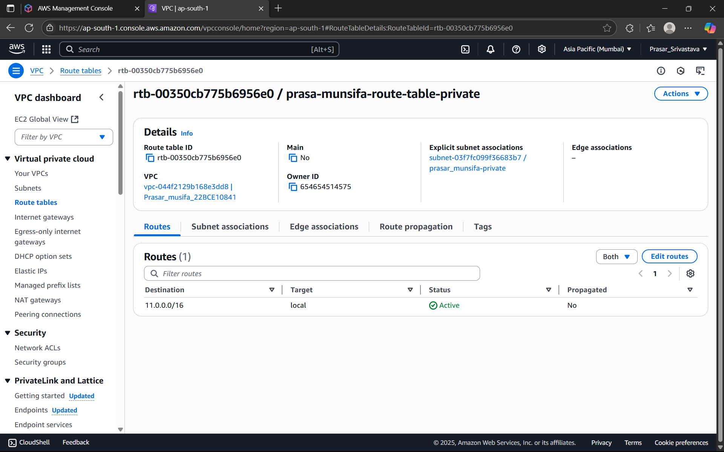

STEP29: CLICK ON ADD ROUTE>SELECT IP ADDRESS

:0.0.0.0/0>SELECT NAT GATEWAY>CHOOSE THE NAT GATEWAY THAT YOU HAVE CREATED>

CLICK ON SAVE CHANGES.

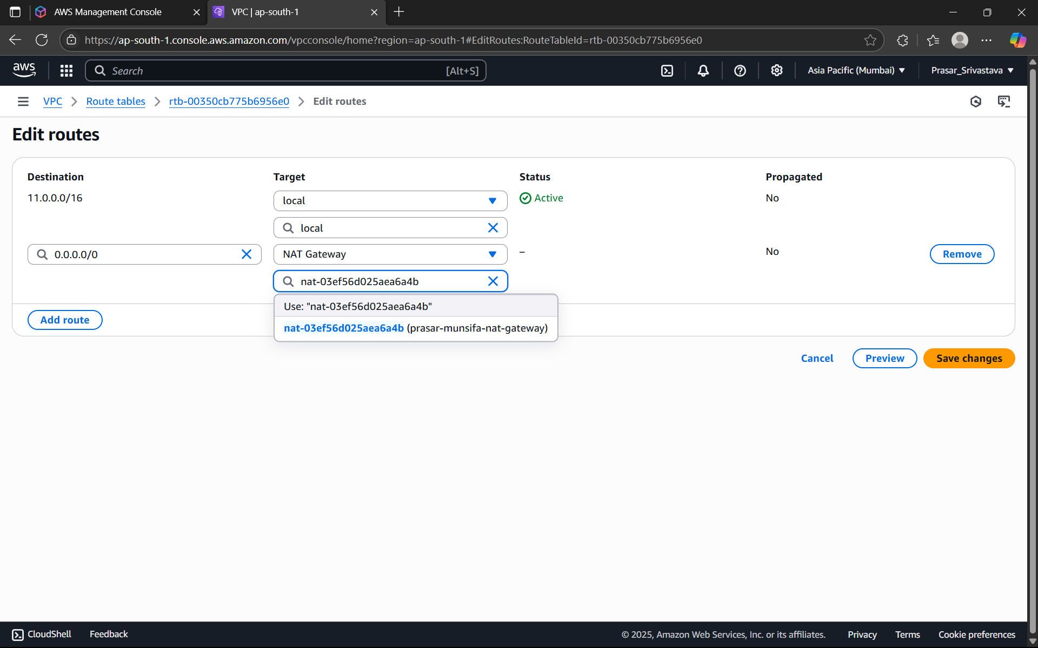

STEP30: PRIVATE SUBNET IS UPDATED WITH NAT GATEWAY

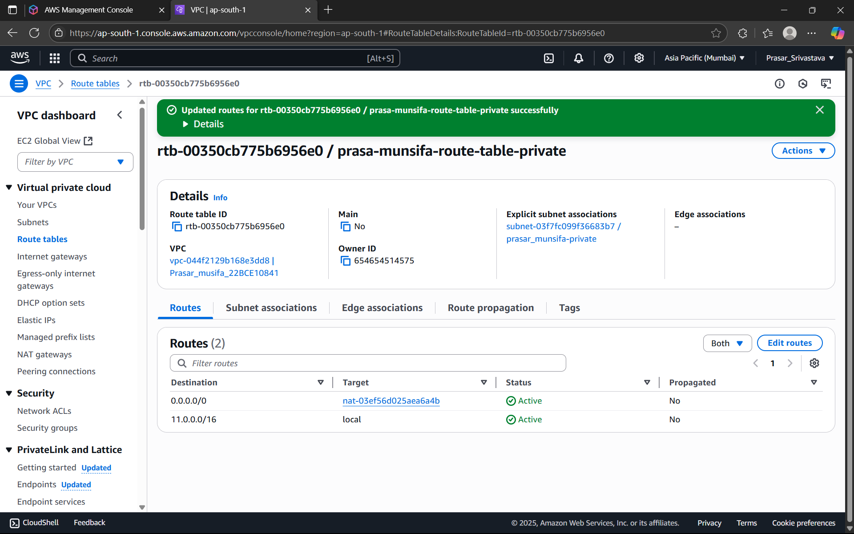

STEP31: WHOLE NETWORK SET UP IS READY, NOW WE HAVE TO CREATE EC2 INSTANCES

FOR BOTH PUBLIC AND PRIVATE SUBNET. SEARCH FOR EC2>CLICK ON EC2

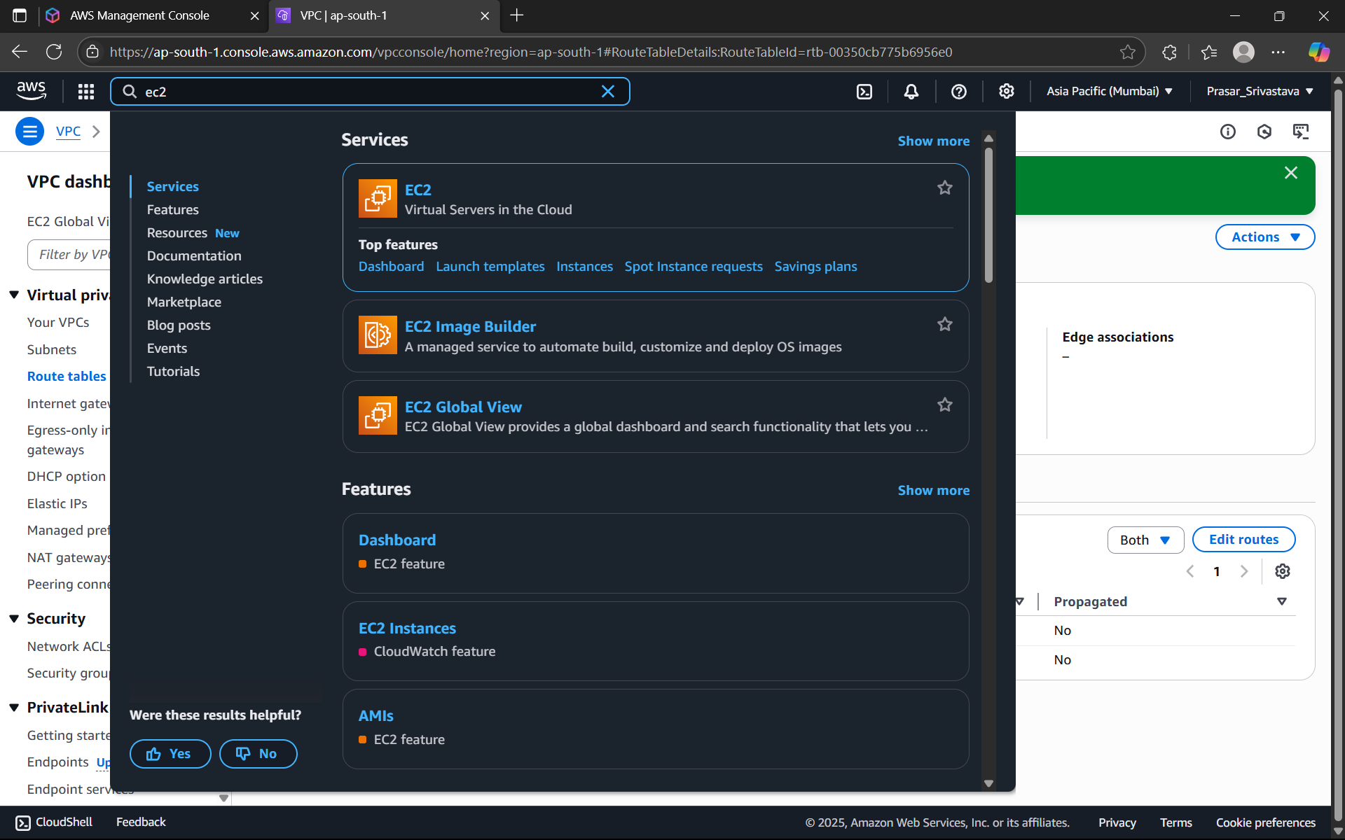

STEP 32: CLICK ON LAUNCH INSTANCE

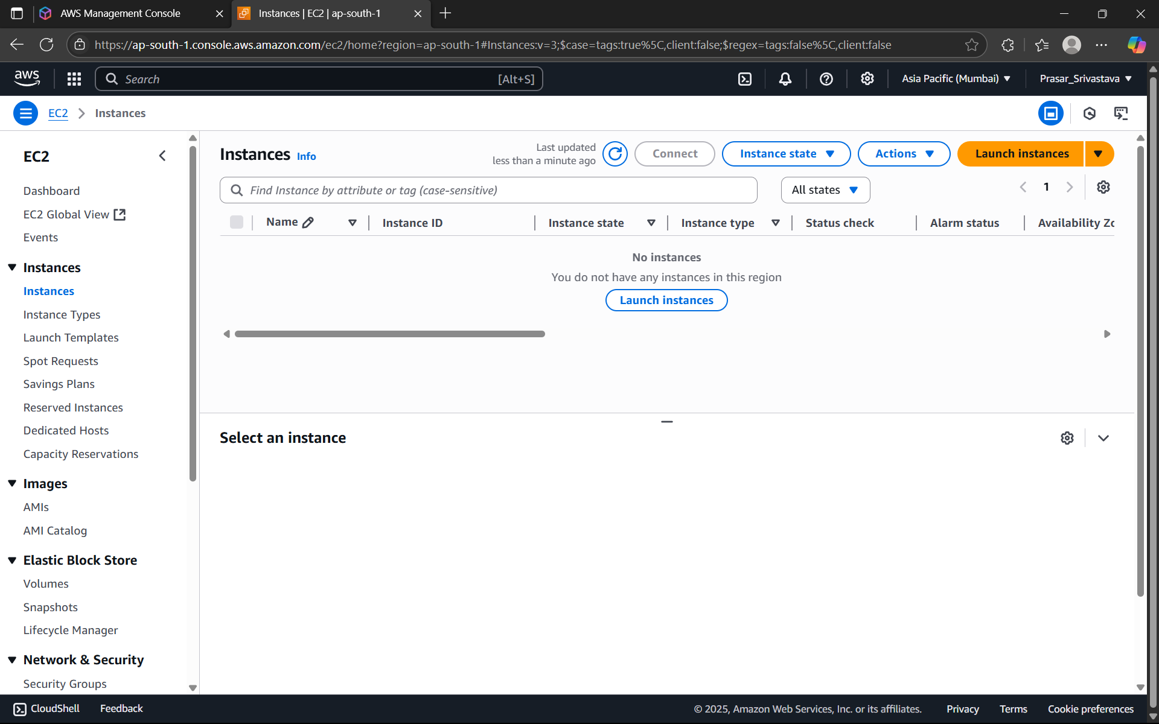

STEP 33: GIVE A SUITABLE INSTANCE NAME>CHOOSE OS:UBUNTU

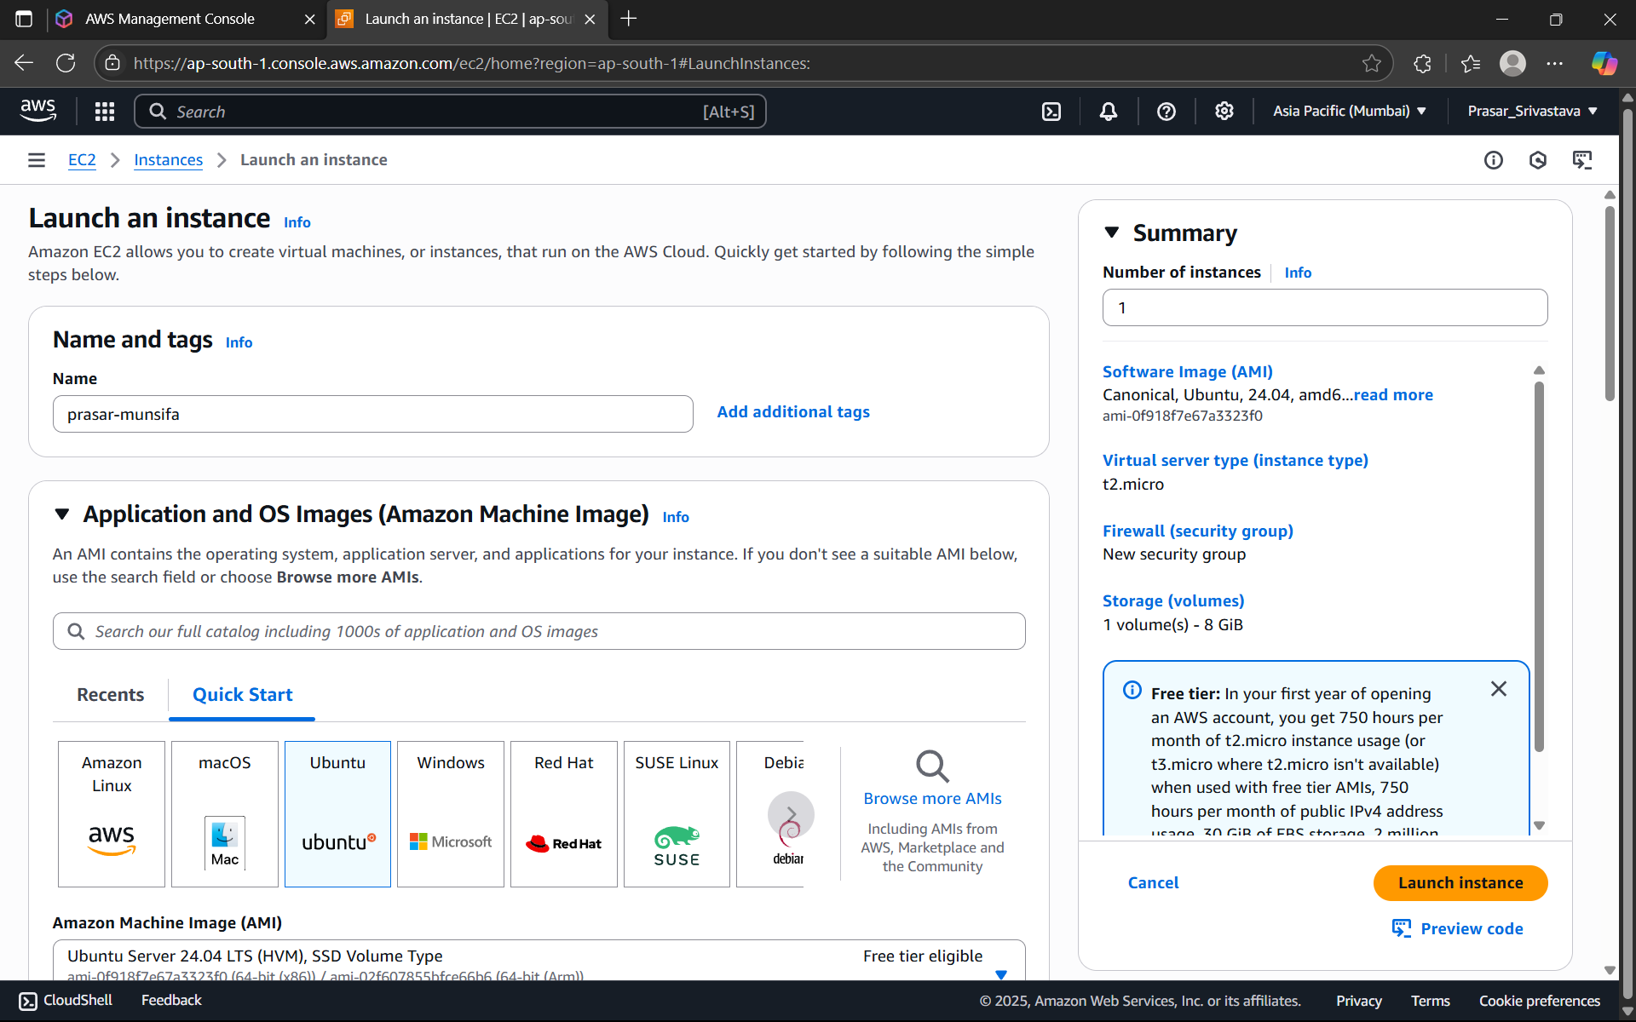

STEP 34: CHOOSE THE DEFAULT ARCHITECTURE> FREE TIER INSTANCE TYPE

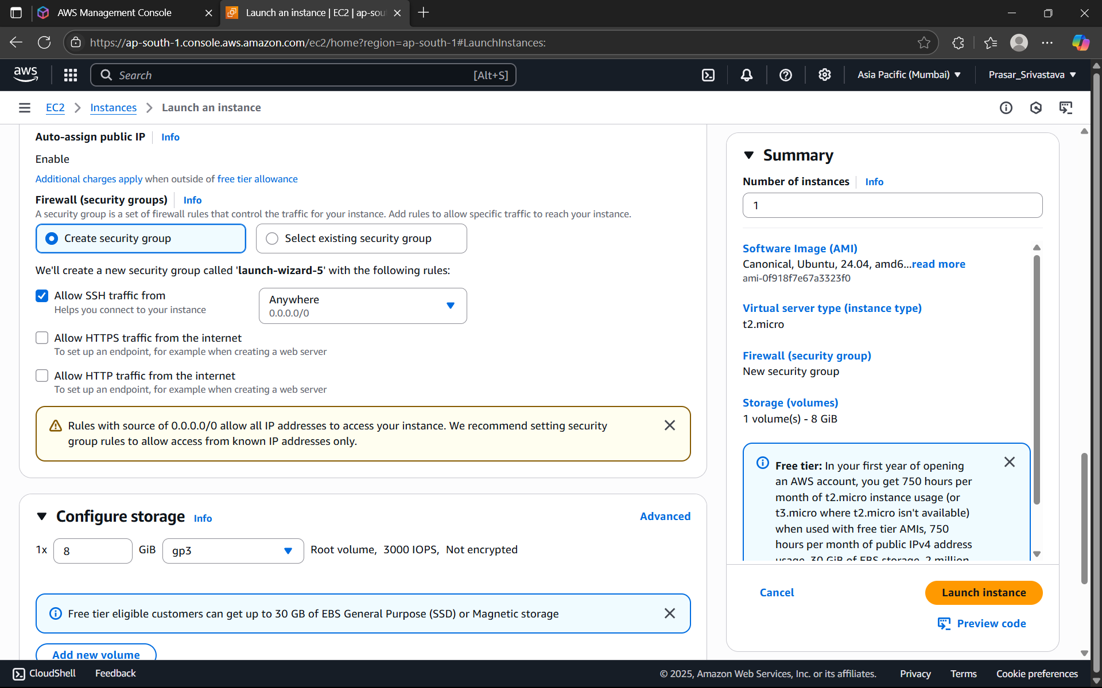

STEP 35: CREATE KEY PAIR

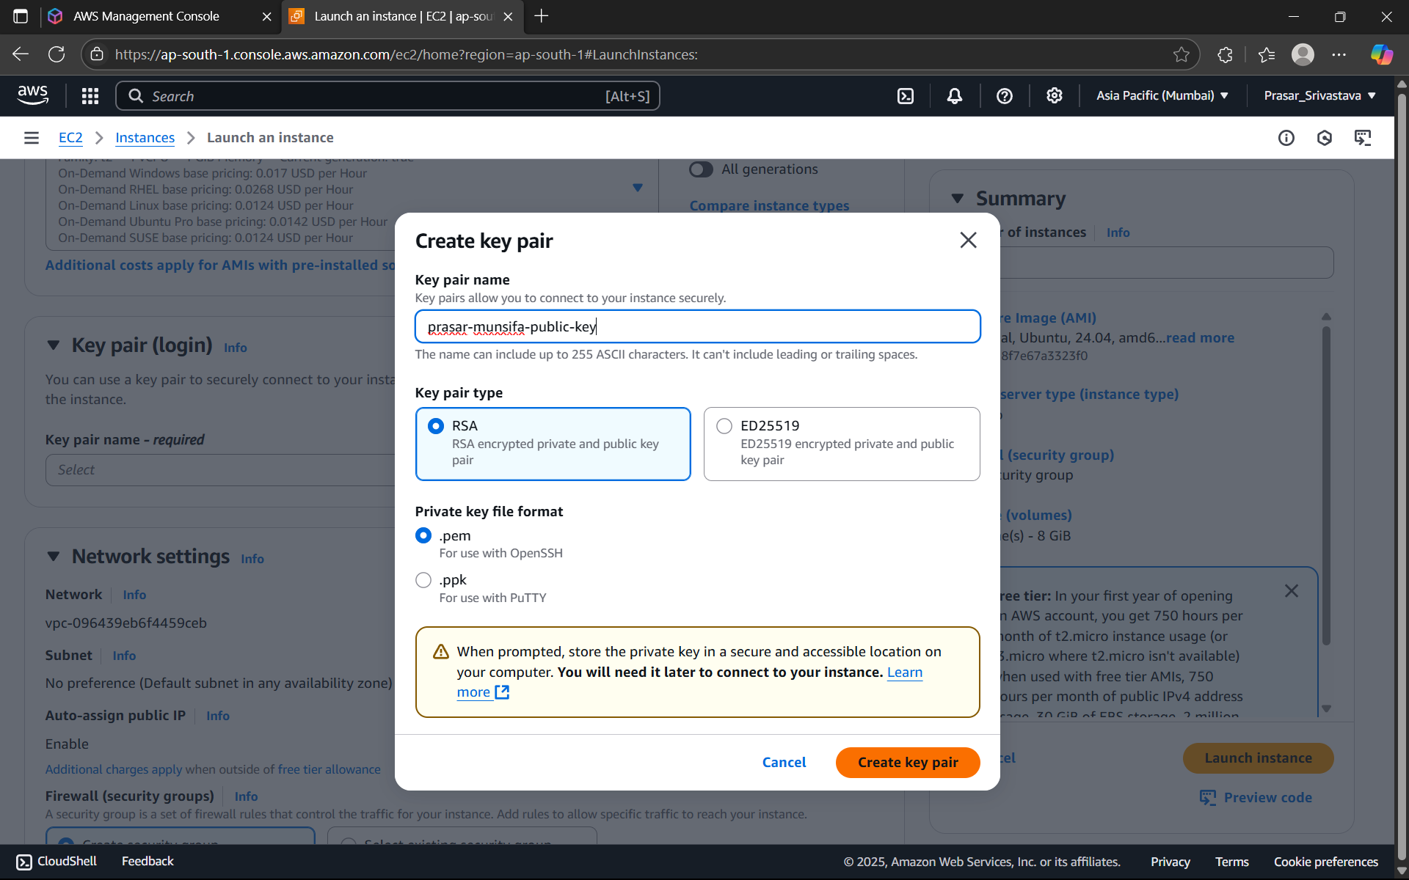

STEP 36: EDIT THE NETWORK SETTING>CHOOSE THE VPC CREATED EARLIER>SELECT THE

PUBLIC SUBNET> ENABLE THE AUTO-ASSIGN PUBLIC IP>CHOOSE CREATE SECURITY GROUP

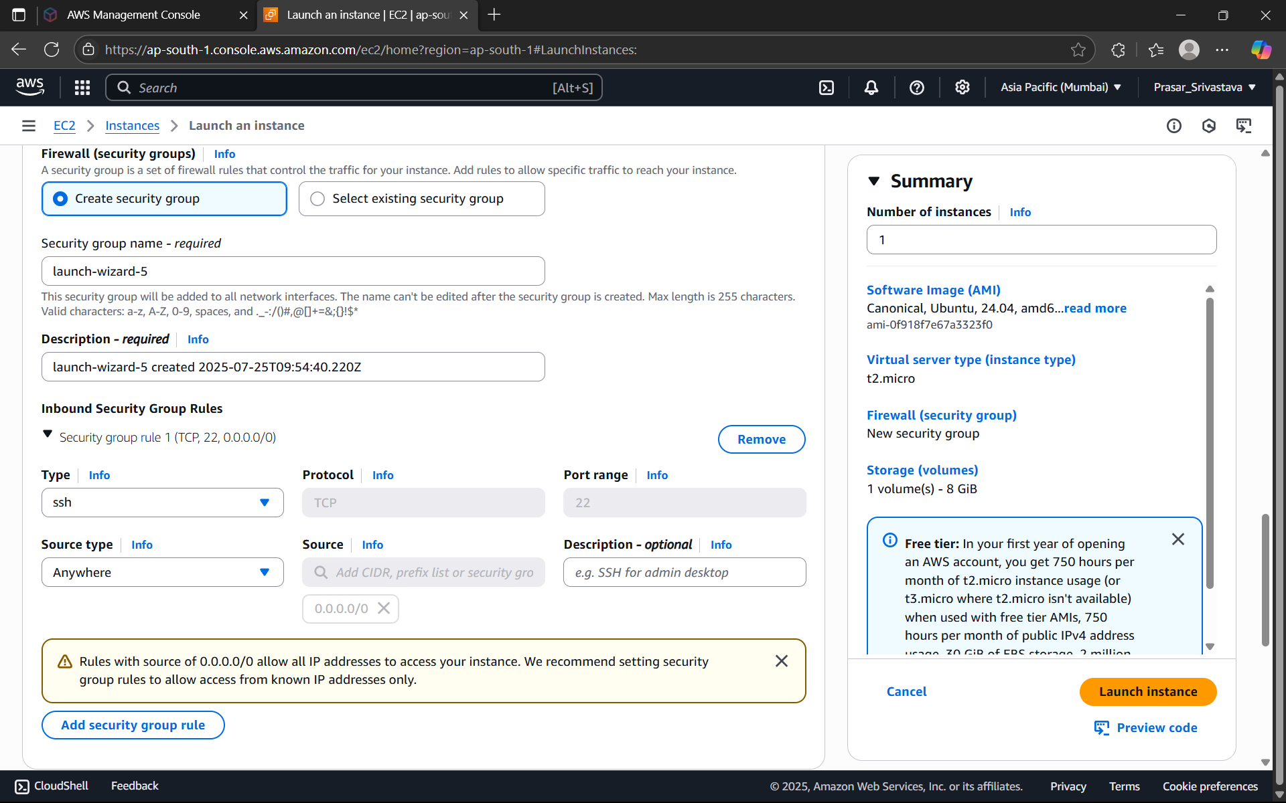

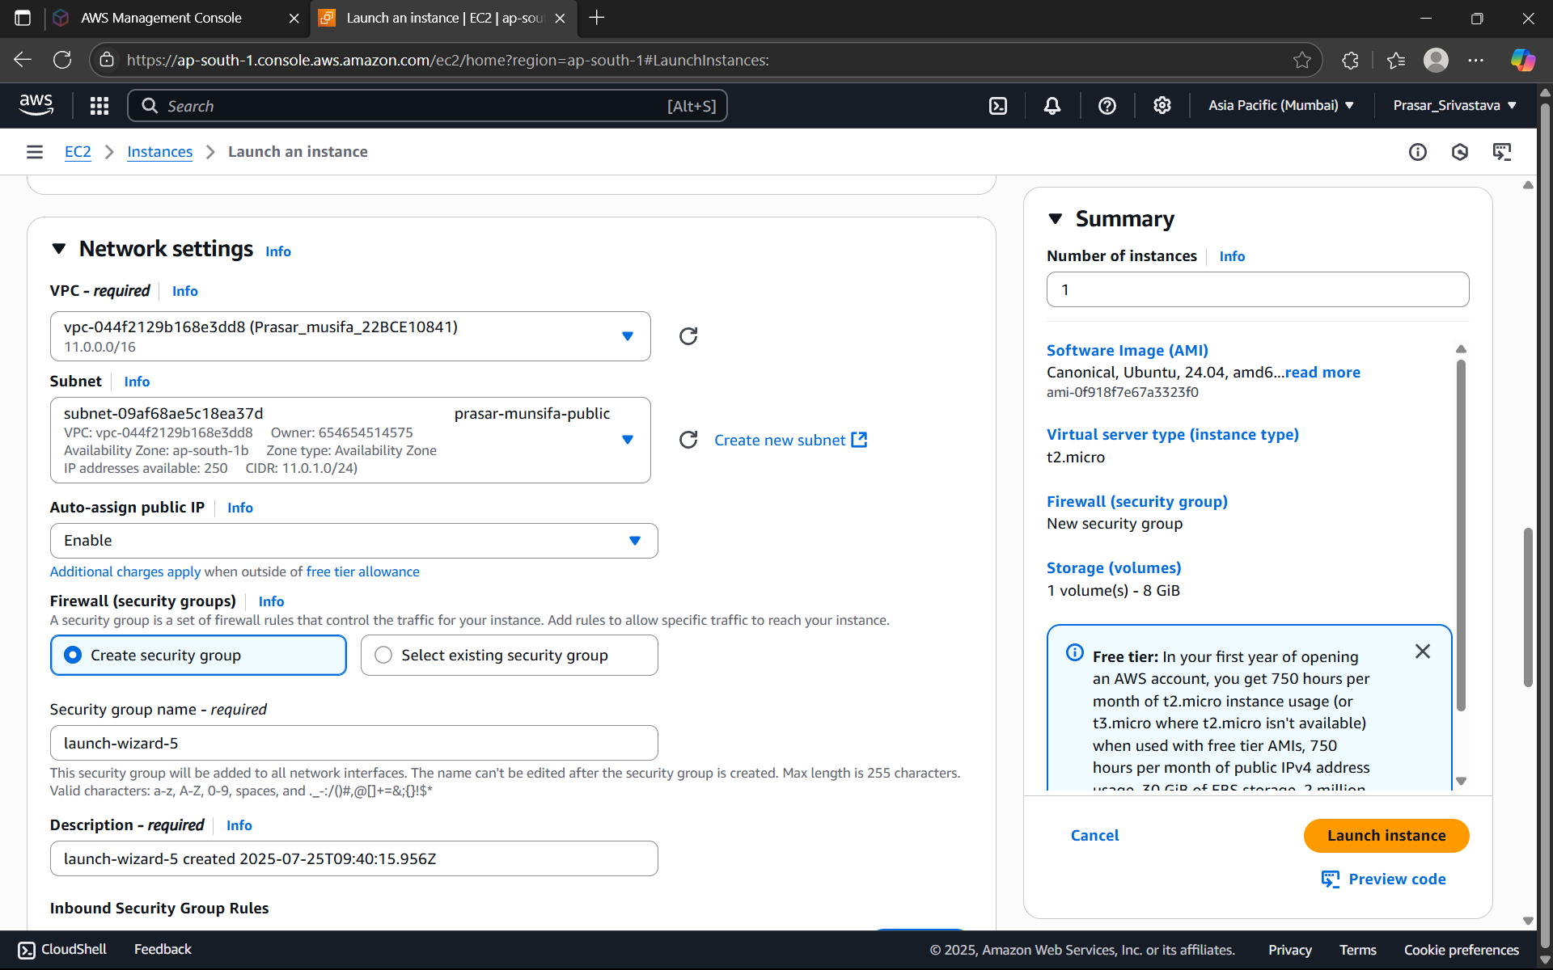

STEP 37: SECURITY GROUP RULE-1 IS DEFAULT> CLICK ON ADD SECURITY GROUP RULE



STEP 38: CHOOSE ALL ICMP-IPV4> SOURCE:0.0.0.0/0

STEP 39: CHOOSE DEFAULT CONFIGURE STORAGE: 8GB>CLICK ON LAUNCH INSTANCE

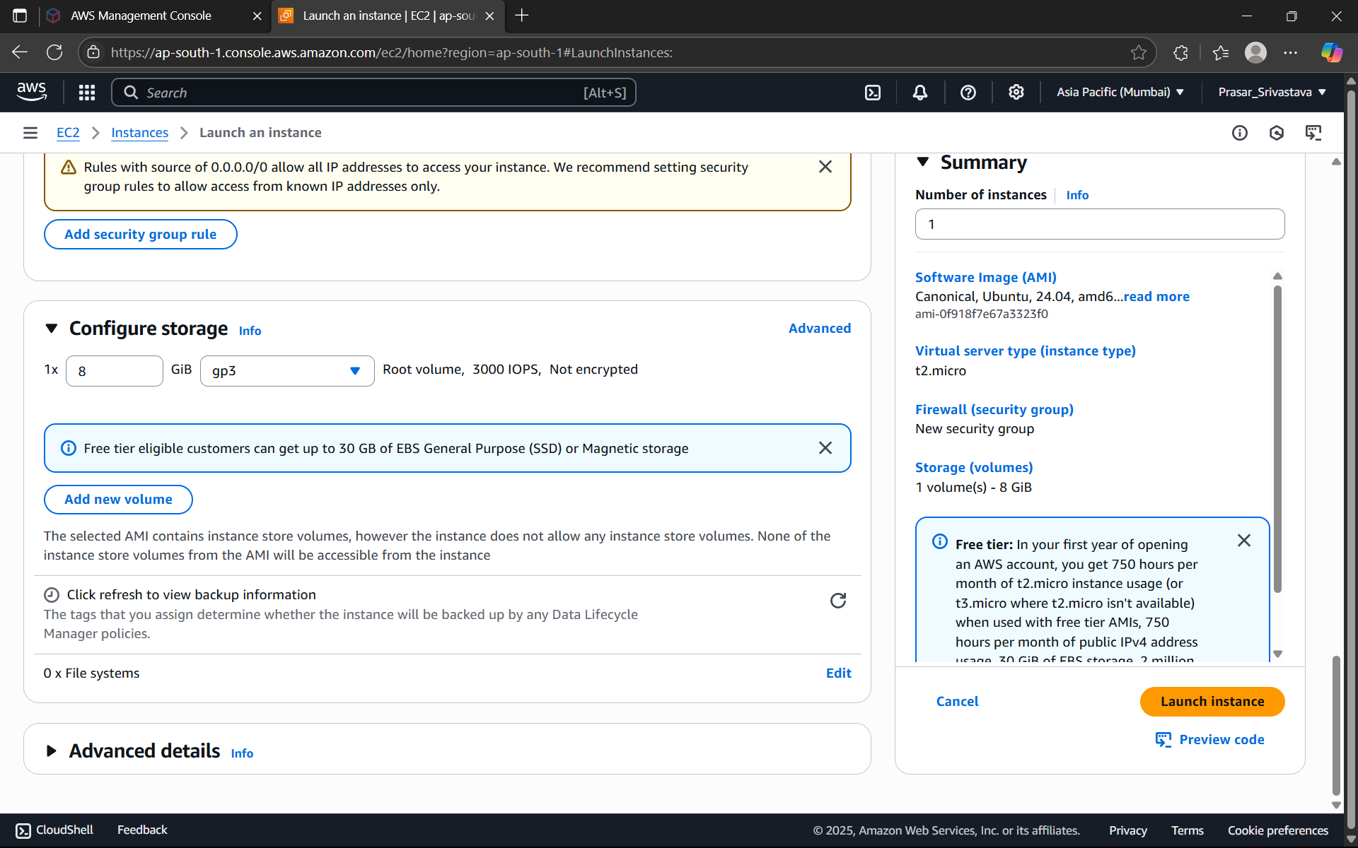

STEP 40: PUBLIC INSTANCE CREATED

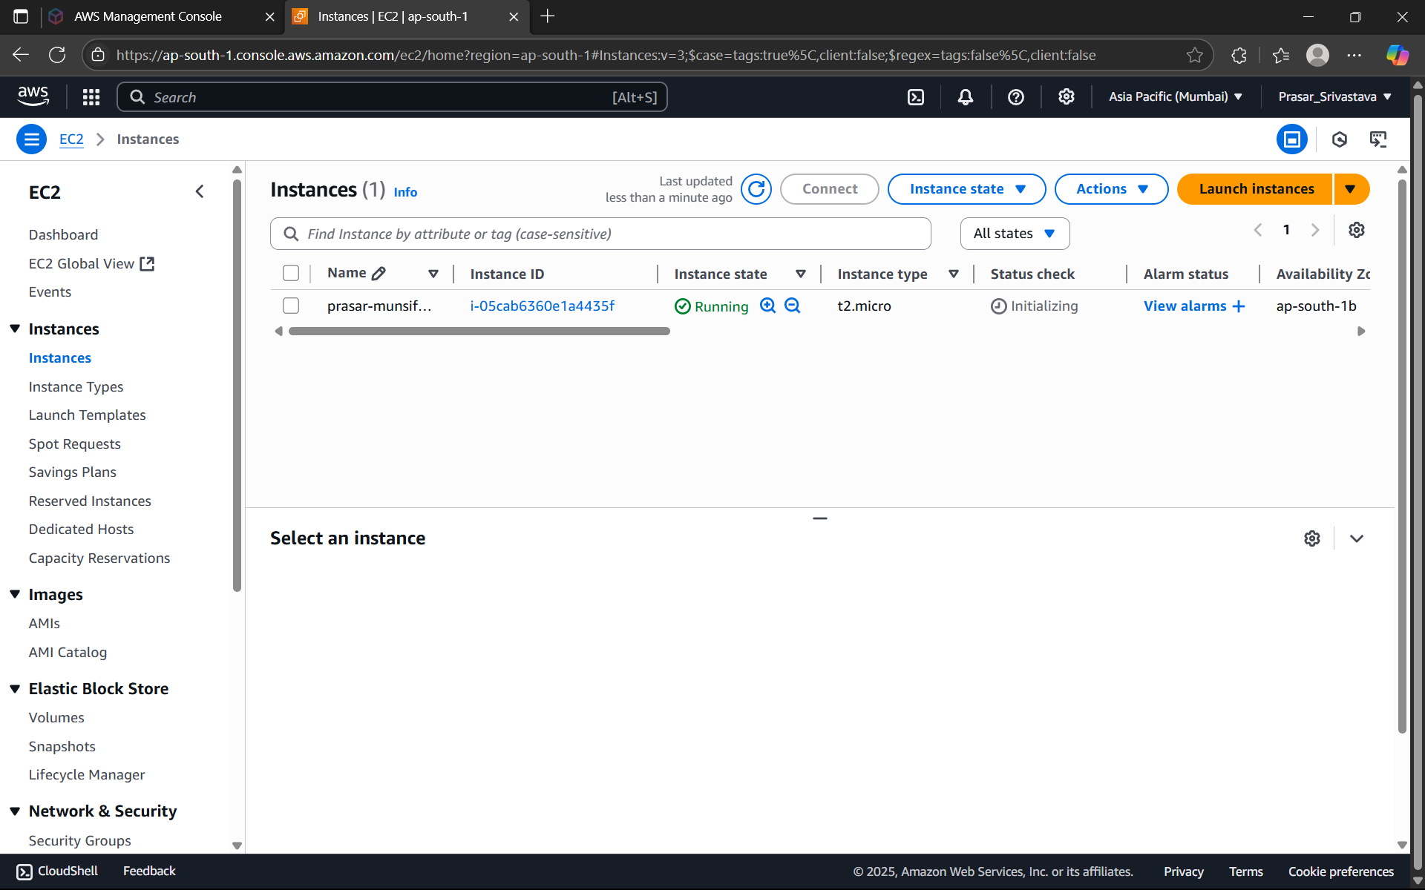

STEP 41: CREATE EC2 INSTANCE FOR PRIVATE SUBNET WITH THE SAME STEPS

DISABLE AUTO-ASSIGN-PUBLIC IP.

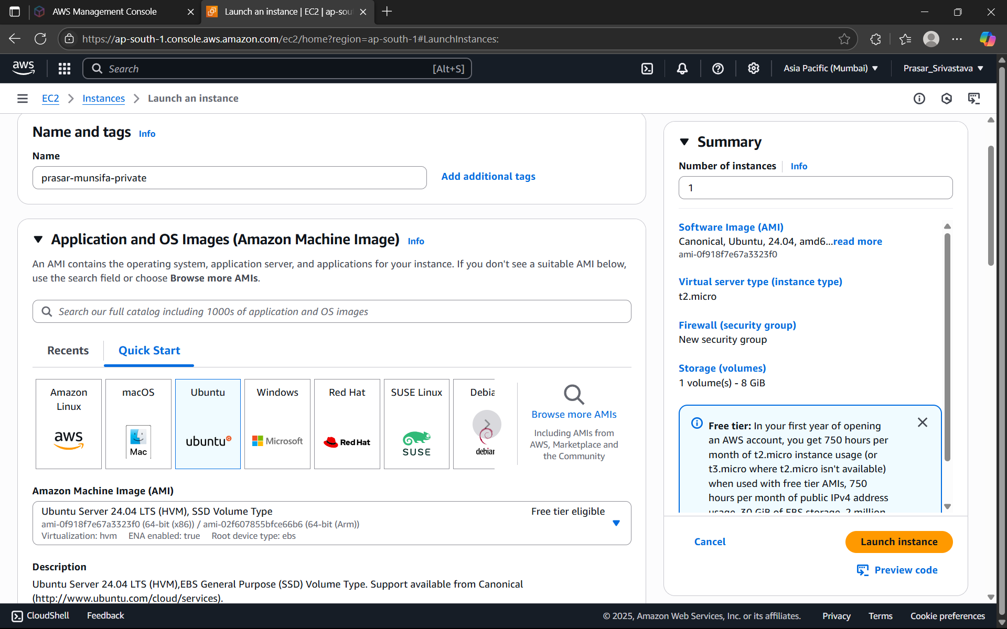

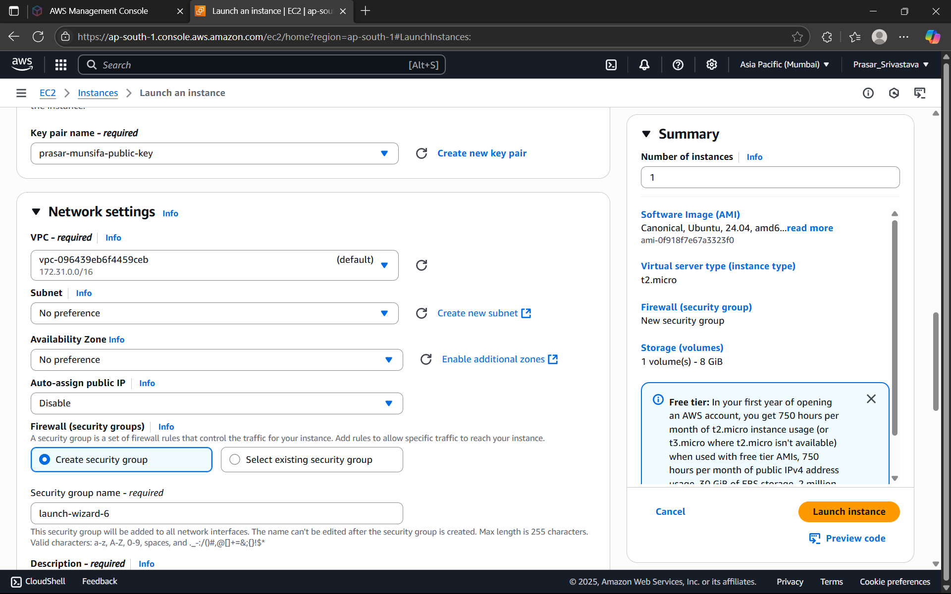

STEP 42: ADD SECURITY GROUP RULE>CHOOSE ALL ICMP-IPV4>

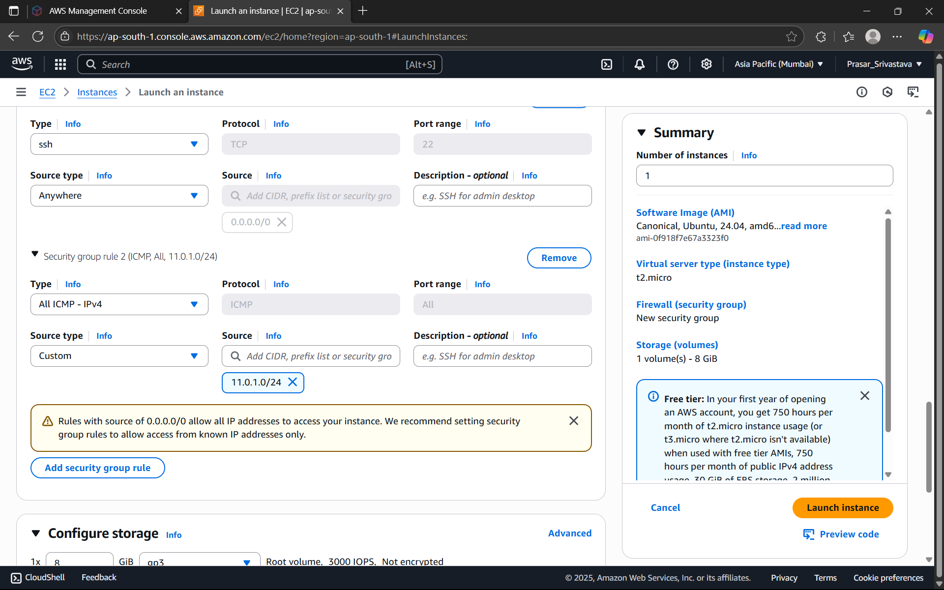

SOURCE:11.0.1.0/24(PUBLIC SUBNET IP ADDRESS, COZ ONLY PUBLIC SUBNET CAN ACCESS

THE PRIVATE SUBNET)>KEEP DEFAULT STORAGE>CLICK ON LAUNCH INSTANCE

STEP 43: PRIVATE EC2 INSTANCE IS CREATED

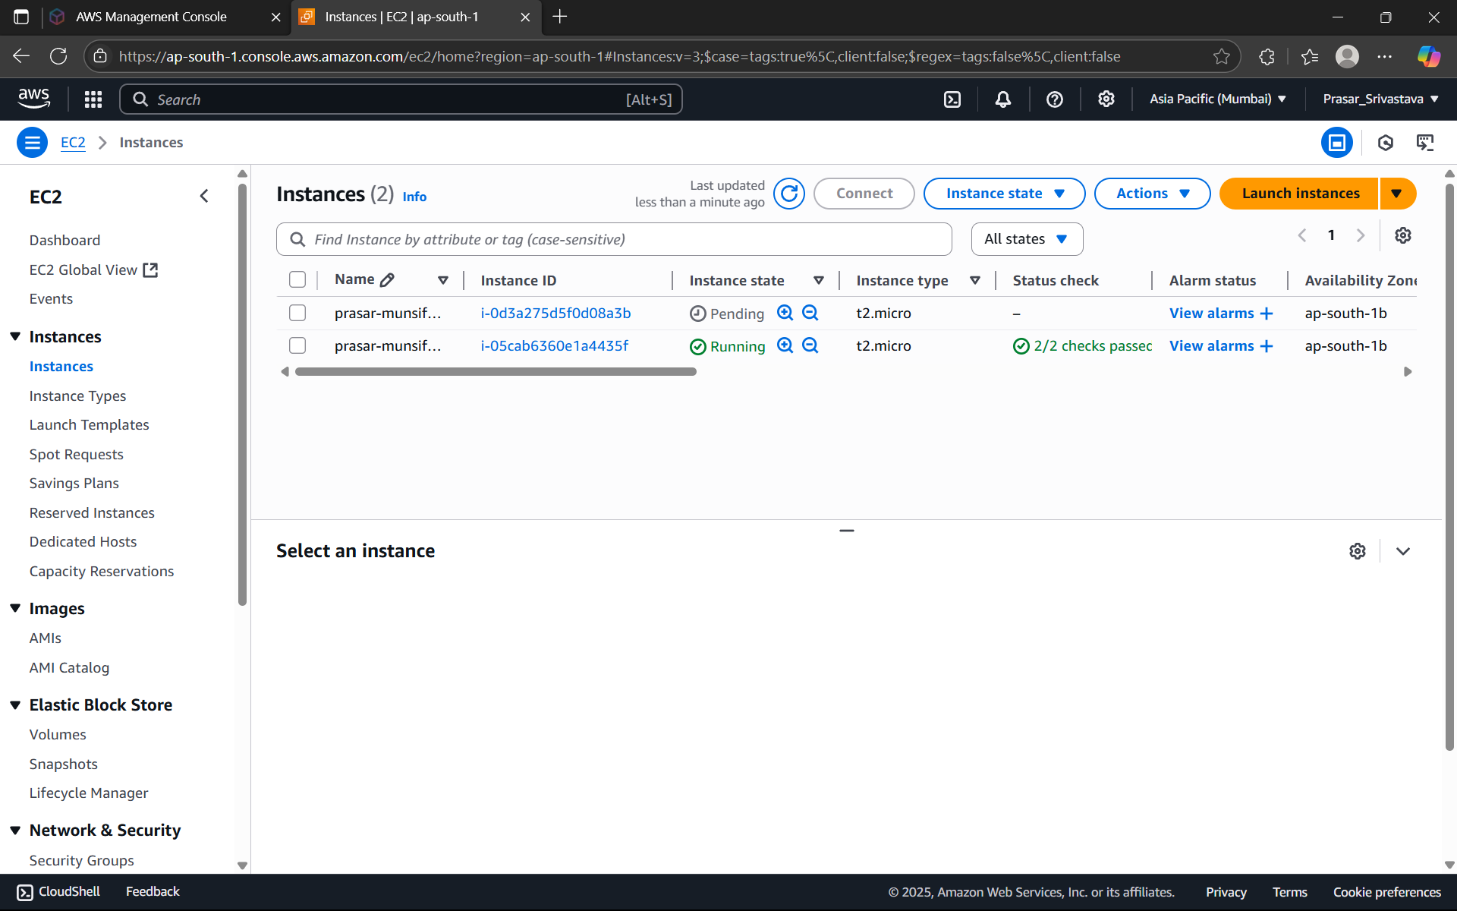

STEP 44: NOW CONNECT THE PUBLIC EC2 INSTANCE.CLICK ON THE PUBLIC INSTANCE>

CLICK ON CONNECT

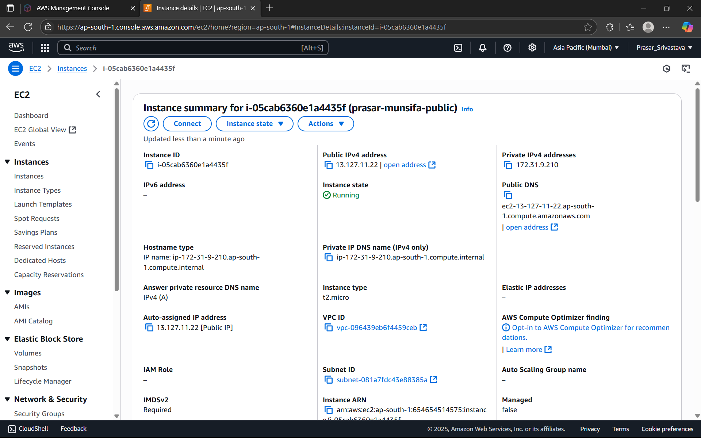

STEP 45: CLICK ON SSH CLIENT> COPY THE EXAMPLE AND PASTE IN TERMINAL TO

CONNECT

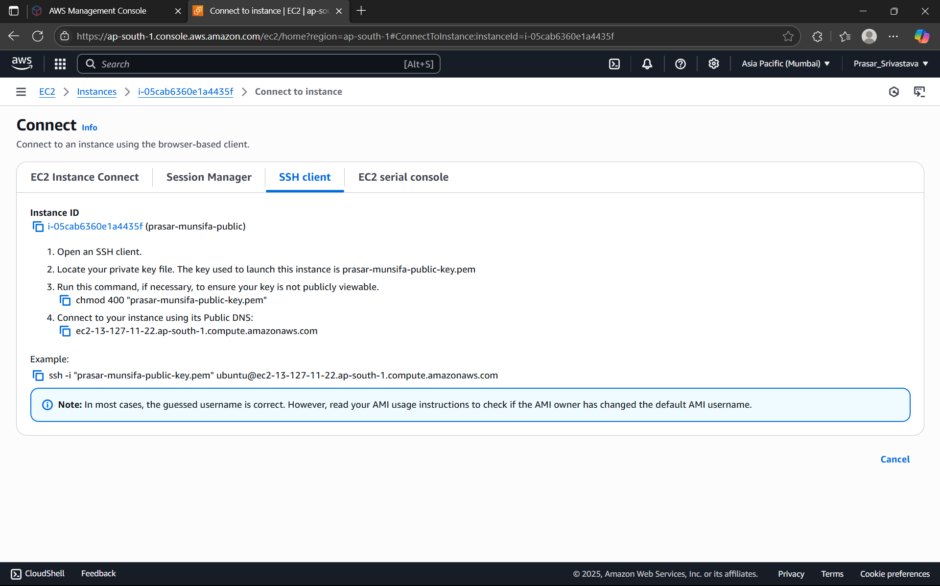

STEP 46: OPEN THE TERMINAL IN YOUR LAPTOP AND TYPE THE FOLLOWING COMMAND>

NOW PASTE THE COMMAND HERE FROM THE SSH CLIENT

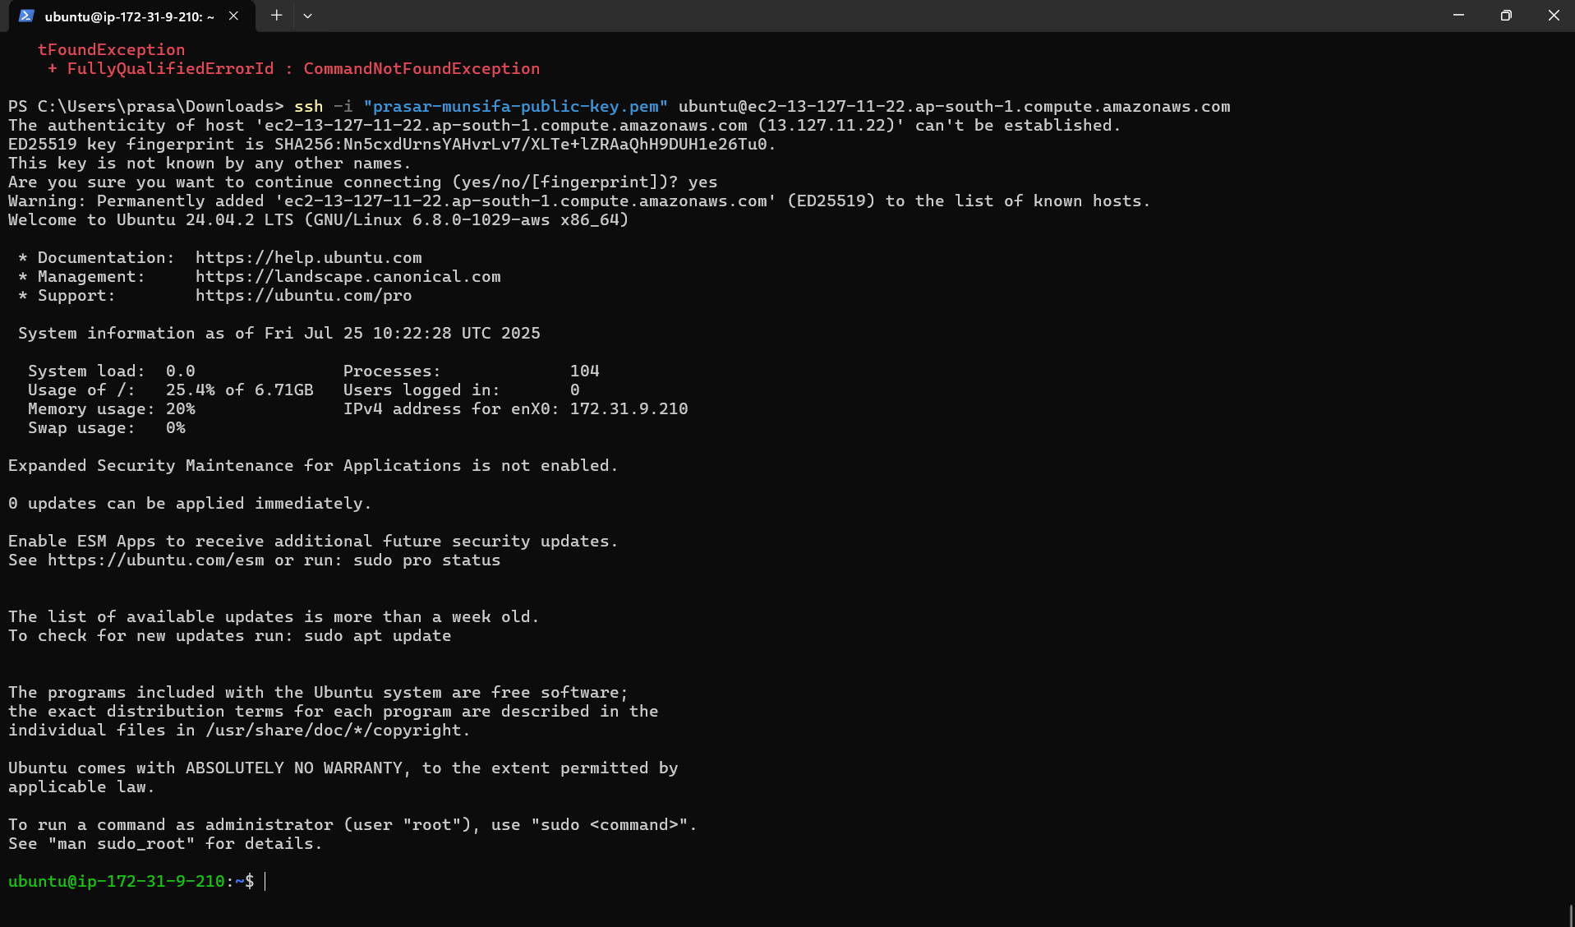

STEP 47: PUBLIC EC2 INSTANCE IS CONNECTED

STEP 48: NOW PING THE PUBLIC EC2 INSTANCE WITH THE HELP OF YOUR LOCAL

TERMINAL. GO TO INSTANCE AND COPY ITS IP ADDRESS AND TYPE THE FOLLOWING

COMMAND. (IT MEANS FROM OUTSIDE AWS, WE ARE ABLE TO CONNECT TO THE PUBLIC

EC2 INSTANCE)

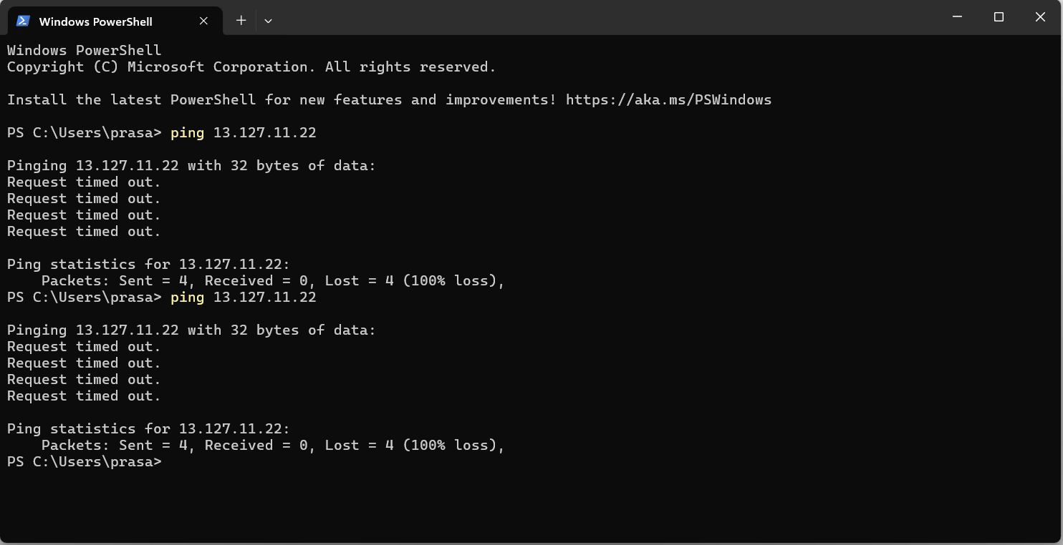

STEP 49: NOW NEXT FROM PUBLIC EC2 INSTANCE TERMINAL, TYPE THE FOLLOWING

COMMAND TO ACCESS RESOURCE FROM OUTSIDE THE AWS

NOTE: curl ipinfo.io: It is a command used in the terminal to retrieve information about your

current IP address using the "curl" tool and the "ipinfo.io" web service; essentially, it fetches

details like your location, ISP, and public IP address by sending a request to the IPinfo.io API

via the curl command.

It is seen that public EC2 instance is accessible from outside world as well as it can also

access outside resources. But we know that, private instance that we have created under

private subnet is not accessible from outside world but it can be accessed by the public EC2

instance only.

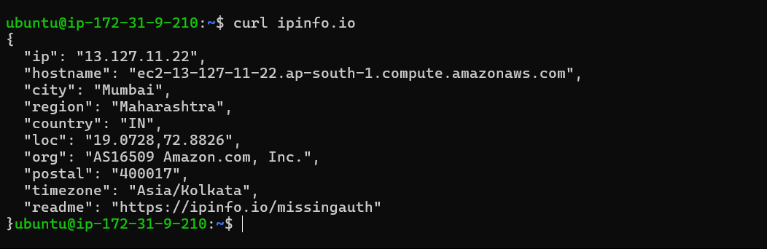

STEP 50: PING PRIVATE EC2 INSTANCE FROM THE LOCAL TERMINAL. COPY THE PRIVATE IP

ADDRESS OF THE INSTANCE AND TYPE (PING 11.0.2.160) IN THE LOCAL TERMINAL.

ITS SHOWING REQUEST TIMED OUT. i.e., IT IS UNABLE TO CONNECT TO THE PRIVATE EC2

INSTANCE FROM THE LOCAL TERMINAL. NOW LET’S TRY TO CONNECT IT FROM THE PUBLIC

EC2 INSTANCE TERMINAL.

STEP 50: TYPE THE FOLLOWING COMMAND TO CONNECT TO THE PRIVATE EC2 INSTANCE

(PING 11.0.2.160). CONNECTION ESTABLISHED AS SHOWN BELOW.

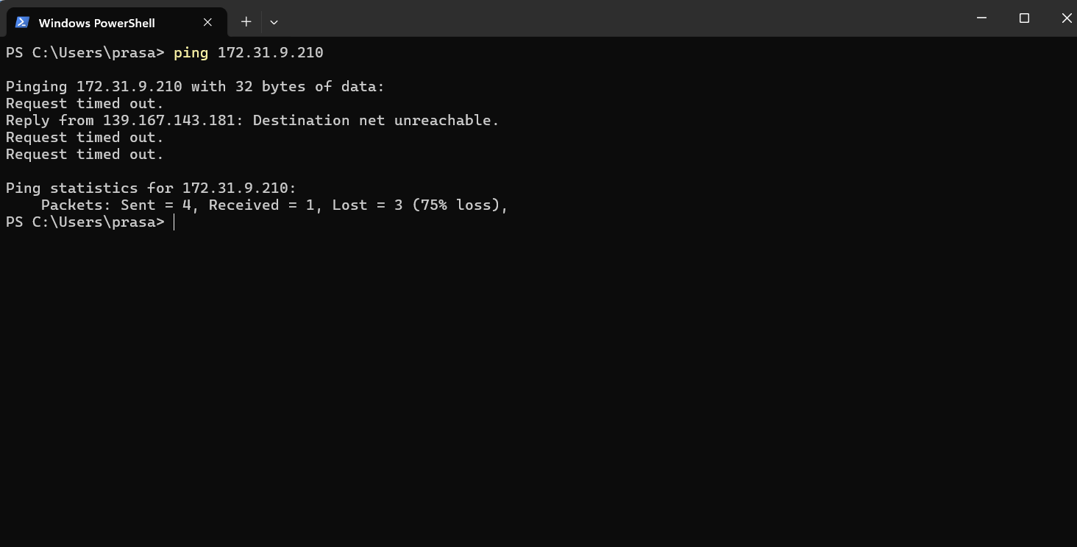

RELEASE ALL THE RESOURCES THAT ARE USED IN THE EXECUTION OF THE LAB.

1. TERMINATE THE EC2 INSTANCES.

2. DELETE ROUTE TABLE:

a. ROUTE TABLE>EDIT ROUTE>REMOVE NAT GATEWAY (PRIVATE)

b. ROUTE TABLE>EDIT ROUTE>REMOVE INTERNET GATEWAY (PUBLIC)

c. ROUTE

TABLE>SUBNET

ASSOCIATIONS>EDIT

ASSOCIATIONS>DESELECT>SAVE CHANGES

d. SELECT BOTH THE ROUTE TABLES>ACTIONS>DELETE ROUTE TABLES.

3. DELETE SUBNETS:

SUBNET

a. SUBNETS> SELECT BOTH THE SUBNET ACTIONS>ACTIONS> DELETE SUBNET

4. DELETE NAT GATEWAY:

a. NAT GATEWAY>SELECT THE NAT GATEWAY>ACTIONS> DELETE NAT GATEWAY

5. DELETE VPC

a. VPC>SELECT THE VPC CREATED>ACTIONS>DELETE

6. RELEASE ELASTIC IP

a. ELASTIC IP>SELECT THE ELASTIC IP>ACTIONS>RELEASE THE ELASTIC IP

Prasar Srivastava  
22BCE10841  
AWS Solution Lab2

STEP1: OPEN THE AWS CONSOLE AND CLICK ON IAM DASHBOARD



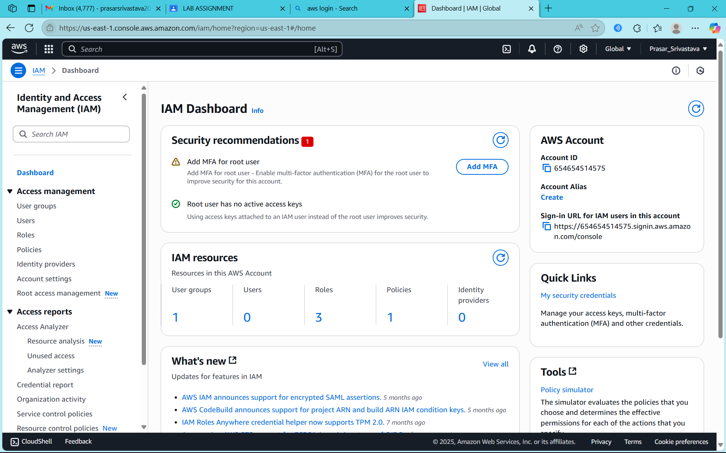

STEP2: CLICK ON USERS

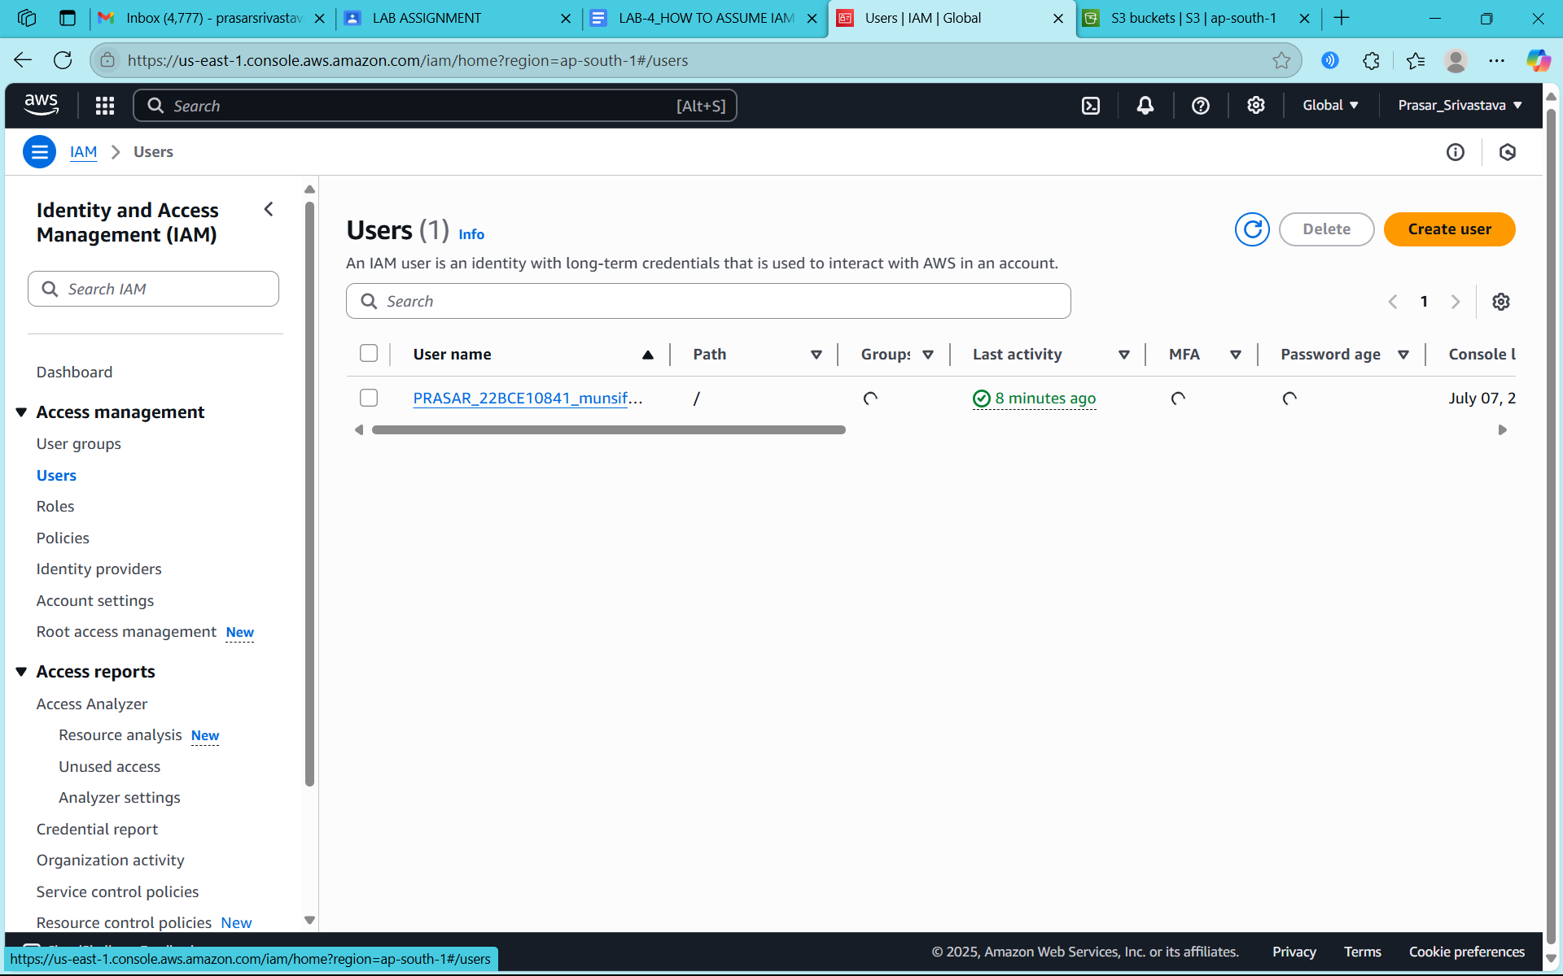

STEP2: CLICK ON IAM USER THAT YOU WANT TO ADD IN GROUP

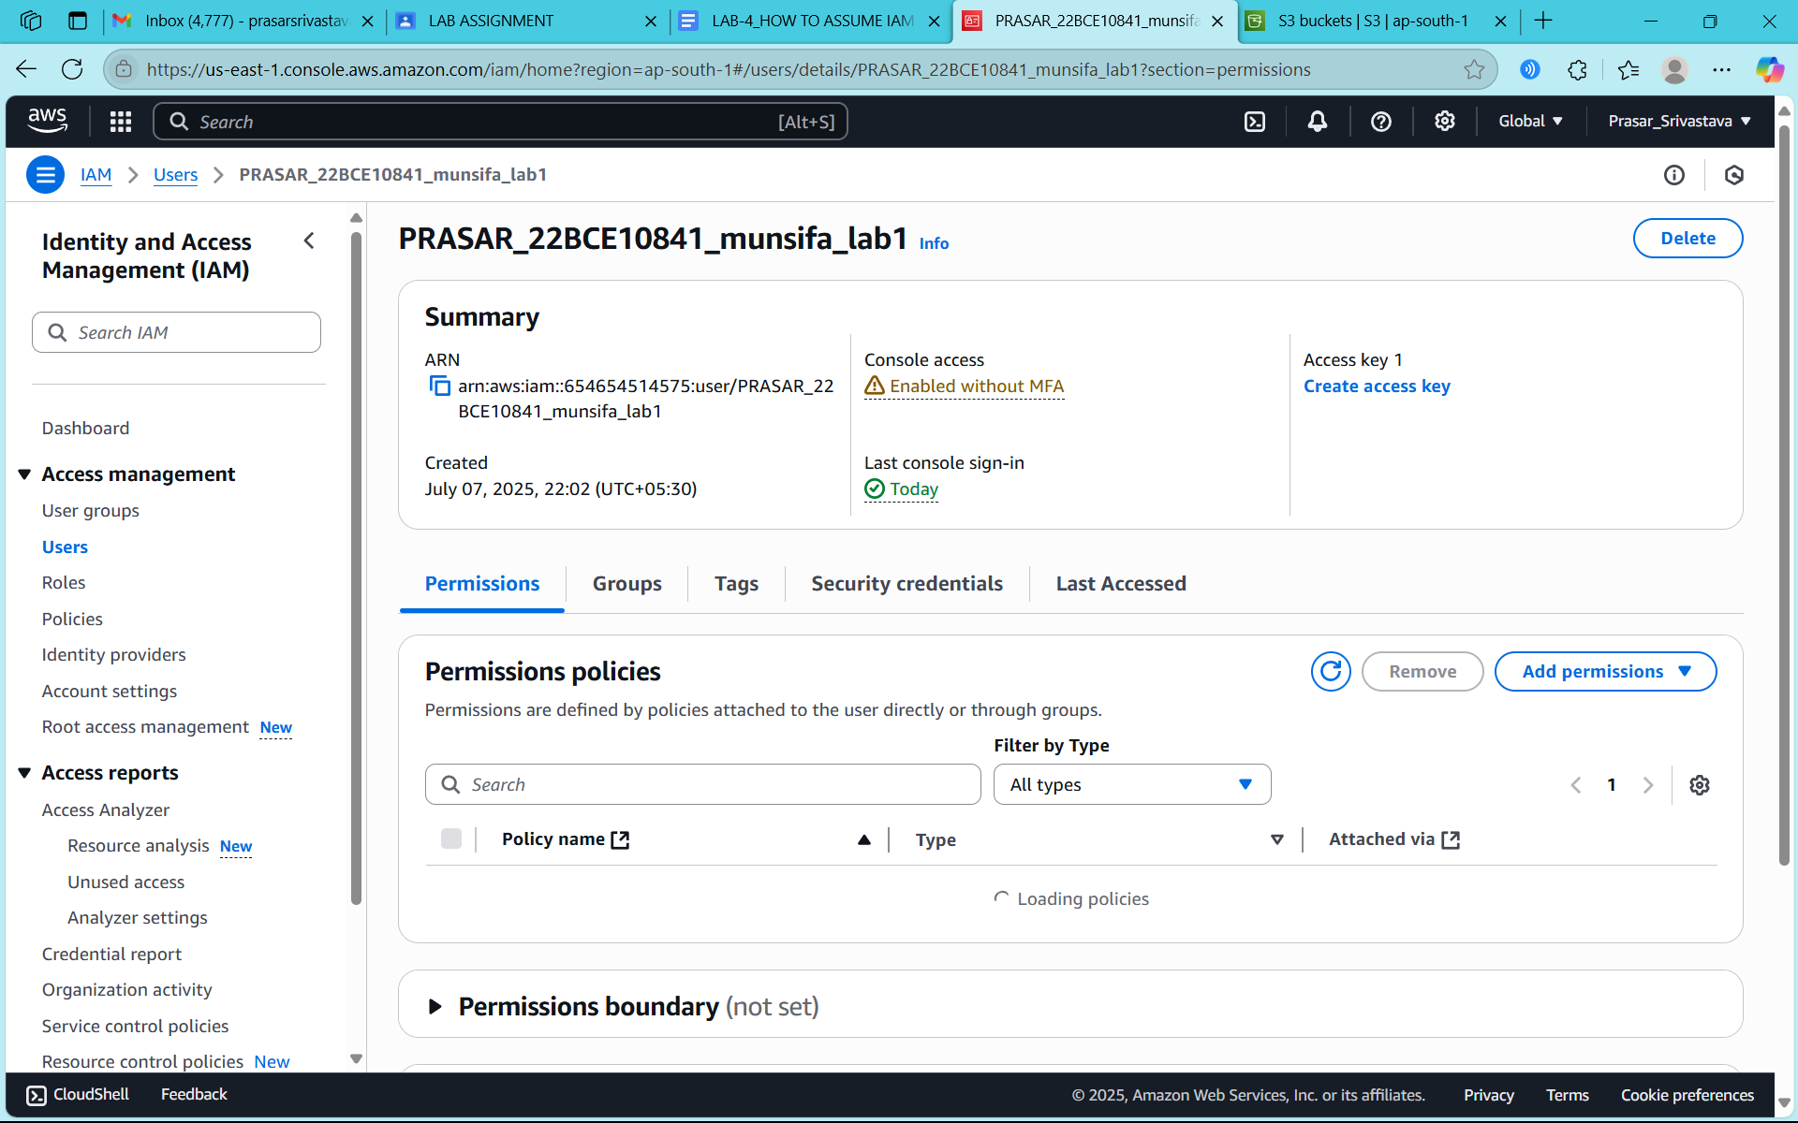

STEP3: SELECT ON THE POLICY THAT WAS EARLIER CREATED

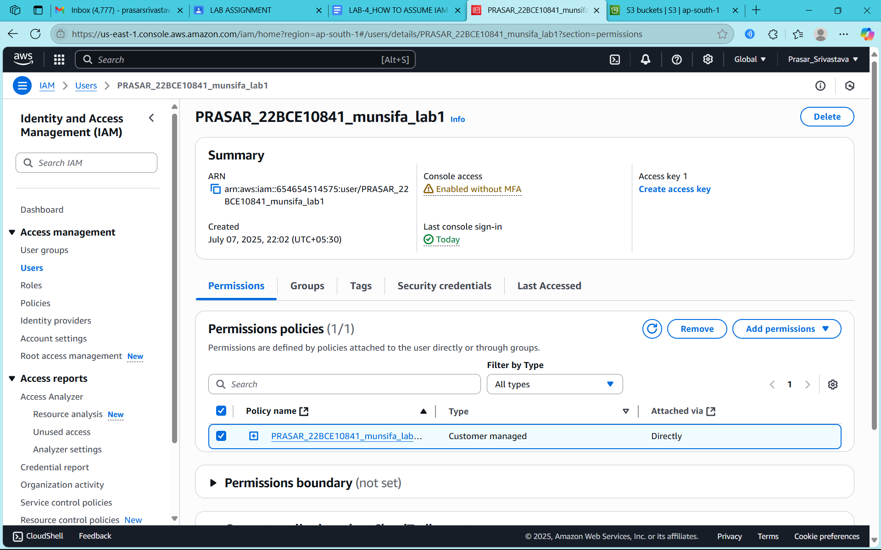

STEP4: CLICK ON REMOVE POLICY

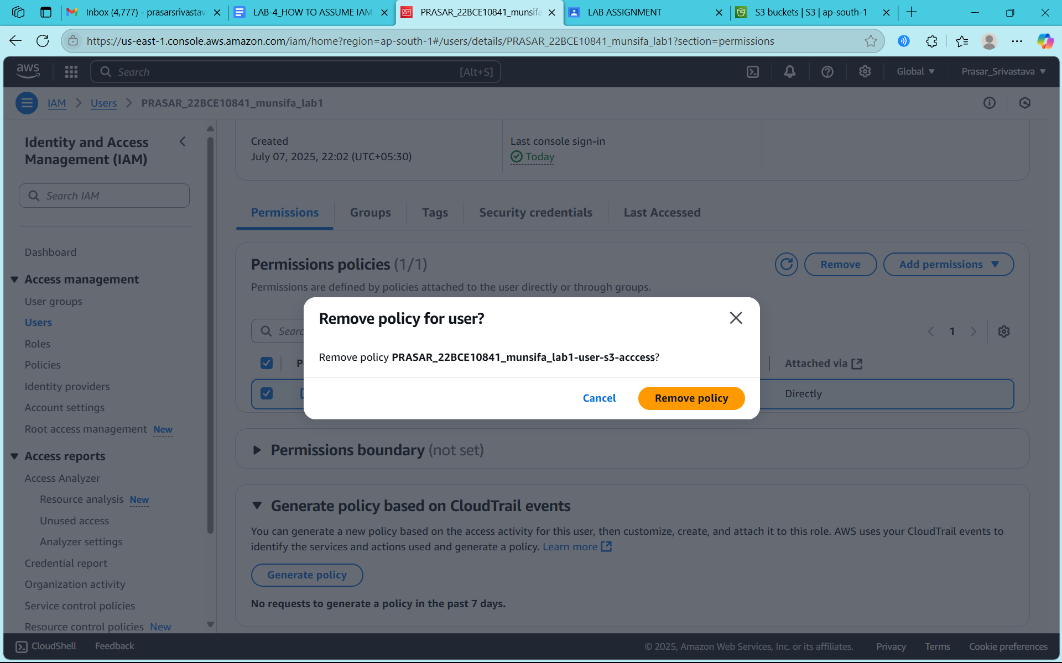

STEP5: YOUR POLICY IS REMOVED

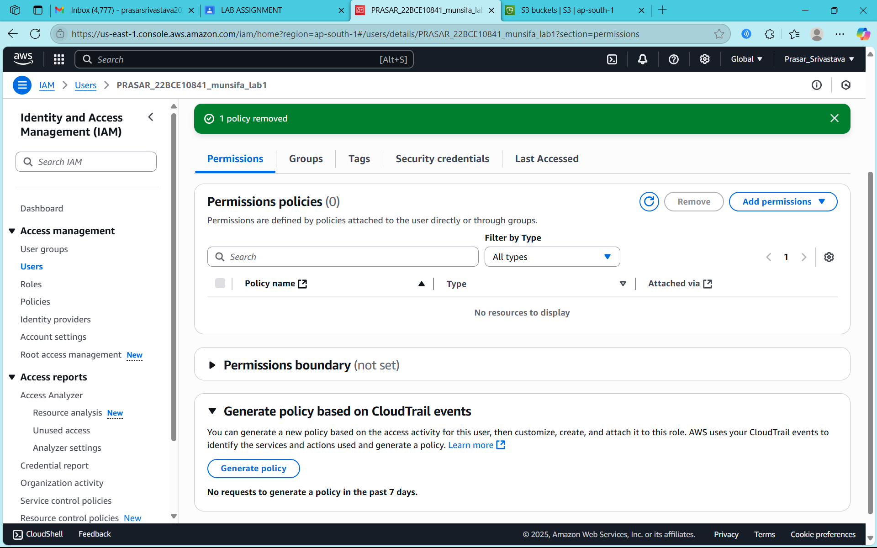

STEP6: CLICK ON USER GROUPS

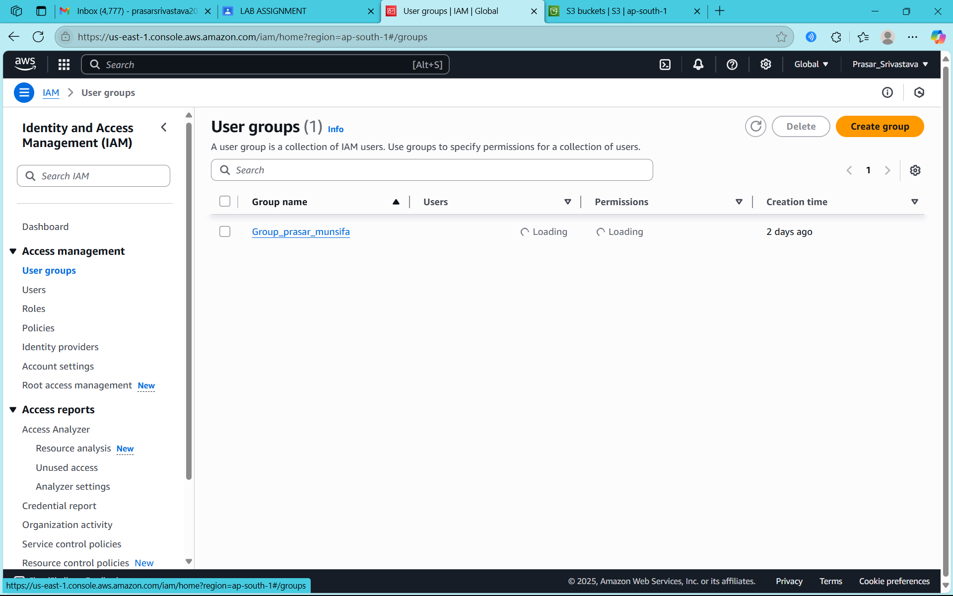

STEP7: CLICK ON CREATE GROUP

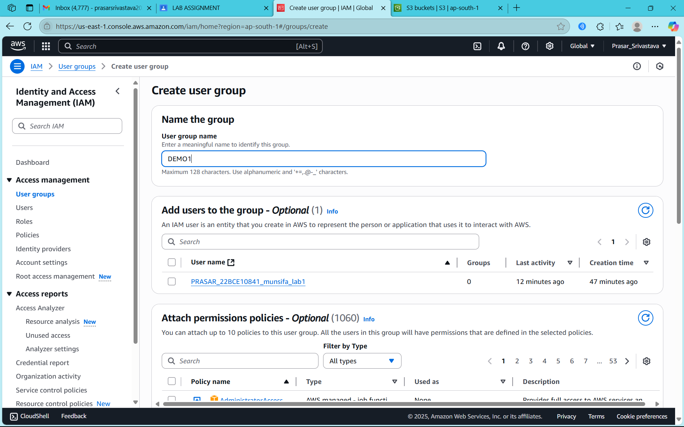

STEP8: TYPE THE NAME OF THE GROUP



STEP9: CLICK ON CREATE USER GROUP

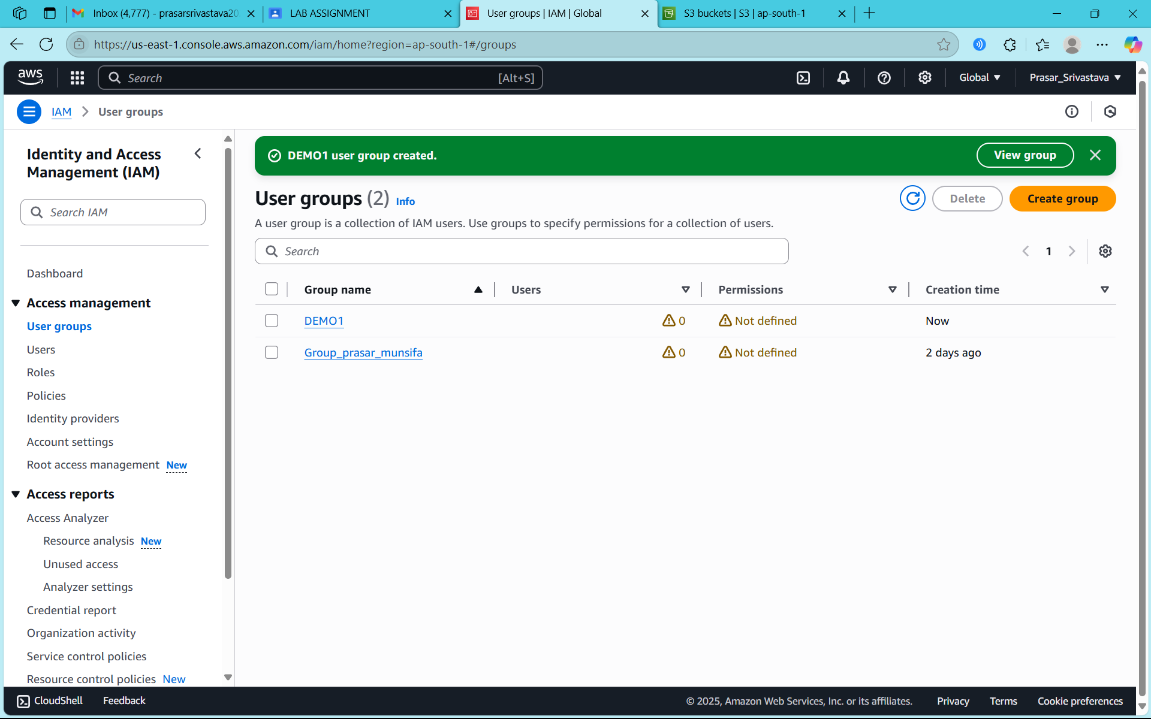

STEP10: DEMO1 GROUP CREATED



STEP11: CLICK ON DEMO1 GROUP

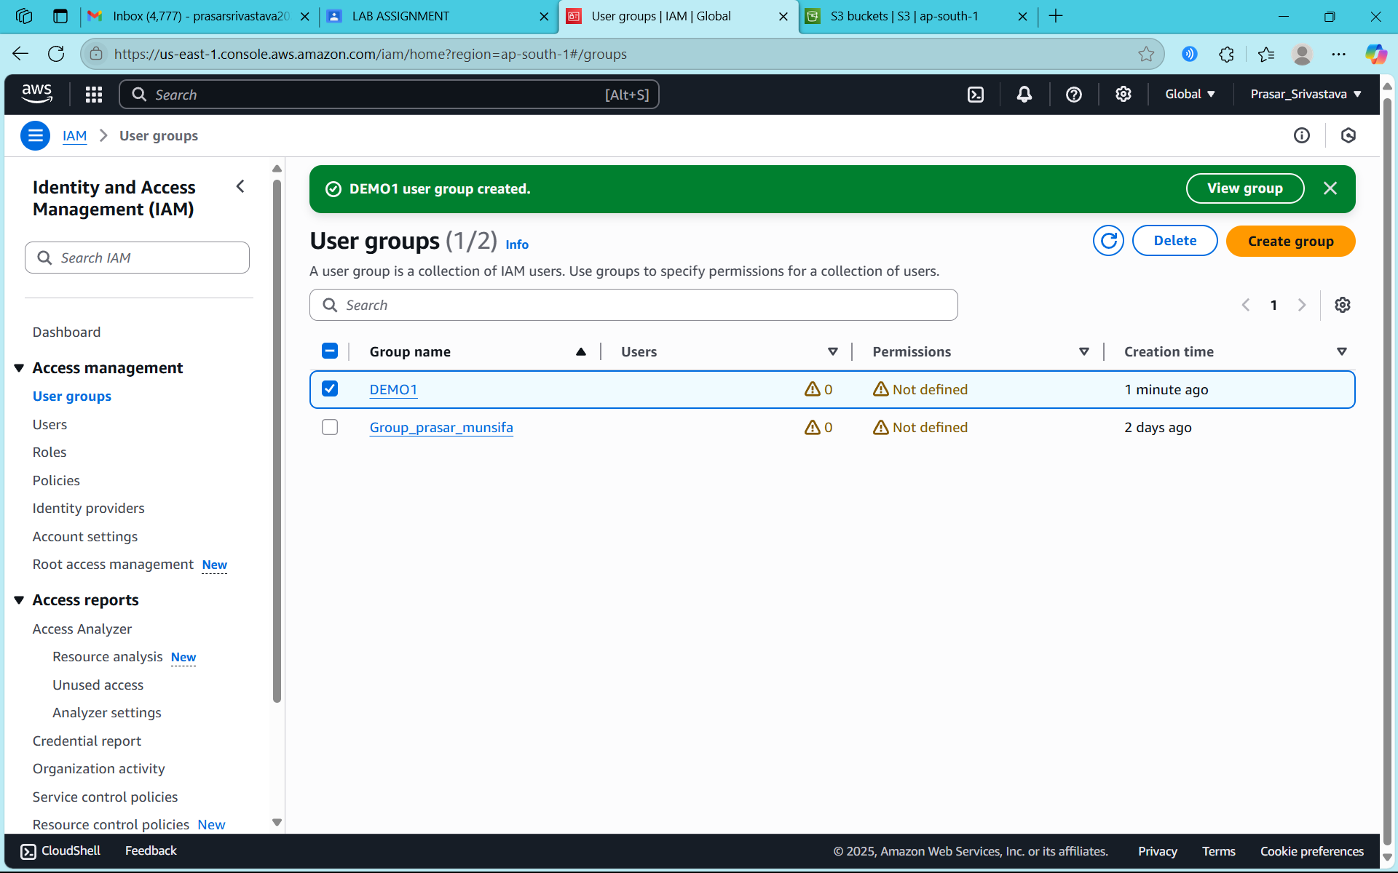

STEP12: CLICK ON ADD USER

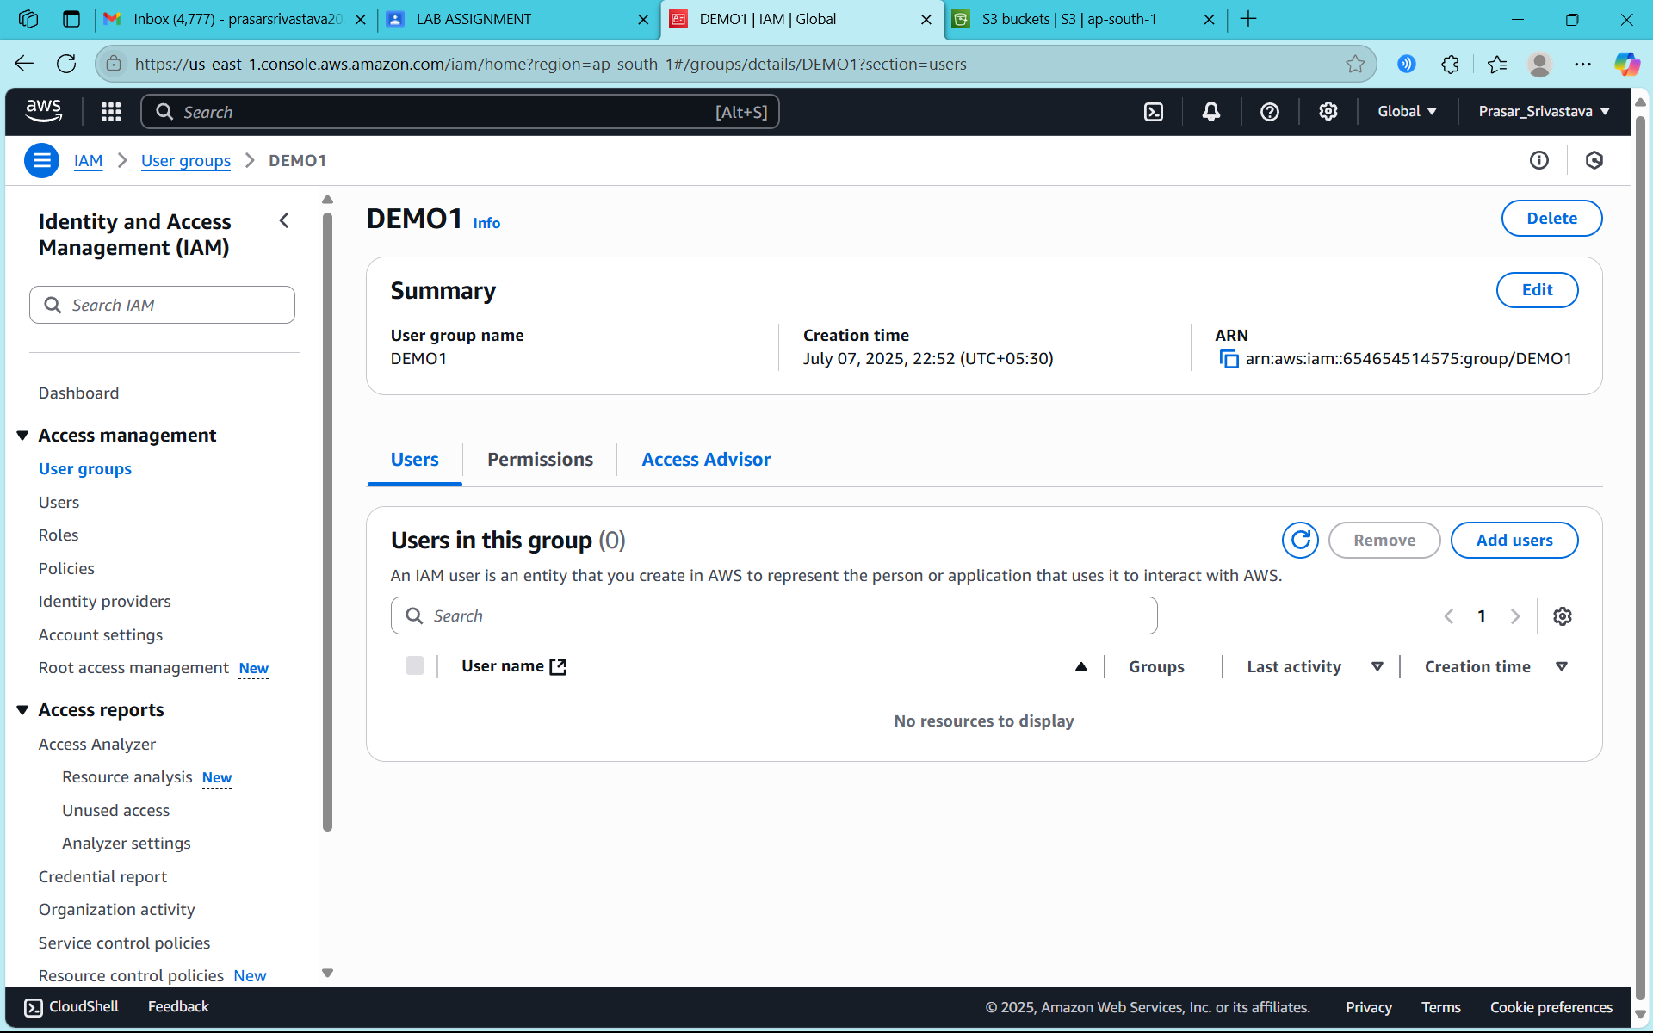

STEP13: SELECT THE USER YOU WANT TO ADD

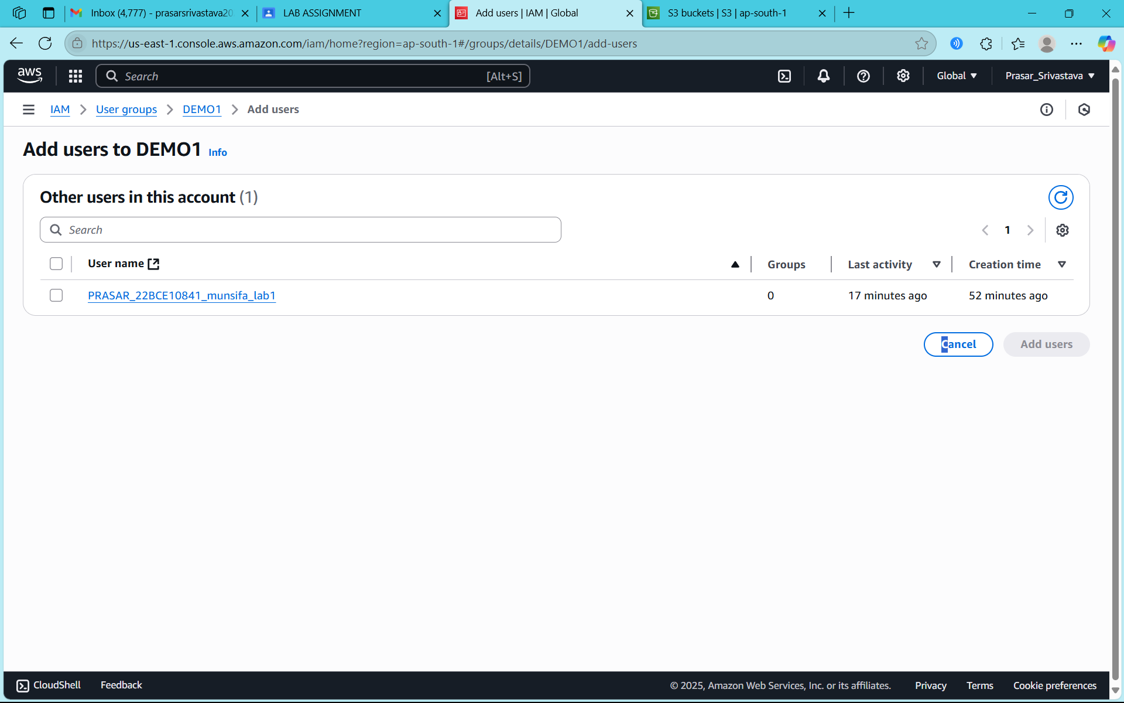

STEP14: CLICK ON ADD USER

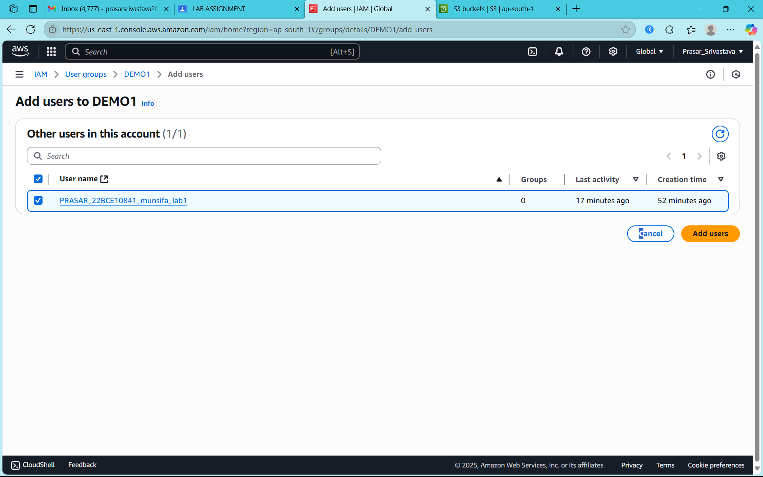

STEP15: USER IS ADDED TO THE GROUP

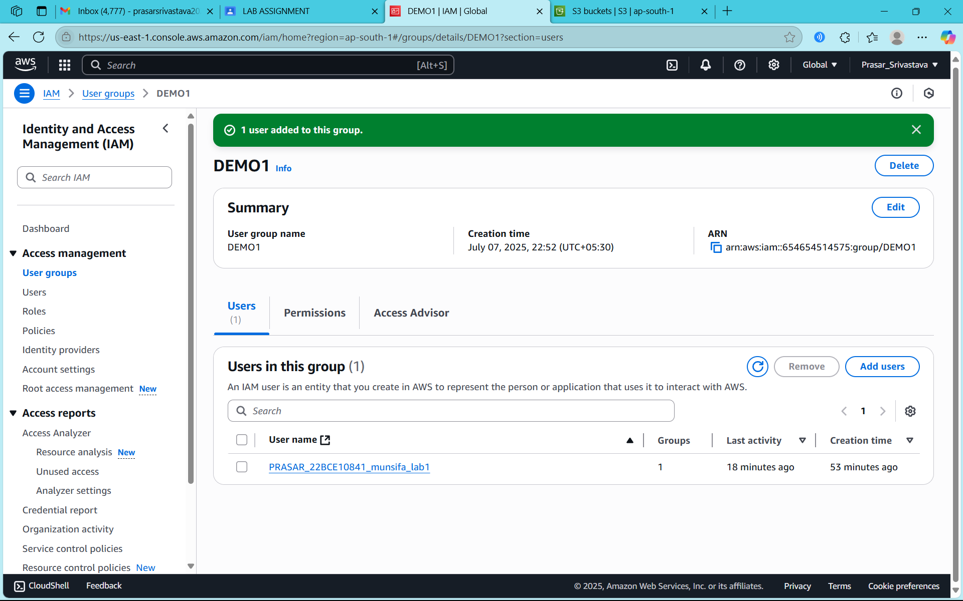

STEP16: CLICK ON THE DEMO1 GROUP

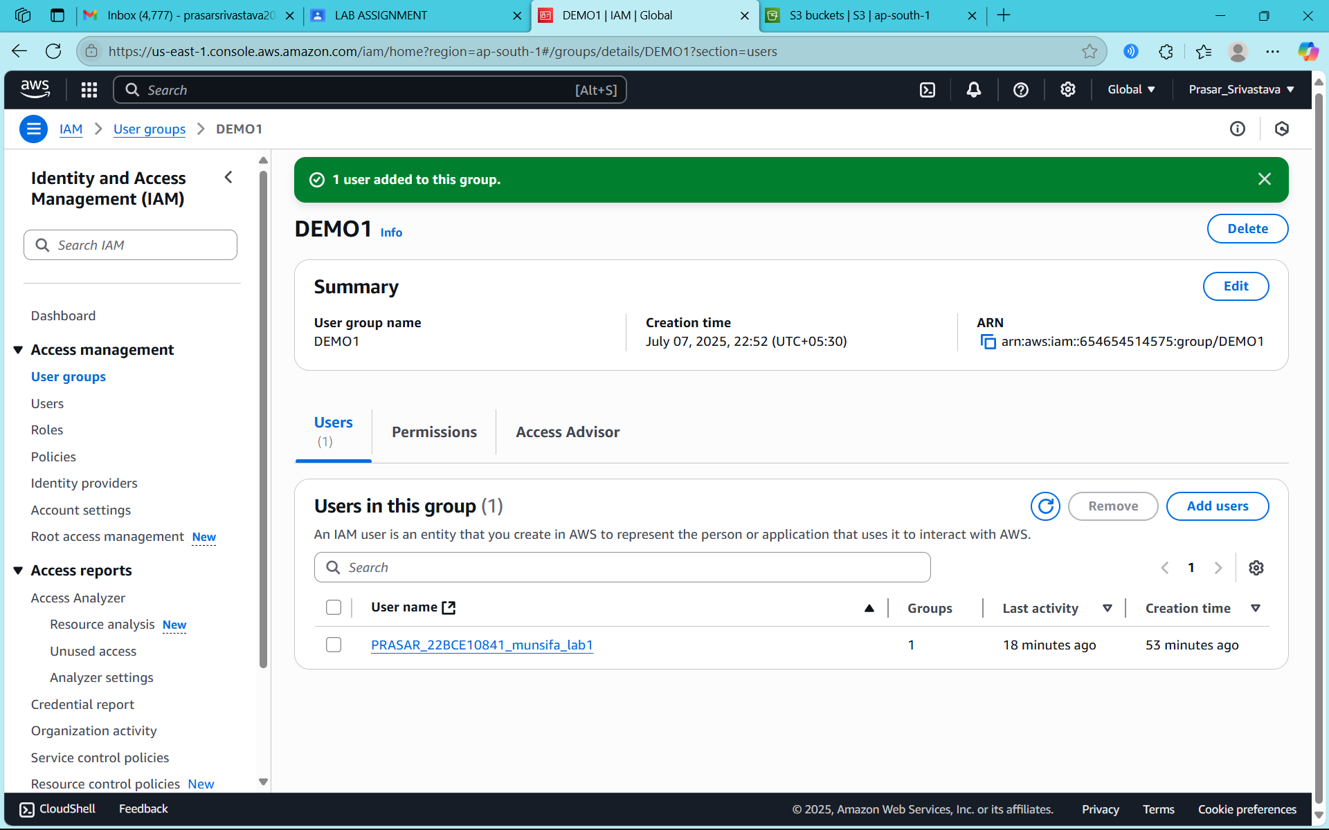

STEP17: CLICK ON ADD PERMISSIONS

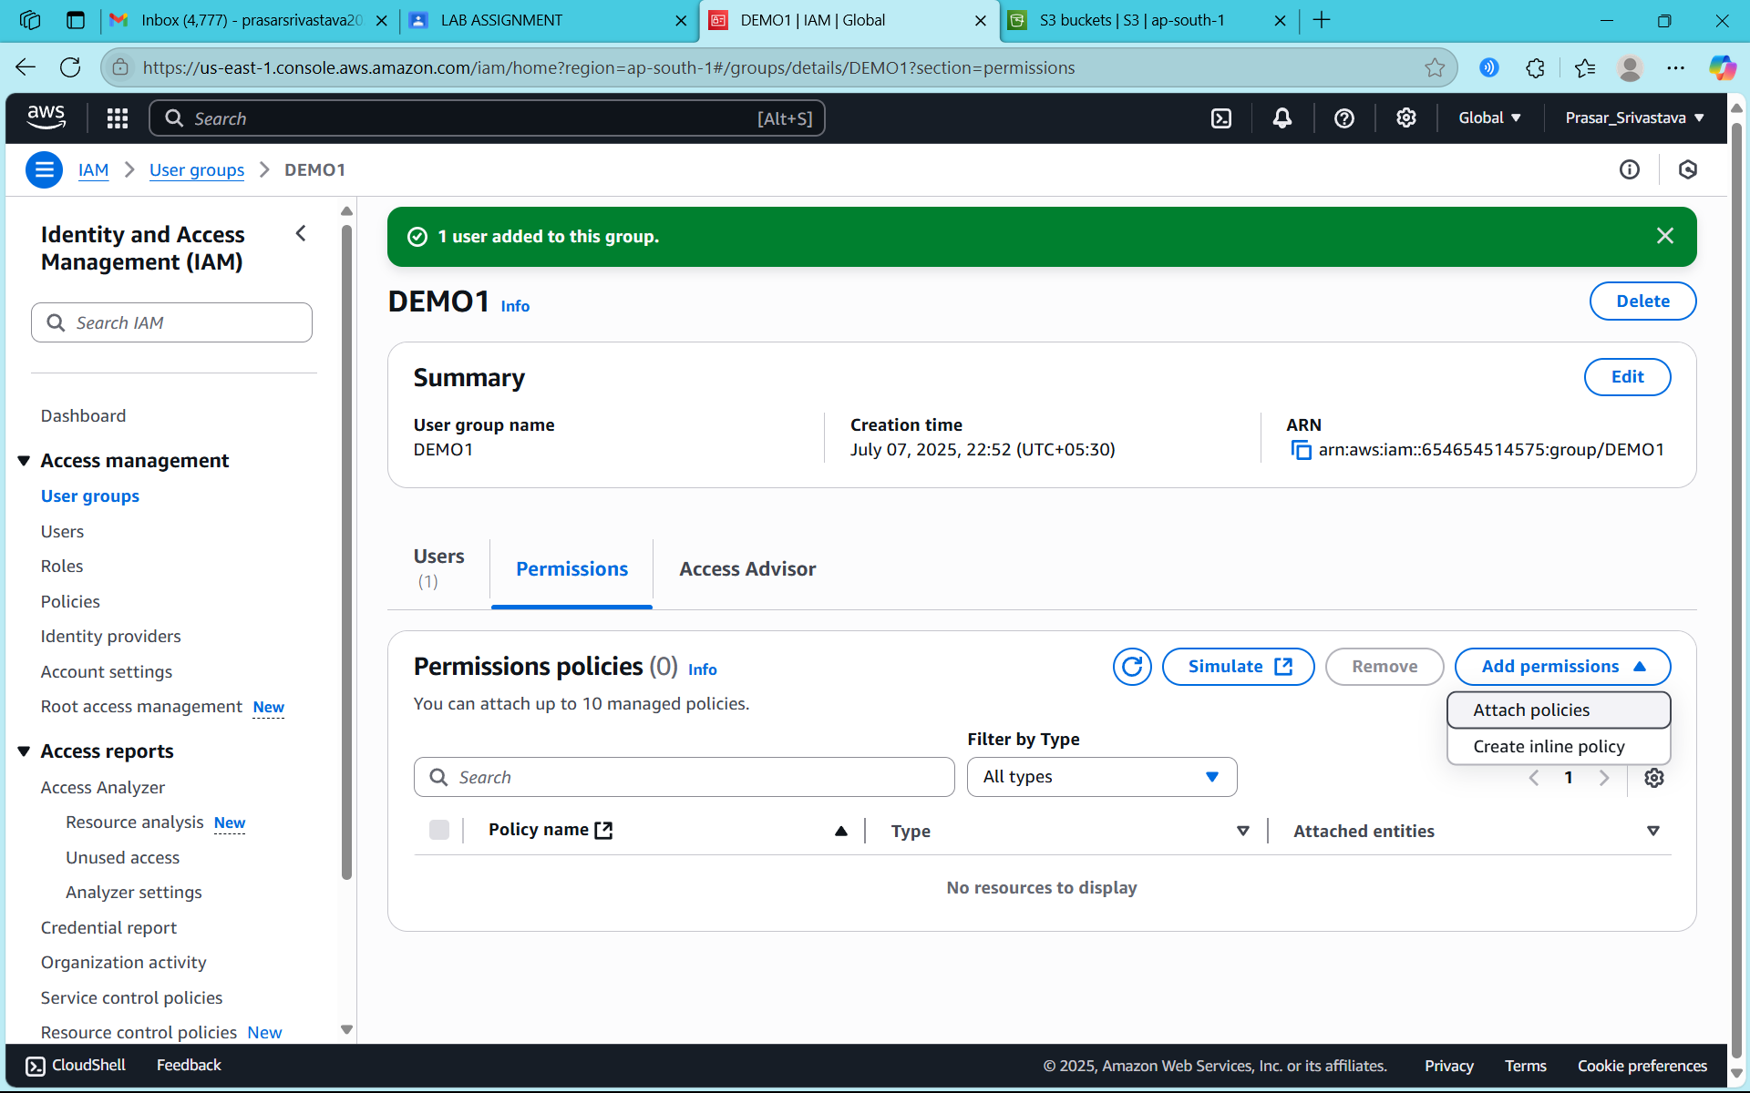

STEP18: SELECT THE POLICY THAT YOU HAVE CREATED

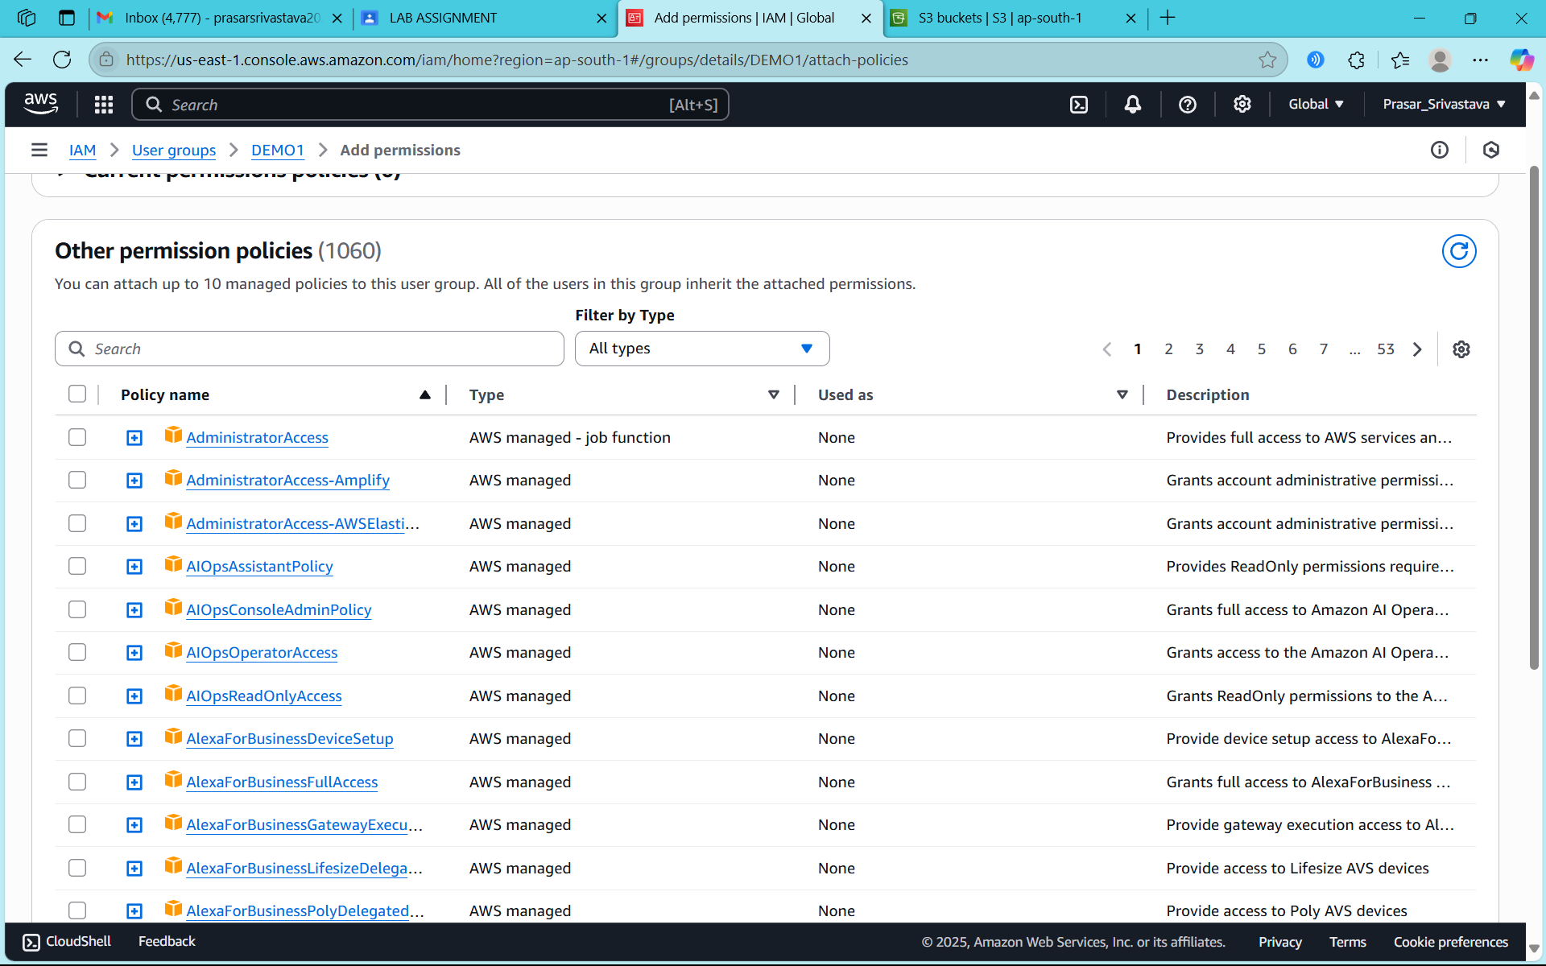

STEP19: CLICK ON ATTACH POLICIES

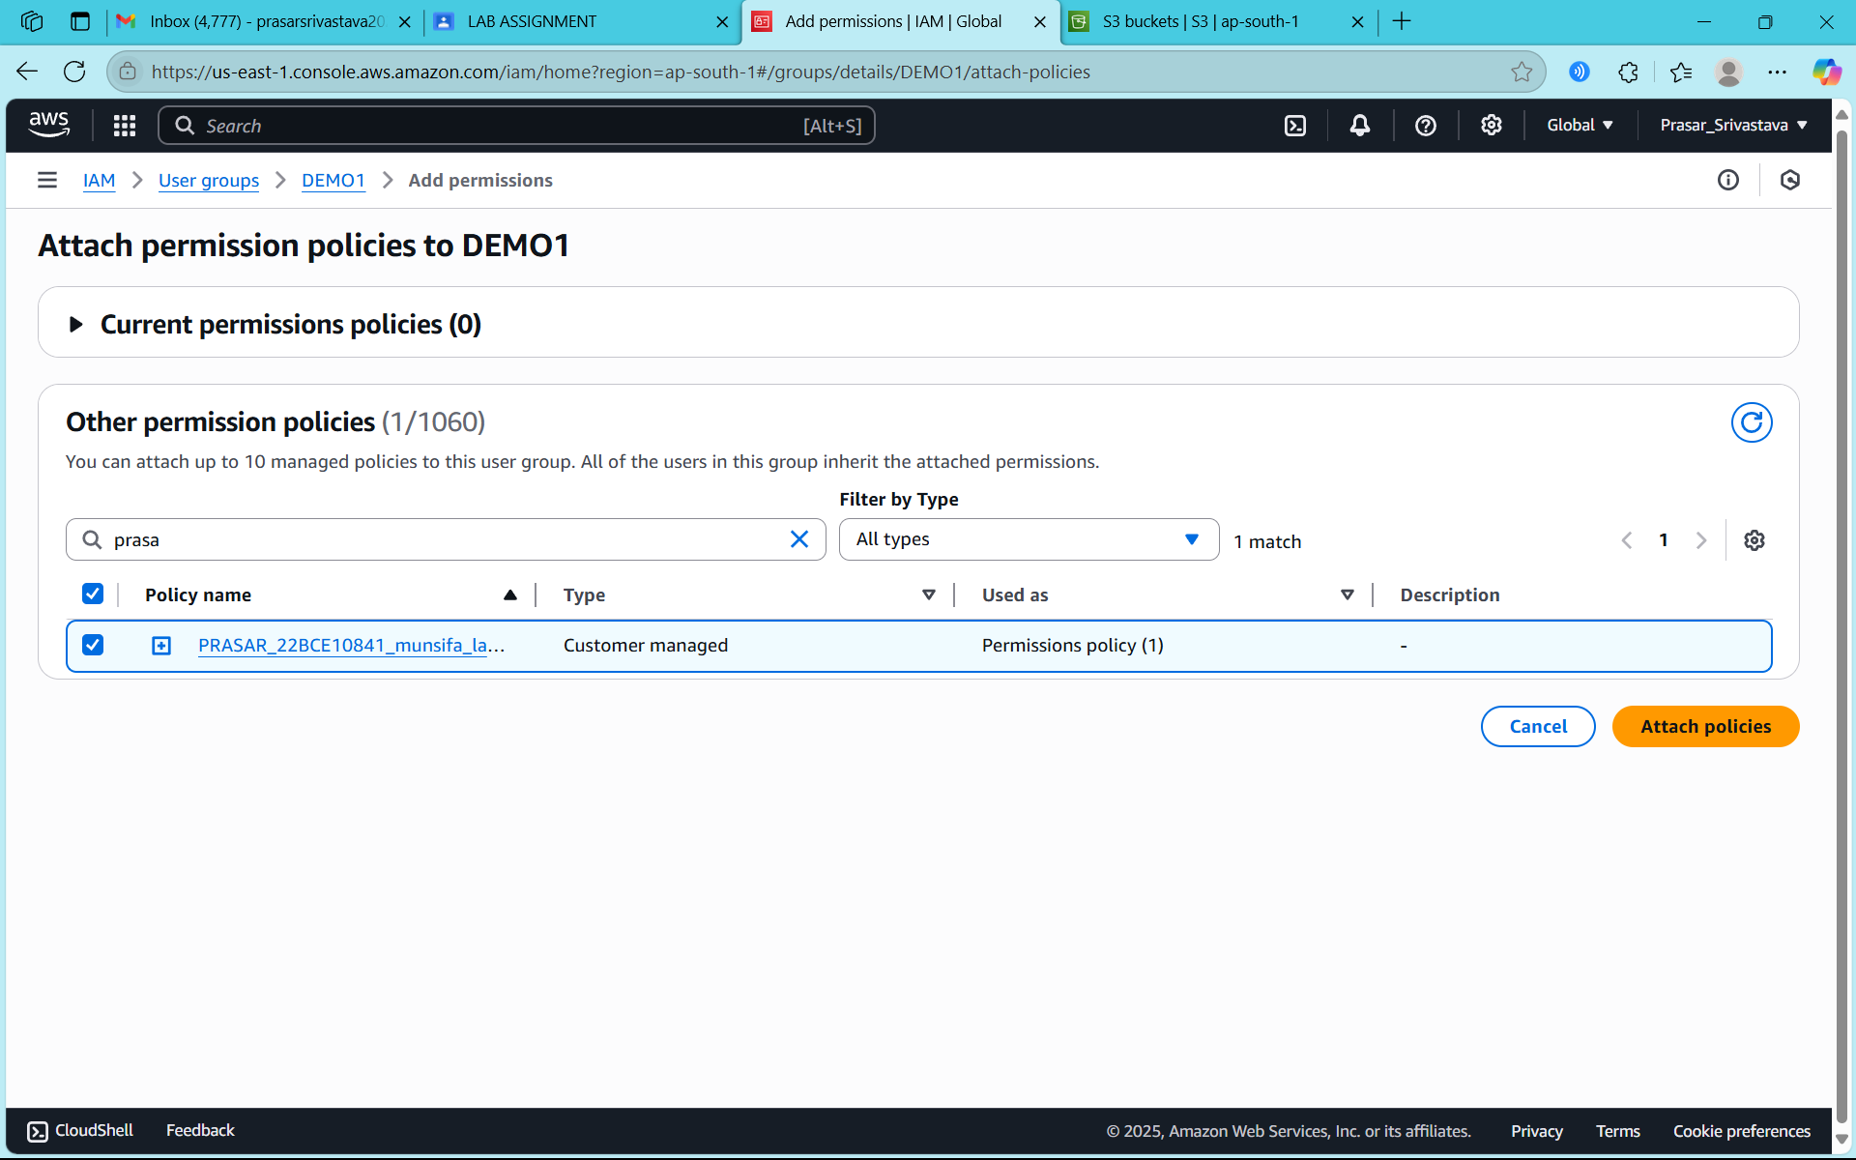

STEP20: POLICY IS ATTACHED TO THE GROUP

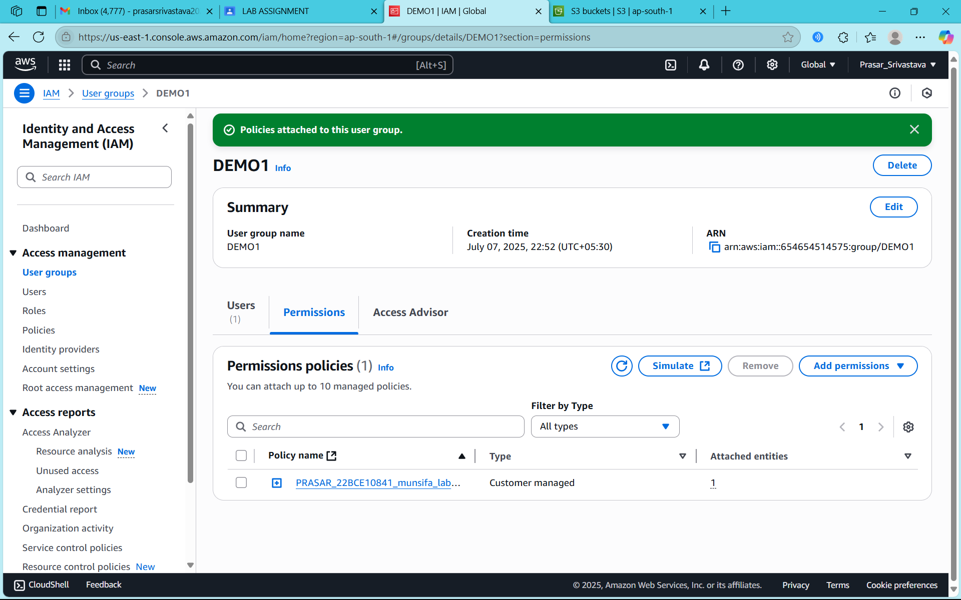

Prasar Srivastava  
22BCE10841  
AWS Solution Lab2

STEPS TO CREATE IAM ROLE AND ASSIGN TO IAM USER WITH POLICIES

STEP1: GO TO CONSOLE PAGE AND CLICK ON IAM

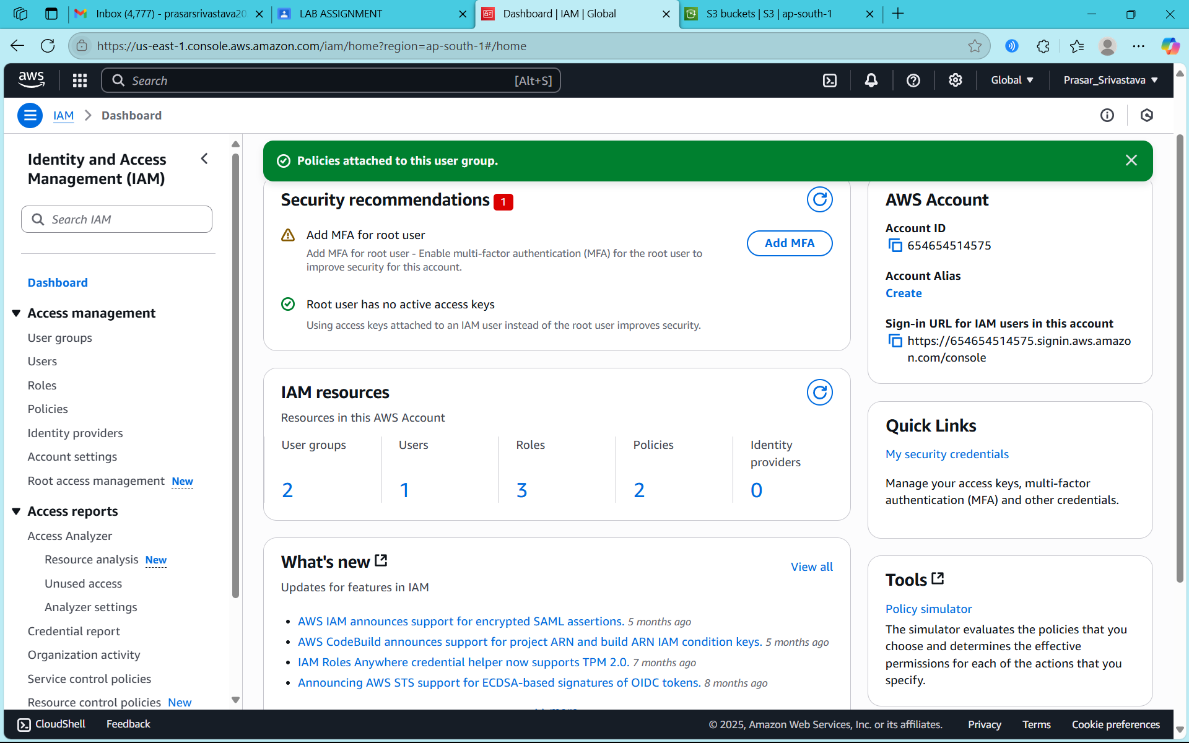

STEP2: GO TO ROLES FROM IAM DASHBOARD AND CLICK ON CREATE ROLE

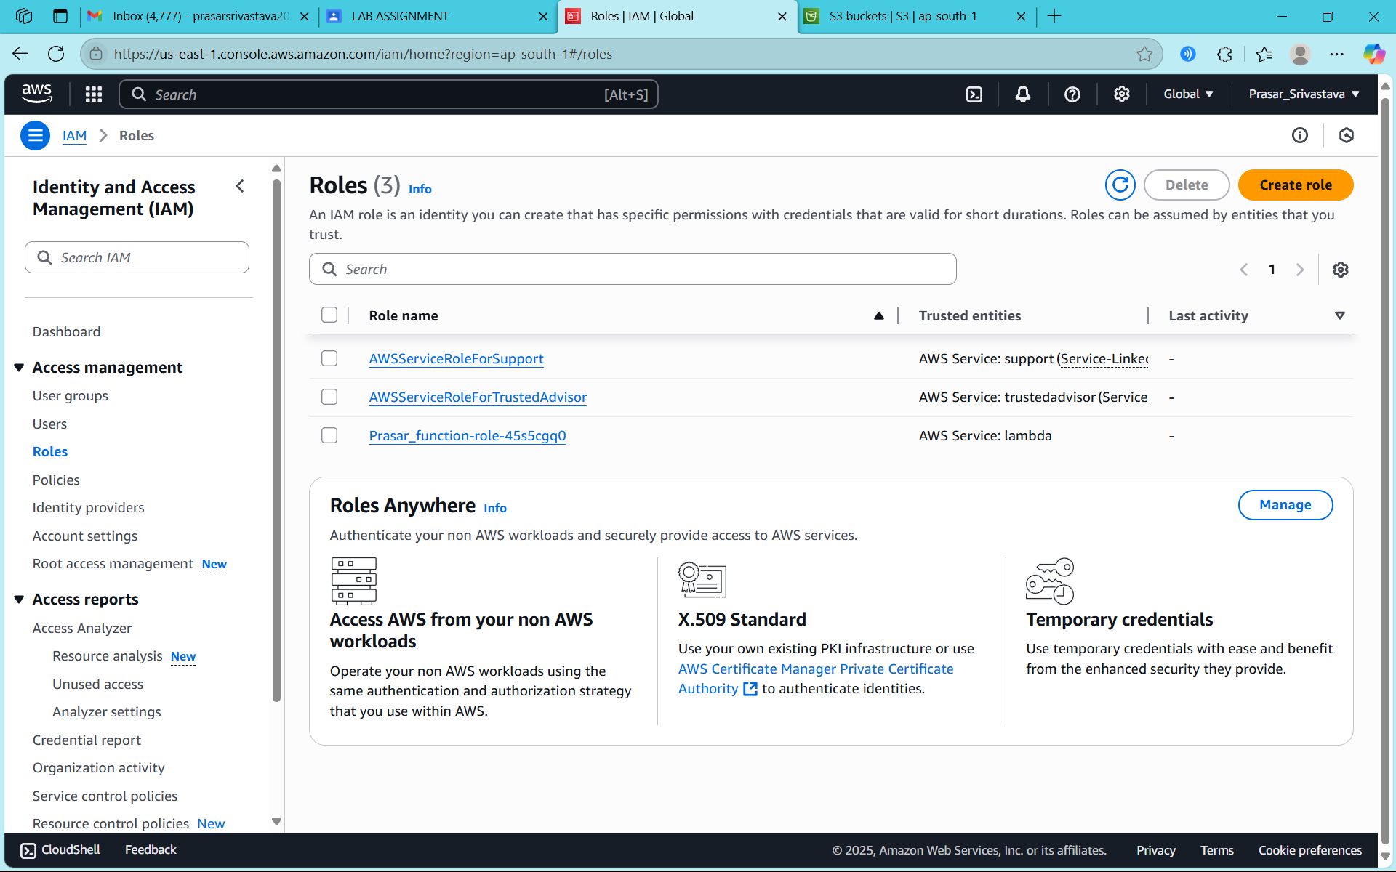

STEP3: SELECT AWS ACCOUNT



STEP4: CHOOSE ROOT ACCOUNT AND CLICK ON NEXT

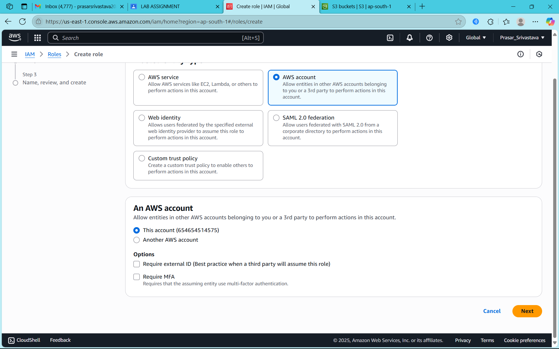

STEP5: SELECT AMAZONS3FULLACCESS POLICY

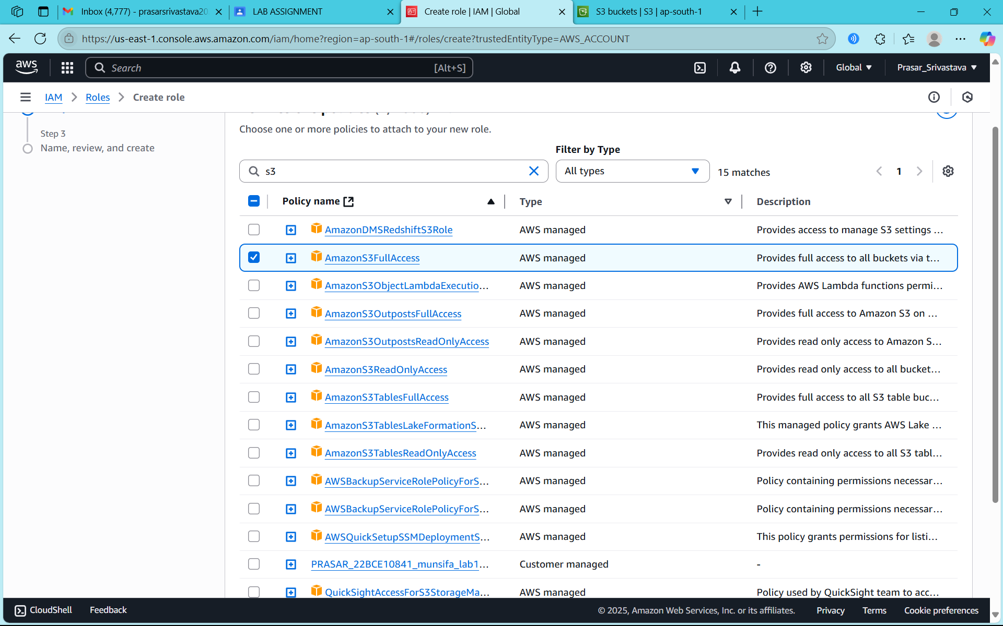

STEP6: ENTER THE ROLE NAME AND CLICK ON CREATE ROLE

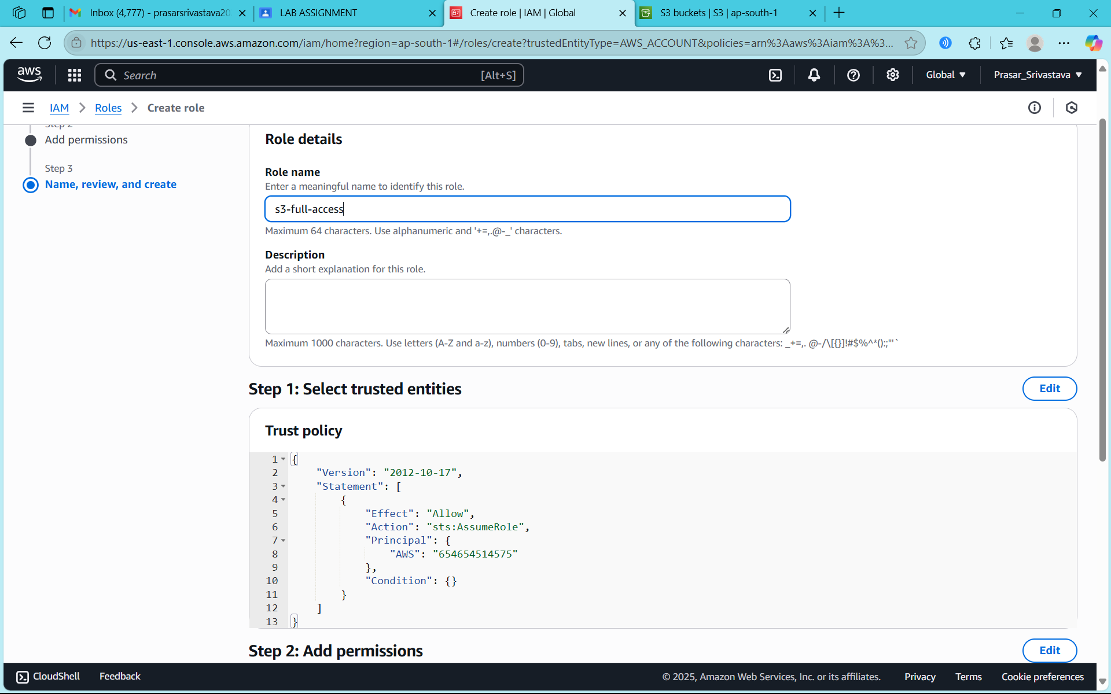

STEP7: ROLE IS CREATED

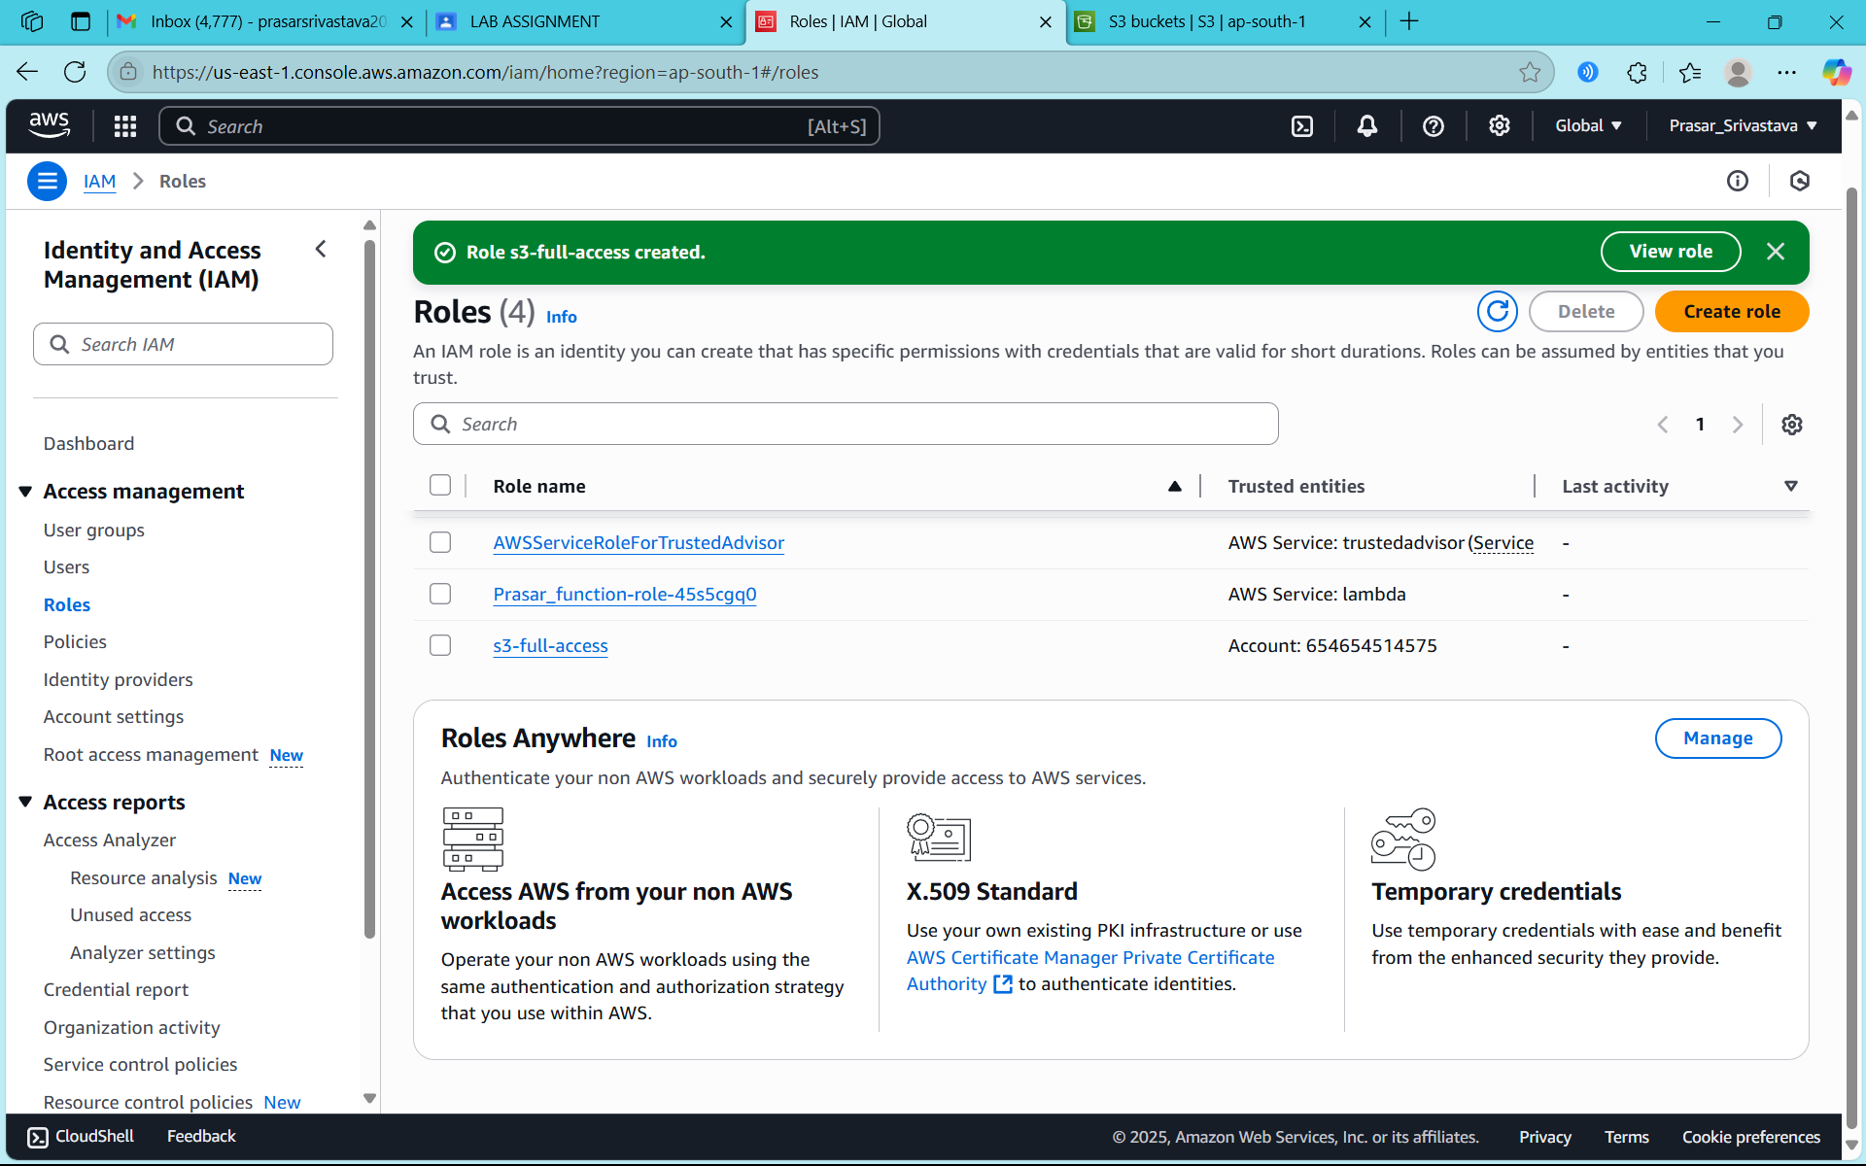

STEP8: NOW CLICK ON USERS FROM IAM DASHBOARD

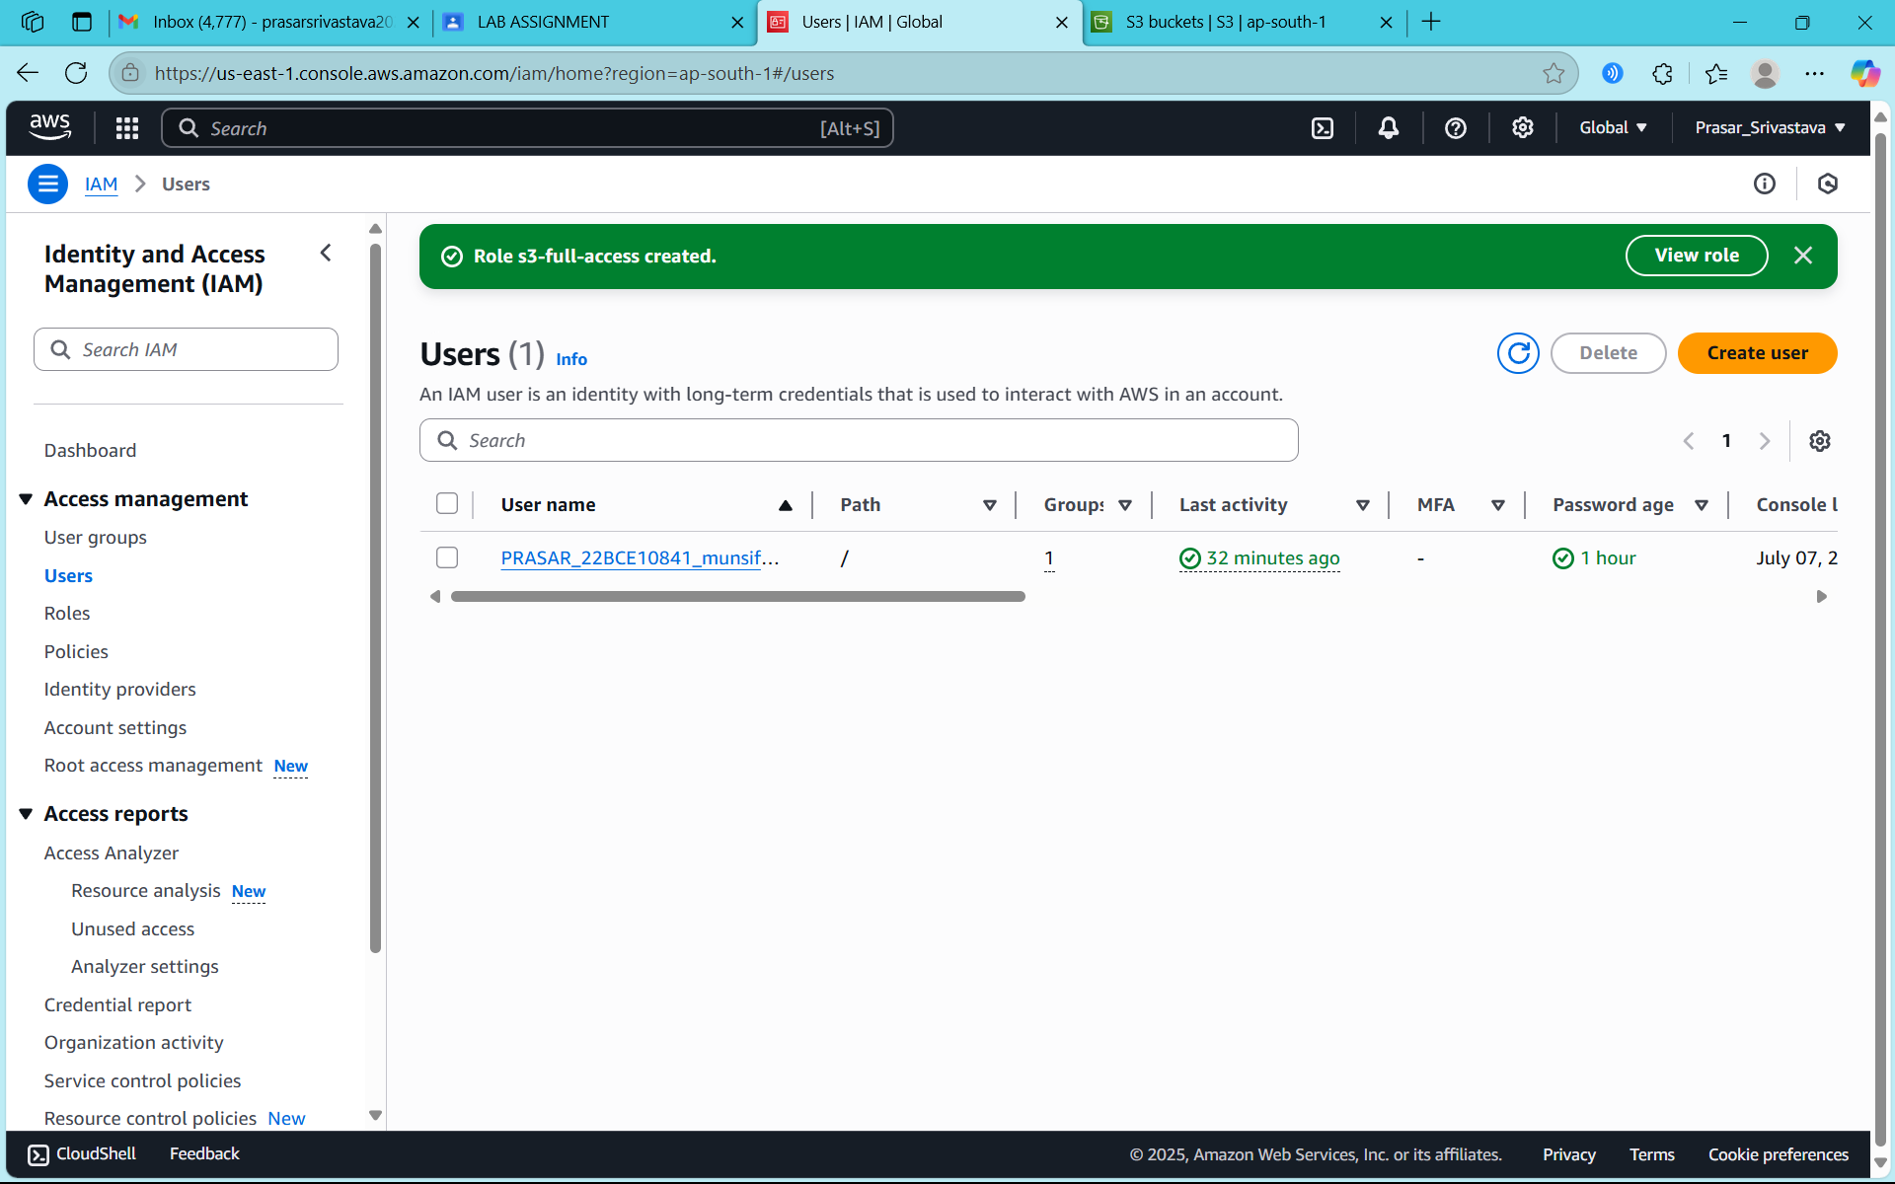

STEP9: NOW SELECT AN IAM USER WHICH YOU HAVE CREATED EARLIER

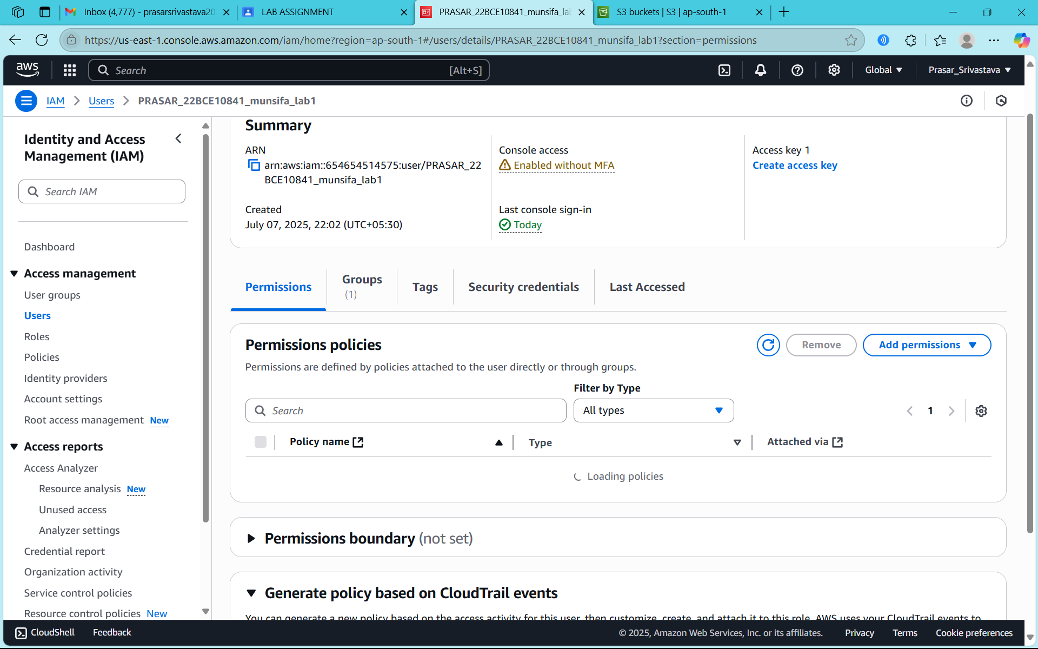

STEP10: NOW CLICK ON ADD PERMISSIONS AND CHOOSE CREATE INLINE POLICY

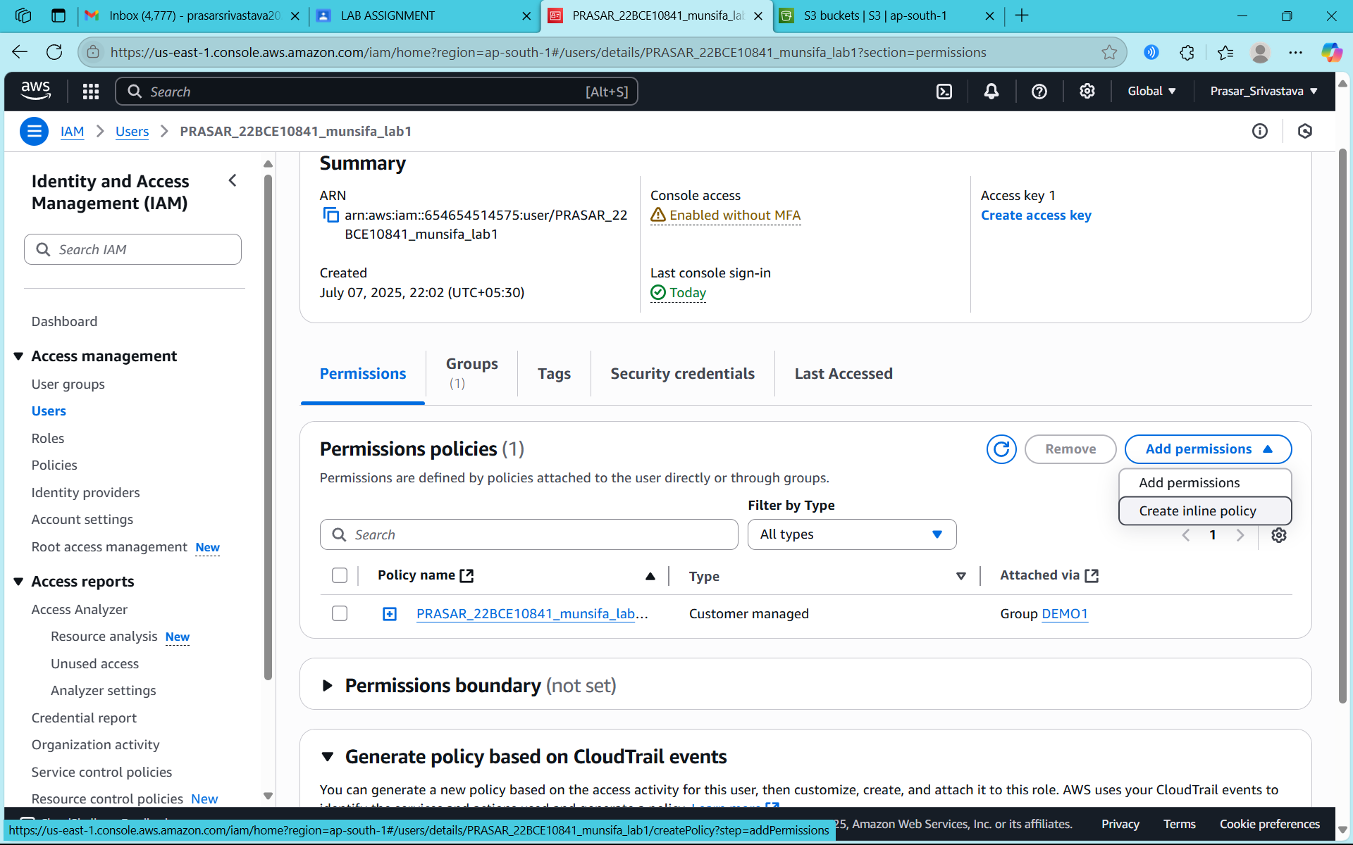

STEP11: NOW CLICK ON JSON EDITOR

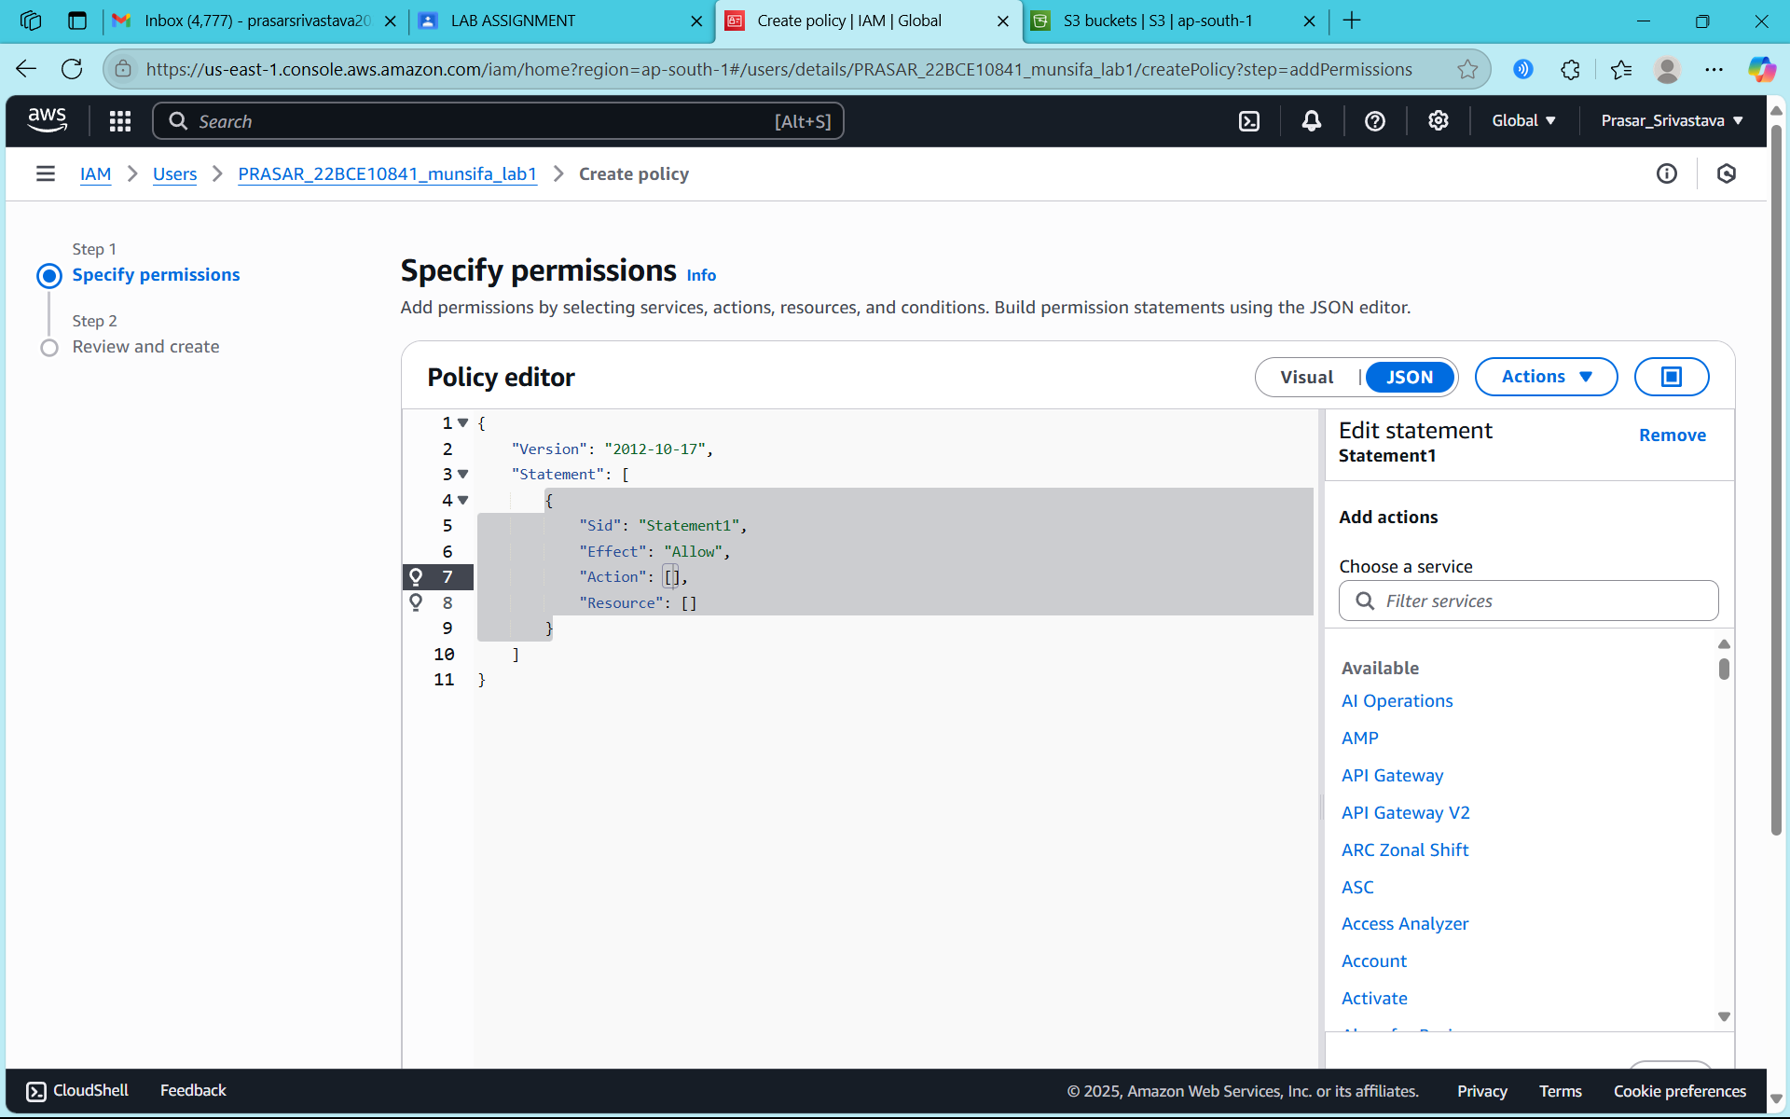

STEP12: NOW OPEN IAM DASHBOARD IN SEPARATE TAB AND CLICK ON ROLES

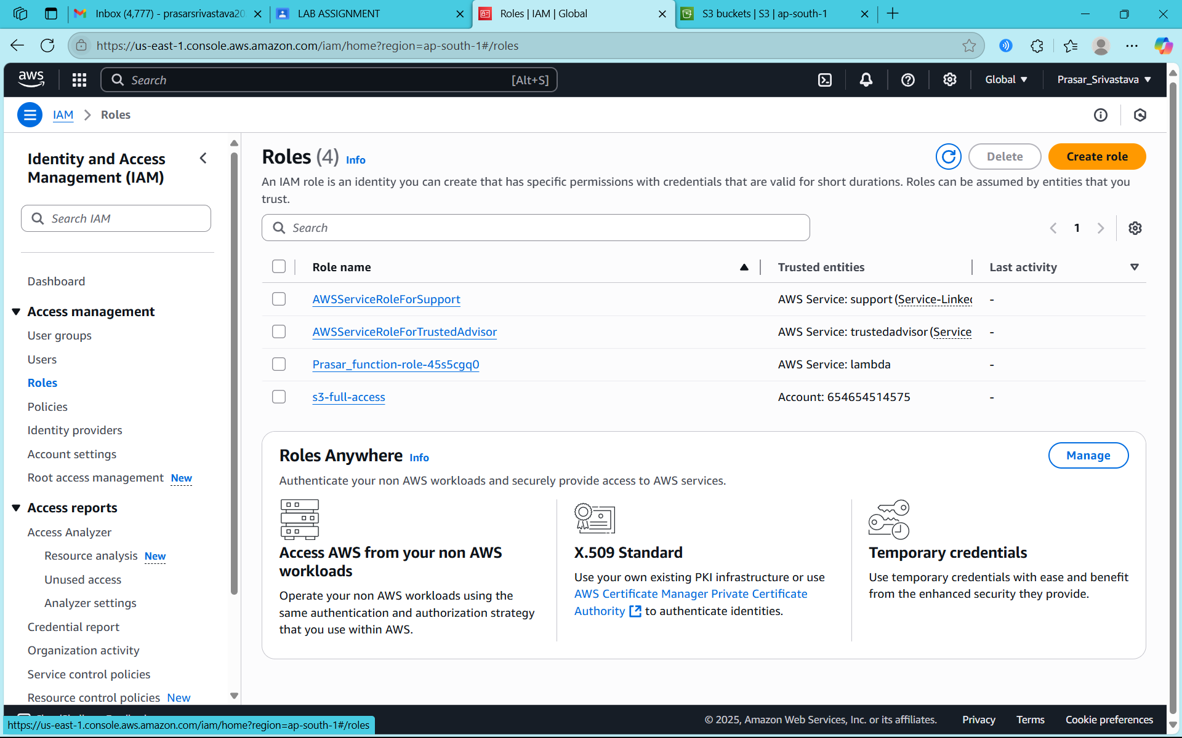

STEP13: CLICK ON THE ROLE THAT YOU HAVE CREATED AND COPY THE ARN NO

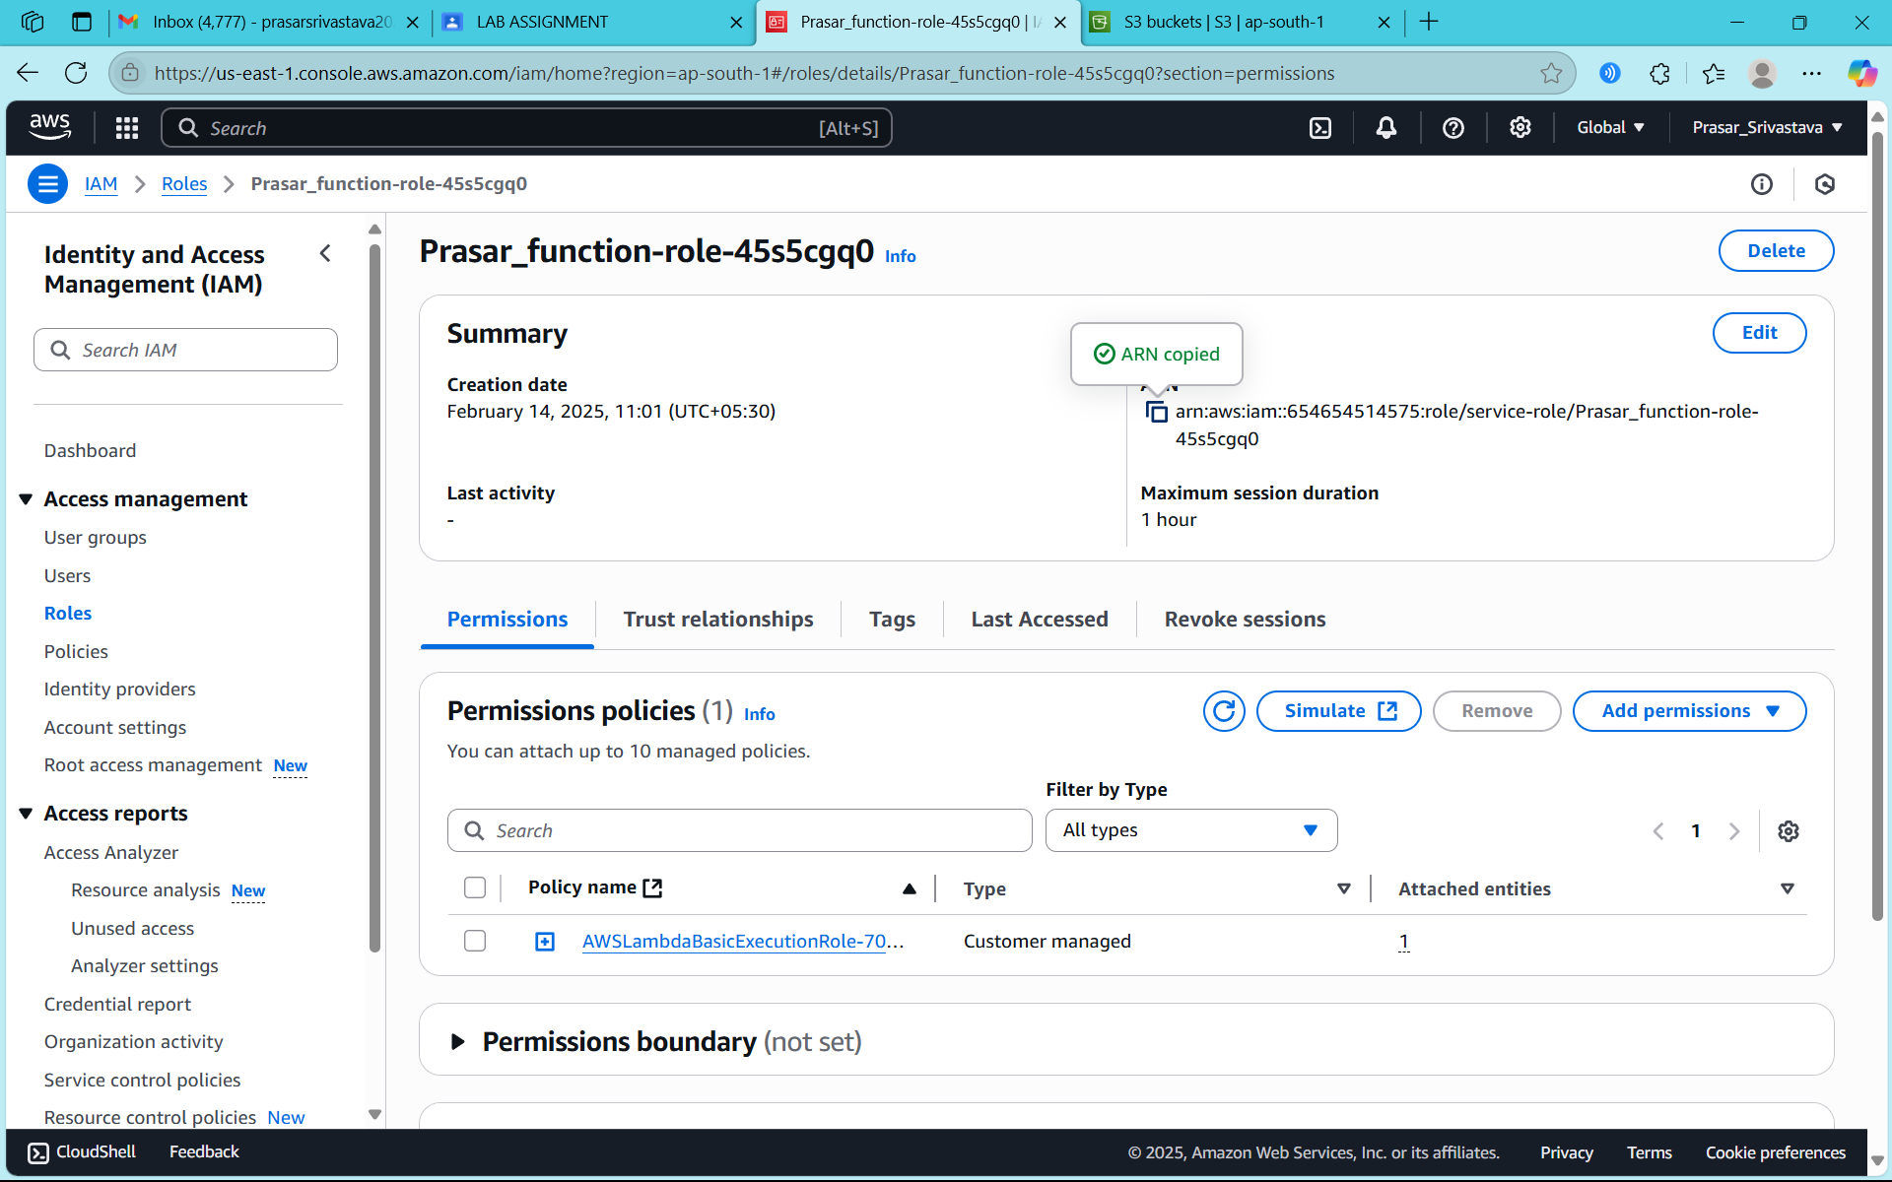

STEP14: GO TO AGAIN USER>TEST-USER>CREATE INLINE POLICY> MODIFY THE CODE (PASTE ARN IN RESOURCE)

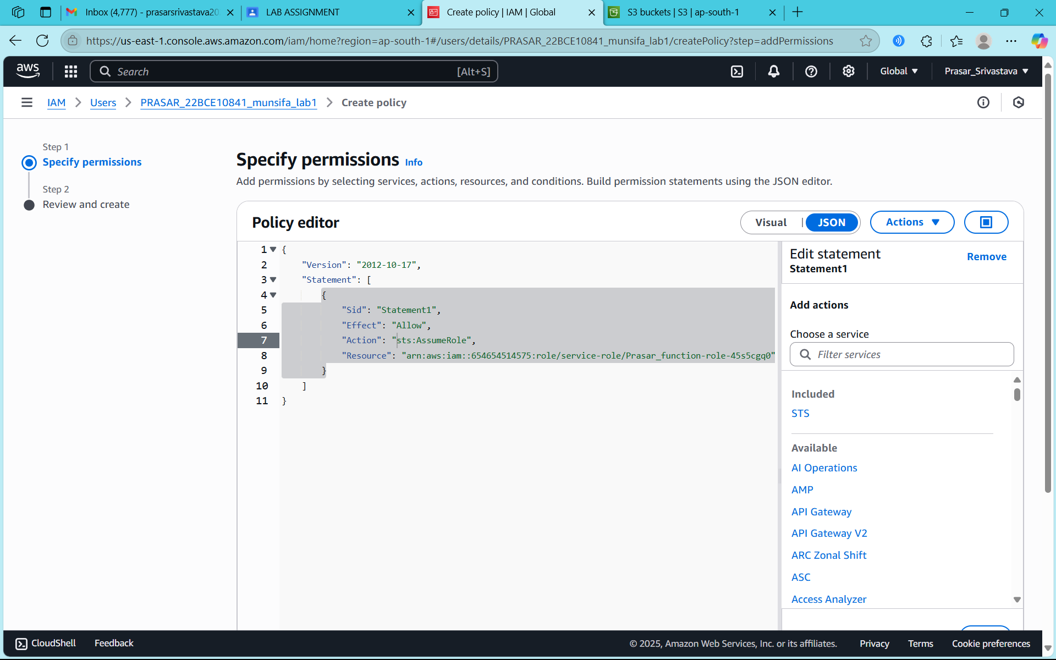

STEP15: TYPE A POLICY NAME AND CLICK ON CREATE POLICY

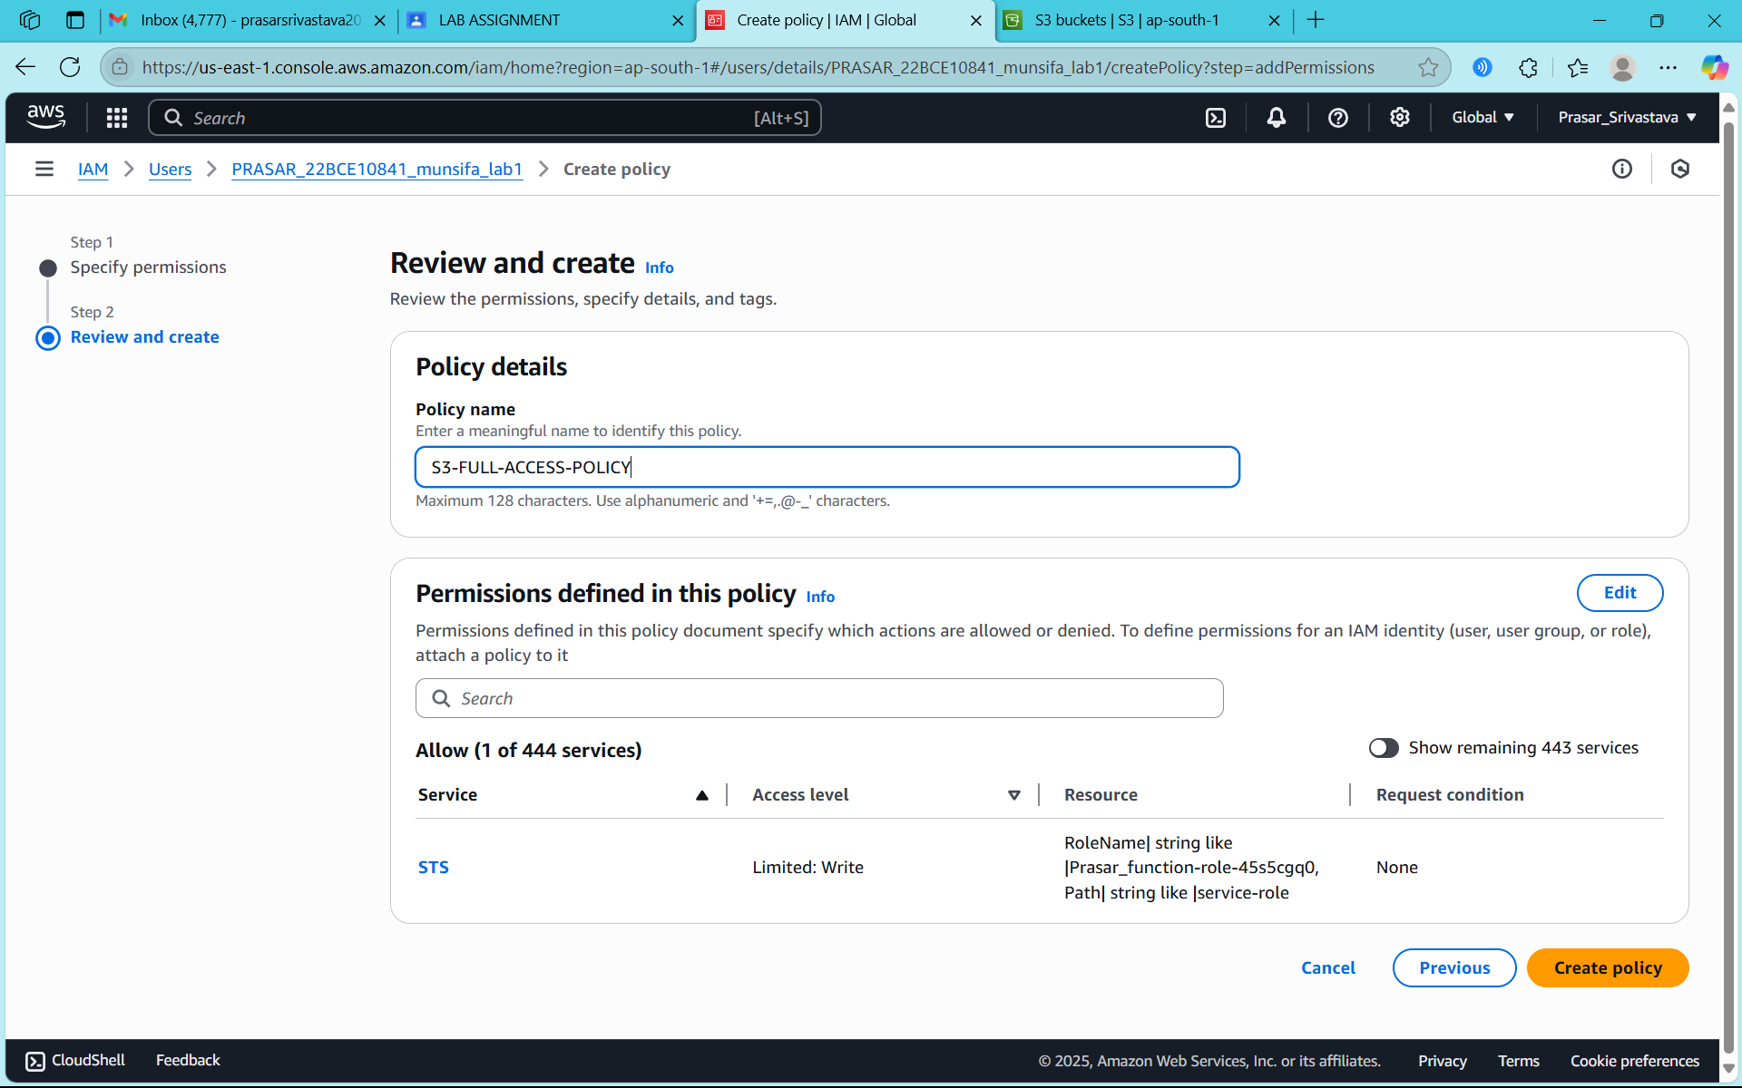

STEP16: POLICY CREATED

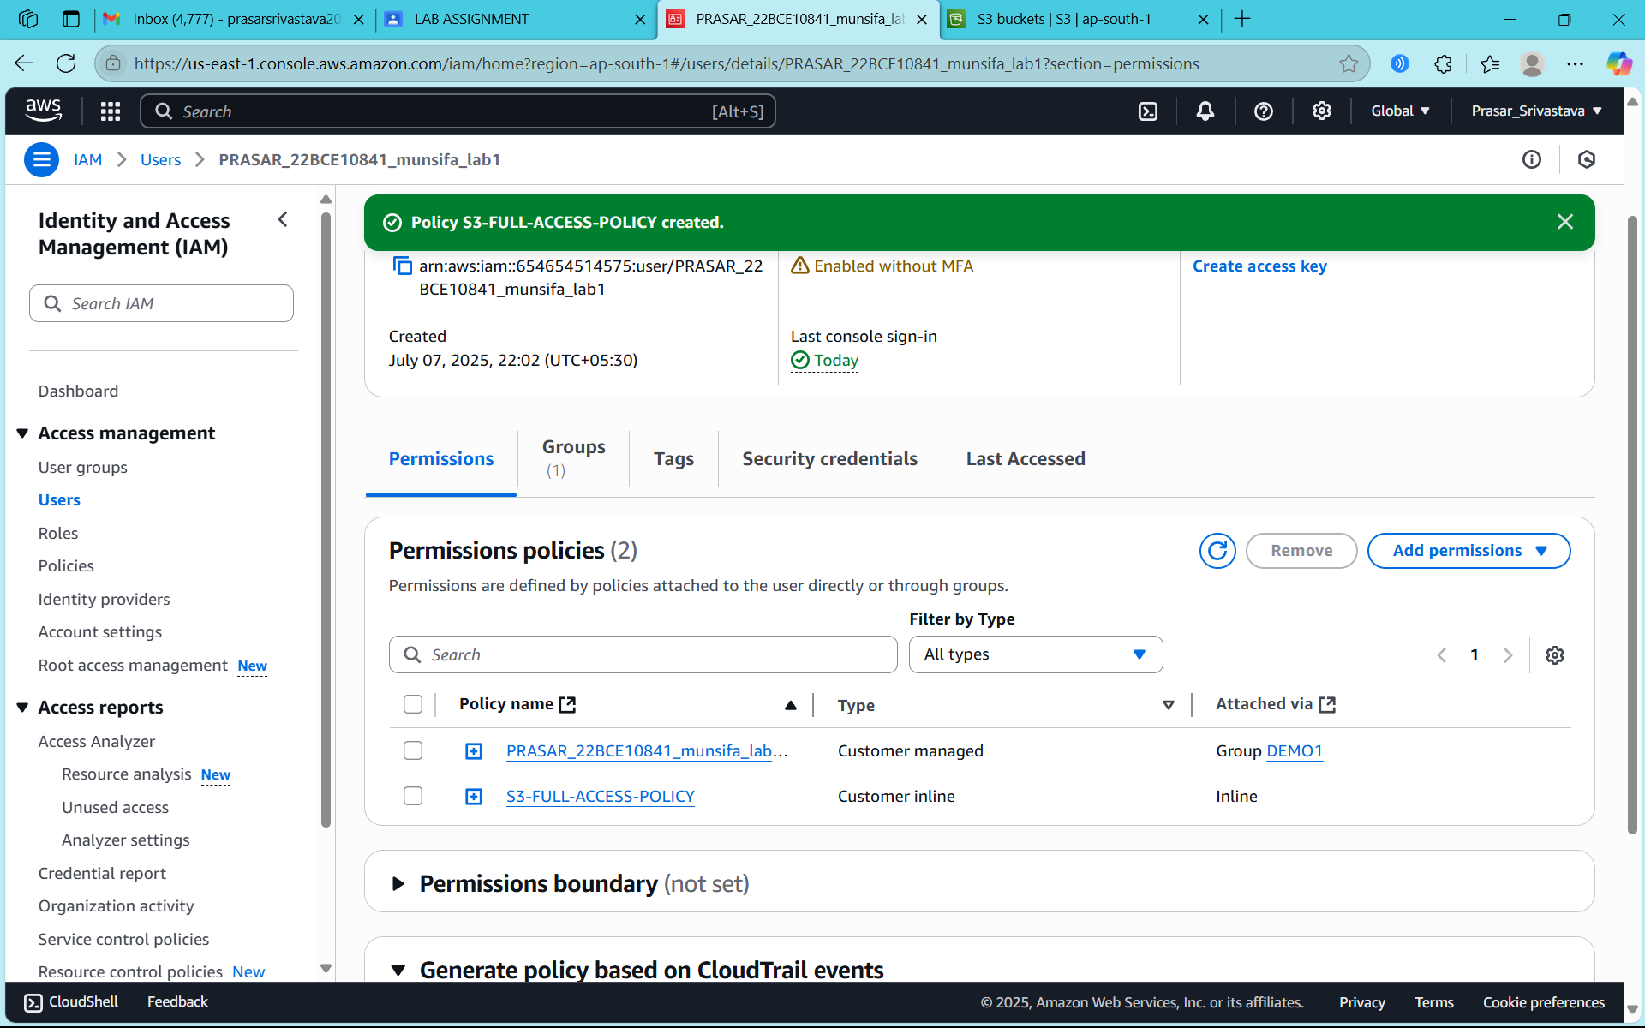

STEP17: GO TO ROLE>S3-FULL-ACCESS>COPY THE LINK FOR SWITCH USER

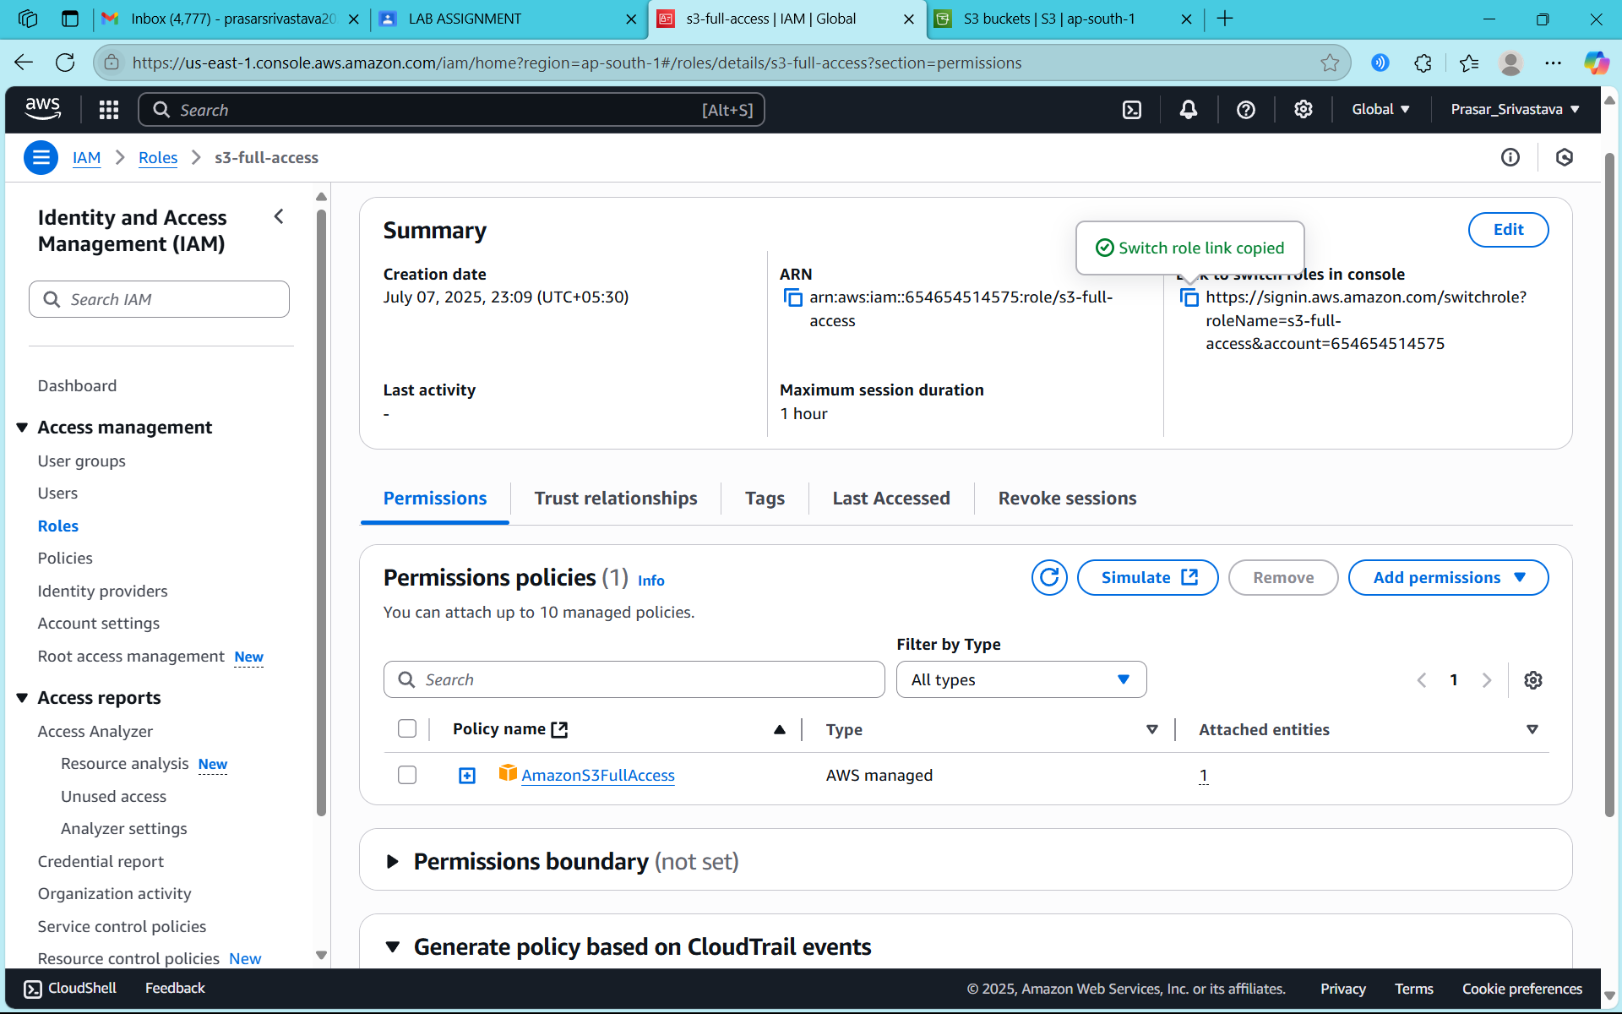

STEP18: PASTE THE LINK IN A DIFFERENT WINDOW AND CLICK ON SWITCH ROLE

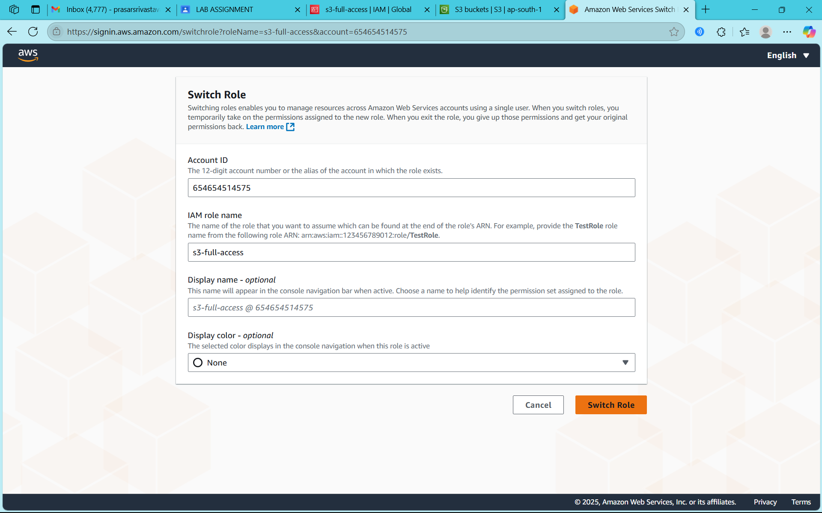

STEP19: CONSOLE PAGE FOR NEW ROLE IS DISPALYED

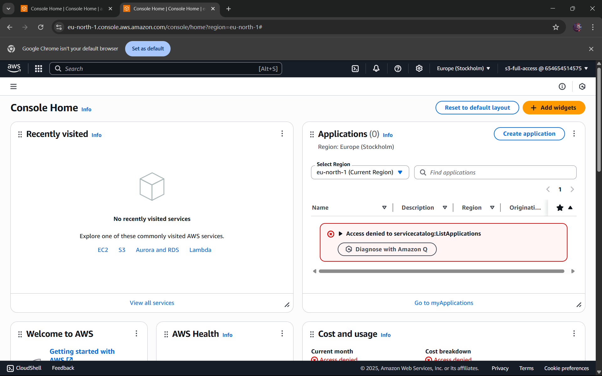

STEP20: SEARCH AND SELECT S3 DASHBOARD

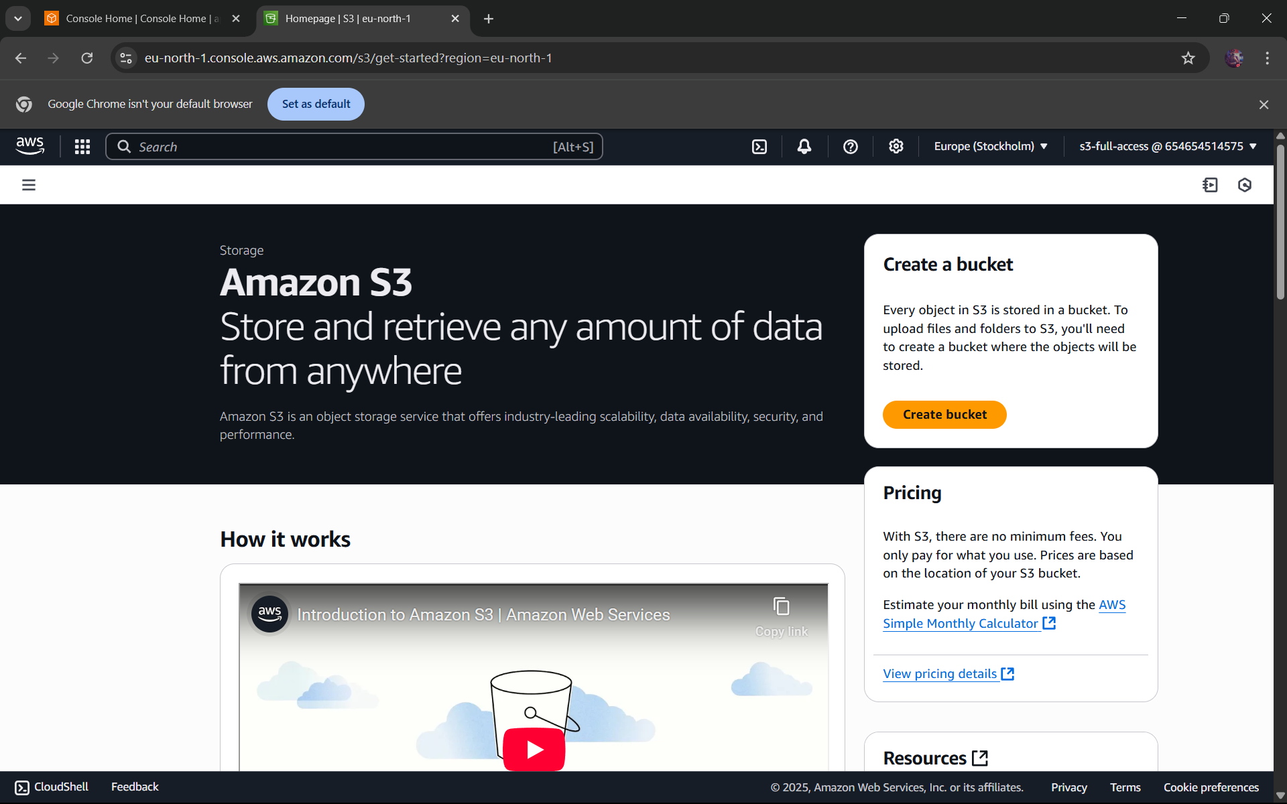

STEP21: CLICK ON GENERAL PURPOSE BUCKET

